Set the pass code that unlocks a panel's settings
The four to six digits that stand between a passer-by and a panel's own settings, where the app can be left, the screen rotated and the pairing wiped. Where it comes from, the two places it can be changed, and why the console can overwrite it but never read it.
2026-08-25 · https://offision.com/help/en/devices/set-a-device-pass-code/
Behind the room a panel is showing sits the panel's own settings page, and it is
not a booking screen. It rotates the display, changes the language, restarts the
app, leaves Offision altogether and — one row further down — wipes the pairing
and sends the panel back to a registration code. The pass code is the only thing
in front of all of that.
It is four to six digits, and it lives on the device, not on your server.
That single fact explains everything else on this page: every panel leaves the
factory on the same 0000, no two panels have to share a code, and the console
can push a new one down but can never show you the current one.
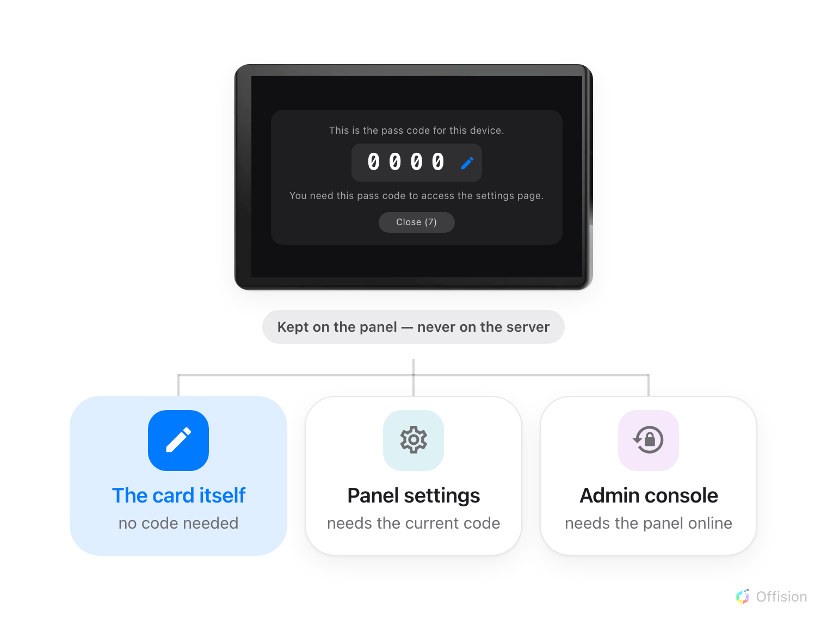
The card a panel raises to itself, seconds after it is paired.
Before you start:
The panel is paired and showing its room — see
Connect a booking panel to Offision. To use the
console route you also need an account that can manage devices, and the panel
has to be online at the moment you change it.

1. Change it while the panel is new
A few seconds after a panel lands on its room it raises the card above by
itself. Nobody asked for it; it appears because this is the one moment somebody
is certain to be standing at the panel, and it closes itself on a ten-second
countdown.
The pencil in the corner of the digits opens Edit pass code without going
anywhere else, and this is by far the cheapest moment to set one. The panel asks
twice — Enter new pass code, then Confirm new pass code — on its own
keypad. If the two do not match it quietly starts over at the first screen
rather than telling you so; watch for the heading changing back.
Do it before the panel goes up:
A panel still on 0000 on a wall is a panel anybody in the corridor can
rotate, re-language or un-pair. Everything below is a way of doing this later,
and later is always more work.

2. On the panel, afterwards
Once that card is gone, the same change lives behind the pass code you are
trying to replace.
Tap the panel to bring up its control bar and choose the settings button. The
panel asks to be unlocked, then Setting in the console's left-hand list
carries Change pass code — the same two-step keypad as before.
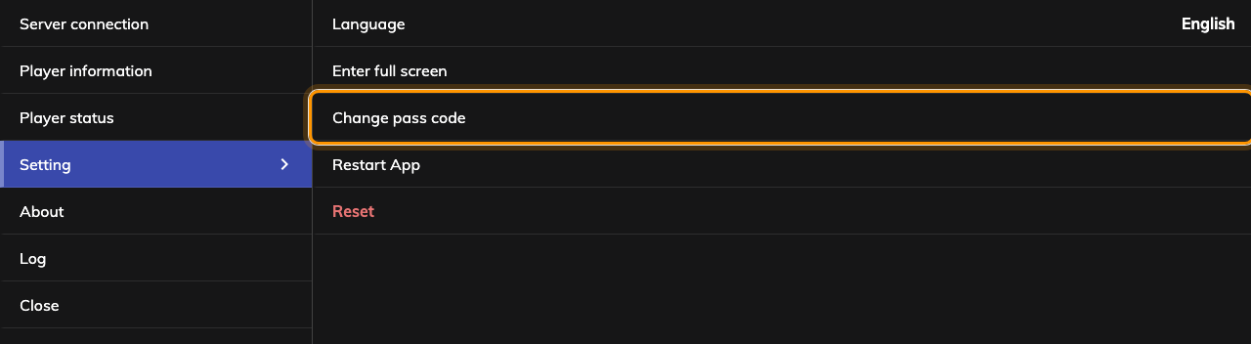
The panel's own settings page. Change pass code sits above the rows it protects.
The rows under it are what the pass code is for: Restart App, and last and
in red Reset, which forgets the server and the pairing and sends the panel
back to a registration code. Panels running the installed Offision app carry
two more — Reboot device, and Leave Offision, which closes the app and
returns the screen to its launcher.
Three ways through the gate:
The keypad is not the only one. A user who is a player manager can tap their
staff card on the panel instead, or an administrator can scan the QR code the
unlock screen shows. Either opens the same console without anyone knowing the
digits — which is what to reach for when a panel's code has been lost and the
panel is not online.

3. From the console, when nobody is at the panel
Since 4.5.9 the console can push a new code down to a panel without anyone
standing at it. Go to Devices › Booking panel › Devices and select
the panel's row. Reset passcode sits with Real-time screen and Reboot
at the top of the detail panel.
Where in Offision: admin app → device/booking-panel/device (Booking panel)
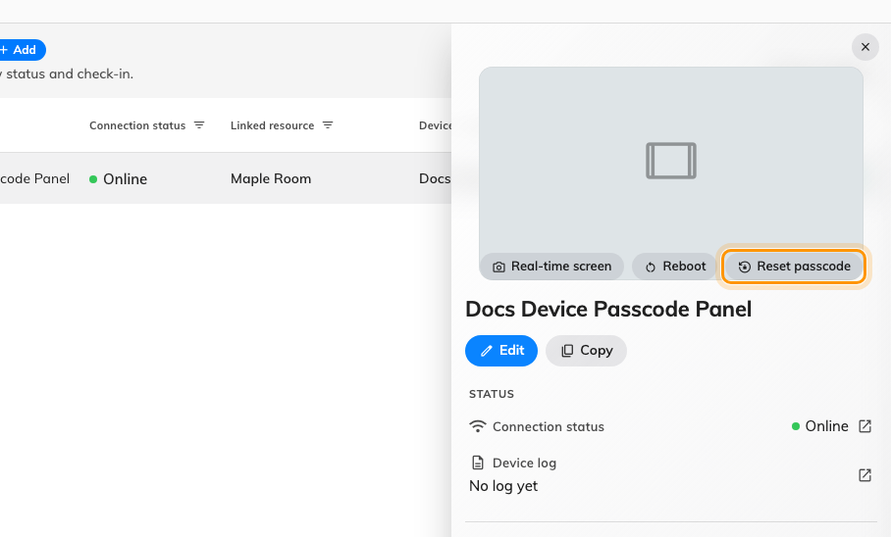
A panel's detail, with the action that overwrites its pass code.
Type the new code into New passcode and again into Confirm passcode —
4-6 digits, and the button stays disabled until both match. Saving takes a
moment longer than most: the console waits for the panel itself to confirm it
has stored the code, so a save that succeeds is proof the panel applied it.
Three things about this route are worth knowing before you rely on it:
- The panel must be online. Reset passcode is greyed with Device is
offline against a panel that is not answering, and there is no queue — the
code is not delivered later.
- It overwrites, it never reveals. There is nowhere in the console that
shows a panel's current pass code. A lost code is replaced, not recovered.
- Signage screens too. The same detail panel serves Devices ›
Signage › Devices and the device monitoring list, so a reception kiosk
or a lobby screen is reset exactly the same way.

4. Check it worked
Walk to the panel and open its settings with the new code. Then try the old one:
the keypad should refuse it with Invalid pass code and clear itself. A panel
that still takes the old code did not receive the change — which, on the console
route, means the save did not finish.

What this pass code does not control
- Who may check in at the panel. The User passcode a person types to
identify themselves is a different thing entirely, set by each person on
themselves — see
Let people identify with a passcode at the panel.
- Other panels. This code belongs to one device. Unlike the buttons, the
skin and the identification methods, it does not come from a shared
configuration, so changing it changes nothing else — see
How a panel gets its settings.
- Leaving the app on every panel. Leave Offision appears only where the
panel is running the installed Offision app and has a launcher to return to. A
panel showing the player in its own browser has nowhere to go, so the row is
absent.
- Retiring a panel. Reset on the panel wipes the pairing from the panel's
end; Disconnect device in the console releases the hardware while keeping
the record. They are different actions for different situations — see
Connect a booking panel to Offision.
- A panel that starts again. Anything that clears the panel's storage — a
factory reset, a re-pairing, a reinstalled app — puts it back on 0000.

