See every device in one place
One table for panels, screens, e-paper tags, doors, lockers, microphones, gateways and sensors — filtered by where they are and whether they are answering, with the detail of any one of them beside it.
2026-08-25 · https://offision.com/help/en/devices/see-every-device-in-one-place/
Device monitoring is the one screen that does not care what kind of hardware
something is. Panels, signage screens, e-paper tags, door controllers, lockers,
microphones, gateways and sensors all arrive in the same table, described in the
same columns, and filtered the same way.
Where in Offision: admin app → device/monitoring (Device monitoring)

Two halves
The top half is where things are: a switch between Earth, city, building,
floor and room, with a list on the left and a map, a stack of floors or a floor
plan on the right. Choosing a place narrows the table underneath to what is in it.
The bottom half is the table.
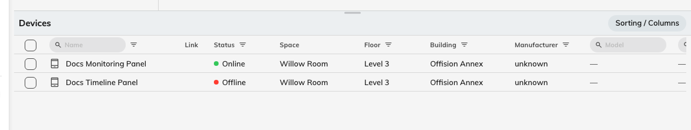
Every kind of device in one table, scoped to the place chosen above it.
The page remembers where you left it, so a facilities manager who works one
building lands there next time rather than on the globe.

The columns that answer the question
Status is either Online or Offline, and it is the live connection
state — the same thing the offline alert watches, so a device the table calls
offline is a device that will be emailed about once its threshold passes.
Last seen is how long ago the device was answering, written as a relative time
with the exact moment on hover. It is the column that separates "the network
blinked" from "this has been dead since Friday".
Battery applies to devices that have one, e-paper tags especially, and shows a
lightning mark when the device is plugged in instead. A tag that has gone quiet
here is usually out of range rather than flat — see
How fast Qbic e-paper tags update.
The rest describe the thing rather than its health: Name, Space,
Floor, Building, Manufacturer, Model, IP address, and — hidden
until you ask for them — MAC address, Serial number, Firmware,
Browser version, App version and Type. Sorting / Columns chooses
which appear and in what order, and remembers your choice.
Link opens the device's own web interface, on its own network address. That
only works from a computer on the same network as the device, which is why it asks
before it opens.

Filtering happens in the headers
There is no toolbar. Each column header carries its own control: type a name,
choose one or more device types, pick Online, Offline or Low battery,
choose a floor or a building, choose a manufacturer. Combine them freely —
Offline plus a building answers "what is broken here" in two clicks.
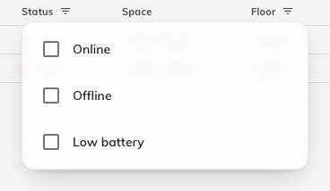
The Status filter: Online, Offline, or Low battery.
Clear filter on an active header drops just that one.

The detail beside it
Selecting a row opens the device on the right. What appears depends on what it is.
For a panel or a screen it is the device's own record: Connection status,
Device information, Network info, Hardware, System version, its
Linked resource and its configuration — plus Real-time screen, which
fetches a live screenshot, and Reboot. Both are greyed out while the device is
offline, with Device is offline on hover, because there is nothing there to
ask.
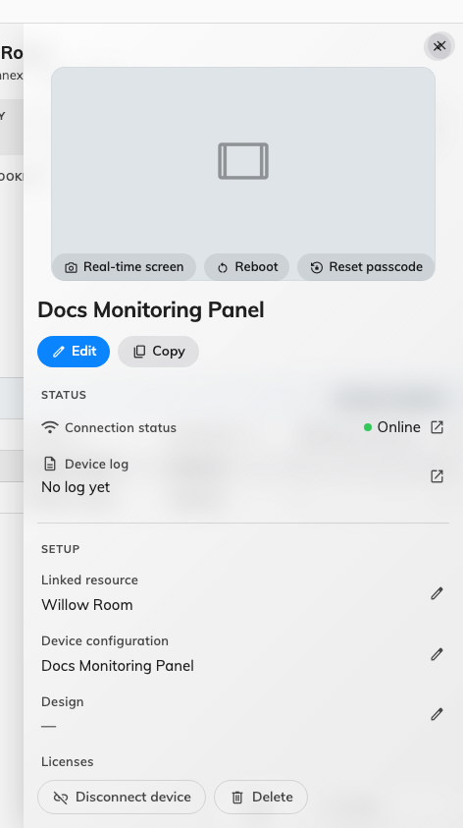
A device that is answering: its connection state at the top, and the two actions that need it live.
For a sensor it is the readings and a link to their history; for something with
controls — a camera, a screen, a relay, a lock — it is those controls. For a
gateway it is the devices hanging off it.

Deleting from here
The detail panel ends with Delete, so a device you have just found dead can be
removed without going to find it on another page.
It is offered for IoT devices and gateways, and for players, which have always
had it. Deleting a gateway takes its expansion units and their child devices with
it, and a control processor says so before it goes. Doors, e-paper tags,
microphones and locker boxes have no Delete here — those rows are a read-only
view of a record that lives elsewhere, so they are deleted on their own pages.
Not everything here updates live:
Panels, screens, e-paper tags, sensors and gateways announce their own connection
changes, and the table refreshes when they do. Doors, lockers and microphones have
no such signal, so their rows only change when the page is reloaded.

Where this stops
This screen tells you a device is not answering. It does not tell anybody else —
that is the offline alert — and it
does not show you what a working screen is currently displaying, which is
Screen monitoring.

