Save energy on room panels
Let panels switch their screens off when nobody is there. What it saves, how to tie it to your rooms' business hours so panels stay awake through the working day, and what to check when one never sleeps.
2026-08-25 · https://offision.com/help/en/devices/save-energy-on-room-panels/
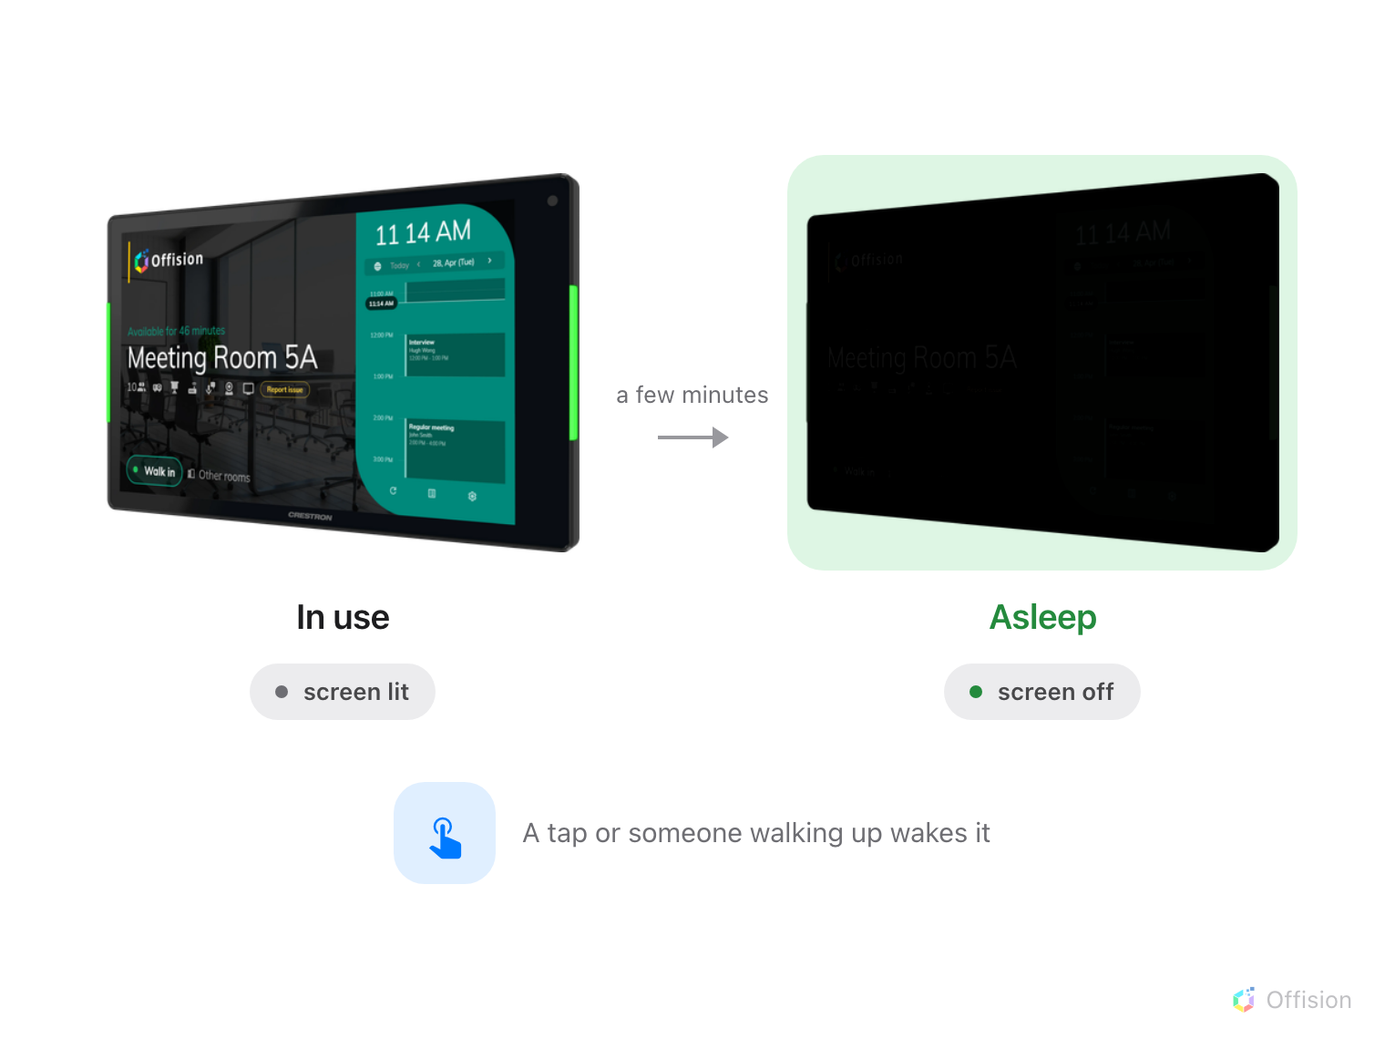
Left alone, a panel turns its screen off — and on a panel that can switch its backlight off with it, that is most of the power it draws.
A booking panel outside a meeting room is on every hour of the year, and for
most of those hours there is nobody in the corridor to read it. Save energy mode
is what stops it lighting an empty corridor.

What it actually saves
The largest single draw in a panel is its backlight, not its processor. So the
saving depends entirely on whether the panel can switch that backlight off, or
can only paint its screen black and leave the light behind it burning.
Panel | What happens in save energy mode | Power saved
Qbic Android panels, TD- and HC-series | The backlight switches off | Yes — a panel asleep uses less than half the power it does lit
iAdea panels | The LED status bar dims; the screen backlight stays on | The status bar only
Samsung, LG, Crestron, Cisco, Neat, desktop and browser players | The screen goes black | None — the backlight stays lit

Every panel shows the same dark screen, so the row above is the only way to tell
which ones are actually saving anything. It is worth checking before you promise
a number to anyone. On the panels that only go black it is still worth having —
a dark corridor at night is usually the point, and the panel stops burning its
screen in.

Set it up
Before you start:
You need an account that can manage devices and rooms. Each room whose panel
should sleep needs a business hour — without one the panel will never sleep,
whatever you set below.

1. Give the rooms a business hour
Go to Booking › Booking hours and create the opening hours the site
works to, then open each room under Booking › Rooms and set its
Business hour.
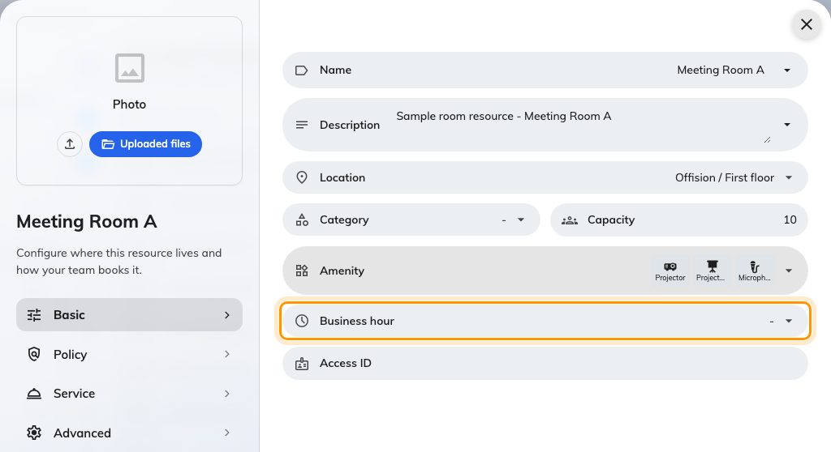
The business hour on a room.
The hours come from the room, not from the panel and not from the system
default. One business hour can serve a whole floor, so this is the field to
change later when the building's hours change — not the panel settings.

2. Open the panel configuration
Go to Devices › Booking panel › Panel configurations and open the
configuration your panels use. Choose Edit in the detail panel on the right.
Where in Offision: admin app → device/booking-panel/configuration (Panel configurations)
Everything below reaches every panel on this configuration and no others.
Where only some rooms should sleep, give them a configuration of their own.

3. Go to Screen saver & energy
The editor opens on Room booking panel, whose settings are grouped into
tiles. Screen saver & energy is the last of them before the design-by-purpose
overrides.

4. Turn on save energy mode
Switch on Enable save energy mode, then set Turn off screen after — the
idle time before the screen goes dark. The choices run from 15 seconds to
5 minutes.
Three minutes suits a corridor panel. Shorter than a minute is worth avoiding on
panels people walk past all day, because the screen spends its time waking and
sleeping rather than being either.

5. Turn on Only outside business hours
This is the switch that ties the panel to the room. With it on, the panel stays
awake right through the room's opening hours and only starts counting down once
they end. Leave it off and the panel sleeps whenever it is left alone, at three
in the afternoon as readily as at midnight.
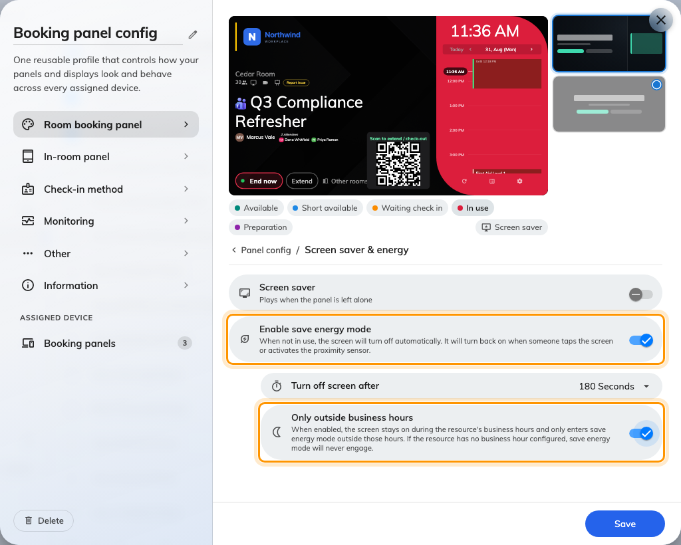
Save energy mode, restricted to the hours outside the room's business hour.
This switch arrived in 4.5.0.

6. Save, then check a panel
The save bar sits at the foot of the editor. Wait until the room's business
hours have ended, leave a panel alone for the time you set, and look at it. It
should be dark, and it should come back the moment you touch it.

What wakes a sleeping panel
A touch. Any tap or drag anywhere on the screen.
Somebody walking up. Qbic HC-series panels carry a proximity sensor, and the
panel watches it while asleep — anyone closer than about a metre and a half
wakes it before they have touched anything. Panels without that sensor wake on
touch alone.
A meeting starting. On an in-room panel, the room turning busy wakes the
screen by itself, with a short welcome that names the organizer.
In-room panels sleep on their own rule:
Panels running an in-room control skin get a second, shorter rule: when the room
is free and the next booking is more than ten minutes away, the panel sleeps
after one minute regardless of the idle timer. That minute is fixed and cannot
be configured. Added in 4.5.4, and switched by In-room panel save energy
mode — which now lives on the configuration's own In-room panel page,
under Idle & screen off, rather than beside the door panel's screen saver
settings.

If a panel never turns its screen off
Stand at the panel and leave it alone for longer than its Turn off screen
after time. If it goes dark and comes straight back on by itself, start at
solution 2. If it never goes dark at all, start at the top.
Solution 1 — The room has no business hour (most common)
This is the answer far more often than the other four together.
Only outside business hours asks one question — is it inside the room's
business hours right now? A room with no business hour assigned answers yes, at
every hour of every day, so the panel is never allowed to sleep.
Open the room under Booking › Rooms and check its Business hour.
Either give it one, or turn Only outside business hours off.
Where in Offision: admin app → booking/room (Standard Rooms)
Solution 2 — People keep walking past it (common)
A sleeping Qbic HC-series panel watches its proximity sensor constantly. Anyone
within about a metre and a half resets the idle countdown without touching
anything — so a panel in a busy corridor can spend the whole working day
restarting its timer.
You will recognise this one because the panel does sleep late at night and never
during the day.
Raise Turn off screen after so short interruptions do not matter, or turn on
Only outside business hours so the daytime traffic stops counting at all.
Solution 3 — It is showing a screen saver, not staying awake (common)
A panel playing a screen saver playlist looks lit, and from ten metres away it
is easy to read that as "it never turned off".
The two never run together — an asleep panel shows nothing at all, so save
energy mode always wins over the screen saver. Open Screen saver & energy
and check which of the two is actually switched on.
Solution 4 — The screen is dark but the panel is still lit (less common)
Here the panel does sleep — it just does not get any dimmer, and up close you
can see the backlight still burning behind a black screen.
That is the table at the top of this page: only some panels can switch their own
backlight off. Nothing is misconfigured, and there is no setting that changes
it. It is what the hardware can do.
Solution 5 — It is an in-room panel and the room is busy (less common)
The in-room rule needs the room to be free and the next booking to be more
than ten minutes away. A room booked back to back never satisfies both, so its
panel stays awake through the day — by design, because a panel that sleeps
ninety seconds before a meeting starts is a panel people think is broken.
Check the room's day. If it is solid, the panel is behaving correctly.
Still need help:
Note the panel's model, the room's business hour, whether Only outside
business hours is on, and whether the panel is dark at 3am. Those four
identify which cause applied.

