Reuse a panel that was set up for something else
A panel already showing signage, a lobby board or a kiosk cannot be added as a booking panel on top of that. What an edit still covers, what has to be released first, and what the old record goes on holding until it is deleted.
2026-08-25 · https://offision.com/help/en/devices/reuse-a-panel-for-another-purpose/
The hardware and the job it does are two different things here. The screen on
the wall is one device; the row in the console is a record, and that record was
created to do one job — show a room, play a board, greet a visitor. A panel can
be claimed by one record at a time, and the job was settled by the wizard that
claimed it.
That is why no row offers to change it. What a panel is can be read on its
record and never edited there, so moving hardware from one job to another is not
an edit at all: it is a release and a fresh pairing.
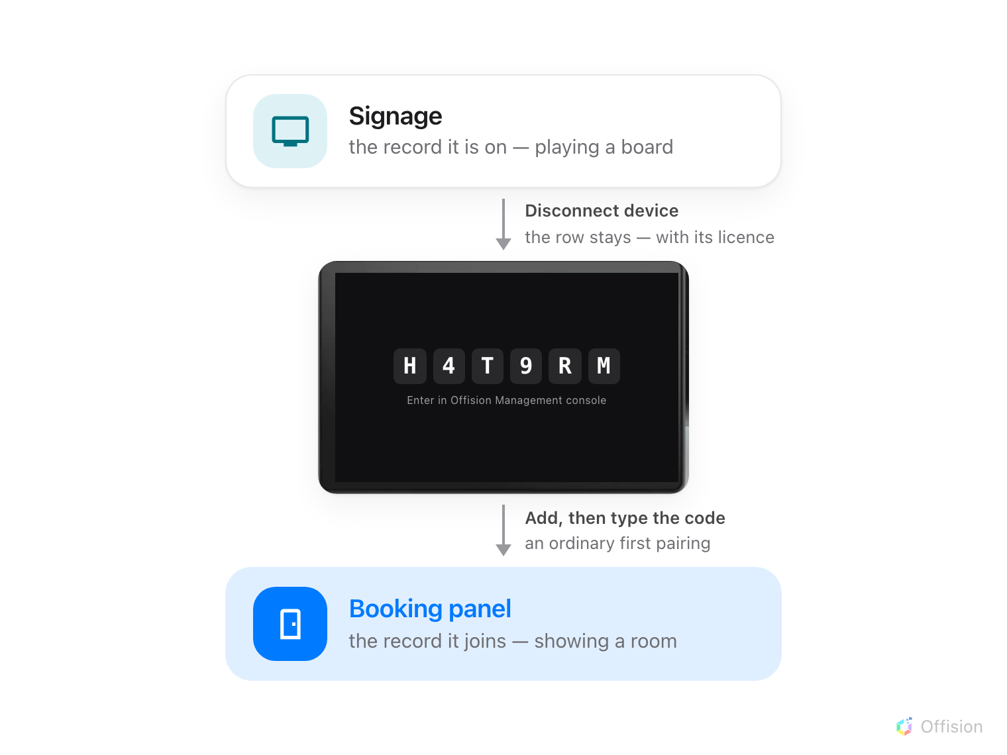
One panel, two records. Nothing passes between them — it is released back to a code, then claimed again.
Before you start:
The panel is powered and on a network that can reach the internet, and you can
open Devices in the console. Know which record it is on now: a booking panel
sits under Booking panel › Devices, and a signage screen, lobby board or
reception kiosk under Signage › Devices.

Can I just add it as a booking panel?
No. Adding a panel means typing the six characters it is showing into a wizard,
and a claimed panel is not showing them — it is showing its room, or its board.
Release it and the code comes back, usually within a few seconds.
Or was it running somebody else's software?:
A screen that has been a Teams or Zoom scheduling panel is a different question,
and the answer is settled before any of this: it has to be a model Offision
supports and it has to be able to run the Offision app. Check it against
Which booking panel hardware Offision supports.
The rest of this page is about hardware already added to Offision.

What an edit already covers
Two changes look like this one and are not. Neither goes near the hardware.
- Another room. Change Linked resource on the panel's row. The panel
follows within seconds; it does not need to be paired again.
- Room booking panel, or meeting assistant. Both are the same room panel
wearing a different design, so this is the Design row on the record — see
The meeting assistant panel, inside the room.
That Design dialog also carries a Desk booking panel tile, and on an
existing panel it is the one choice there that does nothing: what makes a panel
a desk panel is the desk it was paired to, not the design.

What has to be released
Everything else, because it means a different record:
- a signage screen, lobby board or reception kiosk becoming a booking panel, or
a booking panel becoming any of those — they are added in different places and
never share a record
- a room booking panel becoming a desk booking panel, and the reverse

1. Release it
Open the record the panel is on now, select its row, and take Disconnect
device at the foot of the detail.
Where in Offision: admin app → device/booking-panel/device (Booking panel)
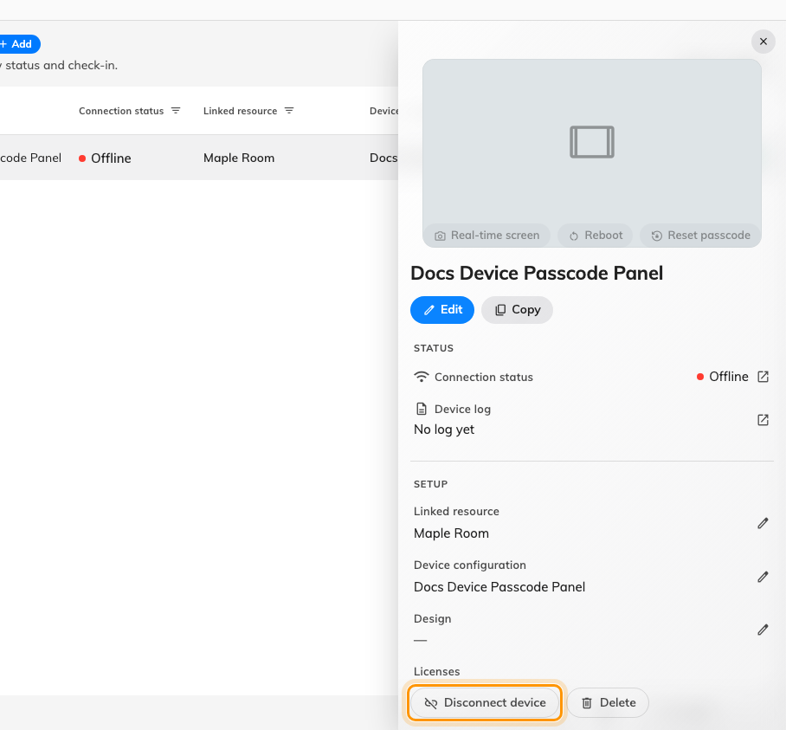
The foot of the device detail. Disconnect releases the hardware; Delete removes the record with it.
The panel wipes its pairing by itself, restarts, and comes back on a fresh
six-character code. The record stays where it was, now with no hardware on it.
An offline panel never hears it:
The release is sent to the panel as it happens and is not queued, so a panel
that is off or off the network keeps showing its cached screen. Do it at the
panel instead: Reset, at the foot of the panel's own settings, which is
behind the device pass code.

2. Pair it where it is going
From here it is an ordinary first pairing. Go to the list this panel is joining,
choose Add, answer the wizard, and type the six characters at the end of it —
Connect a booking panel to Offision walks the
booking-panel wizard, and the signage wizard asks for the content instead of the
room.
Read the code off the panel now rather than reusing one noted before the
release. The panel has restarted since, and a restarted panel shows a different
one.

3. Check it worked
The panel has a row in its new list, and Connection status should read online
within a minute. The old record, if you kept it, now shows no device against it.
Then prove it end to end rather than trusting the row: book the room and watch
the panel change while you are standing at it.

What this does not do
- It does not free the licence. A record with no hardware still holds its
device licence. That is released when the record is deleted, not when it
is disconnected — so delete the old row unless the panel is going back to that
job.
- It does not move any settings with the panel. The configuration, the
content and the room belong to records, not to hardware, and the new record
starts with whatever the wizard gave it.
- It does not touch the panel's own settings. Released from the console, a
panel keeps its language, its scale and the pass code it was given. Released
by Reset at the panel, it keeps none of them — that route clears the
device's storage, so the pass code is back on 0000 and worth setting again
the moment it pairs. See
Set the pass code that unlocks a panel's settings.

