Every switch that puts a button on the panel
Three groups of Room booking panel decide what a person at the room may do — walk in, check in, extend, open the door, and whether they may cancel the meeting at all. Every switch, row by row, and what still cancels a booking when the panel cannot.
2026-08-21 · https://offision.com/help/en/devices/panel-function-reference/
What a person standing at the room may do — take it, check in, extend, report a
problem, and whether they may cancel the meeting at all — is three groups of the
configuration's Room booking panel page. Turning Show cancel booking button off
is how you stop people canceling meetings from the door.
These are settings of a configuration, not of a panel, so every switch here
lands on every panel sharing that configuration — see
How a panel gets its settings.
Where in Offision: admin app → device/booking-panel/configuration (Panel configurations)
Select the configuration and open it with the edit action. It opens on Panel
config; the switches below are in three of its groups:
- Use a booking — the QR code, and what may be done to the booking in front
of you: walk in, check in, check out, extend.
- Book from the panel — booking ahead from the timeline, the details dialog,
and the cancel button inside it.
- Door & extras — other rooms, the door, and reporting a problem.
All three are greyed out while Touch screen mode is off, which is the switch
in the first cell of the group menu — see
Run a panel as a display-only screen.
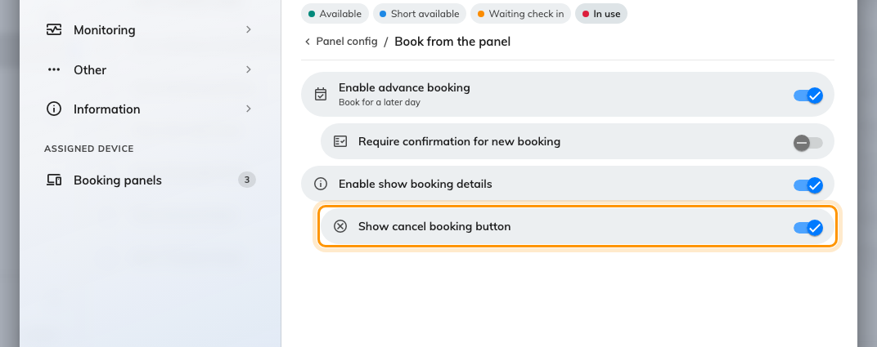
Book from the panel, with Show cancel booking button under Enable show booking details.
A new configuration starts with every button on except the door: someone at the
room can do everything until you take something away.

What these switches look like at the door
The action row is the panel's centrepiece, and it is entirely these groups'
product: every button in it is one of the switches below. Which of them the
panel offers at any moment also follows the room's state — a meeting waiting
for its organizer offers Check in, one in use offers End now and
Extend, a free room offers Walk in.
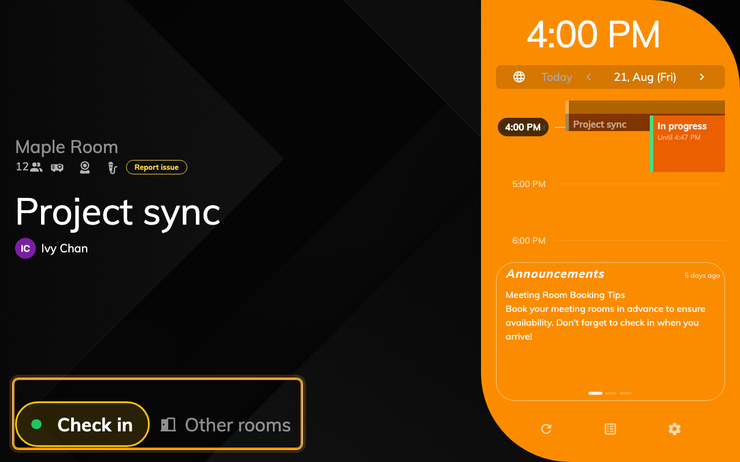
The action row on a meeting waiting for check-in. Every button in it is one of these switches.

The two switches that frame everything else
Setting | What it does | When to change it
Show QR Code for booking | Floats a QR card on the panel; scanning it opens the User Portal to book, check in or extend from a phone. | Off where the card crowds a small screen, or you want everything to happen on the panel itself.
Touch screen mode | On, the panel is interactive and shows action buttons. Off, it is a display-only screen with every button hidden. | Off for a glanceable status display — a screen behind glass, or one nobody should operate. Run a panel as a display-only screen is the whole flow.

Everything below exists only while Touch screen mode is on; turning it off
hides the whole list, on the panel and in the group menu.
The Center design draws fewer of these:
Show QR Code for booking, Enable advance booking, Require confirmation
for new booking, Enable show booking details, Show cancel booking
button and Show report issue button have no surface on the Center
design, so they are disabled while it is the design in play — see
Choose a panel design.

Use a booking — what may be done to the meeting in front of you
Setting | What it does | When to change it
Show walk in button | A free room offers Walk in — the room from now, no app involved. The whole flow is its own page. | Off where passers-by should not be able to take the room.
Allow visitor walk-in booking — under walk in | Lets somebody identify as a visitor rather than a user when walking in. Needs the Visitor management licence. | On in visitor-heavy spaces; off keeps walk-in to staff.
Require confirmation for walk-in — under walk in | Adds a last screen to name the meeting and say how many are coming. | Off for a one-tap flow; on where bookings should carry a real title.
Show check-in button | A booking waiting for its organizer offers Check in — see Check in at the booking panel. | Off where check-in happens elsewhere — the user app, or a sensor.
Show check out button | A meeting in use offers a way to end early and release the room. | Off where rooms should hold their slot to the end regardless.
Show extend button | A meeting in use offers Extend, up to the next booking. | Off where back-to-back schedules must not stretch.
Require confirmation for extend — under extend | Asks for a confirmation before the extension is submitted. | Off for one tap; on to prevent accidental extends.

Book from the panel — booking ahead, and the cancel button
Setting | What it does | When to change it
Enable advance booking | The timeline can be tapped to book ahead — now and the coming few days. | Off where the panel is for the current meeting only and booking ahead belongs to the user app.
Require confirmation for new booking — under advance booking | Asks for a confirmation before the new booking is submitted. | Off for one tap; on where a mis-tap on the timeline is easy.
Enable show booking details | Tapping a booking opens its details — title, organizer, attendees. | Off where meeting titles and names are not for whoever walks past.
Show cancel booking button — under booking details | The details dialog offers Cancel booking, deleting the meeting from the screen. | Off to stop people canceling meetings at the door. They can still see the details; they just cannot remove the booking.

Canceling from the panel is not anonymous: unless the room books only from the
panel, the person is asked to
prove who they are first, the same way as for
check-in.
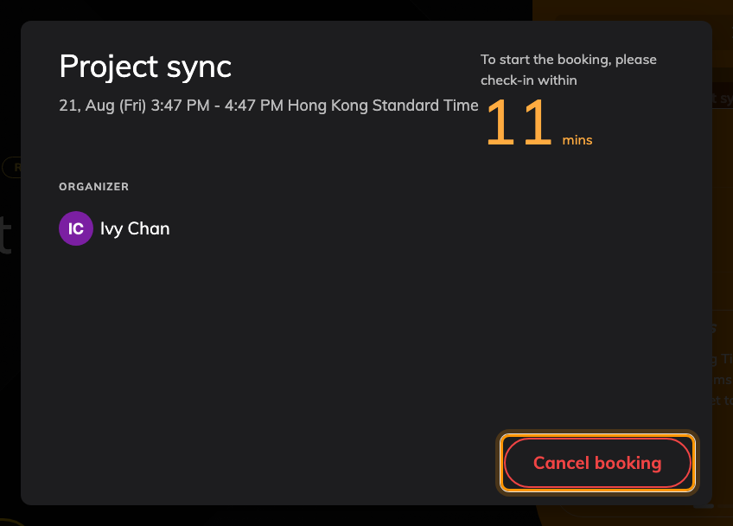
The details dialog, with Cancel booking at its foot — the row this switch removes.

Door & extras — finding rooms, the door, and problems
Setting | What it does | When to change it
Show other rooms button | A busy room offers to find a free one nearby. | Off where the panel should speak only for its own room.
Show open door button | The panel offers Open door, using the Qbic AC-500 relay board to trigger the door lock. | On only for panels wired to a lock; it does nothing without one.
Allow visitor open door — under open door | Lets an identified visitor open the door, not only staff. Needs the Visitor management licence. | On where visitors reach the room unescorted.
Open duration (in seconds) — under open door | How long the door stays open after the button, before it locks itself again (1–60). | Longer for doors people reach slowly; the default is ten seconds.
Card scan opens door during meeting — under open door | While a booking is in use, tapping a card opens the door directly instead of showing the extend / check-out dialog. | Off if a card tap during a meeting should offer actions rather than open the door.
Show report issue button | Lets anyone report a problem with the room through the panel. | Off where facilities requests come in some other way.

When the cancel button is missing anyway
Five different things remove it, and only the first is its own switch:
- Show cancel booking button is off — or Enable show booking details is,
which removes the dialog the button lives in.
- Touch screen mode is off, which hides every button at once.
- The meeting is checked in. A meeting in use is ended with check-out, not
canceled; the panel shows End now and Extend instead.
- The booking is in a state that cannot be canceled at all — already ended, or
already canceled from somewhere else.
- The panel runs the Center design, which has no booking-details dialog
for the button to live in — see Choose a panel design.

What this does not control
- Canceling from anywhere else. The organizer can still cancel from the user
app or their calendar. To freeze a booking near its start everywhere, use
Limit user can edit or delete booking before it start in the resource
policy — see Resource policy settings.
- Other people's meetings in the user app. Only the organizer, or someone
they delegate, may cancel there — that rule is built in, not a setting.
- Who counts as identified. The credentials the panel accepts are the
Check-in method page — see
How somebody proves who they are at the panel.
- Whether check-in is required, and its window. That is the resource's
policy, not the panel's — see
How check-in and no-show work.

