How a panel gets its settings
A panel holds almost nothing of its own. Its buttons, its identification and its look come from a named configuration that other panels share — which is why changing one panel can change twenty.
2026-08-21 · https://offision.com/help/en/devices/panel-configurations/
Nothing you change about a panel is stored on the panel. Its buttons, the
credentials it asks for, its skin and its screen saver all come from a panel
configuration — a named set of settings that any number of panels point at.
That is the one thing to understand before anything else in this section, because
it is what makes "I changed one panel and it changed the whole floor" an
accurate description of what happened rather than a bug.
Where in Offision: admin app → device/booking-panel/configuration (Panel configurations)
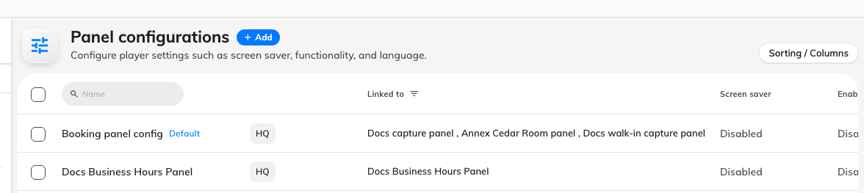
One configuration, with Linked to naming every panel that follows it.

Every setting sits on one of its pages
Opening a configuration opens a rail of pages. The configuration's name is
the rail's title and is edited in place — there is no Basic page.
- Room booking panel — the panel's design and everything it draws or offers, over
a live preview of the panel itself.
- In-room panel — the Meeting assistant screen inside the room. A
different panel with its own settings, which is why it has its own page — see
The meeting assistant panel.
- Check-in method — what the panel accepts as proof of who somebody is, and
whether it may accept nothing at all.
- Monitoring — the remote-control countdown, and whether anyone is
emailed when a panel goes offline.
- Other, then Information on an existing configuration.
- Booking panels, under the rail's one section title — the devices this
configuration drives.
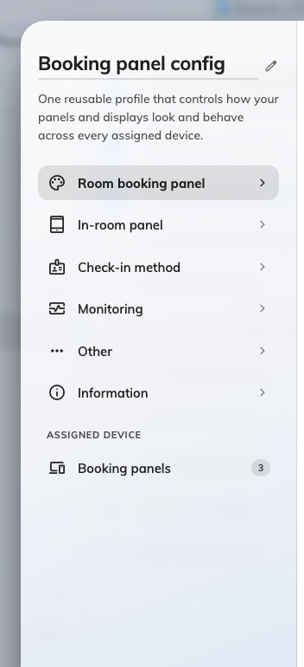
The rail. Room booking panel holds most of what the rest of this section sends you to.

Room booking panel is a preview over eleven groups
Room booking panel is not a page of switches. It is a live preview of the panel
with a menu of groups beneath it, each opening as a subpage — so the panel stays
on screen while any group is edited.
The first cell of that menu is Touch screen mode, and it governs three of
the groups: with it off the panel is a display-only screen and Use a booking,
Book from the panel and Door & extras have nothing to offer — see
Run a panel as a display-only screen.
Group | Holds
Background & logo | Background image mode and file, the company logo, the font
Status colours | The colour of each room state
Display languages | Which languages the panel offers
Room details | Room name text size, amenities
Booking details | Title, organizer, attendees, thumbnails, online-meeting logo
Timeline & clock | Announcements, 24-hour clock, the two timeline options
Use a booking | QR code, walk in, check in, check out, extend
Book from the panel | Advance booking, booking details, cancel
Door & extras | Other rooms, open door, report issue
Screen saver & energy | The idle playlist and save-energy mode
Design by purpose | A design override for individual booking purposes

The three action groups are the old Function page, and every switch in them
is still listed in Function settings. Colour
control and Screen saver were pages of their own too; they are Status
colours and Screen saver & energy here.
A greyed-out setting is the design saying no:
The panel has two designs, and the Center design draws far less than
Scheduling does — no side rail, no background image, no QR slot. A setting
that design cannot draw is disabled rather than hidden, so the form never
pretends to change something the panel will ignore. See
Choose a panel design.

Making one panel behave differently
There is no per-panel override. A panel that has to behave differently needs a
second configuration, and then to be moved onto it.
Both halves are done from the same dialog: build the configuration, then open
Booking panels, under Assigned device at the foot of the rail, and tick
the panels it applies to. The same move can be made from the other direction, on
the panel list, by setting a panel's configuration there.
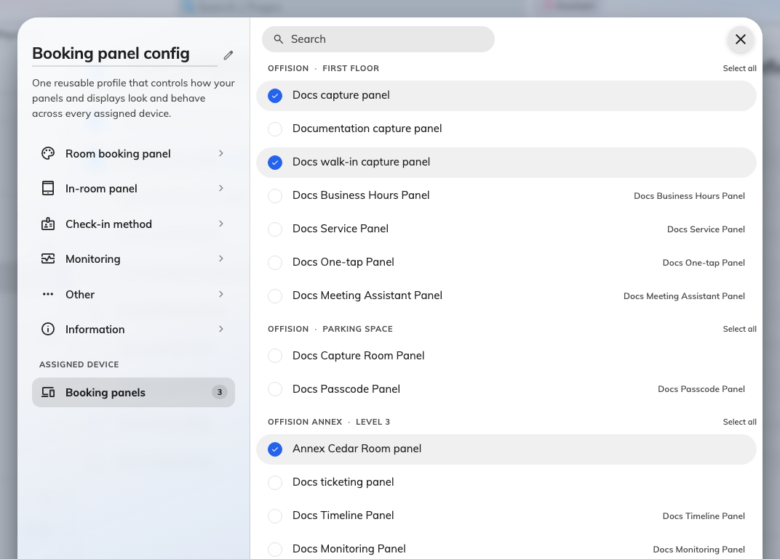
Every panel in the estate, by building and floor, with this configuration's ticked.
A lobby panel that should not let passers-by take the room, and a team-floor
panel that should, are two configurations. So are a panel with a card reader and
one without.
Saving tells you the blast radius:
Saving a configuration that already drives panels raises This change will
effect the following devices and lists them. It is worth reading rather than
confirming through — that list is the answer to "who else did I just change".

What this does not control
- Who may book the room, and for how long. That is the resource's policy —
see Resource policy settings.
- Whether check-in is required, and how long somebody has to do it. Also the
policy — see How check-in and no-show work.
- Which credentials exist at all. The organisation-wide Check-in method
screen sets the default for every panel; a configuration may override it, and
that is the subject of How somebody proves who they are at the panel.
- Which room a panel shows. That is the panel's own resource assignment, not
a configuration setting.

