Mount a panel in portrait
What a room panel draws when the device is turned on its side, why the schedule column folds itself away there, and the one configuration switch worth turning on before you rotate the first one.
2026-08-25 · https://offision.com/help/en/devices/mount-a-panel-in-portrait/
Before you start:
The panel is already connected and its
configuration uses the Modern design — the one with the schedule column.
The Center design has no column and is not affected by any of this.
A panel does not have a portrait setting. Turn the device on its side — in the
device's own display settings, or by mounting it that way — and the panel
follows the screen: the same two panes, side by side, redrawn for a screen
that is now narrower than it is tall.
That is the part that surprises people. The schedule column keeps its share of
the width, and at 800 pixels across that share is a sliver — so on a portrait
panel the column starts folded into its tap rail on its own, whether or not
the configuration asks for it. The room's name, status and buttons get nearly
the whole width; the clock stands on its side in the rail.
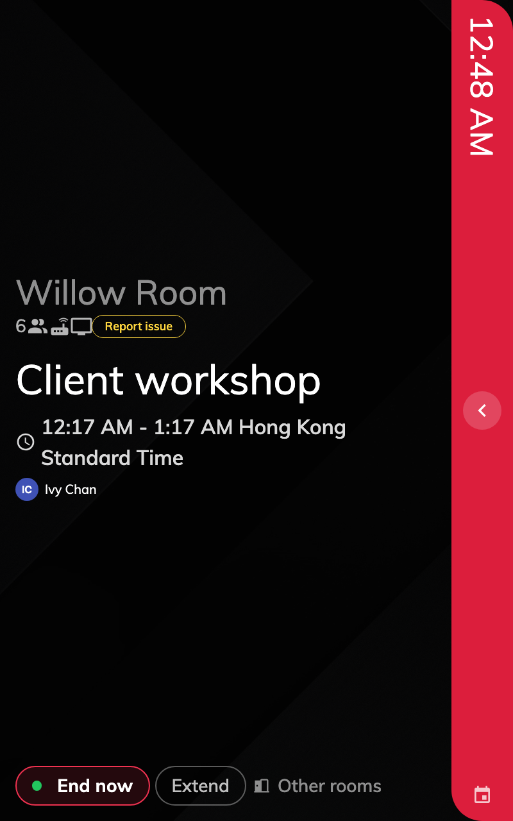
A panel on its side. The schedule column is folded into the rail on the right.

1. Rotate the device
Rotation is the device's, not Offision's. Set it wherever that device keeps its
display orientation — on an Android panel, its own display settings — and the
booking panel redraws itself the moment the screen turns. Nothing to save in
the admin console.

2. Turn on the collapse switch anyway
Open the panel's configuration and, in the Timeline & clock group, turn on
The timeline area is collapsed by default.
Where in Offision: admin app → device/booking-panel/configuration (Panel configurations)
On a portrait panel the switch changes nothing you can see — the column is
folded already. Two reasons to turn it on regardless:
- The configuration then says what the panel does. Somebody reading it later
should not have to know that portrait folds the column by itself.
- A configuration is shared. If it also serves small landscape panels, they
get the same relief — the column folds for them too, which is what
the cramped-panel article
recommends.
Saving a configuration that panels are already on raises a confirmation naming
them. Confirm it; each panel picks the change up on its next reload.

3. Check it on the panel
Tap the rail. The column slides open to its full width with the day's schedule
in it, and a chevron on its edge folds it back by hand. Left alone it re-folds
after three minutes without a touch, so a panel someone opened at nine is not
still open at noon.
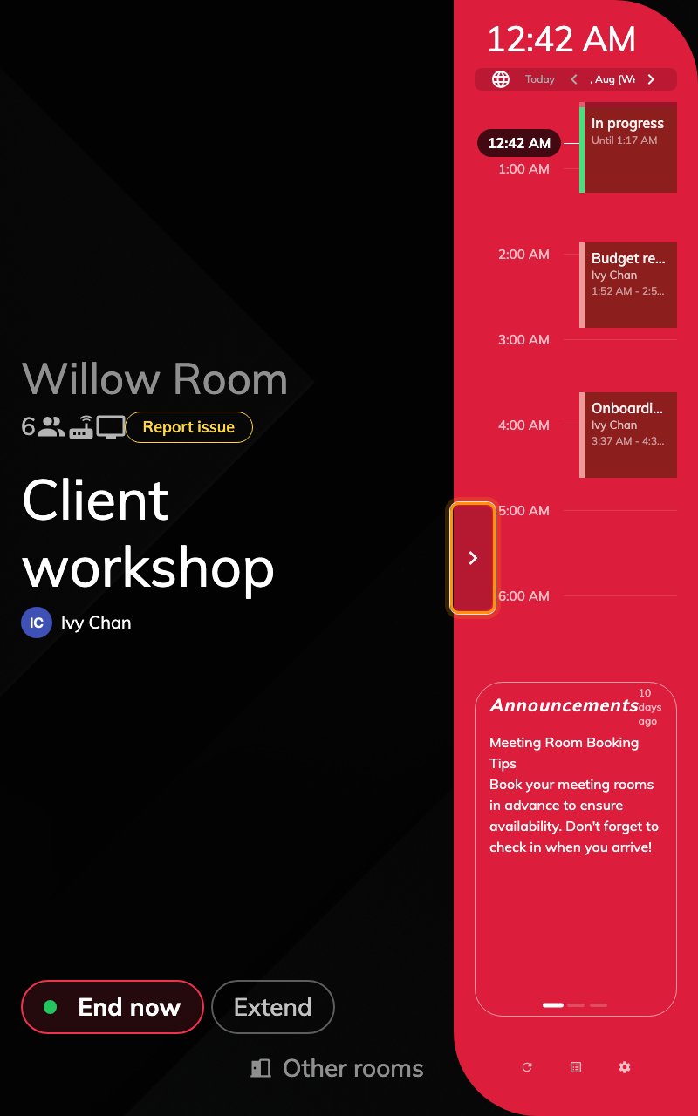
The same panel after a tap on the rail. The chevron folds it back.
While the column is open the room's own details narrow to make room for it.
That is the expected trade — the column is a thing somebody opens to look at,
not the panel's resting state.

What this does not control
- The compact layout. A screen 560 pixels wide or narrower, or under 480
tall, draws the single-column layout with no schedule anywhere — a phone-sized
door plate, not a rotated 10-inch panel. Nothing here applies there.
- The Center design. It has no column in either orientation.
- The panel's language, logo or buttons. Those come from the same
configuration as in landscape; see Panel configurations.

