Know when a device goes offline
A panel that has quietly stopped answering looks exactly like a panel nobody has walked past. Offision can email somebody instead of waiting for a person to notice — and it waits a while first, on purpose.
2026-08-20 · https://offision.com/help/en/devices/know-when-a-device-goes-offline/
A screen on a wall fails silently. It keeps showing whatever it last drew, so from
the corridor a panel that lost its network an hour ago is indistinguishable from
one that is working. Offision watches the connection rather than the picture, and
can email somebody the moment a device has been quiet for longer than you are
willing to tolerate.

What counts as offline
Not "the screen is dark", and not "nobody has touched it". A device is online for
as long as it holds its connection to the server; it goes offline the moment that
connection drops and stays dropped.
That is deliberately narrower than it sounds. A panel whose backlight has failed
is still online. A panel someone unplugged is offline within seconds. A panel on a
flaky access point flickers between the two — which is exactly why the alert does
not fire on the first drop.
There is a second, slower route to the same place. A device that holds its
connection open but stops sending its health figures for an hour is given up on
and marked offline as well. The wait then starts from the moment it was given up
on, not from the last figures it managed to send — so an alert down this route
arrives later than the device actually went quiet.

Why it waits
Every alert is set to wait a while before it is sent, because a network that
blinks for ninety seconds is not a fault anybody should be emailed about. The
Offline threshold is how long a device has to stay unreachable before it
counts as a problem, and it is the setting that decides whether the alert is
useful or ignored.
Set it short and a site with ordinary wireless noise will email somebody several
times a week about panels that fixed themselves. Set it long and a genuinely dead
panel spends the morning dead. Most estates land somewhere in the middle: long
enough that a reboot or a brief outage passes unremarked, short enough that
somebody hears before the first meeting of the day.
The threshold is per configuration, not per device:
The wait, and the list of people told, both live on the configuration a device
shares with others. Panels that need a different answer need a configuration of
their own.

Who gets told
Nobody by default. The alert names its own recipients — people, groups of people,
or both — and reaches exactly those. It is not a broadcast to administrators, and
having permission to manage devices does not put somebody on the list.
Everyone named is emailed the same message, and somebody who qualifies twice over
— named directly and sitting in a named group — still receives one copy.

Two emails, not one
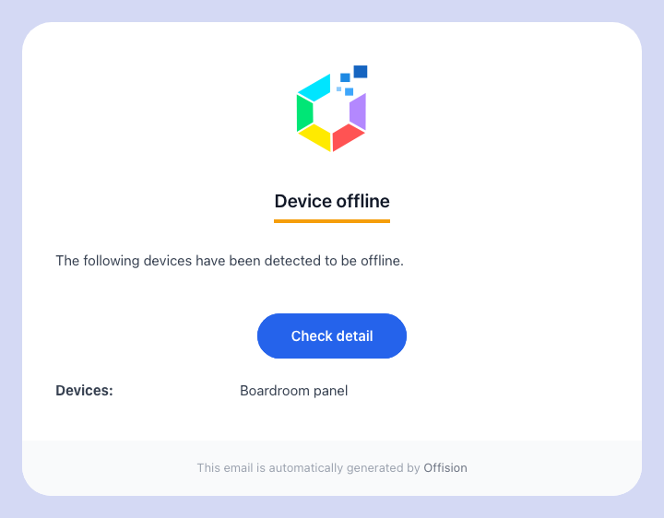
The Device offline email, naming the device that stopped answering.
Device offline goes out once the threshold has passed, and lists every device
on that configuration that has just crossed it. If four panels lose the same
switch, that is one email naming four devices rather than four emails.
It is sent once per outage. A panel that stays down all weekend does not
produce an email every few minutes.
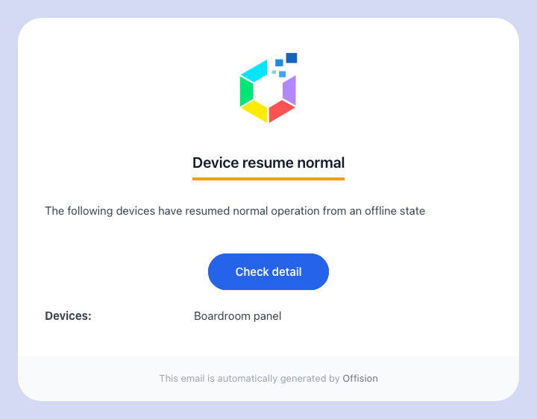
Device resume normal closes the loop when the device comes back.
Device resume normal goes out when the device comes back, to the same people.
There is no waiting period on this one — recovery is reported promptly, because
the question it answers is "can I stop driving to the office". Once it has been
sent, the device is armed again: the next outage produces a fresh alert.

What it does not do
- It does not reach the device. The alert tells people; it changes nothing on
the panel and cannot restart it.
- It does not show on the panel. There is no offline colour and no offline
message — see what the panel colours mean.
A device that cannot reach the server also cannot be told to say so.
- It does not cover devices that were never paired. A device record created
ahead of the hardware arriving has nothing to lose, so it is never reported
offline.
- It is not the same as a health warning. A screen with a weak signal, a hot
processor or a flat battery is still online, and none of that is emailed. Those
show up on Screen monitoring.

