How somebody proves who they are at the panel
Five credentials the panel can ask for, plus the option of asking for nothing. What each one needs in place first, and why two panels in the same building can ask for different things.
2026-08-21 · https://offision.com/help/en/devices/identify-at-the-panel/
Before a panel books a room, checks somebody in, or lets them out early, it wants
to know who is standing there. Five credentials can answer that, and a sixth
option says not to ask.
When more than one is available, the panel offers Choose authentication
method first. With exactly one it goes straight into it, and with none it
refuses the action outright.
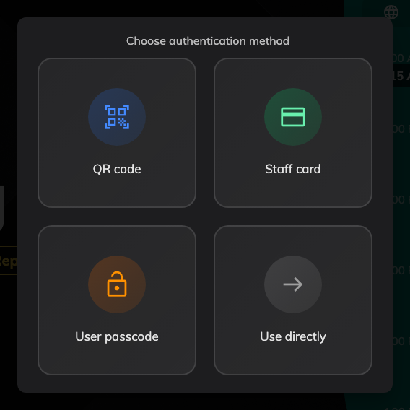
Four methods on this panel, including the one that asks for nothing.

The five credentials
Method | What the person does | What has to exist first
Face identification (BETA) | Looks at the panel | A camera on the panel hardware, and up to three photos uploaded in advance by each person
QR code | Scans the code on the panel with the Offision app | The app, signed in. The code rotates and expires on a visible countdown, with Generate new QR code underneath it
Staff card | Holds their card near the reader | A card reader on the panel, and a card number stored against them in Access cards — see Check in by tapping a staff card
User passcode | Picks their name, then types a 4–8 digit passcode | The passcode, which each person sets themselves in the user app — or which an administrator sets for someone who has forgotten theirs
Booking pin | Types the pin from the booking | An existing booking to act on — which is why it never appears on a walk-in. The person reads the pin off their booking mail or the booking itself in the app

The QR code is the one people get backwards. The panel shows the code and the
person scans it with their phone; the panel is not reading a code off their
screen. Whether it renders Black & white or Colorful is a setting beside
the method itself.
User passcode always takes two steps, because the passcode alone does not say
whose it is. Where the action has a booking attached the panel already knows the
candidates; on a walk-in it has to search everybody.
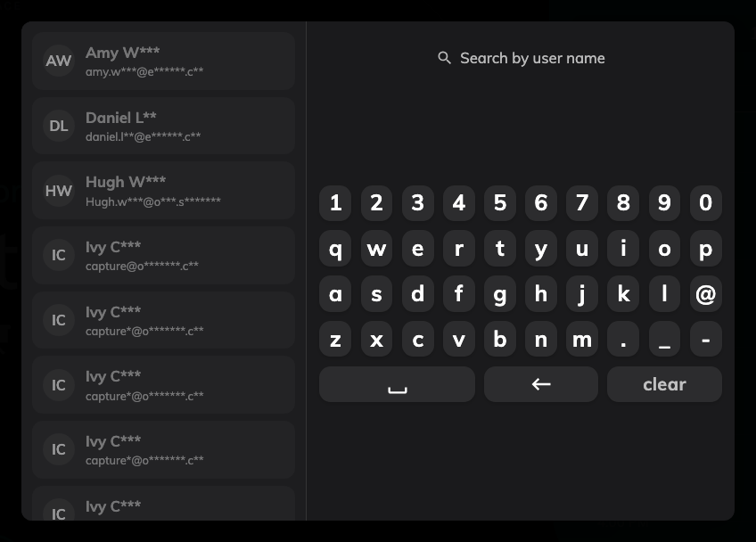
Name first, passcode second — shown here with Mask part of user name from search list on.

Asking for nothing: Allow anonymous
Allow anonymous adds a Use directly tile. Taking it creates the booking
with no organiser at all — the room is held, and nothing records who took it. It
only ever appears on booking-type actions, and it lives only on a panel
configuration; there is no organisation-wide equivalent, which is deliberate.
Left as the only method on a panel, it removes the question entirely — see
Let people book at the panel without signing in,
which sets one up end to end.

Where the methods are set
Two screens, and the second overrides the first.
Check-in method sets the default for the whole organisation — QR code, Staff
card, User passcode, Booking pin and Face identification, with Enable at least
one of the following check-in methods on the device. Any panel with no override
of its own follows it. See
Checking in at the booking panel,
which shows that screen.
Where in Offision: admin app → device/check-in-method (Check-in method)
Override the system user identification settings, on a panel configuration's
Check-in method page, is what lets panels differ — "By overriding the system
settings, each device can be configured with a different identification method."
A panel in a secure area can insist on a staff card while the one in the open-plan
corner accepts a passcode.
Where in Offision: admin app → device/booking-panel/configuration (Panel configurations)
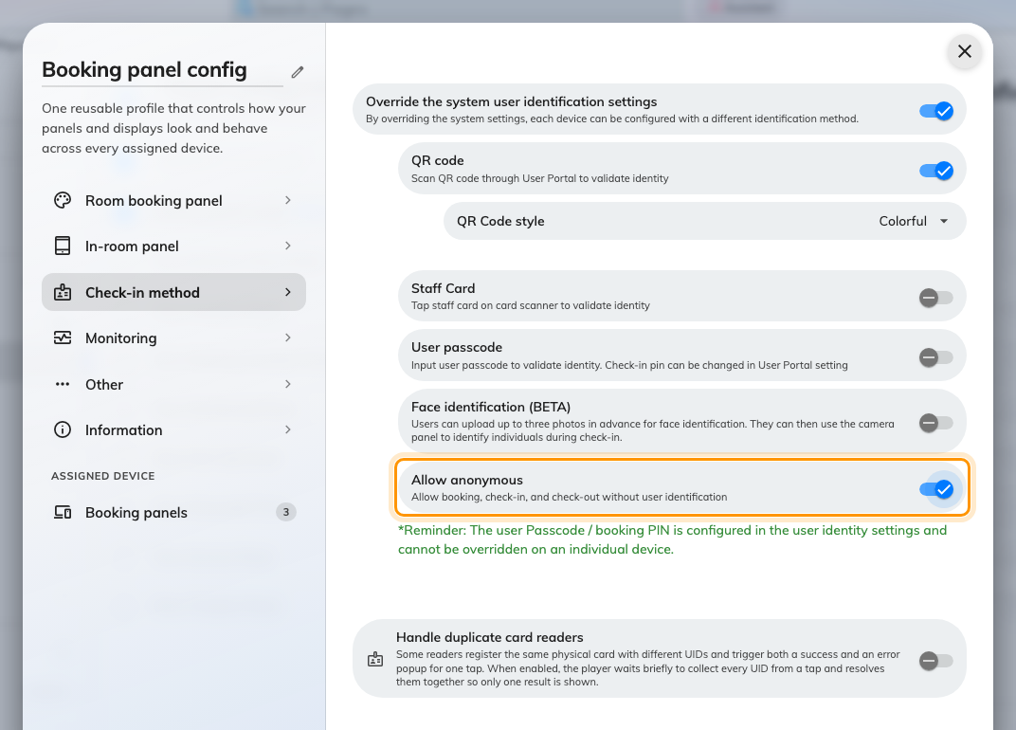
The override, with Allow anonymous underneath the methods it applies to.
Two things do not follow the override:
- Booking pin is not on the per-configuration list at all. A panel takes it
from the organisation-wide screen whatever its configuration says — see
Let outside attendees check in with a booking pin.
- Face identification still needs a camera. Turning it on for a panel that
has none simply leaves the tile off that panel.
The screen's own reminder:
The override page carries a line worth repeating: the user passcode and booking
PIN are configured in the user identity settings and cannot be overridden on an
individual device. Switching a method on and off per panel is what this screen
does; the values people type belong to them, not to the panel.

What this does not control
- Whether the person is allowed to do the thing. Identifying successfully and
being permitted to book, check in or extend are separate questions — the second
is the resource's policy and their permissions.
- The passcode itself. Each person sets and changes it in the user app. An
administrator can give somebody a new one but can never read the current one —
see Let people identify with a passcode at the panel.
- Opening the door. Where a panel drives a lock, unlocking rides along with
the action; a panel with no access hardware still identifies people perfectly
well.
- Which buttons the panel offers. That is the configuration's Room booking panel
page — see Let somebody take a free room at the panel.

