Panels and screens update the moment something changes
Whether panels, signage screens and check-in kiosks update on their own, and how quickly. Nothing is on a refresh timer — bookings, status colours and the screen's own settings all arrive in about a second, including at the door of the room a booking has just left. The same for an event session moved on the agenda: the door panel, the lobby screen's list and the Event list widget follow it.
2026-09-13 · https://offision.com/help/en/devices/how-updates-reach-a-screen/
Nothing on a screen is on a refresh timer. Every room panel, signage screen
and check-in kiosk opens a connection to Offision when it starts and holds it
open, and each change travels down that connection as it happens. A booking made,
moved or cancelled is on the door in about a second — nobody touches the screen,
and nothing has to be sent from the console.
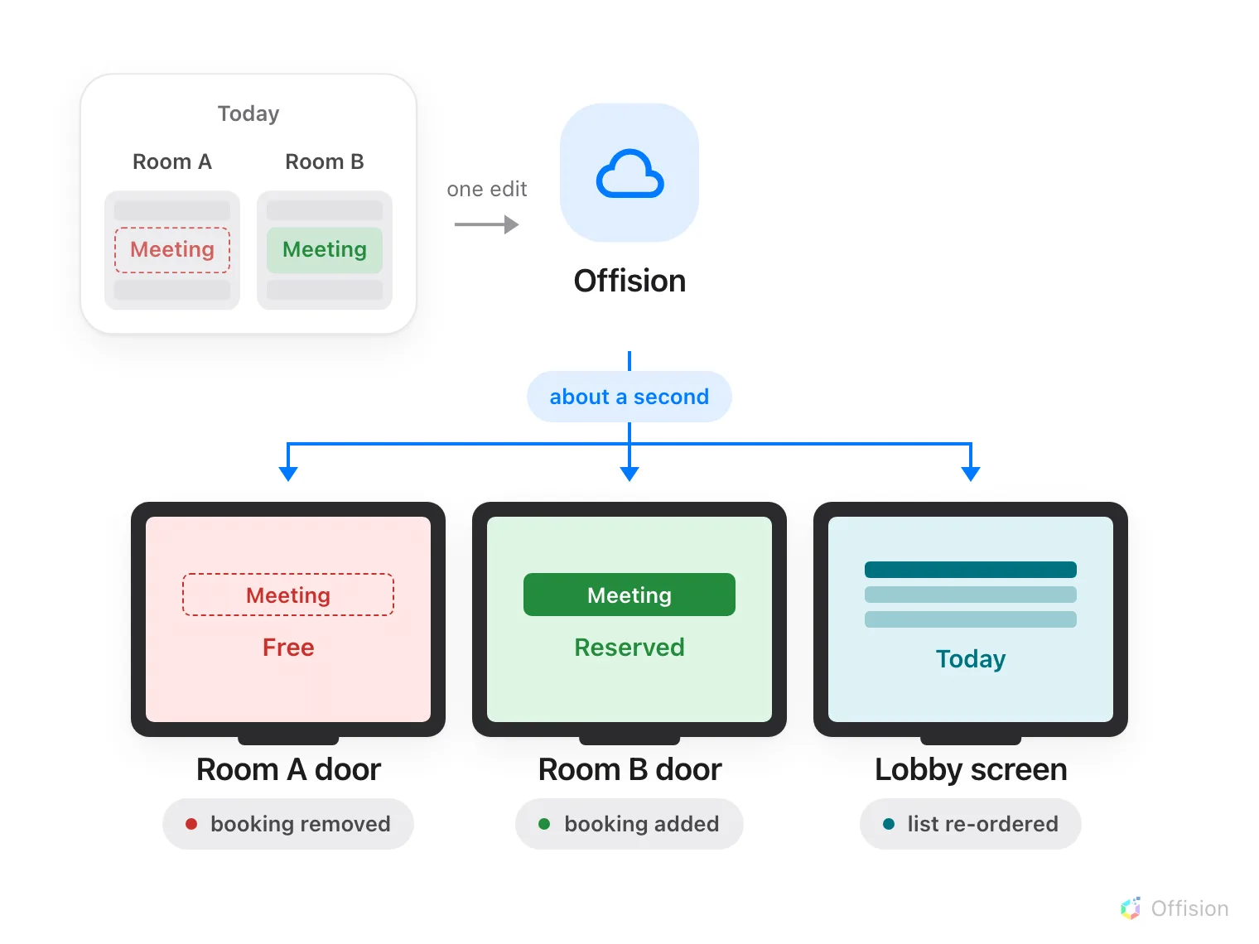
One edit, sent once and delivered to every screen it affects — including the room the meeting has just left.

What arrives this way
Everything a screen shows. Bookings made, moved, cancelled, checked in or ended
early; the room's status colour; occupancy and air quality from the ceiling;
visitors arriving and badges printing; announcements and emergency messages.
A screen's own settings arrive the same way — its design, your logo, which
buttons it offers, its language, how it is mounted, its time zone. Saving a panel
configuration reaches every panel on that configuration in about a second, and
saving signage content reaches every screen already playing it. There is nothing
to refresh, reboot or re-pair afterwards.

The room a booking leaves changes too
Moving a meeting from one room to another changes two doors, not one. Offision
sends the removal to the room the booking left and the booking itself to the room
it arrived at, so both panels are right within about a second of the change being
saved. A lobby or signage screen carrying a booking list is sent the same change
and re-orders itself.
This holds wherever the change was made — the resource calendar, the management
calendar, somebody's phone, or a person standing at another panel.
An event session is a booking too. A session that was given a room holds
that room's booking, so moving the session on the event's agenda moves the
booking, and the two door panels, a lobby screen showing a booking list or the
Event list widget, and the Event information widget all follow within
about a second. There is no publish step and no refresh interval on the screens;
the agenda is the one place the change is made.

If a screen was offline when you saved
Bookings catch up on their own. As well as being sent changes, a panel keeps
checking about every half a minute whether what it is showing is still current,
so a change that arrived while it was unreachable lands shortly after it returns.
Settings do not catch up. A panel that was offline at the moment you saved a
configuration comes back showing the old one, and goes on showing it.
A panel that came back with the old settings:
Once it is online again, Reboot it from its row in the device list — it picks
the configuration up as it starts. Do not do this while it is still offline; see
A booking panel keeps running when the network drops.

What this does not cover
A visitor's own phone. An invitation link opens an ordinary web page rather
than a device, so it re-checks about every thirty seconds instead of being sent
changes.
E-paper tags. A change is sent to a tag immediately, but the ink itself takes
time to turn — see
How fast e-paper tags update.
A screen with no network. Nothing can be sent to it at all, though it keeps
showing the day it already has — see
A booking panel keeps running when the network drops.
An allowlist that is missing one name. Live updates travel over a different
address from the app, and blocking it is the one fault that looks like nothing is
wrong: screens load, then never change. See
Every address Offision connects to.

