Hide the Android navigation bar on a Qbic device
A Qbic device shows Android's back, home and recents buttons along the bottom of the screen, over the player. Fullscreen, in the device's own Player settings, takes them away — and takes away the only way off the screen you are standing on, which is why it goes last.
2026-08-26 · https://offision.com/help/en/devices/hide-the-navigation-bar-on-a-qbic-device/
Android keeps its back, home and recents buttons in a bar along the bottom of
the screen. On a panel on a wall that bar has nothing useful to offer and sits
over the player, so a finished-looking installation usually wants it gone.
It is the device's setting, not Offision's — so it is turned off in Qbic's own
Player settings, and it applies to whatever the device is running.
Before you start:
The device is paired and showing its room, or its playlist, and you are standing
at it. This is the last thing to do to a device, for the reason below.

1. Do everything else first
Fullscreen takes the navigation buttons away from every screen, including
the settings screen you turn it on from. It applies a moment after you tap it,
and from then on there is nothing to navigate with.
So anything else the device needs — the network, the time zone, the content
field, a firmware update — do it now. Coming back to any of it means rebooting
the panel first.

2. Turn on Fullscreen
On the Configuration screen choose Settings, then Player settings,
and scroll to SCREEN.
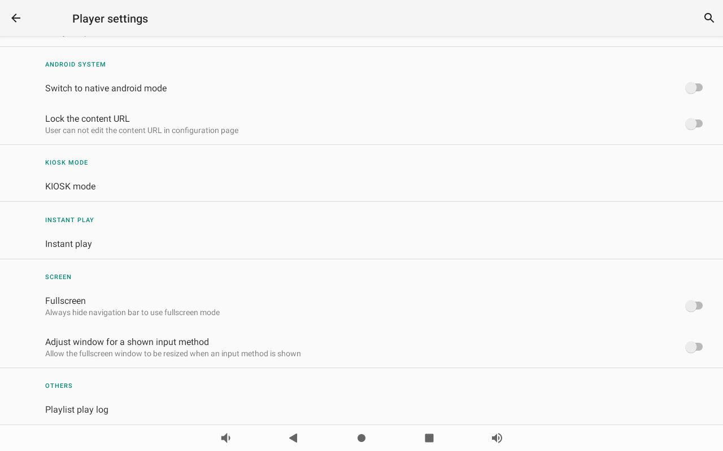
Fullscreen, in the SCREEN section of Player settings.
Fullscreen — "Always hide navigation bar to use fullscreen mode" — is the
one to turn on. Leave Adjust window for a shown input method below it alone
unless the device is one people type on.
Getting off the settings screen:
Reboot the panel. With the bar gone that is the way out, and it is needed once:
from then on the device comes back straight into the player.

3. Check it worked
Reboot, and watch what comes back. A device that lands on its room or its
playlist with nothing along the bottom edge is finished.
Then tap the screen once. The player's own controls should come up and the
Android bar should not.

When you need the bar back
Turn Fullscreen off again in the same place — but with no navigation buttons
you have to get to Player settings first, and on a device running the
Offision app that means leaving the app. The console's Setting ›
Leave Offision does it, and it is in
Install the Offision app on a Qbic device.

What this does not do
- It is not a kiosk lock. The bar is hidden, not disabled by policy —
anyone who leaves the app still reaches Android. Locking the device down is
KIOSK mode, further up the same screen, and it is Qbic's to explain.
- It does not change what the panel shows. The room, the design and the
functions are all chosen in the console when the device is paired.
- Offision has no matching setting. The panel's own console carries no
full-screen row on a device running the installed app, so a panel still
showing the bar is fixed in Player settings, never in the console.

