Finding another room from the panel
Somebody is standing at a busy door. The panel can show what else is free in the building and book it in two taps — and the list explains itself, if you know what its six kinds of row mean.
2026-08-17 · https://offision.com/help/en/devices/find-another-room-from-the-panel/
A meeting is about to start and the room is taken. Other rooms answers that
without anybody opening a laptop: the panel lists what else is free in the
building, and booking one is two more taps.
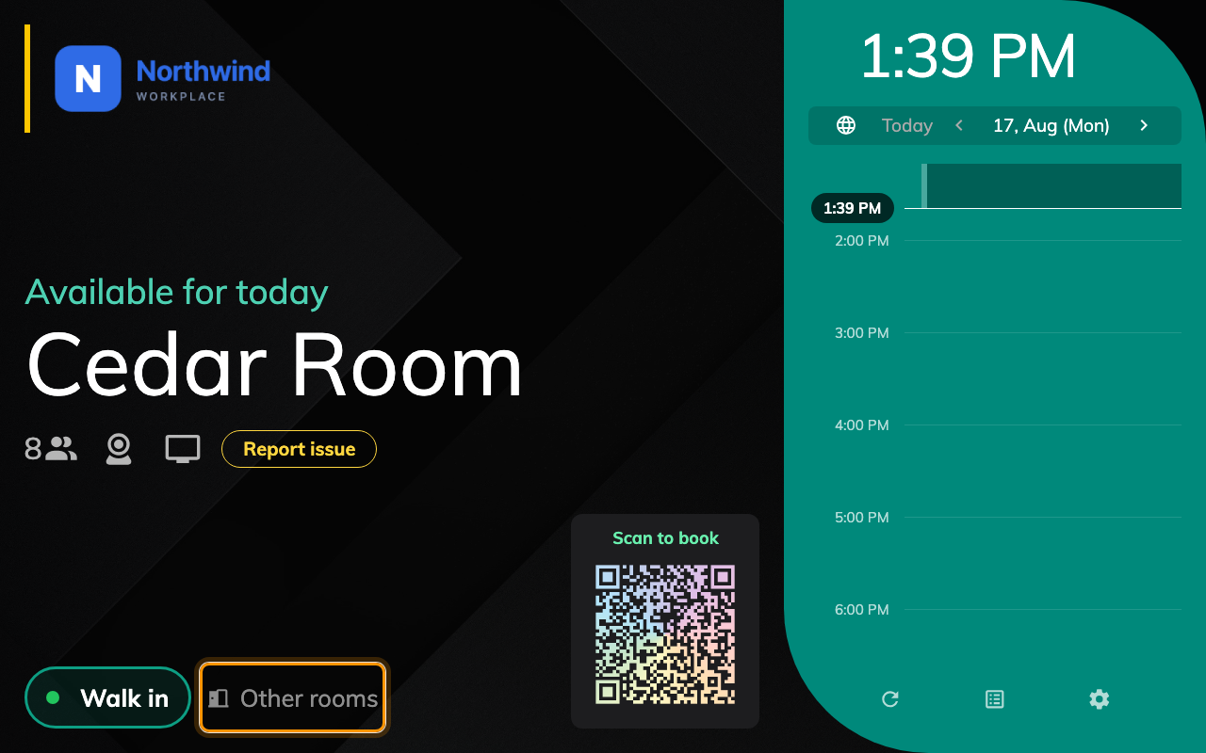
The button sits beside Walk in, and only while this room is free.
That last part surprises people. The button appears only when the panel's own
room is free — a room in use offers End now and Extend instead. Somebody
looking for a room in front of an occupied door is looking at the wrong panel.

The list is the building, not the floor
Every row is a resource of the same kind as this panel's room, in the same
building, that the panel's own room has been removed from. There is no capacity
filter, no amenity filter and no floor filter — capacity and the amenity icons are
shown so you can judge a row, not to narrow it.
The floor still matters, twice: rooms on the panel's own floor are labelled This
floor and are lifted above equally-good rows elsewhere. So the top of the list is
the nearest good answer, not merely the first one.
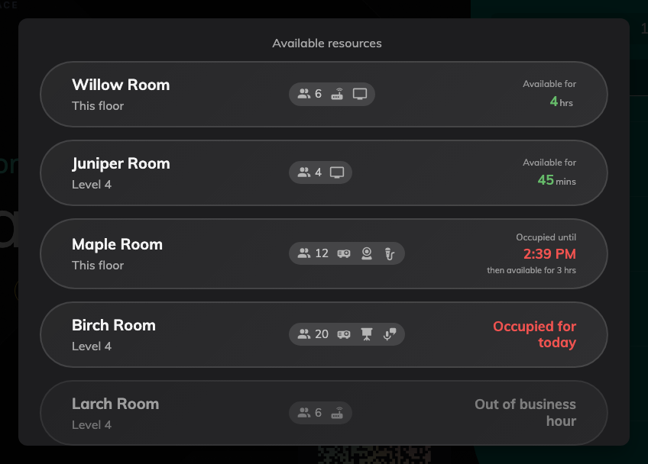
Free rooms first, longest free at the top, this floor ahead of the rest.

Six kinds of row
Four you can tap, and two of those are already busy — a room that frees up in
twenty minutes is often the right answer, so the panel lets you take it and starts
the booking then.
The row says | What it means
Available for 4 hrs | Free now, for that long
Occupied until 14:27, then available for 3 hrs | Busy now, yours from that time
Occupied for today | Busy for the rest of the day
Out of service | A maintenance period covers now
Out of business hour | Outside its hours, and it may not be booked outside them
Out of booking period | Its booking window is closed

The last three are greyed and do not respond to a tap. They are still listed
deliberately: "the room exists and you cannot have it" is a different answer from
"there is no such room", and the reader standing at the door needs the first one.
Where the free time comes from:
The time on a free row counts to the first thing that stops the booking — the next meeting, the end of
the booking window, or the resource policy's maximum booking length. A room with
no limit at all reads as free until the end of the day.

Why a row is greyed
Each greyed state comes from a different screen, which is worth knowing before
going looking:
- Out of service — a
New out of service period on
the resource itself.
- Out of business hour — the resource's business hours, but only where its
policy has Allow non-business hour booking off. With that on, a room
outside its hours is still offered.
- Out of booking period — the policy's Allow booking before a specific
date / Allow booking after a specific date.
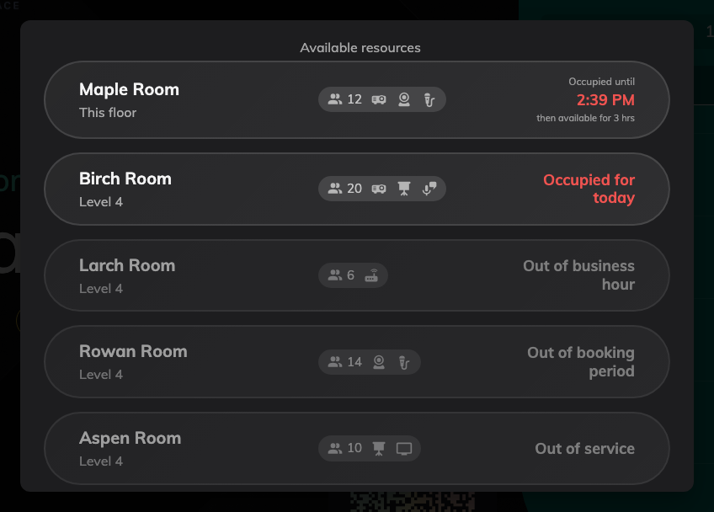
Further down the same list: blocked rooms stay visible, dimmed, and do not respond to a tap.

Turning the button off
Panels that stand somewhere people should not be self-serving a room — a lobby, a
shared floor in a serviced building — can drop it. Show other rooms button is
in the booking panel configuration's Door & extras group, and it is per
configuration, so it lands on every panel that shares it.
Where in Offision: admin app → device/booking-panel/configuration (Panel configurations)
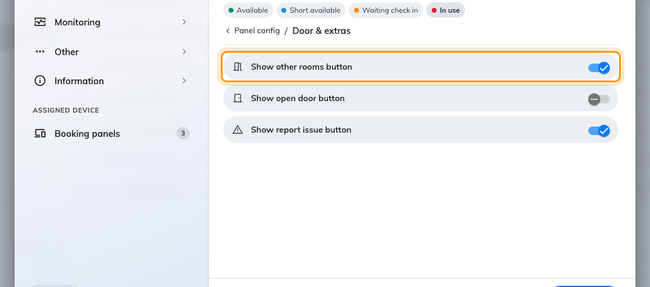
Show other rooms button, in the configuration's Door &amp; extras group.
Panels on the control skin show the same rooms as a Rooms nearby sheet
instead, grouped under a heading per floor; the rows and their statuses are the
same ones.

