Email someone when a device goes offline
Turn the warning email on for a set of booking panels or signage screens, choose how long to wait first, and name the people who should hear about it.
2026-08-20 · https://offision.com/help/en/devices/email-someone-when-a-device-goes-offline/
Before you start:
You need a configuration to put this on, the people who should be told already
set up as users or user groups, and outgoing mail working — the alert uses the
same mail settings as every other Offision email, so if none of those are
arriving this one will not either. See
send email from your own address.
The recipient picker only offers people who can manage devices, so somebody who
should be on the list but is not offered is missing that permission rather than
missing from the directory.
The setting lives on a configuration, not on a device — so turning it on once
covers every panel or screen sharing that configuration. Doing this for booking
panels and for signage is the same job on two different lists.

1. Open the configuration
For booking panels, open Devices › Booking panel › Panel
configurations and open the one your panels use.
Where in Offision: admin app → device/booking-panel/configuration (Panel configurations)

2. Go to the Monitoring page
The configuration opens on Room booking panel. Monitoring is further down the same
rail, and it holds two settings: Ask before remote control, and the alert.
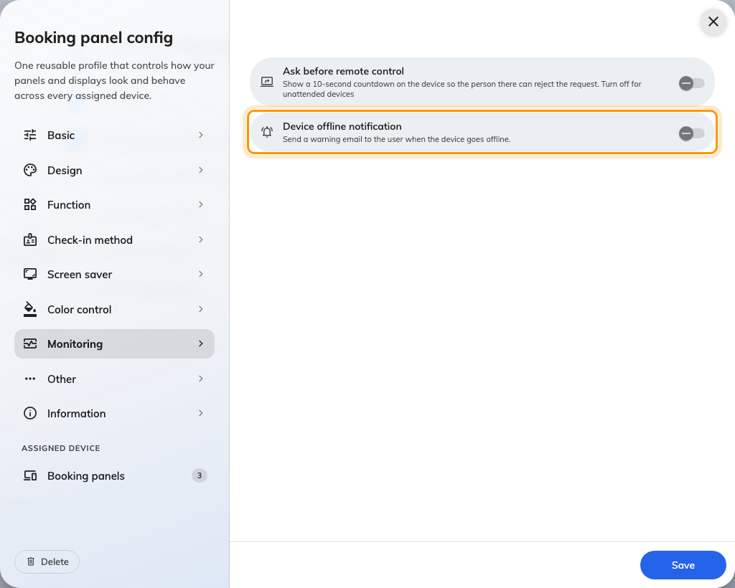
The Monitoring page, with the offline notification switch off.

3. Turn on Device offline notification
Switch on Device offline notification — Send a warning email to the user when
the device goes offline. Two more settings appear underneath it, and neither has
a useful default, so treat this as one step in three parts rather than a switch
you can flip and leave.
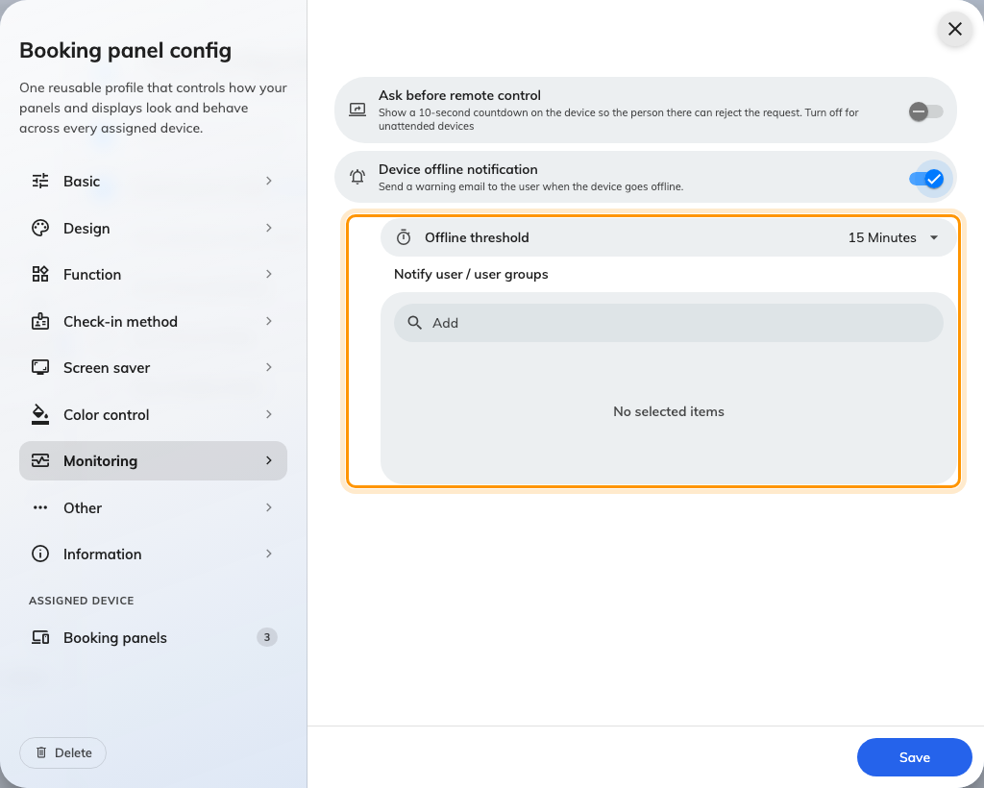
Switched on, the threshold and the recipient list appear beneath it.

4. Choose the Offline threshold
Offline threshold is how long a device must stay unreachable before anybody is
emailed. Pick from the list; the middle of it suits most estates.
Short values are the common mistake. On ordinary office wireless, a panel that
drops for two minutes and comes straight back is normal, and a five-minute
threshold turns that into mail somebody eventually stops reading. Start longer
than feels right and shorten it if real faults are going unnoticed.

5. Name who to notify
Notify user / user groups takes people, groups, or a mixture. Everyone listed
gets the same email, and being in two of the named groups still means one copy.
Prefer a group over a list of individuals where you can. The people who should
hear about a dead panel change over time, and a group can be updated once instead
of on every configuration that names them.
An empty list silently sends nothing:
The switch can be on, the threshold set, and no email ever sent, because there is
nobody to send it to. Nothing warns you about this — check the list before you
save.

6. Save, and do the same for signage
Save the configuration. Devices pick the change up without being restarted.
Signage screens have the same page on their own configurations, under Devices
› Signage › Device configurations. The settings are identical; the lists
are separate, so turning it on for panels does nothing for screens.
Where in Offision: admin app → device/signage/configuration (Device configurations)
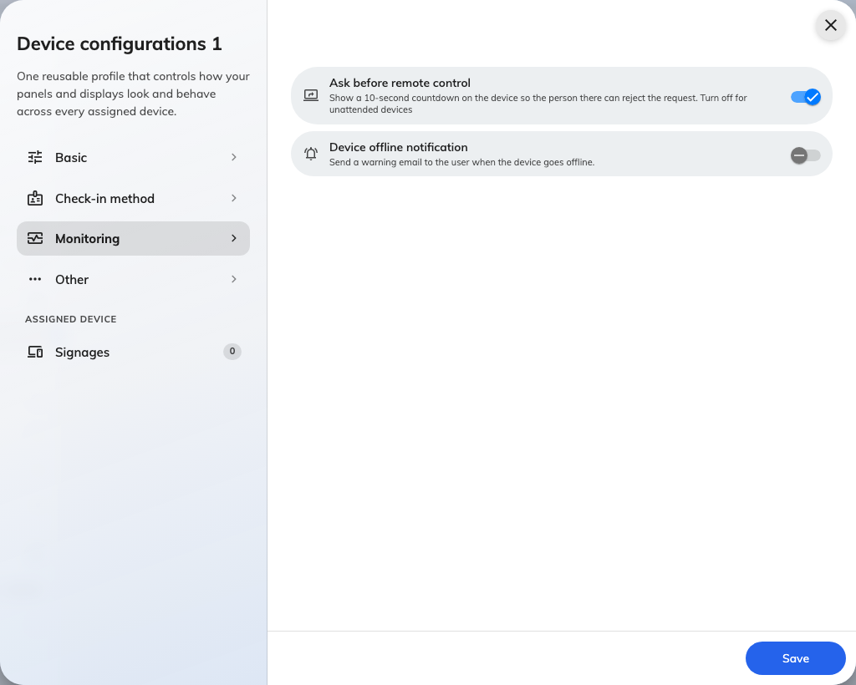
The same Monitoring page on a signage configuration.

7. Check it works
Unplug the network from one panel on that configuration — or take it off the
wireless — and leave it. After the threshold has passed, everyone on the list
should receive Device offline, naming that panel. Plug it back in and
Device resume normal follows shortly after.
Do this once, on purpose, before you rely on it. A configuration that looks
correct and mails nobody is the failure this feature is prone to, and the only
way to find out is to try it. If nothing arrives, work through
no offline email arrived.

