Connect an IAdea room booking panel
A WRP-1000 takes PoE+ and claims itself with a six-character code. Includes the card reader built into its face — the only one Offision supports that returns an HID facility code rather than a serial number.
2026-08-20 · https://offision.com/help/en/devices/connect-an-iadea-room-booking-panel/
An IAdea panel is an Android screen with an Ethernet port on the back, and it
arrives knowing nothing about Offision. There is no vendor cloud to enrol it in
and no second account to hold: you power it, you get the Offision player onto
its screen, and you claim it with a six-character code.
The one decision worth making before you start is how the player gets onto
the screen — as an installed Android app, or in the panel's own browser. The
built-in card reader is the app's, which on these panels is most of the reason
to buy them. That decision is
Run the player as an app or in the browser.
Before you start:
The room this panel will show already exists — see
Add a room. You can reach the switch
port the panel will sit on, because whether that port supplies PoE+ is the
one thing that stops an install dead.

What to have ready
- An IAdea panel. The certified models are the WRP-1000 and the
XDS-1078-A9
- A switch port with 802.3at PoE+
- Network the panel can reach your Offision server from
- About twenty minutes

The card reader is the reason to buy one
Both panels read a staff card on their own face, bottom centre, with nothing
plugged in and nothing on the wall beside them. What makes IAdea different from
every other panel Offision supports is what comes back.
An IAdea panel decodes an HID Global card's facility code and card number.
Every other certified panel returns the card's serial number instead — a
different number, and not the one printed on the card. If your organisation
already issues HID cards and holds their printed numbers, this is the panel that
matches what you have.
Two things to settle at the order stage, because neither can be changed
afterwards:
- The WRP-1000-A reads 13.56 MHz cards.
- The WRP-1000-H reads both 13.56 MHz and 125 kHz, and is the HID one.
It is a separate part number; a panel on the wall cannot be upgraded to it.
Whichever you order, enrol one card and tap it before importing the rest. What a
tapped card then does is in
Check in by tapping a staff card,
and the other ways somebody can identify at a panel are in
How somebody proves who they are at the panel.
The reader is app-only:
The built-in reader works when the panel is running the Offision Android app. In
the panel's browser it is not reachable at all, and a card has to be tapped on a
USB reader instead — which also loses the facility-code decoding, because that
is the built-in reader's. See
Run the player as an app or in the browser.

1. Power it and put it on the network
Mount the panel and take it back to a PoE+ port. It boots into Android.
Give it an address — DHCP over the Ethernet port is the normal answer, and the
panel's own settings are where a static one goes.

2. Get the player onto the screen
A new IAdea panel starts on its own setup: tap the screen while it shows the
PAUSE mark, accept the first page, and work through Network and
Scheduling for the address and the time zone. Then choose Set content
and give it the player address:
That is the browser route, and it is the one the guideline in the wizard walks
through. The other route is to install the Offision Android app on the panel
instead, which is what makes the built-in reader — and its HID facility codes —
work at all; see
Run the player as an app or in the browser.
Either way the panel ends up showing a six-character pairing code, waiting
to be claimed.

3. Add the panel in the console
Go to Devices › Booking panel › Devices and choose Add.
Where in Offision: admin app → device/booking-panel/device (Booking panel)
Pick Room booking panel, then the room this panel will show, then IAdea
panels under Certified devices.
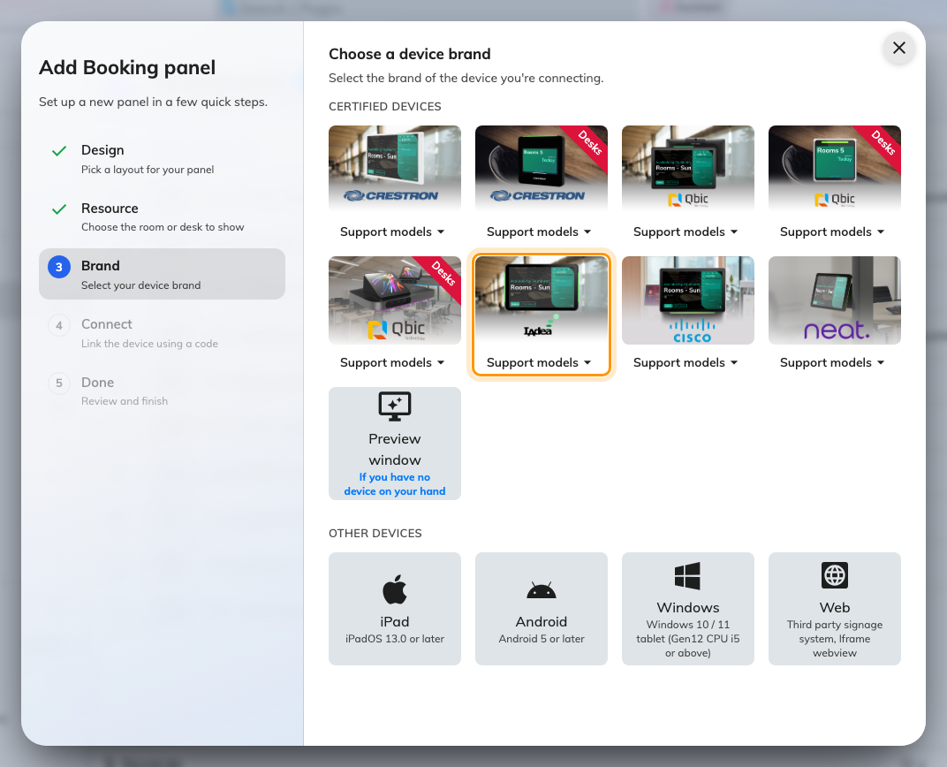
IAdea panels, sixth in the certified devices grid.
That one tile covers both certified models — WRP-1000 and XDS-1078 —
and its Support models button links each of them to IAdea's own page.

4. Claim it with the code
Choosing the tile opens IAdea's own installation guideline beside a single
field. Type the six characters showing on the panel; the field submits itself on
the last one.
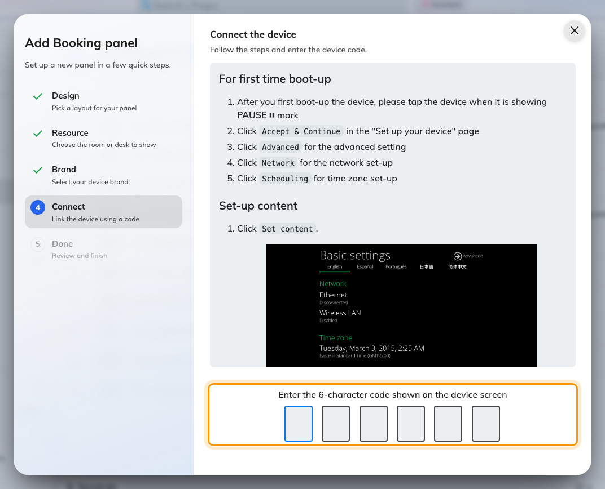
The IAdea guideline, and the field that claims the panel.
The rest of the wizard, and the pass code every new panel raises afterwards, are
covered in Connect a booking panel to Offision —
including why that pass code should be changed before the panel goes up.

5. Check it worked
Within a few seconds the panel stops showing the code and starts showing the
room, and its row goes online within a minute.
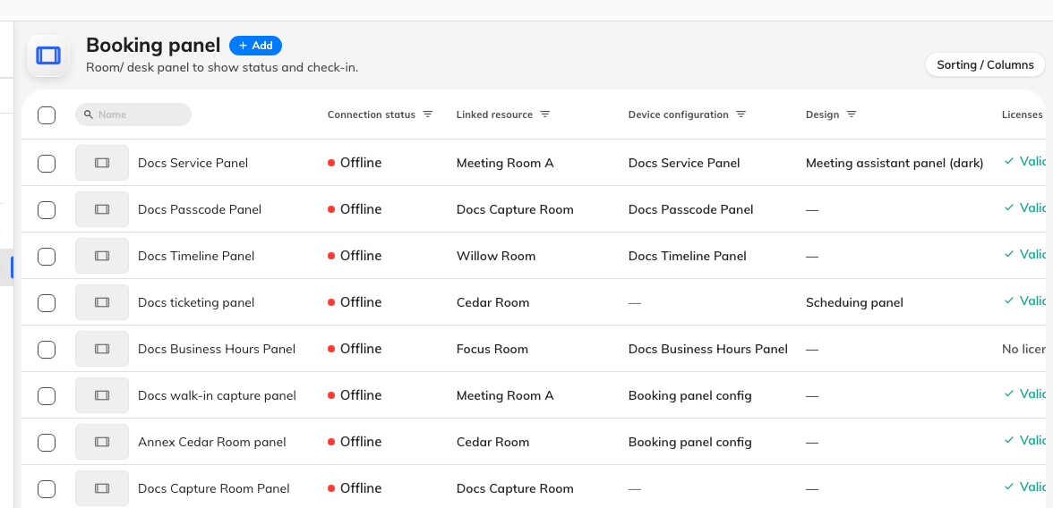
The booking panel list. Connection status is where a paired panel reports in.
Then prove it end to end, twice:
- Book the room for yourself and watch the panel change while you are
standing at it, side lights included.
- Tap a card on the panel's face and confirm the number Offision records
matches the card. On an H model that number is the facility code and card
number; if it is a long serial instead, the panel is reading through a USB
reader or is not an H model.

When it goes wrong
What you see | Usual cause
The panel does not power on | The port is PoE but not PoE+, or the switch's power budget is spent
The panel boots but never reaches Offision | It has no address, or it cannot reach your server. This is between the panel and your network
No pairing code, just a browser home page | The player address was not opened, or the app was installed but never launched
The pairing code is refused | Read it off the panel again rather than retyping what you noted down. A panel that has slept or restarted is showing a different one
The panel shows a room or a board, and no pairing code | It is still claimed by an earlier record. Disconnect it there first — see Reuse a panel that was set up for something else
The panel is online but the side lights stay dark | The panel came up as a plain browser player: its local API did not answer the first probe, and the answer is cached. Reload the page on the panel
A tapped card does nothing | The panel is in a browser rather than the app, or the card is HID and the panel is not an H model. See A card tap does nothing
HID cards read as a long serial | The tap went through a USB reader, not the panel's own. Only the built-in reader decodes the facility code
The panel is online but the room is wrong | The room is chosen in the wizard, before the code. Change it on the panel's own row rather than re-pairing the device

What this does not do
- It does not manage the panel. Firmware, brightness, the network and the
kiosk launcher stay in the panel's own Android settings.
- It does not read a badge with the camera. The panel's camera is what
Face identification uses; nothing here scans a printed badge, and the QR
method works the other way round — the panel shows the code and the person
scans it. Both are in
How somebody proves who they are at the panel.
- It does not decide what the panel can do. The brand tile chooses which
installation guideline you are shown. What the panel is capable of comes from
the hardware and from whether it is running the app — see
Which booking panel hardware Offision supports.

