Put a Microsoft 365 or Google room on a booking panel
A room whose calendar lives in Outlook or Google Calendar drives a panel the same way any other room does — once four things are true. The order they have to be done in, and the one setting on the room's own calendar that decides whether anything reaches the wall at all.
2026-09-07 · https://offision.com/help/en/devices/connect-a-synced-room-to-a-panel/
A room whose calendar lives in Microsoft 365 or Google Workspace drives a booking
panel exactly the way a room Offision owns outright does. Nothing in the pairing
wizard asks which kind it is, and nothing on the panel behaves differently
afterwards — the panel simply shows the room, and the room happens to be a mailbox.
What is different is everything that has to be true before you pair it. Four
things, in this order, and each one is invisible from the panel: skip one and the
panel comes up looking perfectly healthy while showing a room that is never busy.
This page joins two things you already have:
A Microsoft 365 or Google Workspace connection, and a panel. Setting either one up
for the first time is its own article — this is the seam between them, and the
order the four steps have to be done in.

What to have ready
- The calendar connection made, and still signed in
- The room existing as a room mailbox in Microsoft 365, or a resource
calendar in Google Workspace
- Permission to change that room's own calendar settings, for step 2
- A booking agent account set on the connection, if anybody who books this
room is not an account in that same directory — without one they cannot book it
at all, and a panel is where that shows up first. Set it in
Sync rooms from Microsoft 365
or Connect rooms from Google Workspace
- The panel powered, on the network, and showing its six-character code

1. Connect the calendar
If it is not connected yet, do that first and come back. The choice that matters
is the connection mode, because it decides how rooms arrive in step 3 — read
Which Microsoft 365 connection to choose
or Which Google Workspace connection to choose
before you pick one.

2. Set the room to accept invitations automatically
Do this before anything else, and do it on the provider's side. It is the step
that is skipped most often, and it is the one whose symptom looks like a broken
panel rather than a calendar setting.
Offision mirrors the room's own calendar. A meeting reaches the panel once the
room has answered the invitation — so a room that leaves its invitations unanswered
shows nothing on the wall, and reads as free all day while Outlook shows it booked
solid.
- Microsoft 365 — set the room mailbox's calendar processing to accept
automatically.
- Google Workspace — on the resource calendar, set Auto-accept invitations
to automatically add all invitations. Set its Time zone while you are there,
or every booking arrives out by a fixed number of hours.
Offision never sets this for you and never warns that it is missing.
Unless you rely on a booking policy:
Accepting automatically answers before Offision is asked, so its policy is not
applied to anything booked in Outlook. Leave it off on a room whose policy you
rely on — see How a booking is
validated.

3. Bring the room into Offision
The room has to exist as a bookable resource before a panel can be pointed at it.
How it arrives depends on the provider:
 | Microsoft 365 | Google Workspace
How rooms arrive | Pick from a list of rooms, or sync the whole directory at once on an application-family connection | One calendar address at a time — there is no room picker
If a room is missing | Microsoft has usually not published it yet — that settles within a day. If it still does not appear, add it by mailbox address | The delegated account is not subscribed to that calendar yet

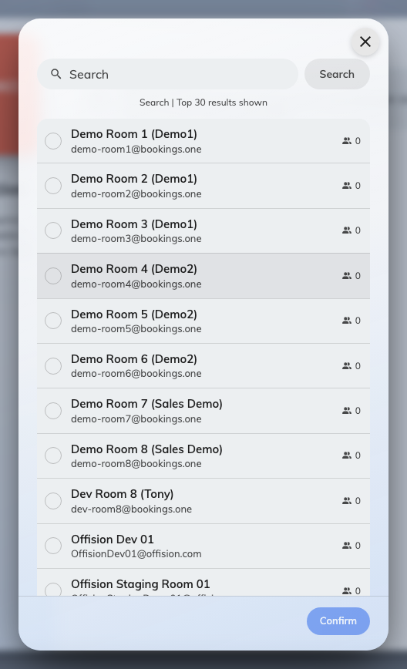
Choosing a Microsoft 365 room. On Google Workspace there is no picker — rooms are typed in by calendar address.
The full walkthrough for each, including the booking agent account that lets
everyone book the room rather than only the people who have connected an account,
is in Sync rooms from Microsoft 365
and Connect rooms from Google Workspace.

4. Pair the panel to that room
Now pair the panel as you would any other — Connect a booking panel to
Offision walks the wizard.
Where in Offision: admin app → device/booking-panel/device (Booking panel)
The only step that needs care here is Resource. The synced room sits in the
same list as every other room and looks no different, so if somebody created a
room by hand with the same name earlier, both are on screen and only one of them
is the one carrying the calendar. Pick the synced one.
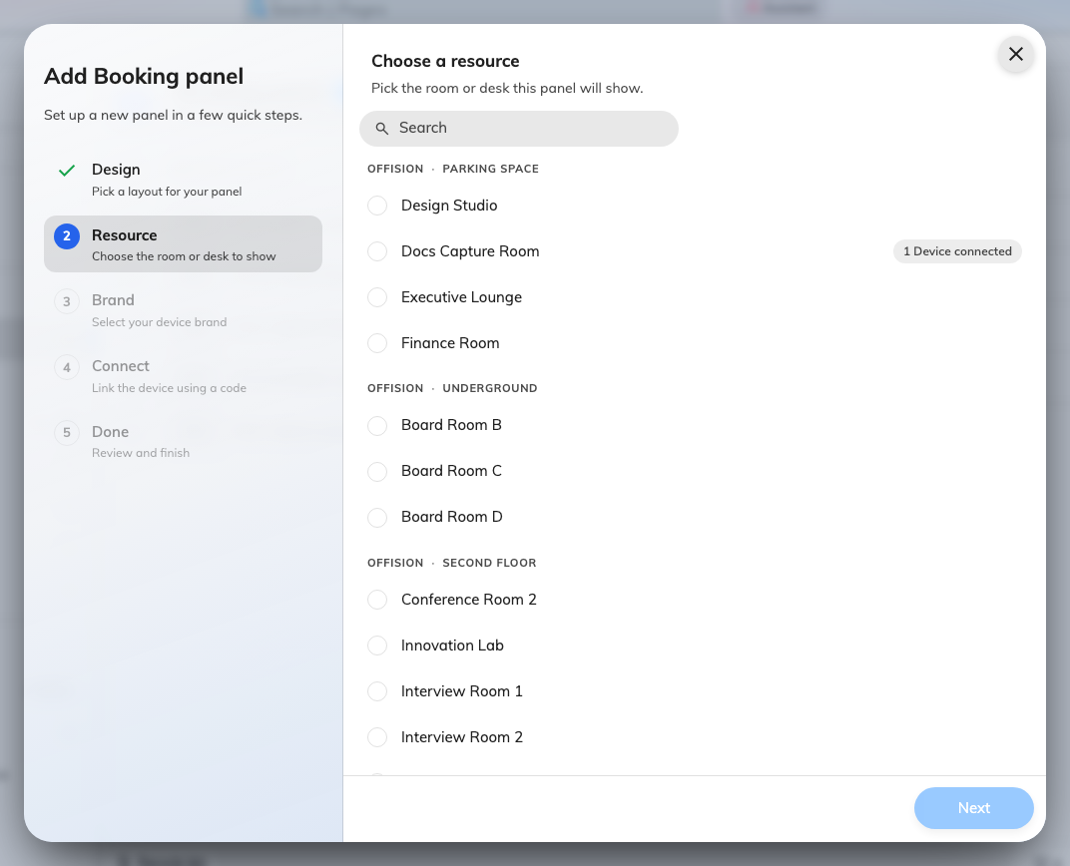
The Resource step: every bookable room in the estate, by building and floor.

5. Check it worked
Prove the whole chain rather than any one link, in both directions:
- Book the room in Outlook or Google Calendar, and watch the panel change
- Book it at the panel, and confirm it appears in the organiser's calendar
- Leave the panel a minute and check its Connection status still reads online
- Have somebody who is not a Microsoft 365 or Google account book it at the
panel — that is the check that proves the booking agent account is doing its job

How quickly the panel changes
Seconds, normally. A change in Outlook or Google Calendar is pushed to Offision,
which pushes it straight out to the panel, so a meeting booked while you are
standing at the door appears without anybody touching the panel.
If that push is ever missed, the panel notices on its own within about half a
minute — it keeps checking whether what it is showing is still current. So the
honest worst case is roughly thirty seconds, and rebooting a panel is never the
fix for a booking that has not appeared yet. Wait a minute; if it is still not
there, it is one of the causes below rather than a slow panel.

When it goes wrong
What you see | Usual cause
The panel shows the room free, while Outlook or Google Calendar shows a meeting | The room is not accepting invitations automatically — step 2. The meeting never reached the room's own calendar, so nothing was mirrored
The panel has not changed for hours, for every room | The connection's sign-in has lapsed — see Bookings stopped syncing with the calendar
One room is stale and the rest are fine | That room's connection was suspended, usually because the mailbox was renamed, deleted or had its sharing changed. Reconnect that room
The room is not offered in the wizard's Resource step | It was never brought across — step 3. It is not an Offision resource yet
The panel shows the right room name but never any meetings | It is paired to a room created by hand that shares the name, not to the synced one. Change its room on the device
A meeting booked in Outlook is missing everywhere, not just on the panel | The room declined it — see A meeting booked in Outlook never appears in Offision
Bookings made in Outlook ignore the room's policy | The mailbox accepts automatically, so Offision is never asked — see How a booking is validated

What this does not cover:
What people may then do at the panel — walk in, check in, extend, cancel — is
set by the panel's configuration and the room's policy, not by the calendar
connection. See Every switch that puts a button on the
panel.

