Connect a Qbic room booking panel
A Qbic panel takes PoE+ and shows whatever its screen is pointed at, so setup is three things: power it, get the player onto it, and claim it with a six-character code. Includes the card reader that is built into its face, and the TD-0360 desk panel.
2026-08-29 · https://offision.com/help/en/devices/connect-a-qbic-room-booking-panel/
A Qbic panel is an Android screen with an Ethernet port on the back, and it
arrives knowing nothing about Offision. Unlike a device managed from a vendor
cloud, there is no enrolment step and no second account: you power it, you get
the Offision player onto its screen, and you claim it with a six-character code.
The only decision that is not obvious is how the player gets onto the
screen. A Qbic panel can run it as an installed Android app or in its own
browser, and the two are not equivalent — the built-in card reader and offline
video are the app's. That decision is
Run the player as an app or in the browser;
this article assumes you have made it.
Before you start:
The room this panel will show already exists — see
Add a room. You can reach the switch
port the panel will sit on, because whether that port supplies PoE+ is the
one thing that stops an install dead.

What to have ready
- A Qbic panel. The certified room models are TD-1070, TD-1070 Lite,
TD-1050 Pro and TD-1060 Slim
- A switch port with PoE+ and headroom in its budget. A TD-1070 asks for
25 W, which a plain 802.3af port cannot supply
- Network the panel can reach your Offision server from
- About twenty minutes

The card reader is the reason to buy one
A Qbic panel reads a staff card on its own face — bottom right on a TD-1070,
bottom centre on a TD-1050 Pro — with no reader hanging off it and nothing on
the wall beside it. That is what separates these panels from a screen that
happens to be the right size, and it is worth getting right at the order stage
because none of it can be changed afterwards.
- The standard part reads 13.56 MHz cards.
- HID Global cards need the H version, which is a separate part number. A
panel already on the wall cannot be upgraded to it.
- Some models also offer an O version, which reads a pass held in Apple
Wallet. Offision does not use it. An O panel reads a 13.56 MHz card
exactly as the standard version does, and a wallet pass tapped on it does
nothing — so order the O version only for something other than Offision.
- The TD-1060 Slim has no built-in reader at all. It takes a USB reader,
like a panel from a vendor that does not build one in.
- A Qbic panel reads the card's serial number, which is not the number
printed on the card. Enrol one card and tap it before importing the rest. The
panel will tell you what it read — see
Read a card number at the panel.
What a tapped card then does — and how a person's card gets attached to them —
is in
Check in by tapping a staff card.
The reader is app-only:
The built-in reader works when the panel is running the Offision Android app.
In the panel's browser it is not reachable at all, and a card has to be tapped
on a USB reader instead. See
Run the player as an app or in the browser.

1. Power it and put it on the network
Mount the panel and take it back to a PoE+ port. It boots into Android.
Give it an address — DHCP over the Ethernet port is the normal answer, and the
panel's own settings are where a static one goes. Wi-Fi is an option on most
Qbic models rather than a given, so on a panel ordered without it, Ethernet is
the only way on.

2. Get the player onto the screen
A Qbic panel that has never been set up boots into its own Configuration
screen. Put the player address in the Content field there and choose
PLAY:
That is the browser route, and it is the one the guideline in the wizard walks
through. The other route is to install the Offision Android app on the panel
instead, which is what makes the built-in card reader and uploaded video work —
see Run the player as an app or in the browser
for the choice, and
Install the Offision app on a Qbic device
for the steps.
Either way the panel ends up showing the same thing: a screen with a
six-character pairing code on it, waiting to be claimed.

3. Add the panel in the console
Go to Devices › Booking panel › Devices and choose Add.
Where in Offision: admin app → device/booking-panel/device (Booking panel)
Pick Room booking panel, then the room this panel will show, then Qbic
panels under Certified devices.
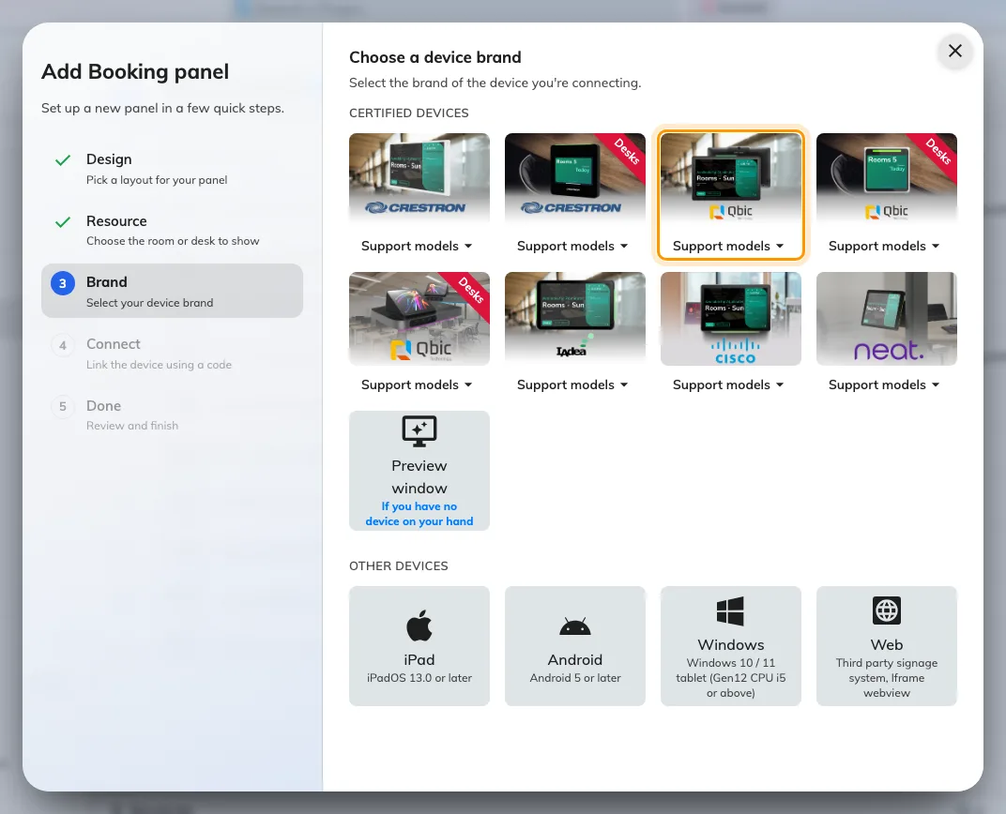
Qbic panels, third in the certified devices grid.
Three of the tiles in that grid are Qbic's, and picking the wrong one is the
easiest mistake to make here. Each tile carries a Support models button
listing what it covers, linked to Qbic's own pages:
Tile | Models it covers
Qbic panels | TD-1050 Pro · TD-1060 Slim · TD-1070 Lite · TD-1070
Qbic desk panels | TD-0350 · TD-0360
Qbic docking | TDD-1000

4. Claim it with the code
Choosing the tile opens Qbic's own installation guideline beside a single
field. Type the six characters showing on the panel; the field submits itself
on the last one.
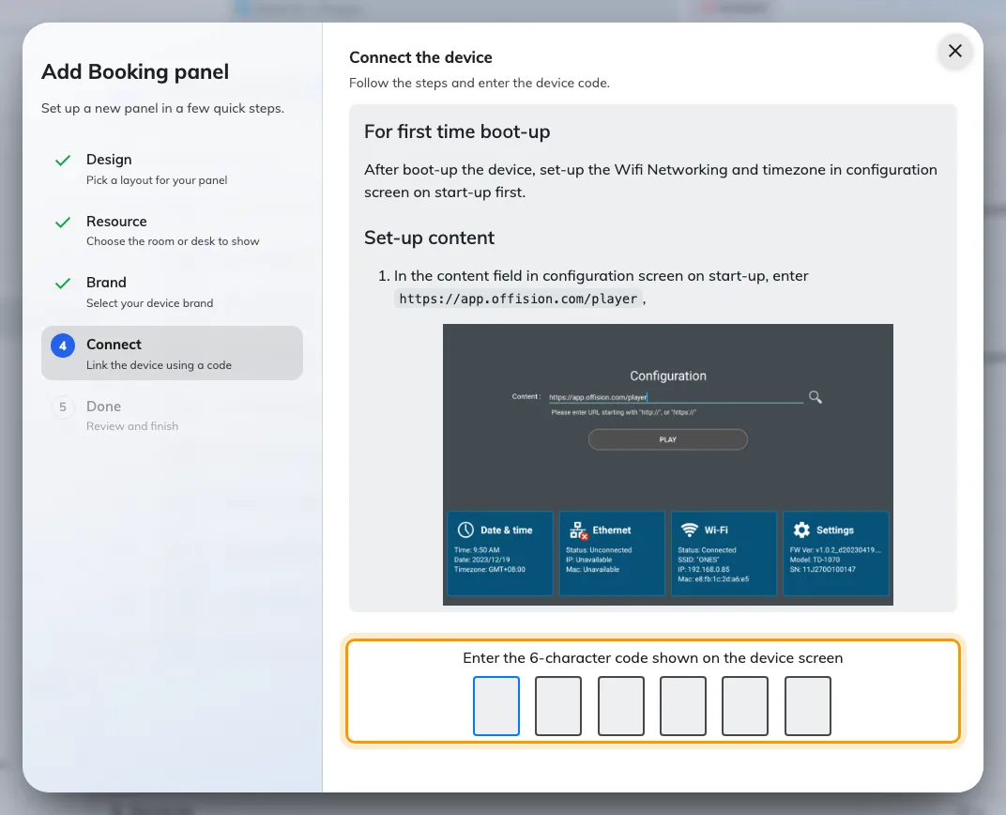
The Qbic guideline, and the field that claims the panel.
The rest of the wizard, and the pass code every new panel raises afterwards, are
covered in Connect a booking panel to Offision —
including why that pass code should be changed before the panel goes up.

5. Check it worked
Within a few seconds the panel stops showing the code and starts showing the
room. Its row in Devices › Booking panel › Devices goes online
within a minute.
Then prove it end to end, twice:
- Book the room for yourself and watch the panel change while you are
standing at it, light bar included.
- Tap a card on the panel's face, if you ordered it with the reader. A
panel whose reader has never been tested is a panel nobody finds out about
until the first Monday morning. The panel's own console shows the number of
the card just tapped, which is the number to enrol — see
Read a card number at the panel.

The desk panel
A TD-0360 is the same idea at desk size: a 3.6-inch square screen that runs
off USB from the desk rather than PoE, so it can go on a desk that has a socket
but no network drop.
It pairs through the same wizard, with two differences: choose the desk panel
kind rather than the room one, and pick Qbic desk panels in the certified
grid instead.
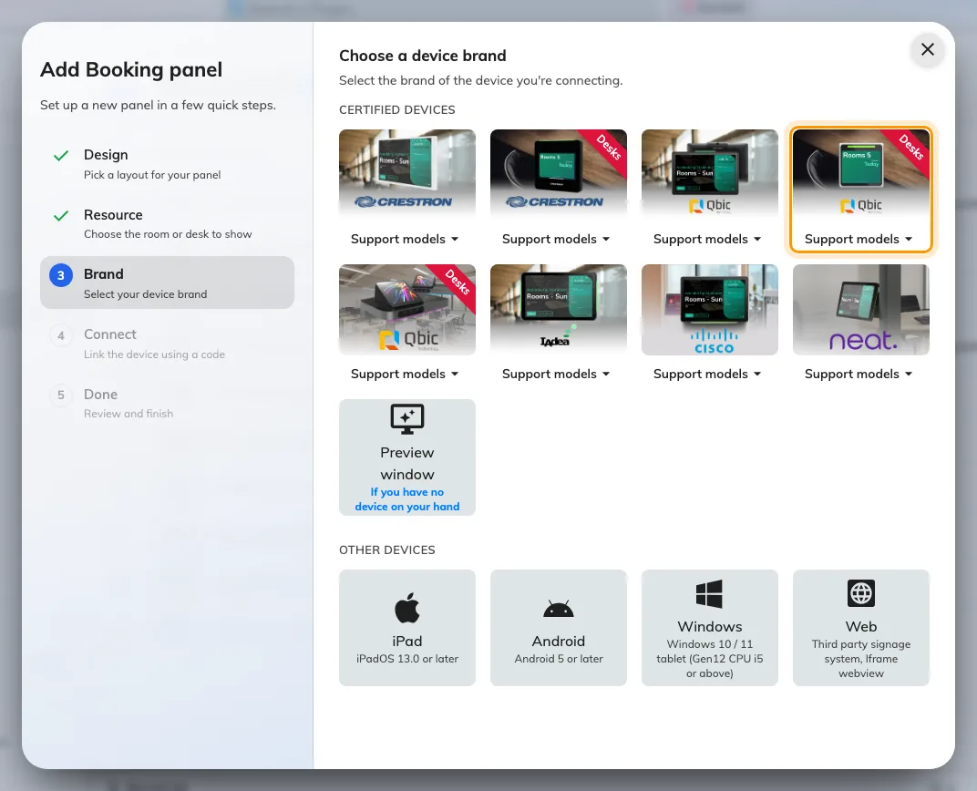
Qbic desk panels, fourth in the grid — the tile the TD-0360 pairs through.
The TD-0350 pairs through the same tile. The TDD-1000 is a dock as well
as a panel — the USB-C cable that powers it charges the laptop plugged into it —
and has a tile of its own, Qbic docking.

When it goes wrong
What you see | Usual cause
The panel does not power on | The port is PoE but not PoE+, or the switch's power budget is spent. A TD-1070 asks for 25 W
The panel boots but never reaches Offision | It has no address, or your network is not letting it out — see Put Offision devices on a locked-down network
No pairing code, just a browser home page | The player address was not opened, or the app was installed but never launched
The pairing code is refused | Read it off the panel again rather than retyping what you noted down. A panel that has slept or restarted is showing a different one
The panel shows a room or a board, and no pairing code | It is still claimed by an earlier record. Disconnect it there first — see Reuse a panel that was set up for something else
The panel is online but the light bar stays dark | The panel came up as a plain browser player: its local API did not answer the first probe, and the answer is cached. Reload the page on the panel
A tapped card does nothing | The panel is in a browser rather than the app, or the card is HID and the panel is not an H model. See A card tap does nothing
HID cards read as the wrong number | A Qbic panel returns the card's serial, not the facility code and card number printed on it. Enrol from a tap, not from the printing
The panel is online but the room is wrong | The room is chosen in the wizard, before the code. Change it on the panel's own row rather than re-pairing the device

What this does not do
- It does not manage the panel. Firmware, brightness, the network and the
kiosk launcher stay in the panel's own Android settings. Offision knows about
the player that paired, not about the box.
- It does not decide what the panel can do. The brand tile chooses which
installation guideline you are shown. What the panel is capable of comes from
the hardware and from whether it is running the app — see
Which booking panel hardware Offision supports.
- It does not cover signage. A Qbic player driving a wall screen is a
different device kind with a different wizard — see
Show signage on a Qbic screen.

