Connect a label printer to a signage screen
Attach a Brother QL label printer to the screen at reception so it prints a visitor badge on every walk-in, check-in and QR registration — from the screen's own device menu, no computer involved.
2026-08-29 · https://offision.com/help/en/devices/connect-a-label-printer/
A signage screen at reception can hand every visitor a printed badge without
anyone standing behind a desk. The moment someone walks in at the screen,
checks in, or finishes registering from the screen's QR code on their own
phone, the screen sends a badge label to a printer sitting under it.
The whole connection is made on the screen itself, from its device menu — no
computer, and no drivers.
The printer to buy is a Brother QL-820 — a small label printer that takes
62&nbsp;mm DK label rolls, in plain black or black&nbsp;&amp;&nbsp;red, and
joins the network over Wi-Fi or pairs over Bluetooth. The QL-810 works the
same way, and on an iPad any AirPrint printer on the network is an
alternative. The screen finds the printer, reads which roll is loaded, and
sizes the badge to it on its own.
An iPad is not the only screen that can do this. Any screen running the
Offision player app prints the same way — an Android signage panel such as a
Qbic or IAdea panel, a Neat board, or a Windows or macOS computer. The
differences are small: AirPrint is an iPad-only alternative, a Neat board
has no Bluetooth so its printer must be on the network, and on a computer the
same settings open in a window titled Label printing. The full list is in
Which devices can print to a label printer.
Before you start:
The screen must be running the installed Offision app, not the panel's own
browser — a browser has no printer to talk to. On a Qbic or IAdea panel that is
the choice made at setup: see
Qbic: app or browser.
The screen should already be up and playing its content — if it is not,
start with
Set up a lobby screen for visitors.
Have the printer powered on with a label roll loaded, on the same network as
the screen or already paired in the device's Bluetooth settings. Unlocking
the device menu takes the device's pass code, or a player manager standing at
the screen with their card or QR code.

1. Open the screen's device menu
Everything in this step happens at the screen, not in the console.
Pull from the left edge of the screen — a slim rail slides out; the
screen hints Pull for settings when it first starts. Tap the cog on the rail.
The screen asks you to prove you are staff: Enter passcode on the keypad,
or a player manager can scan the QR code or tap their card instead.
The Device menu opens. Choose Printer settings.
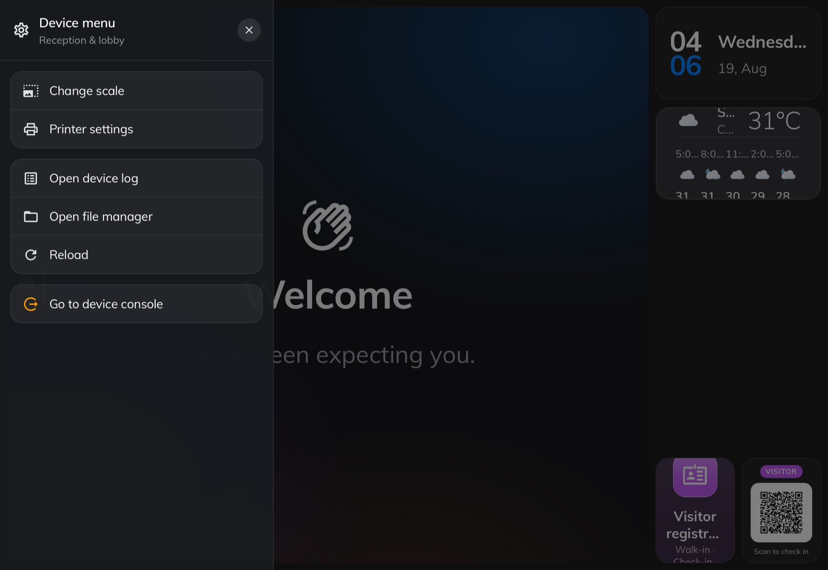
The device menu, pulled out from the left edge — Printer settings is the row with the printer icon.
Printer settings only appears when the screen is running the Offision
player app. The same content opened in an ordinary browser has no printer to
talk to, so the row is not there.

2. Connect the printer
Leave Brand on Brother. On an iPad, AirPrint is the other choice —
pick it only if your printer is not a Brother QL, and choose the printer from
the system list it opens.
Under Connection, Auto looks everywhere; switch to LAN / Wi-Fi or
Bluetooth if you want to search one way only. Then let the scan run —
the printer appears in Printers by name. If the scan cannot find it, tap
Add by IP and type the printer's address —
Printer IP, e.g. 192.168.0.90 — which you can read from the printer's own
network settings printout.
Tap the printer to select it. Label paper fills in on its own with the
roll the printer is carrying — its width, and whether it prints black only or
black&nbsp;&amp;&nbsp;red. There is nothing to choose here; swap the roll and
tap it again to re-read. Print quality trades speed for sharpness and is
fine left on Normal.
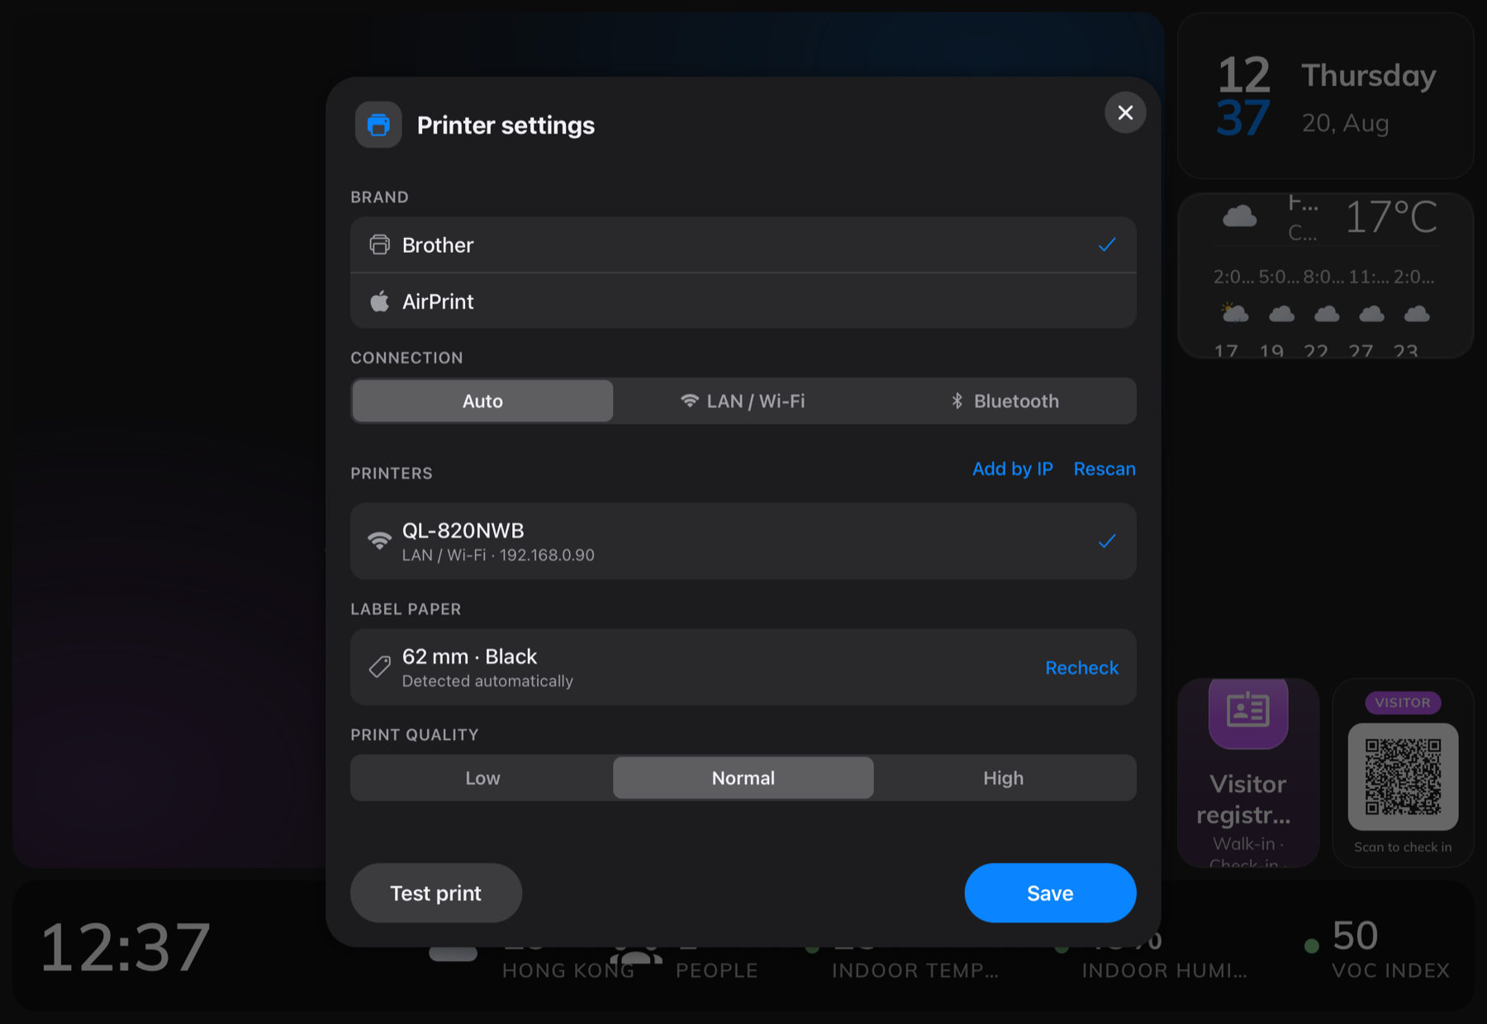
Printer settings on the board — the QL-820 found on the network, with the loaded label roll read from the printer.

3. Test print and save
Tap Test print. A test label should come out of the printer within a few
seconds — if it does, the connection is real, not just a name in a list. Then
Save. The screen remembers the printer from now on, through restarts and
power cuts, and reconnects to it by itself.

4. Check the board is allowed to print
Printing is switched per widget on the content, and it is on out of
the box — this step is a check, not a change, unless someone turned it off.
Open the content in Signage › Content, and in the live preview click
the Visitor registration QR code tile. Its settings open on the right,
and near the bottom sits Print visitor badge label: when on, this board
prints the visitor badge label after a visitor completes registration from
this QR code. The Visitor self service buttons widget carries the same
switch for walk-ins and check-ins made at the screen itself.
Where in Offision: admin app → signage/signage-content (Signage)
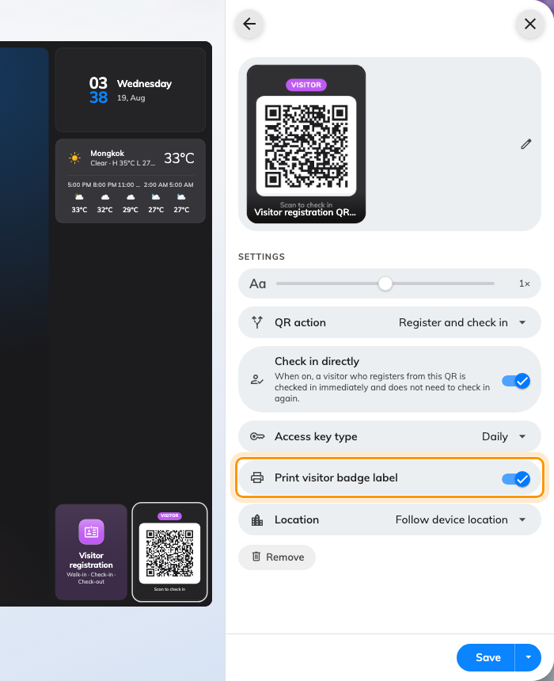
Print visitor badge label, on the QR code widget's settings in the content editor.

5. Check it worked
Walk the visitor's path yourself: register through the QR code on the screen,
or tap through a walk-in at the screen. The screen shows Printing your
badge, and the label comes out below the screen. If you registered from
your phone, the badge prints at the screen while your phone tells you where
to collect it.
Back in Printer settings, the Print tasks list keeps every label the
screen has printed, with a preview — the place to reprint one, and the first
place to look when someone says their badge never came out.

What this does not control
What the badge says and how it looks — logo, name, host, validity — is the
company-wide badge design, set in the visiting settings, not on the screen.
See Change the visitor badge design.
Which visitors the screen serves is decided by the player's location — that is
Set up a lobby screen for visitors.
A receptionist printing badges from the console on a PC connects a printer to
that computer separately — see
Connect a badge printer to your reception desk. The
screen's printer and the reception PC's printer know nothing of each other.
Still need help:
Note the printer model, how it is connected — Wi-Fi, Bluetooth, or added by
IP — what Label paper shows, whether Test print produces a label, and
whether the job appears in Print tasks. Together those separate a printer
that cannot be reached from a screen that was never allowed to print.

