Choose a panel design
A booking panel renders one of two layouts. Scheduling is the full panel with a side rail; Center is one column of type and draws far less — which is why half the settings go grey when you pick it.
2026-08-26 · https://offision.com/help/en/devices/choose-a-panel-design/
A booking panel renders one of two designs, and they are two layouts, not
two colour schemes. The design is set on the configuration, so it lands on every
panel sharing it.
Where in Offision: admin app → device/booking-panel/configuration (Panel configurations)

1. Pick the design
Open the configuration. It opens on Room booking panel: a live preview of the
panel, with the two designs as thumbnails beside it and the settings groups
underneath.
- Scheduling is the full panel: the room block on the left, a side rail with
the day's timeline, the action row, and room for a background image and a
logo.
- Center is one centred column on a flat near-black ground. No rail, no time
grid, no background image, no gradients. The status colour appears in exactly
two places — the state word and the primary button — and the hero is the room
name while the room is free, the booking title while it is not.
Center suits a door where the answer is "free or not, and for how long". Choose
Scheduling where people are expected to read the day off the wall.
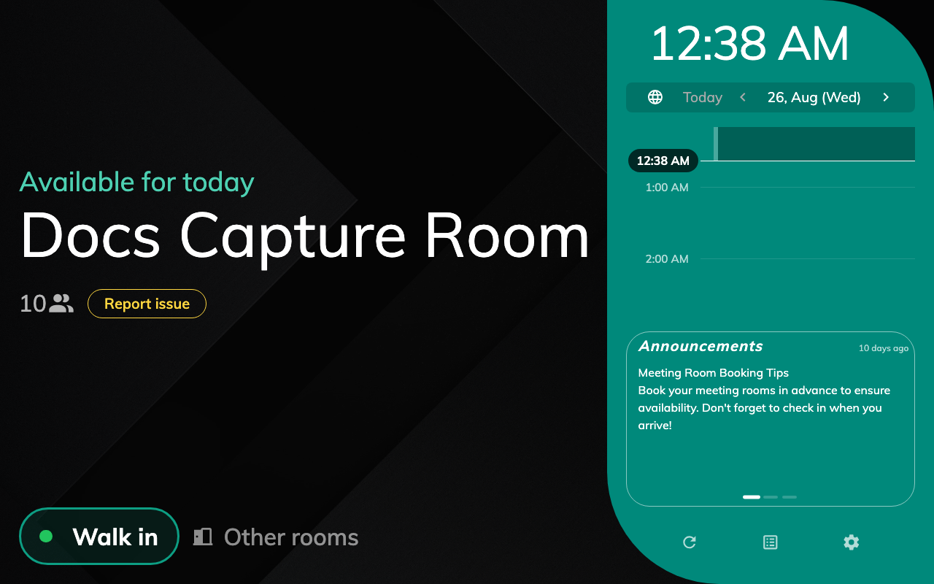
Free — the room block, the day on the side rail, the action row.
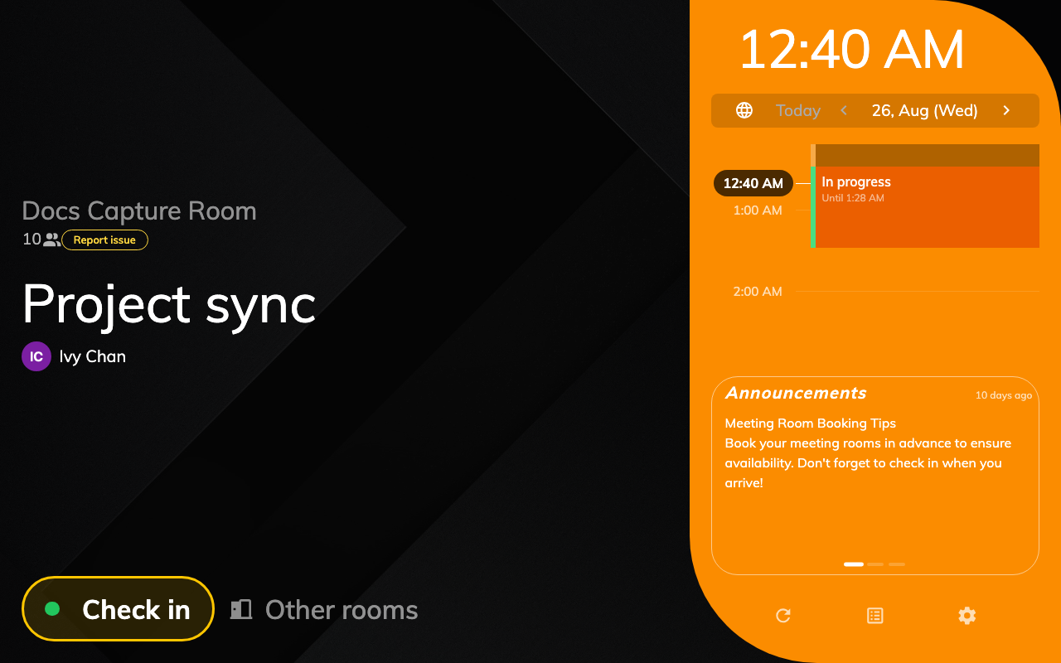
Waiting for check-in — the booking on the rail, Check in in the action row.
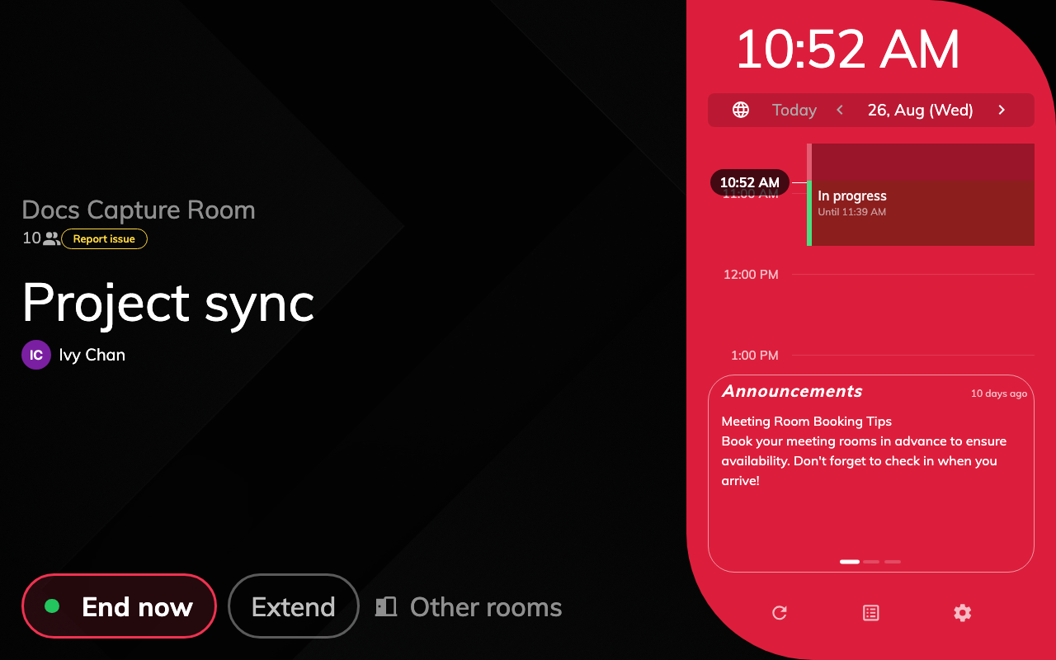
In use — the same booking, checked in.
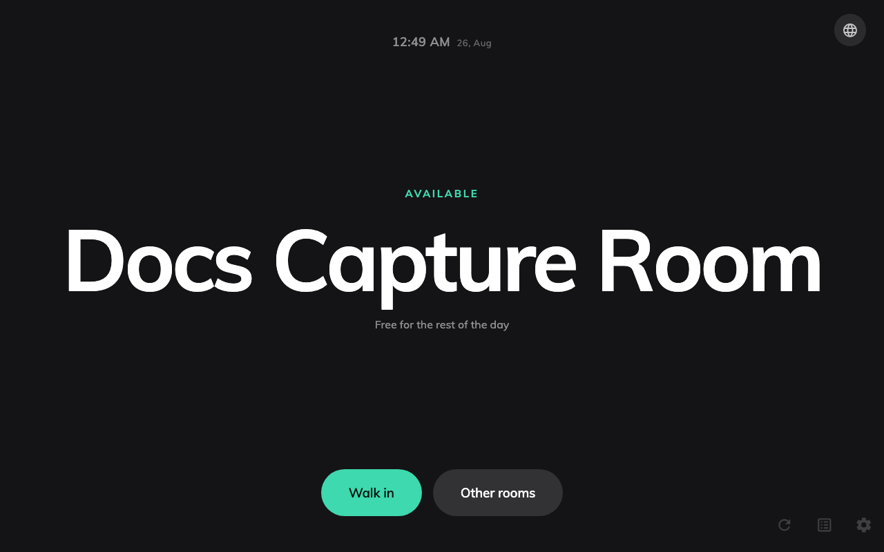
Free — one column, the room name as the hero.
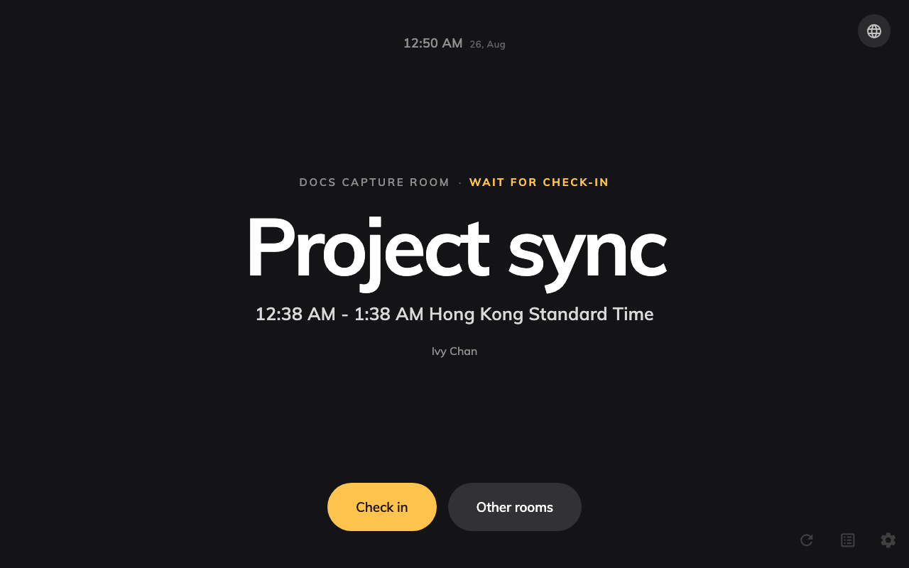
Waiting for check-in — the booking title as the hero, the state word and one button.
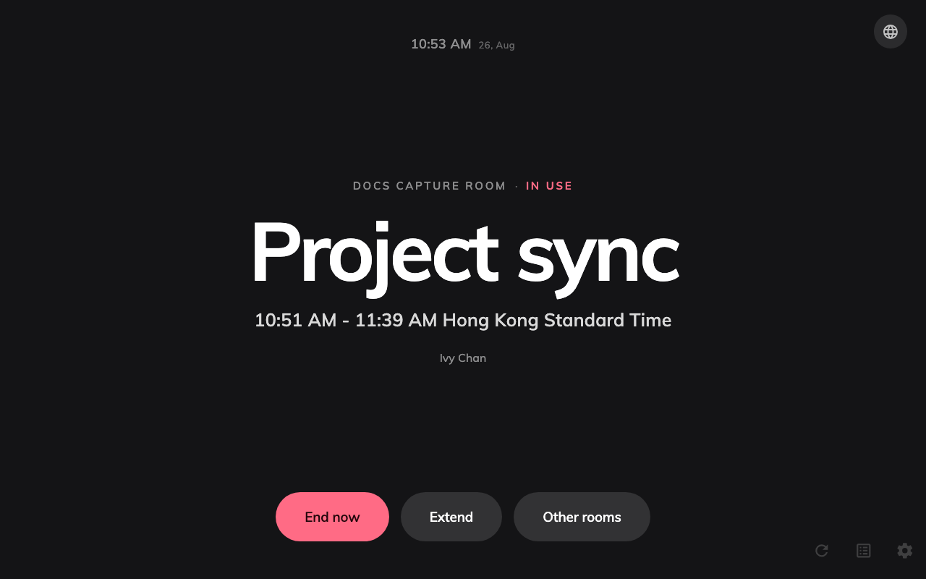
In use — the same booking, checked in.
Same room, same booking, photographed under both designs. Orange is waiting
and red is in use on both — see
What the panel colours mean.

2. Expect settings to go grey
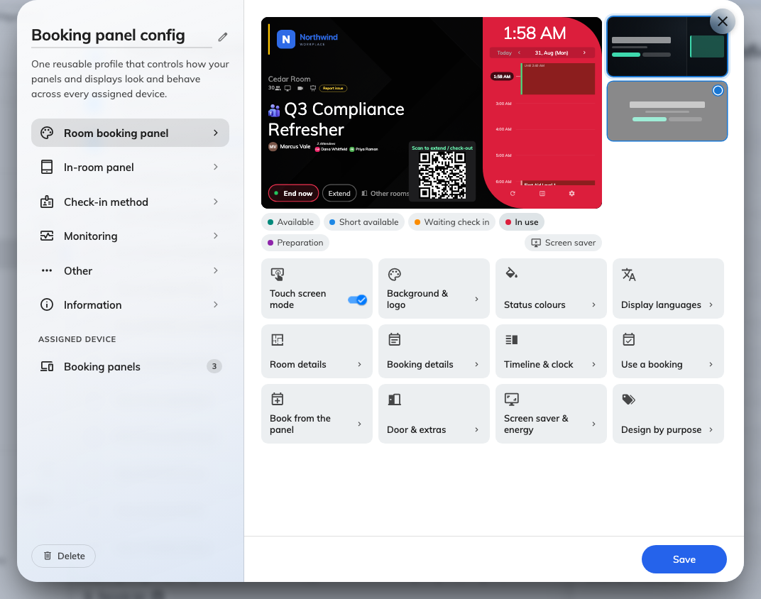
The groups under the preview. A group the design cannot draw is dimmed.
Center has no surface for a good many settings, so the form disables them
rather than letting you change something the panel will ignore:
Not drawn by Center | Where it lives
Background image mode and file, room name text size | Background & logo, Room details
Amenities, and their names | Room details
User thumbnails, organizer title, organizer staff ID, "Anonymous" when there is no organizer, online-meeting logo | Booking details
Announcements, business-hours-only timeline, timeline collapsed by default | Timeline & clock
QR code for booking | Use a booking
Advance booking, confirmation on a new booking, booking details, cancel booking | Book from the panel
Report issue | Door & extras

Scheduling draws all of them. Anything not in that table works on both.

3. Override one booking purpose
The last group, Design by purpose, gives an individual booking purpose a
design of its own — so a room that runs classes can render a different panel for
those bookings without a second configuration.
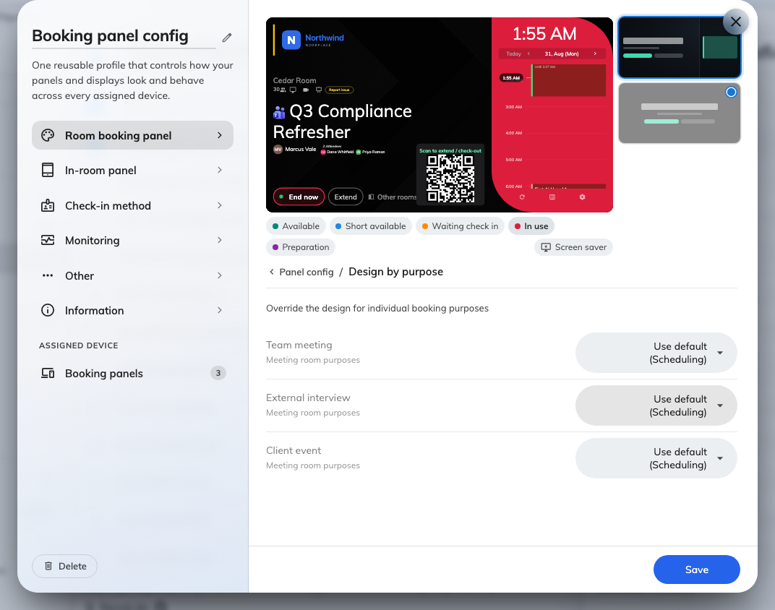
One row per purpose. Anything left on Use default follows the design above.
An override keeps its settings alive:
A setting stays editable while any design in play draws it. A configuration
whose default is Scheduling with one purpose overridden to Center still shows
the side rail most of the day, so the timeline settings stay live — greying them
out there would be a lie.

4. Check it worked
Save, confirm the list of devices the change reaches, and look at a panel. It
picks the change up on its next refresh rather than instantly.
If a panel still draws the old layout after a minute, check it is on the
configuration you edited rather than a second one — see
How a panel gets its settings.

