Let people identify with a passcode at the panel
The identification method that needs no card reader, no camera and no phone — four to eight digits each person sets on themselves. Turning it on, what the panel asks for, and how to give somebody a new one when they forget theirs.
2026-08-19 · https://offision.com/help/en/devices/check-in-with-a-user-passcode/
Four of the five ways a panel can identify somebody depend on something being
present: a card reader on the panel and a card in their pocket, a camera on the
panel and photos of their face, a phone with the app signed in. Any of those can
be missing on the day, and two of them can be missing from the hardware forever.
User passcode is the one that depends on nothing. Each person sets four to
eight digits on themselves in the app; at the panel they pick their name and type
them. It works on the cheapest panel you own, it works for the person who left
their badge at home, and it is the only method a contractor with no company phone
can use. Turn it on everywhere and the other four become conveniences rather than
requirements.
Before you start:
A panel already paired to a room, and the licence that carries user
identification. Everything below is a settings change — nothing has to be
installed on the panel.

1. Turn on User passcode
The identification methods are set once for the whole organisation, on User
identify settings. Turn on User passcode — "Input user passcode to
validate identity."
Where in Offision: admin app → device/check-in-method (Check-in method)
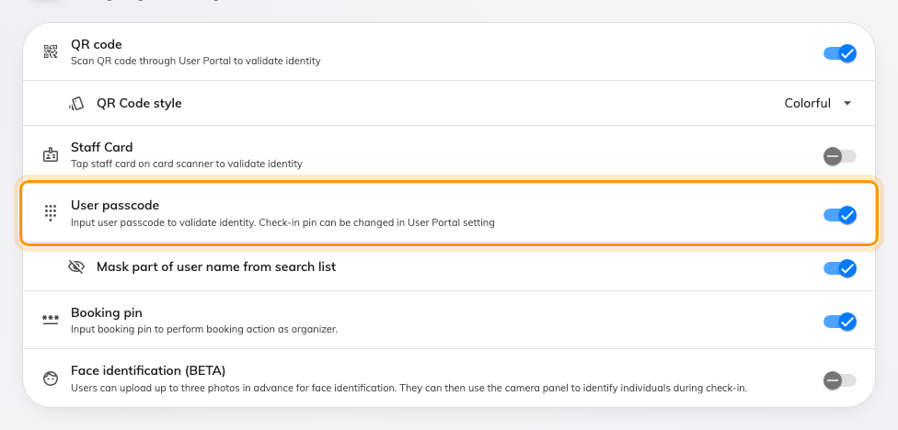
User passcode, with the masking option that appears underneath it.
The page's own rule is at the top of the card — "Enable at least one of the
following check-in methods on the device." — so this is safe to add and only
the last method standing cannot be removed.

2. Decide whether to mask names
Mask part of user name from search list appears underneath, and only once
the method above it is on.
It matters because of what the panel has to do on a walk-in: with no booking to
work from, it offers a search of everybody in the directory, and that list is
readable by whoever is standing there. Masking hides part of each name and
address, so somebody still finds themselves by typing their own name but cannot
browse the staff list off a screen in a corridor.
Turn it on for any panel in a public or semi-public space. Leave it off only
where the panel is behind a controlled door.

3. Per-panel, if you need it
Unlike the booking pin, this method can be overridden on an individual panel:
a panel configuration's Check-in method page carries User passcode in its
own list. The values people type still belong to them and are still set in one
place — it is only whether the panel offers the method that varies.
How somebody proves who they are at the panel covers
that screen, and the option of asking for nothing at all.

4. Tell people to set theirs
Nothing works until each person has a passcode, and until step 1 is done the row
does not exist in their profile to find. So announce it after you turn it on, not
before.
Point them at Set your user passcode,
which is one screen and about a minute. You cannot set one on their behalf in
bulk; each person types their own.

5. What the panel does with it
Where more than one method is enabled the panel asks first — Choose
authentication method — and User passcode is the orange tile.
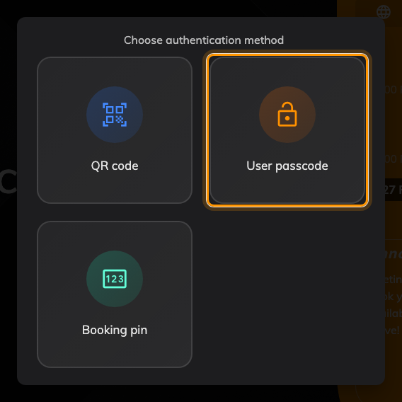
User passcode among the methods on this panel.
Then it establishes who, and it does that three different ways depending on
what it already knows:
- One candidate — checking somebody's own booking in — it skips straight to
the number pad.
- Several candidates — a booking whose policy allows attendees to check in,
check out and extend — a short list of the people invited.
- No candidates — a walk-in, where there is no booking yet — the search
screen, with an on-screen keyboard, over the whole directory. This is the one
masking applies to.
Somebody who has not set a passcode still appears in those lists, greyed. Tapping
their name answers "You need to set up a user passcode in the user app first"
rather than failing silently, which is worth knowing before the first report
comes in.

6. When somebody forgets theirs
Open Directory → the person, and the User passcode row in the panel on
the right. Type four to eight digits and save.
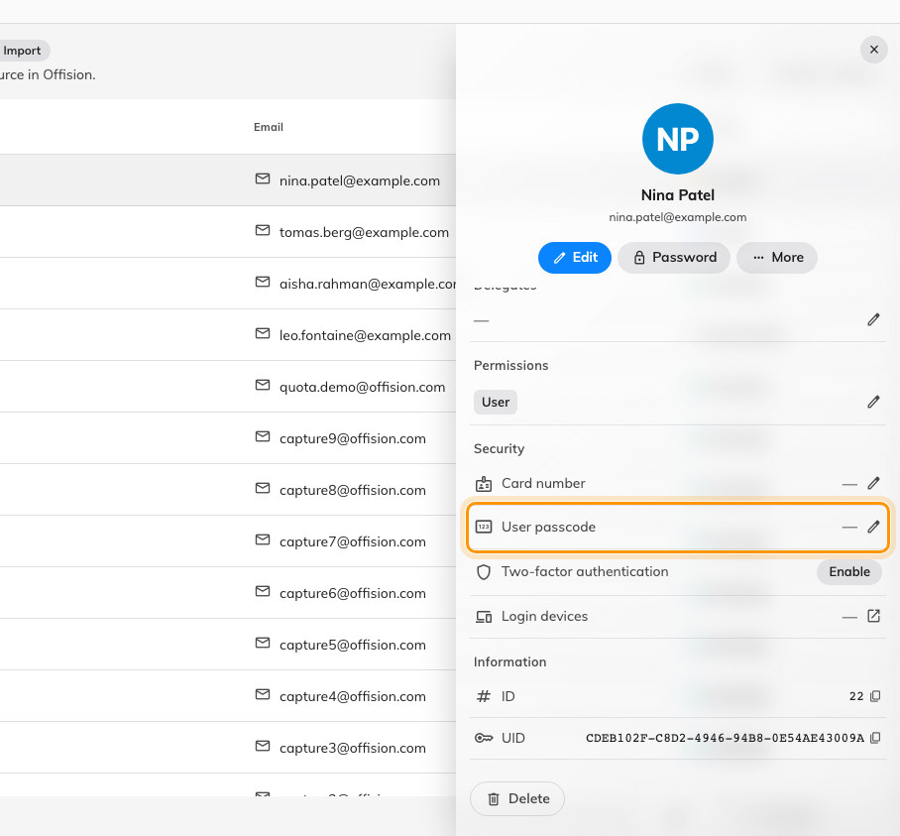
The User passcode row. A dash means none is set; the value is never shown.
Where in Offision: admin app → directory/user (Users)
Two things to say out loud when you do it:
- You cannot read the old one. Nowhere in the console shows the value — the
row and the list column carry a tick or a dash and nothing else. So this is
always "here is a new one", never "your one is 4416".
- Tell them to change it. The code you just typed is a code you know. Ask
them to go into their profile and replace it.

7. Check it worked
Set a passcode on yourself, book a room with a panel outside it, and check in
with the orange tile. The booking should go to in-use under your name.
Then try it the other way round: pick somebody in the search list who has no
passcode, and confirm the panel says so rather than accepting anything.
A wrong passcode is not locked out:
There is no attempt counter and no cooldown — a rejected code clears the pad and
can be tried again straight away. The screen gives up only after sixty seconds
with nobody touching it. That is what makes step 2 worth doing: on a panel in a
corridor, masking the names is the protection, not the retry limit.
It is not the booking pin:
The booking pin is a different code with a similar name: it belongs to a
booking rather than to a person, it is generated rather than chosen, and it
lets somebody with no account at all check in. See
Let outside attendees check in with a booking pin.

