What to enter on the AXIS device
The three screens to fill in on an AXIS door lock's own settings page — the MQTT client, the subscription and the four event rules — with the fields that fail silently when they are wrong.
2026-08-30 · https://offision.com/help/en/devices/axis-door-lock-settings-reference/
Three screens on the AXIS device's own settings page, filled in from Config guideline
in Offision — which is where Connect an AXIS door lock
sends you. Every value below has a copy button beside it there.
Do all three. A device that has done only the first reports Connected and still never
opens a door, because nothing is listening for the command.

MQTT client
On Config guideline, open step 1, MQTT config. Every value the device needs is on
this one screen, each with a copy button beside it.
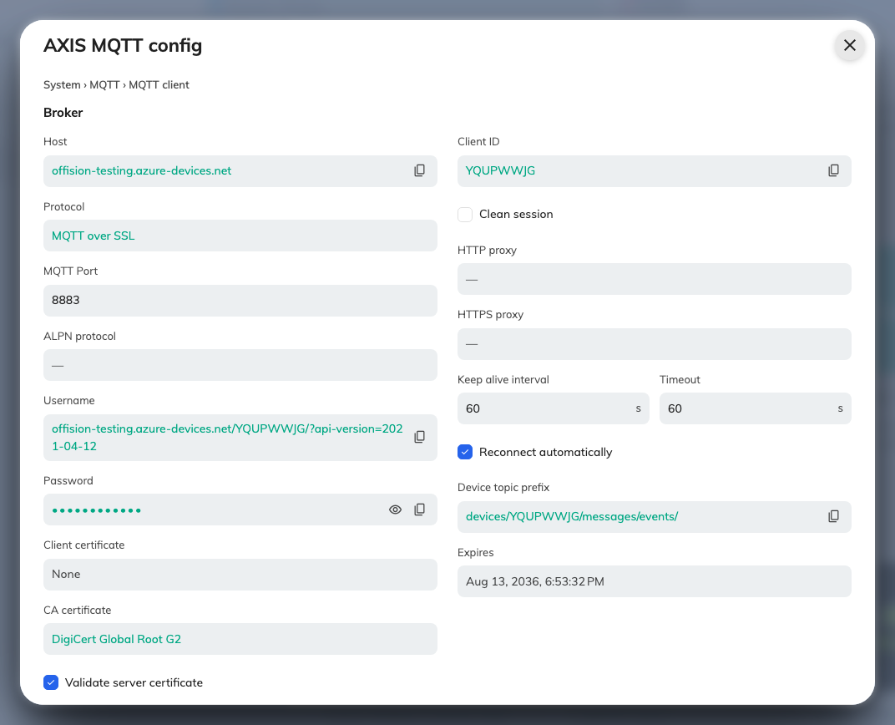
MQTT config, as Offision generated it for this device.
Now open the AXIS device's own settings page in a browser, sign in, go to
System › MQTT › MQTT client, and enter what the screen above shows. Password stays
hidden until you reveal it.
Save, and the device should report Connected.
Connected is not the whole story:
Connected only means the device reached the broker. It does not mean the device is
listening for anything. A box can sit there connected, reporting its status quite
happily, and still never receive a single command — that is what the next step fixes.

MQTT subscription
On Config guideline, open step 2, MQTT subscription.
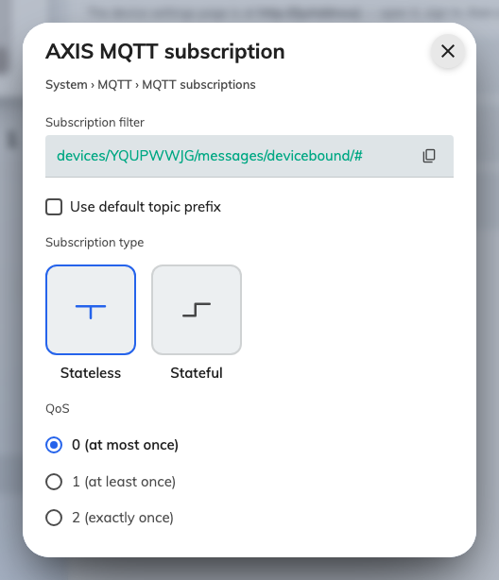
The subscription to add on the device.
On the device, go to System › MQTT › MQTT subscriptions and add one subscription
matching that screen.
Note:
Two fields here are worth checking twice, because getting either wrong produces a device
that looks perfectly healthy and never opens a door.
The filter must keep its trailing /#. Offision's broker adds a short suffix to every
message it delivers, so a filter that stops at the exact topic never matches anything.
Use default topic prefix must stay off. The filter is already complete; switching
the prefix on puts the device's own prefix in front of it and the match fails.

Event rules
On Config guideline, open step 3, Event rules. There are four rules, one per tab: two of them open and close
the door, and two report the state of the relay back to Offision.
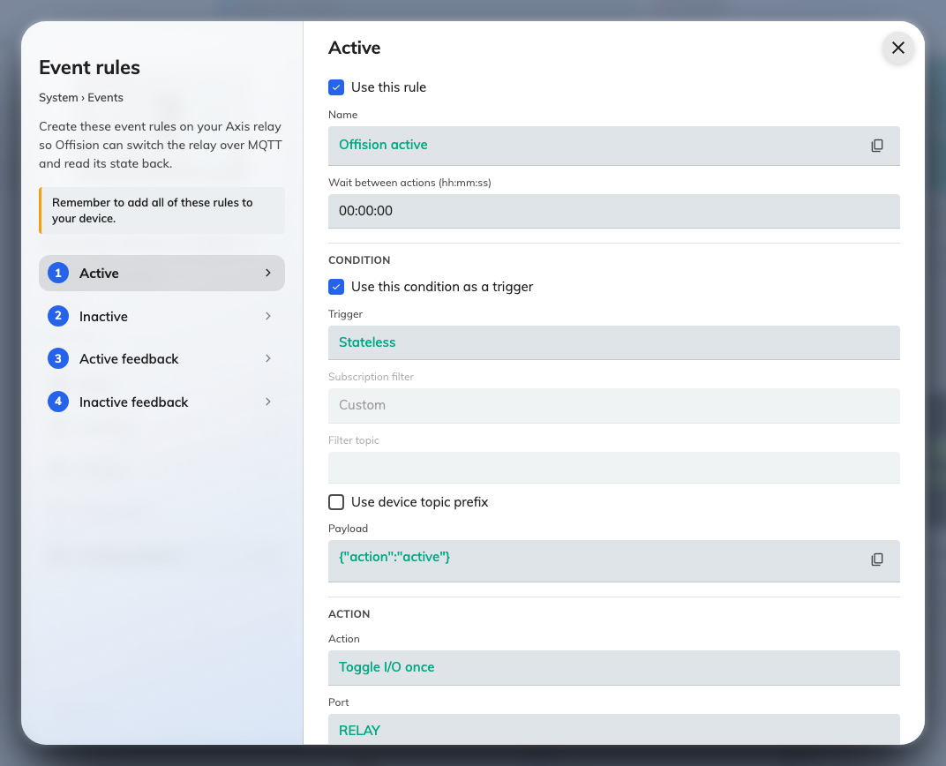
Event rules. Each tab is one rule, field for field.
On the device, go to System › Events and add a rule for each tab, matching the screen
field for field.
Three fields that fail silently:
Filter topic is empty here — the opposite of the last step, and the single most common
reason a door never opens. The subscription needs its filter; the rule must not have one.
A rule with a filter topic simply never fires, with no error anywhere.
Duration is 00:00:00. Any other value makes the device flip the relay back on its
own, which inverts everything: an unlock ends up locked, and a lock ends up leaving the
strike energised and the door open. Offision handles the timing itself.
The port is RELAY, not O1. They are different ports on the same device, and a rule
pointed at the wrong one does nothing at all — no relay movement, often not even a log
entry. RELAY must also be usable as an output; if it is set up as an input, the rule
fires into nothing.
The last two rules only report; they never open anything. They are what makes the device's
tile in Offision show whether the door is currently locked.
How the strike should be wired:
Offision assumes fail-secure wiring: relay energised means unlocked, relay at rest
means locked. Wired the other way round, every command comes out backwards — and a power
cut leaves the door open.

What this does not cover
- Which door the lock belongs to. Pairing the lock to a room panel is done in Offision
— see Connect an AXIS door lock.
- The wiring itself. Offision assumes fail-secure, but which terminals the strike lands
on is the AXIS installation guide's subject, not this one.
- Anything on a different AXIS device. The relay-extender and camera products connect
through a control processor instead.

