A booking panel keeps running when the network drops
The panel keeps showing the day it already has and keeps its own clock, so the door never goes blank. What stops is anything that needs the server — checking in, extending, ending early — and the panel says which connection is missing and recovers on its own.
2026-09-12 · https://offision.com/help/en/devices/a-panel-keeps-running-when-the-network-drops/
A panel by the door is the most visible thing Offision runs, so on a site with an
unreliable line the question is really about the worst case: what is on that
screen when the connection is gone.
It keeps working as a display. The panel goes on showing the day it already has
and goes on counting its own clock, so the screen does not blank, does not fall
back to a loading spinner, and does not announce anything to the corridor. What
stops is only what has to reach the server — and the panel says so rather than
failing quietly.

What keeps working
The panel holds the day it last loaded, and nothing discards it when the
connection goes. Today's bookings stay on screen, along with who has the room
next and the room's status colour.
The clock is the panel's own. That is what keeps the display honest through an
outage: at the moment a booking starts, the colour still changes from green to
orange or red, a countdown still counts down, and the screen saver and
energy-saving schedule still come and go on time. A panel left alone through a
two-hour outage looks, from the far end of a corridor, like a panel that never
lost anything — because for the purpose of reading the room, it has not.
Anything the panel does by itself keeps working too: the language picker, waking
the screen, and the panel's own settings console behind its pass code.
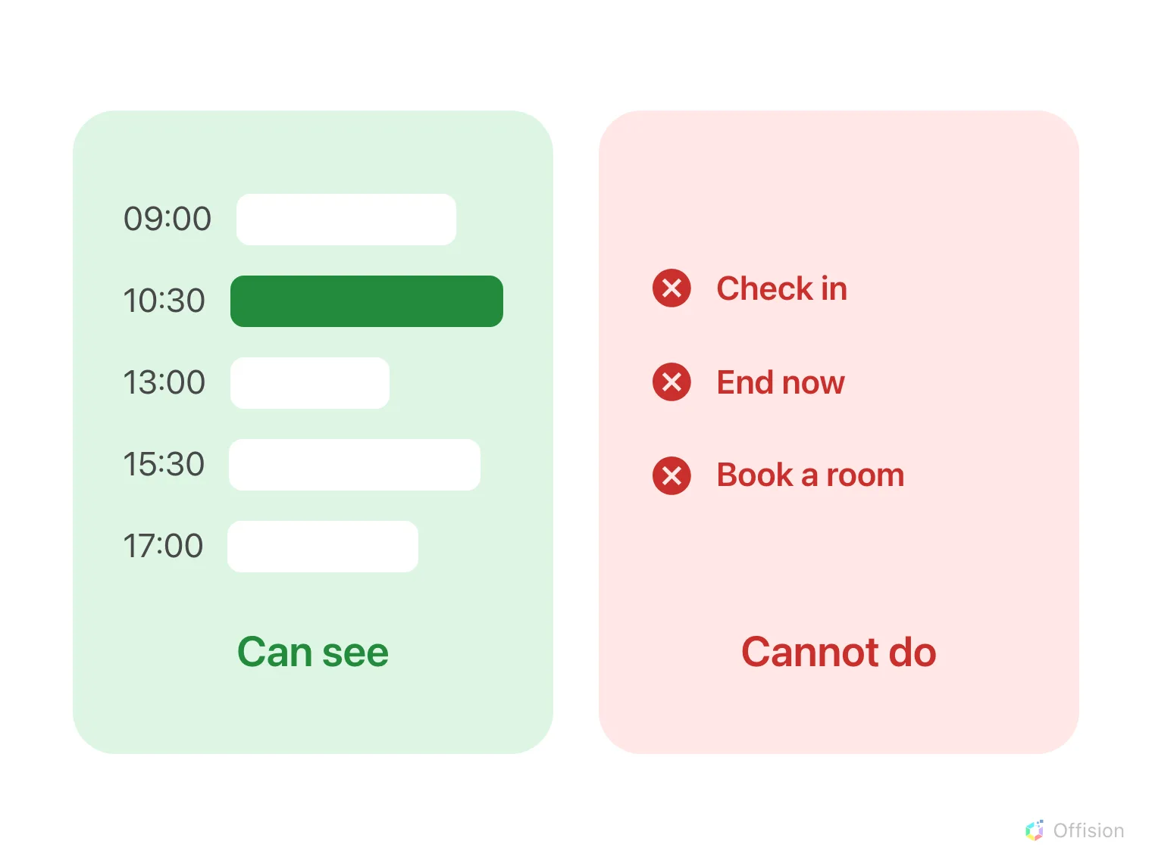
The day stays on the screen. What stops is everything a person would do at the panel.

What stops
Everything that has to reach the server: Check in, End now, Extend,
taking a free room on the spot, and looking for another room in the building.
The buttons do not vanish and do not grey out. They stay where they are and
still respond to a tap — and the tap then fails with Unable to connect to the
server. Please check your internet connection, which clears itself after a
minute. Somebody at the door is told why nothing happened instead of being left
pressing a button that appears to do nothing.
Nothing is held and sent later. There is no offline queue: a check-in
attempted during an outage is not stored on the panel and replayed when the link
returns. That is a decision rather than a gap — a check-in records the moment the
server hears it, so a replayed one would land at the wrong time and quietly
corrupt the no-show reporting it feeds. Once the link is back, checking in again
takes a second.

It says which connection is missing
About three seconds after the drop, a card appears on the panel with a
struck-through Wi-Fi mark and a Reload action. It carries one of two
messages, and the difference between them is the useful part.
The panel says | What it means
No internet connection | This device has no network at all. Look at the room's access point, its cable, its switch
Server connection error | The device has a network but cannot reach Offision. The panel end is fine; look at the server or the line out of the building

So a panel on a flaky site tells whoever walks past which half of the problem to
go and look at, without anybody opening the console first.

It comes back on its own
The panel keeps trying for as long as it takes — every five seconds for the
first minute, then every minute, indefinitely, and immediately whenever the
device sees a network again. When the server answers, the card retracts itself
and the panel reloads its day. Nobody has to visit the panel, and nothing has to
be reset in the console.
It also refuses to reload itself while it is offline, including the reload it
would otherwise do when the date changes at midnight, and holds that until the
network is back. A page that reloads with no network does not come back, and the
panel is built to avoid exactly that.
Do not reboot a panel to fix an outage:
A panel that is already running has its day in memory. A panel that restarts has
to authenticate before it can draw anything, and during an outage it cannot — so
it lands on a Not connected screen with a Retry button and nothing else.
Power-cycling is the one action that turns a working display into a blank one.

Seeing it from the console
The corridor cannot tell you whether a panel is connected: the status colours
have no offline state, by design. Connection status, in the booking panel's
device list, is where it shows.
Where in Offision: admin app → device/booking-panel/device (Booking panel)
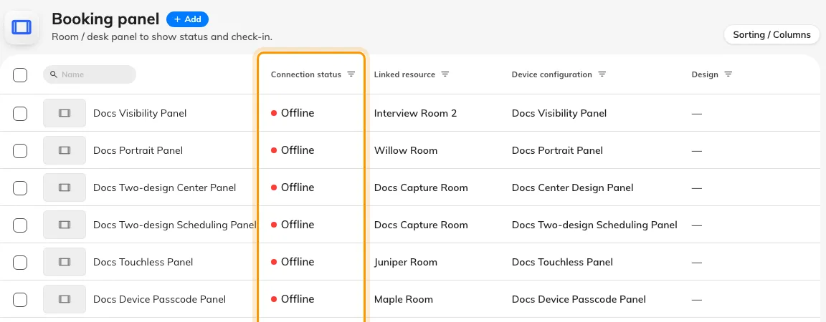
Connection status in the device list — the one place a lost panel is visible.
Offision can also email somebody rather than wait for a person to notice; see
Know when a device goes offline.

What this does not cover
- A panel that never paired. A device showing its six-character code has no
day to keep — see Connect a booking panel.
- A panel that is connected but stale. If the panel is online and the
bookings are still wrong, the fault is between Offision and the calendar
rather than at the door — see
Put a Microsoft 365 or Google room on a booking panel.
- Releasing a panel while it is offline. Disconnect device is sent as it
happens and is not queued, so it has to be done at the panel instead — see
Reuse a panel.

