Post an announcement to the app and the screens
Write a notice, choose who sees it and for how long, and confirm it arrived — in the app, as a notification, and on the screens.
2026-08-18 · https://offision.com/help/en/broadcast/post-an-announcement/
Before you start:
You need an account that can manage announcements, and the Announcement feature
turned on for your organisation — the Add button is greyed out with a tooltip
saying so when it is not. If you are going to target the notice, have the user
group, the building or the floor already set up: this dialog picks from them, it
does not create them.
Announcements are one screen's work. Almost all of the thinking is in step 3.

1. Open the announcement list
Go to Broadcast › Announcements and choose Add.
Where in Offision: admin app → broadcast/announce/announcement (Announcements)
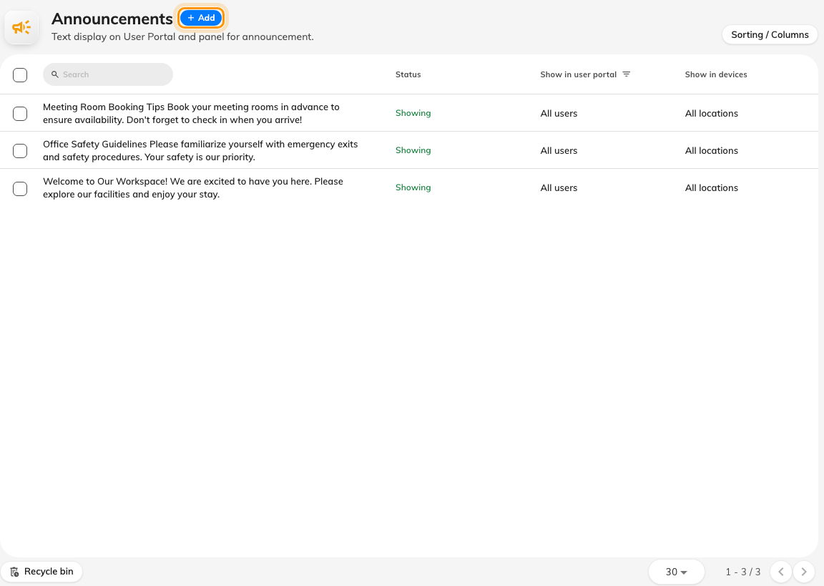
The announcement list. Add sits beside the title.

2. Write the notice
The dialog opens on Content, which is one rich-text box and one switch.
Put the point in the first line. There is no title field, so the first line is
what every small rendering of the notice uses as its heading — the card on the app's
home screen, the tile on a board. Lift B out of service Friday is a heading;
Please be advised that… is not.
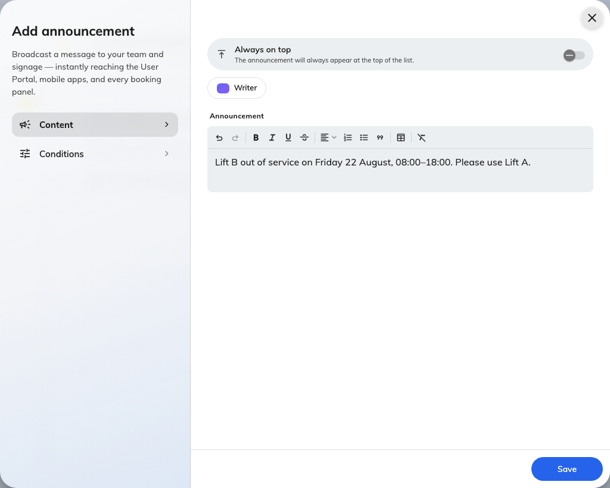
Content: the announcement body, with Always on top above it.
Turn on Always on top only for a notice that should outrank the others while it
is up. It affects order, not how long the notice lives, and it is worth nothing if
every announcement has it.
If AI writer is available, it will draft the notice from a short instruction.
Read what it produces before saving — it is a starting point, and the first line
still has to work as a heading.

3. Choose who sees it, and for how long
Open Conditions. Three questions, and the defaults are not what most people
expect.
Show on User Portal puts the notice in the app and notifies the people it
targets. Leave Specify users to receive the announcement off and it goes to
everyone with an account; turn it on to pick users or groups.
Show on devices puts the notice on booking panels and signage. Leave Specify
devices to display the announcement off and it appears on every screen; turn
it on to pick floors or buildings.
Blank does not mean nobody:
On both halves, naming nothing means everybody — every account, every screen. If
you only wanted one department to see a notice, you have to say so; the empty state
is the widest possible audience, not the narrowest.
Effective period bounds when the notice is visible. Set both ends or
neither: a period with only a start, or only an end, is shown for good. Leaving it
off is right for a standing notice and wrong for anything about a particular day.
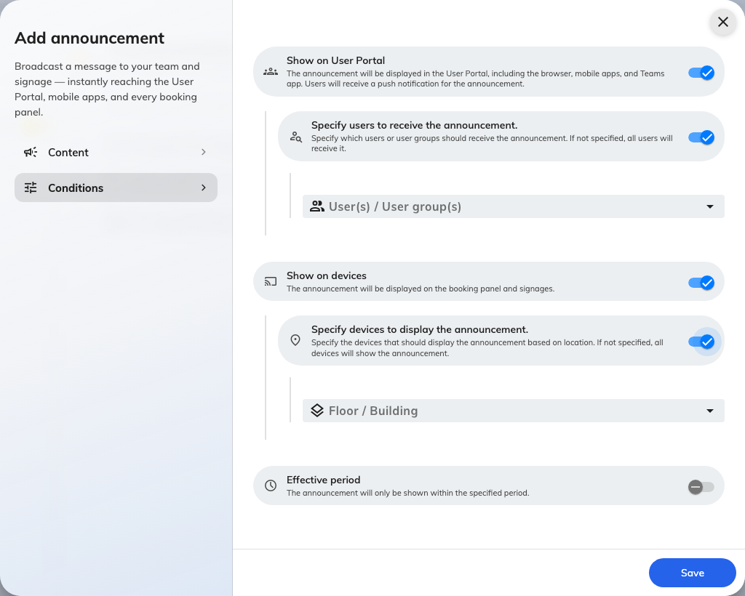
Conditions, with both audiences narrowed: named users and groups, then named floors and buildings.
Choose Save. If the period has not started yet, nothing happens until it does —
that is the point of setting one.

4. Check it arrived
Check all three surfaces, because they fail independently.
In the app. Open the Offision app as somebody the notice targets. It appears on
the home screen with an unread dot, and pinned notices sort first.
As a notification. The same person gets a row in their notification list and a
push on whatever they are signed in on. This is the leg that reaches people who are
not looking at anything.
On a screen. Walk past one of the screens you targeted, or open a booking panel
on a targeted floor. If it is missing there but present in the app, the cause is
almost always the device's own location — see
The announcement is in the app but not on the screens.
Fix it by replacing it, not by editing it:
Editing an announcement corrects what is on screen and in the app, but nobody is
notified a second time. If it matters that people see the correction, delete the
old notice and post a new one.

