An announcement went out but nobody saw it
The notice is in the admin list and looks right, but staff say they never got it. Six causes, ordered by how often they turn out to be the one.
2026-08-18 · https://offision.com/help/en/broadcast/nobody-saw-the-announcement/
Is it missing from the app, or only from their phone?:
Two different problems wear the same complaint. Ask one person to open the Offision
app and look at their notification list. If the announcement is there, the notice
was delivered and only the pop-up failed — go straight to solution 6. If it is not
there, it was never delivered to them, and solutions 1 to 5 are the causes.
Open the announcement and read its Conditions page before working down this
list — five of the six causes are visible on it, and the sixth is the clock.
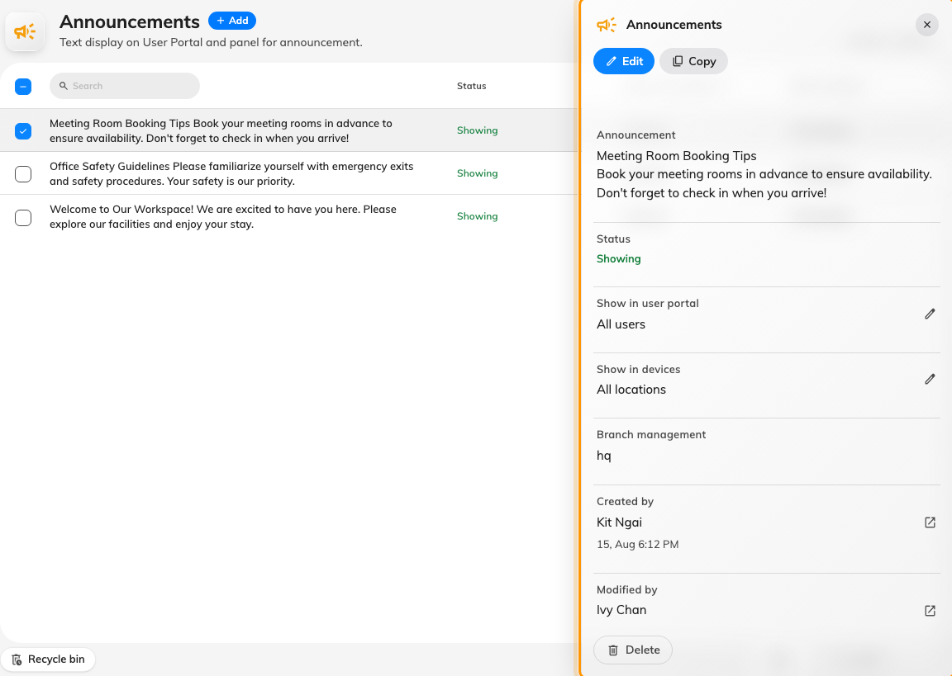
Selecting a row opens its detail panel, which shows the audience and the period without opening the editor.
Solution 1 — Show on User Portal is off (most common)
One switch governs the whole app half of the feature: the notice in the app, the row
in the notification list, and the push. With Show on User Portal off, the
announcement is a screens-only notice and reaching nobody in the app is exactly what
it is set up to do.
This is far and away the most common cause on a notice that looks perfect in the
admin list, because the list's Show in user portal column reads as a filter and
is easy to skim past.
Open the announcement, go to Conditions, and check the first switch.
Where in Offision: admin app → broadcast/announce/announcement (Announcements)
Solution 2 — It was targeted, and the people complaining are not in the target (most common)
With Specify users to receive the announcement on, only the users and groups named
underneath get it — nobody else, and no fallback.
Two things make this less obvious than it sounds:
- Groups are resolved when the notice goes out, not when it is written. Somebody
added to the group afterwards was not a member at that moment and is not
retrospectively notified.
- A user targeted through a group they were removed from stops receiving it
from the next announcement onward, silently.
Check the named list against the people complaining. If it is genuinely meant for
everyone, turn Specify users off — an empty list is not "everyone", it is a
required field.
Solution 3 — The effective period has not started yet (common)
An announcement with Effective period on and a start in the future is invisible
and un-notified until that moment arrives. The admin list shows it as Upcoming,
which is the fastest way to spot this.
That is intended behaviour — it is how you write Monday's notice on Friday — but it
catches people who set a period to bound the end and picked a start of "tomorrow"
without meaning to.
The mirror case is worth checking at the same time: a period whose end has already
passed reads Passed, and an expired notice is never announced late.
Solution 4 — It was announced once already, and then edited (common)
The notification goes out once per announcement. Editing one afterwards updates
what is on screen and in the app, but notifies nobody a second time.
So the sequence that produces this complaint is: post a notice, notice a mistake,
fix it, and assume the fix went out. It did not. Everybody who was notified got the
original wording; anybody who has not opened the app since sees the correction only
when they do.
If it matters that people see the correction, post a new announcement rather than
editing the old one.
Solution 5 — It has been less than five minutes (less common)
Announcements are not notified at the instant you press Save. A background pass picks
up newly-effective announcements every few minutes, so a notice can be visible in the
app — where it is read live — before the notification for it has gone out.
Wait five minutes before treating it as a fault. If nothing has arrived after that,
the cause is one of the others.
Solution 6 — Notifications are switched off where they are looking (less common)
If the announcement is in the person's notification list and they simply never saw
a pop-up, delivery worked and the last hop did not. That hop is not Offision's:
- Browser — notifications must have been allowed for the Offision site. A browser
that was never asked, or was asked and refused, shows nothing.
- Phone — the mobile app needs notification permission, and the device must have
been signed in recently enough for its registration to still be current.
- Teams — the Teams channel needs the tenant-wide connection in place; without it
the other channels still work and Teams alone stays quiet.
The distinguishing test is the one in the box at the top: the row exists, the pop-up
did not.
If none of these fit:
Collect these before opening a ticket — together they separate the six causes above
from anything else:
- the announcement's ID (turn the ID column on in Sorting / Columns);
- a screenshot of its Conditions page, showing both switches and the period;
- the email address of one person who did not receive it, and whether the row is
present in their notification list;
- roughly when it was saved, and whether it has been edited since.

