How an announcement reaches people
What decides who sees an announcement and when — the two audiences, the targeting rule that surprises everybody, the effective period, and the one notification you get per announcement.
2026-08-18 · https://offision.com/help/en/broadcast/how-an-announcement-reaches-people/
An announcement is the shortest path from "everyone needs to know this" to everyone
knowing it. Four things about how it works catch people out, and all four are
decided in one dialog.

An announcement has no title
There is one text box, and what you type in it is the announcement. Nothing asks
you for a subject.
Everywhere the notice is shown small — a card on the app's home screen, a tile on a
board — the first line is promoted into the heading. So write the first line as one:
Lift B out of service Friday reads well as a heading and the rest of the
paragraph follows it. A notice that opens with "Please be advised that…" gets a
heading that says "Please be advised that…" on every screen in the building.

Leaving the audience blank means everybody, not nobody
This is the single most misread part of the feature, and it applies to both
audiences independently.
Turn on Show on User Portal and name no users and no groups, and the
announcement goes to every account on the system. Turn on Show on devices
and name no floor and no building, and it appears on every screen. Naming
somebody narrows it; naming nobody does not silence it.
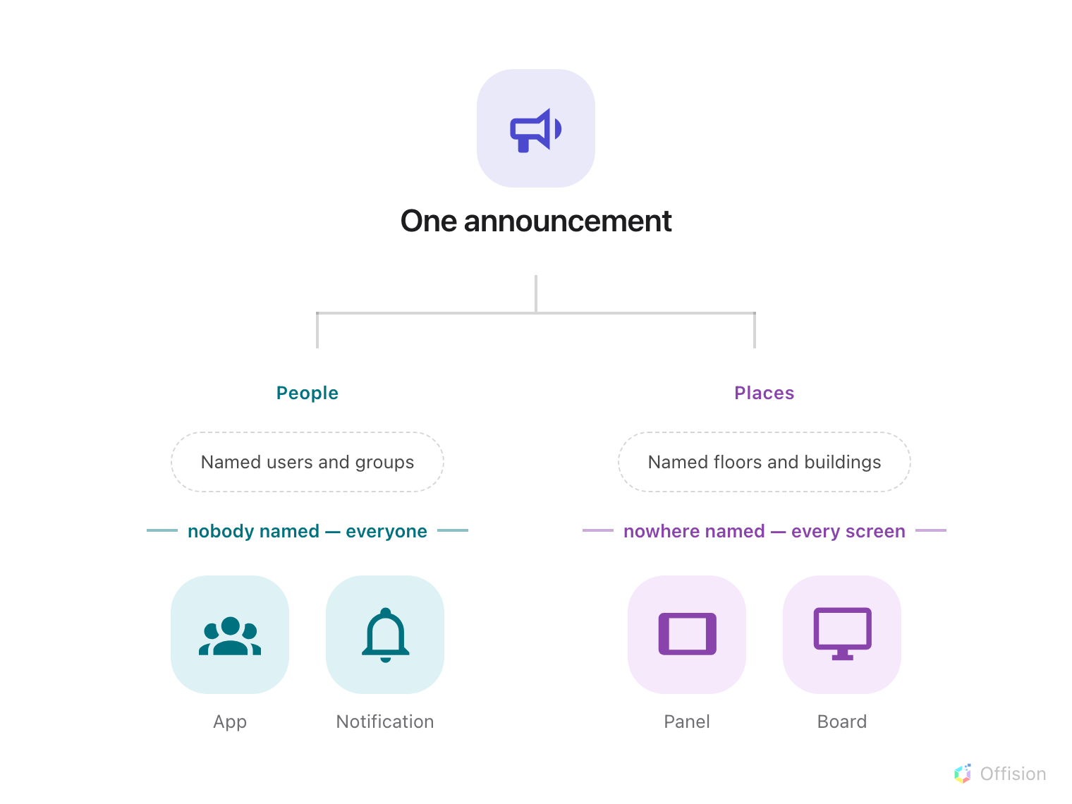
Two independent halves, and an empty filter on either side opens it to everybody rather than closing it.
The two halves also do not talk to each other. An announcement aimed at the Finance
group and at Level 3's screens does not restrict Level 3's screens to Finance — the
screens show it to whoever walks past, because a screen has no idea who is looking
at it. Anything genuinely confidential belongs in an announcement with
Show on devices off.

Half an effective period never expires
Effective period decides when the announcement is visible. It is optional, and
the useful thing to know is what happens when it is half filled in.
A notice is shown when either end is missing, or when now falls between the two.
So a period with only a start, or only an end, is shown always — it never begins
counting down and never expires. Set both ends, or set neither.
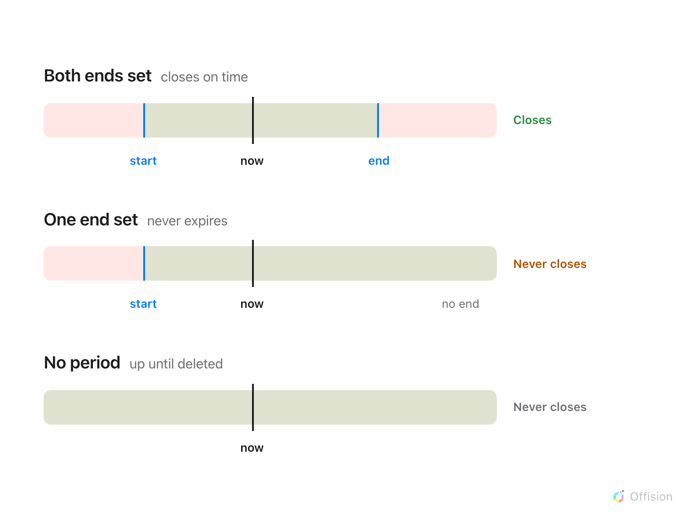
Only a period with both ends set actually closes; one end alone leaves the notice up for good.
Set no period at all and the announcement stays up until somebody deletes it, which
is right for a standing notice and wrong for a notice about last Friday.
Always on top is a separate answer, and it is about order rather than time: a
pinned announcement sorts above the others wherever they are listed. Pinning a
notice does not extend it, and an expired pinned notice is simply gone.

The notification goes out once
Posting to the User Portal does more than put the notice in the app. Everyone it
targets also gets:
- a row in the app's notification list, which they can mark read; and
- a push notification on whatever they are signed in on — the browser, the
mobile app, and Teams.
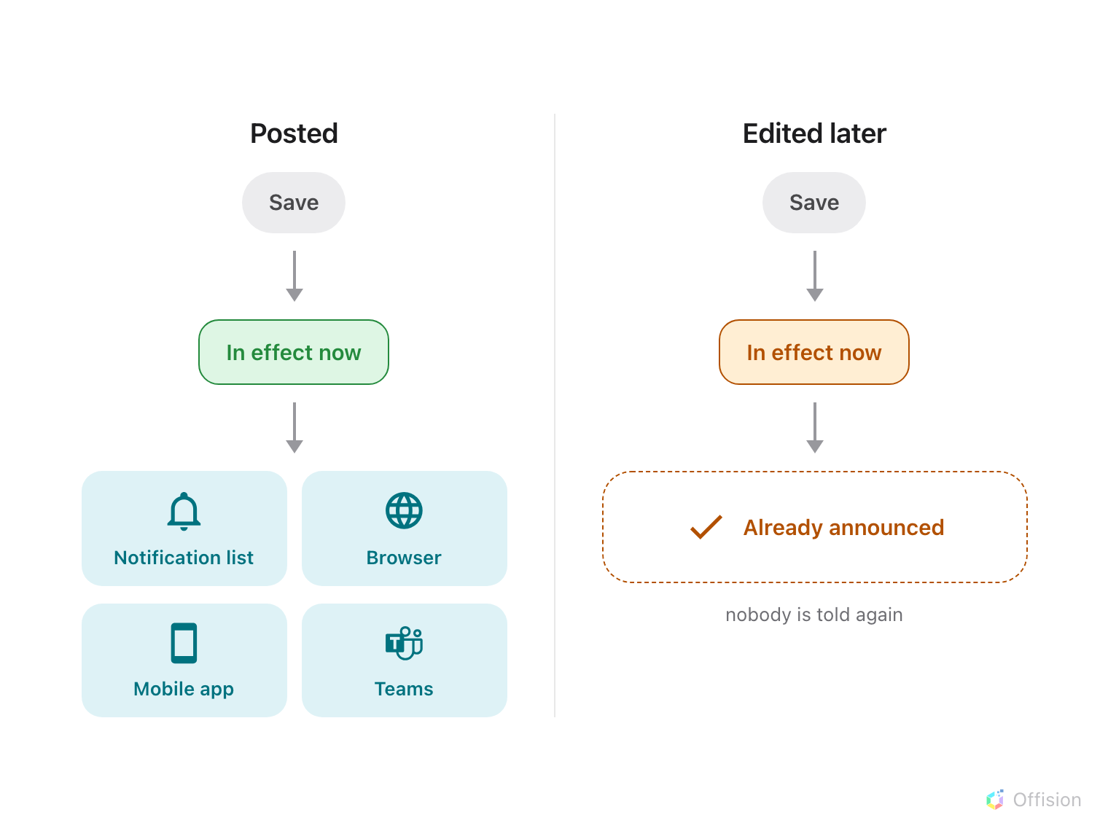
One announcement, one announcement-wide notification — and an edit afterwards reaches nobody again.
Two consequences worth planning around:
- A scheduled announcement notifies when it starts, not when you save it. Post
Monday's notice on Friday with an effective period starting Monday and the push
lands on Monday.
- Editing never re-notifies. The correction appears on every screen and in the
app, but nobody is told about it. If it matters that people see the correction,
post a new announcement.
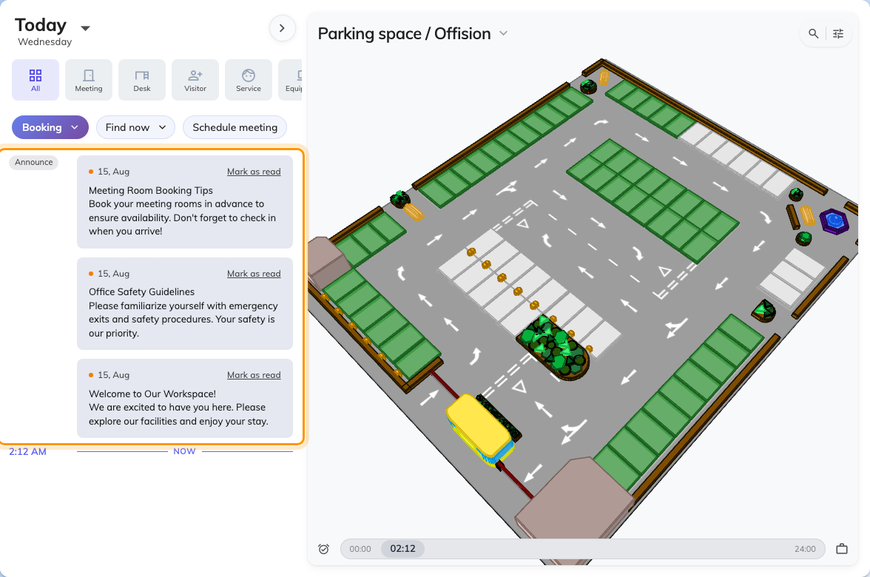
Announcements on the app's home screen, each with its unread dot and Mark as read.

Where you watch it from
Broadcast › Overview is the operational view: what is running right now,
and how many notices are live.
Where in Offision: admin app → broadcast/announce/overview (Broadcast)
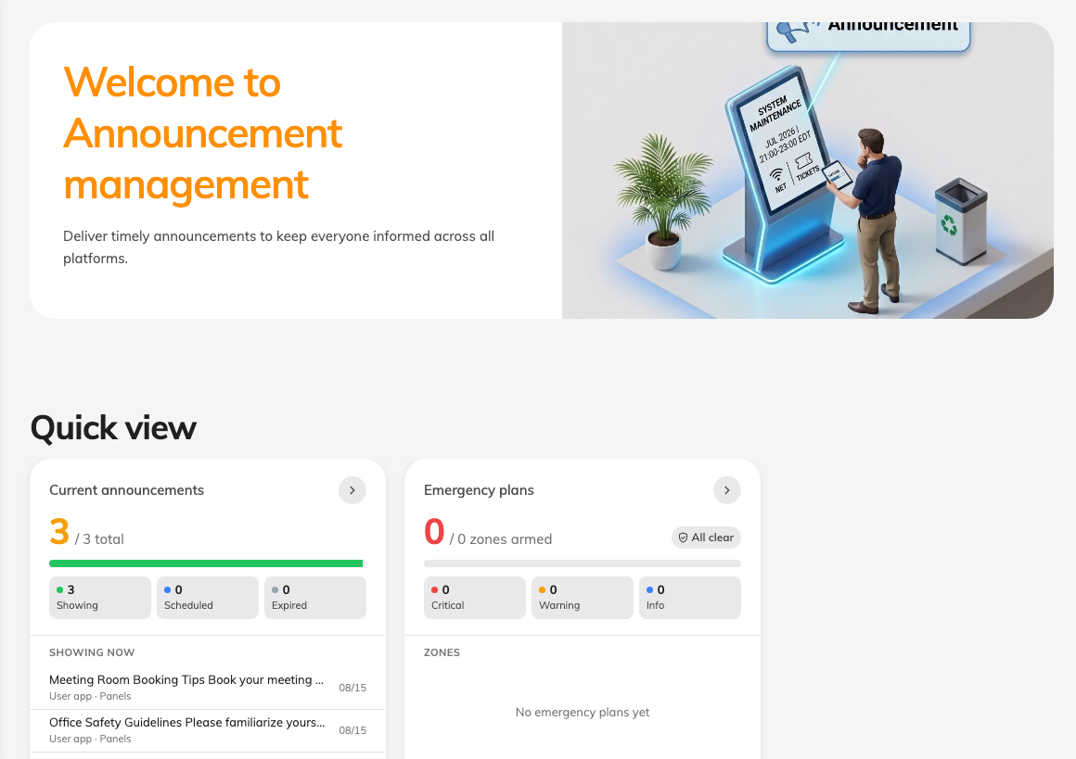
The Broadcast overview, with the announcements currently in effect.
A notice nobody can act on:
An announcement is one-way. There is no reply, no acknowledgement to collect, and
no report of who read it — a reader can mark their own copy read and nothing rolls
that up. If you need to know that people have read something, that is a different
job from announcing it.

What an announcement does not control
- Which screen shows it. Naming a floor selects screens by where they are, and
where a screen is comes from the device, not from here. A screen with no location
matches only untargeted announcements — see
The announcement is in the app but not on the screens.
- Who may post one. That is a Directory permission, not a setting on the notice.
- Anything about one booking. A message for the people in one meeting belongs on
that booking.

