Create a vote
Create one question with 2–6 choices and choose its audience, anonymity, and closing date.
2026-10-03 · https://offision.com/help/en/broadcast/create-a-vote/
Where in Offision: admin app → broadcast/poll (Poll)
Open Broadcast → Poll. You need the Announcement feature enabled and permission to create data-source entries.
- Add a poll and enter a title and description.
- Select Vote. Write one question and 2–6 choices; the question is required and employees choose one answer.
- Translate the title, question, and options into the audience's languages.
- Open Conditions. Choose the users or groups, anonymity, whether respondents see vote results, and an optional closing date.
- Save, then verify the poll appears on Home for a targeted employee.
A selected closing date ends at the end of that day. Check the displayed date before saving. Once someone responds, questions and anonymity cannot be edited. Read results or close the poll.
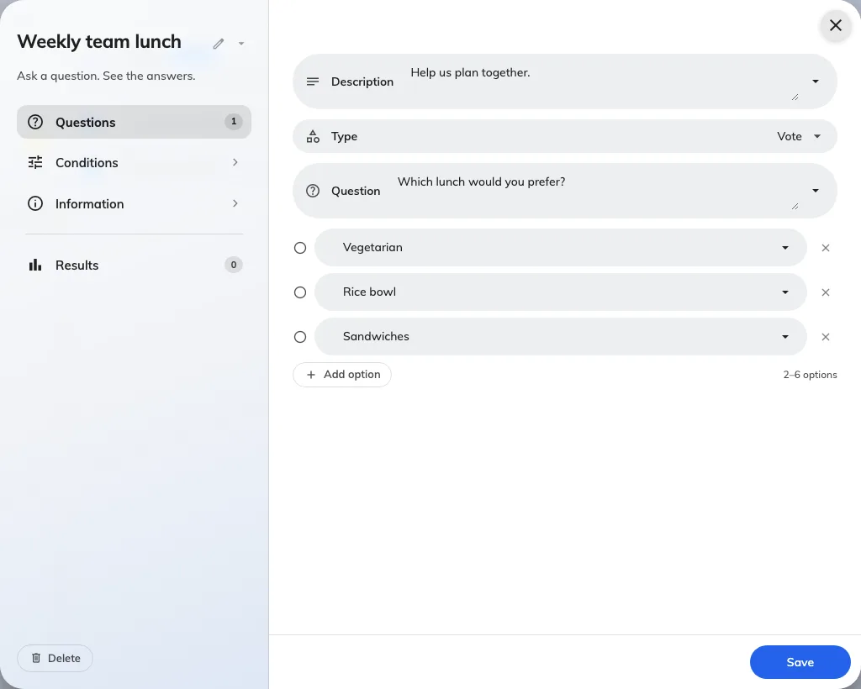
A vote has one required question and its choices.
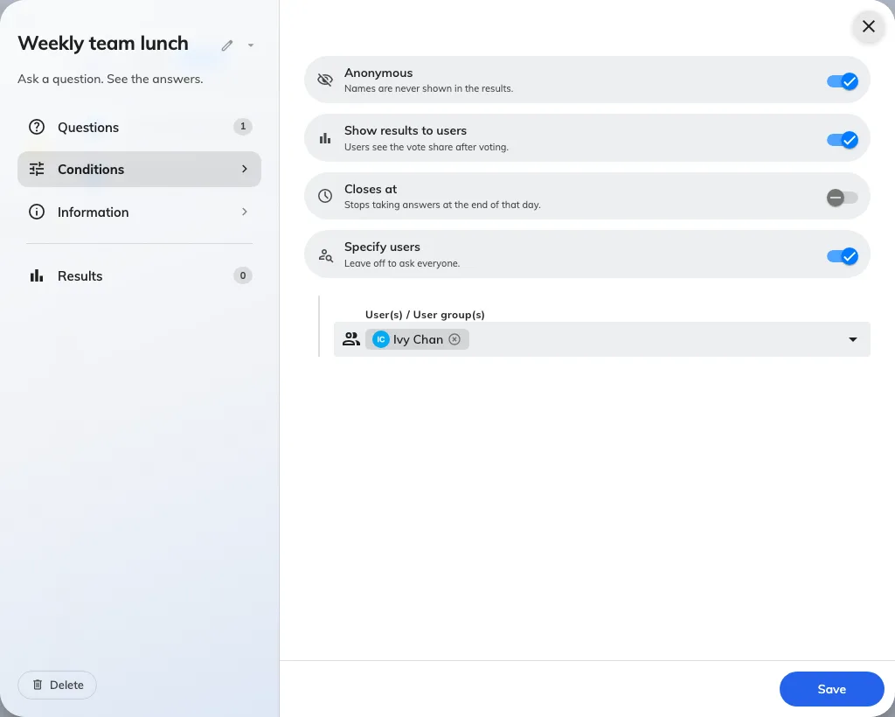
Conditions set the audience, anonymity, and closing date.

