Create a questionnaire
Collect multiple-choice, text, or rating answers and choose which questions are required.
2026-10-03 · https://offision.com/help/en/broadcast/create-a-questionnaire/
Where in Offision: admin app → broadcast/poll (Poll)
Open Broadcast → Poll, add an entry, and select Questionnaire.
- Enter and translate the title and description.
- Add 1–50 questions. Choose single choice, multiple choice, text, or rating. Choice questions need 2–20 options; ratings run from 1 to 5.
- Mark the questions required or optional, order them, and translate the questions and options.
- In Conditions, choose the audience, anonymity, and optional closing date.
- Save and check the questionnaire on the targeted employee's Home. They answer one question at a time before submitting.
Text answers accept up to 2,000 characters. After the first response, you cannot change the questions, type, or anonymity. Questionnaire results are for administrators; the vote-only employee result switch does not apply. Read results.
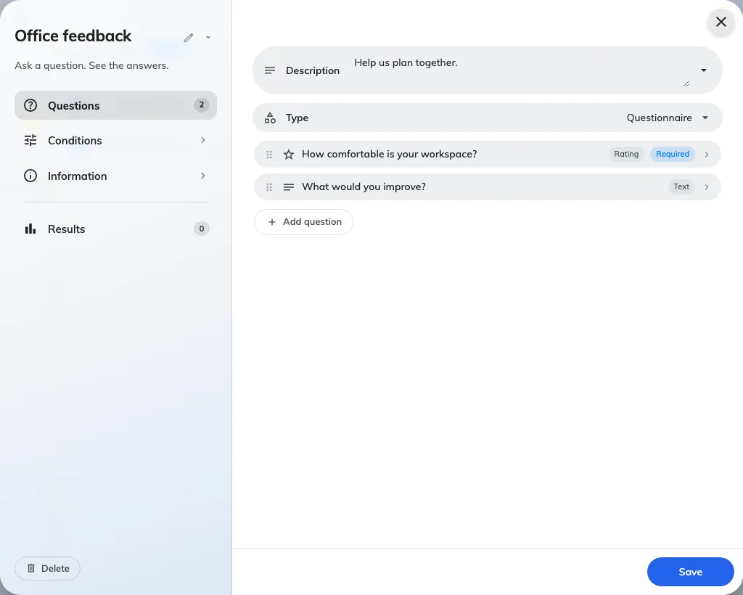
Questionnaire questions can use different answer types.

