Announcement settings reference
Every field in the Add and Edit announcement dialog, and every column in the announcement list — what each one does, and when it is worth changing.
2026-08-18 · https://offision.com/help/en/broadcast/announcement-form-reference/
The dialog behind Broadcast › Announcements › Add, field by field. It has
the same two pages when you add and when you edit, plus an Information page on
an existing announcement.
Where in Offision: admin app → broadcast/announce/announcement (Announcements)

Content
Field | What it does | When to change it
Always on top | Sorts this announcement above the others everywhere they are listed — the app's home screen, the notification list, a board. Adds a pinned badge in the admin list. | For a notice that must outrank the rest while it is up. Worth nothing if every announcement has it.
AI writer | Drafts the announcement body from a short instruction and replaces whatever is in the box. Only present when the feature is available to your organisation. | When you know what to say but not how to word it. Always read the result — the first line becomes the heading everywhere.
Announcement | The notice itself: rich text, with bold, italic, lists and links. There is no separate title — the first line is promoted to the heading wherever the notice is shown small. | Always. Put the point in the first line.

Text colour and size are deliberately not offered. A notice is rendered at half a
dozen sizes on screens you cannot see, and hand-set colours are the first thing to
become unreadable on a dark board.

Conditions
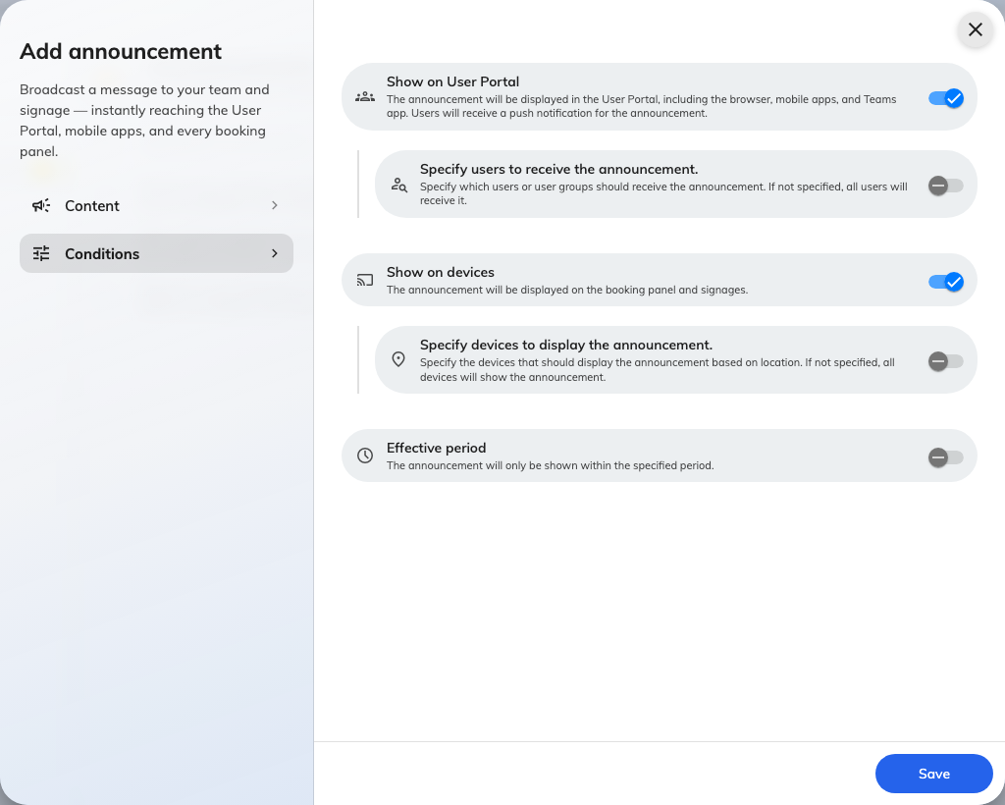
Conditions: two independent audiences, then the period.
Field | What it does | When to change it
Show on User Portal | Puts the notice in the Offision app — browser, mobile and Teams — and notifies the people it targets, once. | Off for a notice meant only for the screens, such as a lobby greeting.
Specify users to receive the announcement | Narrows the app audience to the users and groups you name below. Off means every account, not none. | On whenever the notice concerns one department, floor team or role.
User(s) / User group(s) | The named recipients. Groups are resolved to their members at the moment the notice goes out. | —
Show on devices | Puts the notice on booking panels and signage boards. | Off for anything you would not want a visitor in the lobby to read.
Specify devices to display the announcement | Narrows the screens to the floors and buildings you name below. Off means every screen. | On whenever the notice is about one building or one floor.
Floor / Building | The places whose screens show it. A screen is selected by where it is, which comes from the device, not from here. | —
Effective period | Bounds when the notice is visible. | On for anything about a particular day. Set both ends — with one end missing the notice is shown for good.

The two audiences do not constrain each other:
Targeting users and floors does not mean "these users, on these floors". The app
half is filtered by account; the screen half is filtered by place, and a screen shows
the notice to whoever walks past it. Confidential notices need Show on devices
off.

Information
Present when editing, and read-only: who created the announcement and when, who last
changed it and when. It is the audit trail for a notice somebody is asking about.

The announcement list
The list opens with four columns; everything else is opt-in from Sorting /
Columns. Sorted by creation order, newest first.
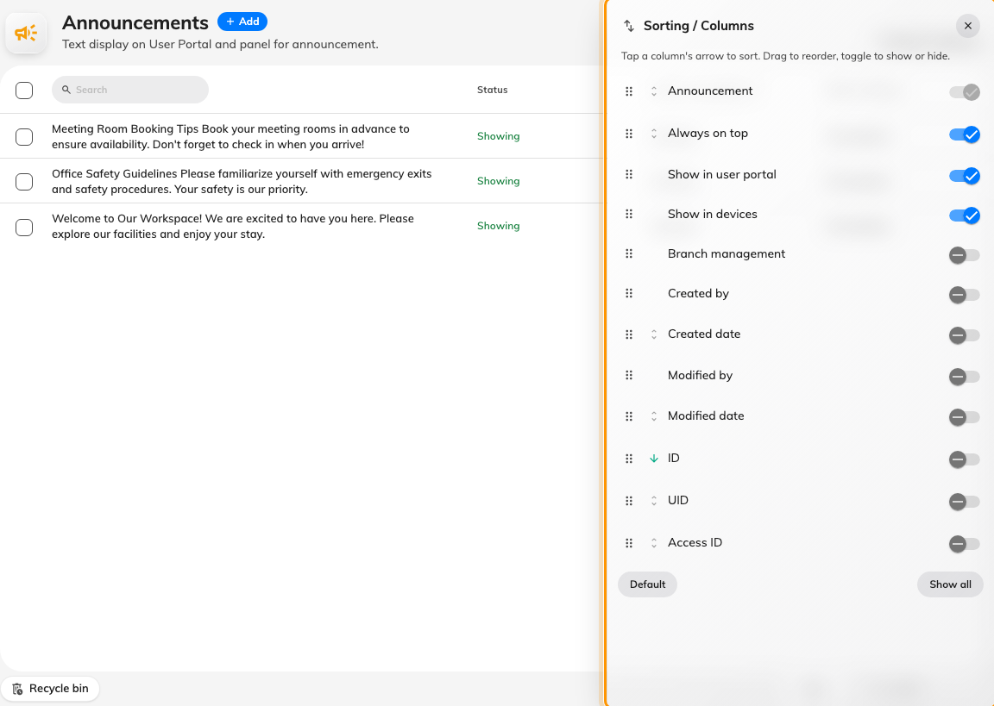
Sorting / Columns, where the audit and identifier columns are turned on.
Column | Shows | Shown by default
Announcement | The notice as plain text, clamped to three lines. Always present and always first. | Yes
Status | A pinned badge when Always on top is set, then one of Showing, Upcoming or Passed, then the period itself. An announcement with no end date always reads Showing. The Sorting / Columns menu lists this column as Always on top. | Yes
Show in user portal | Who the notice goes to in the app — the named users and groups, or everybody. Doubles as a filter. | Yes
Show in devices | Which screens show it — the named floors and buildings, or all of them. Doubles as a filter. | Yes
Branch management | The organisation unit the announcement is filed under. | No
Created by / Created date | Who posted it, and when. | No
Modified by / Modified date | Who last edited it, and when. Useful when a notice on screen does not match what somebody remembers writing. | No
ID / UID / Access ID | The announcement's identifiers, for support and for the external API. | No

Deleting an announcement moves it to the recycle bin rather than destroying it, so a
notice removed by mistake can be restored from the deleted view.

What this does not control
- When the notice is sent. There is no send time. The effective period's start
is when it becomes visible and when the notification goes out.
- Where a screen is. Floors and buildings here select screens by location; the
location itself is a property of the device, in Devices.
- Who may post an announcement. That is a permission, in
Directory.
- Whether anyone read it. A reader can mark their own copy read; nothing
aggregates that.

