Which report answers which question
A map from the question you are asking — how busy the rooms are, who never turns up, which department books the most — to the one analytics page that answers it, with what each page filters by and what it exports.
2026-09-02 · https://offision.com/help/en/booking/which-report-answers-which-question/
Ten pages in the Booking menu look like "the report", and none of them is. Each
answers a different question, so start from the question and open the one page
built for it. Dashboard is the front door; the rest sit under Analytics
and Logs, except Email report, which lives under Settings.
Where in Offision: admin app → booking/dashboard (Dashboard)
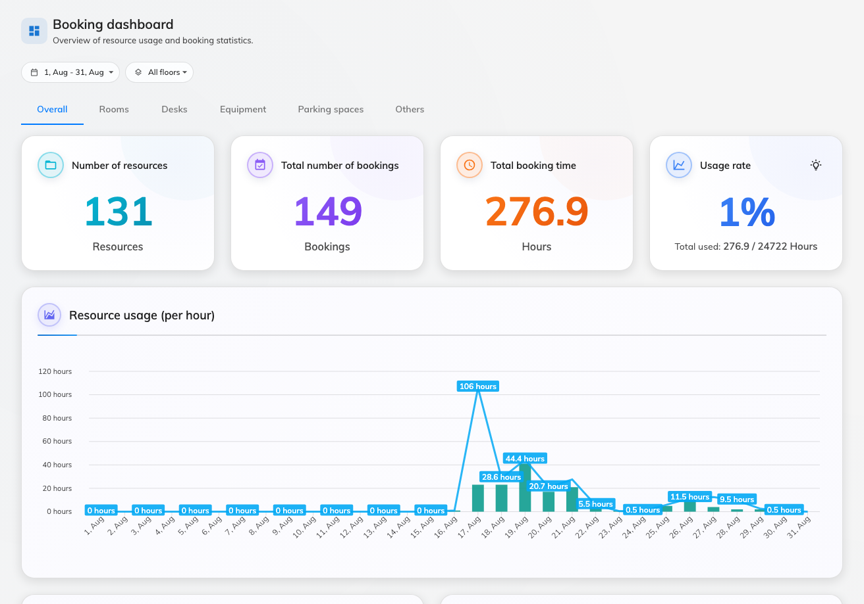
Dashboard — four numbers, then the charts.
The question you have | Open | What it gives you
How is the estate doing right now, on one screen? | Dashboard | Four numbers — resources, bookings, booked time, usage rate — and four charts. Date range, floors, resource-type tabs. No export.
Which floor or room should we add or retire? | Resource usage analytics | A floor-plan heat view, a usage trend, resource ranking, top users and peak hours. Each ranking card has its own Export to Excel.
Who books rooms and never turns up? | No show analytics | No-show rate, user and resource no-show rankings, and an events log. Export to Excel per card.
How much does each department or person use? | User resource usage | A pivot you build yourself — any two dimensions as Rows and Columns, bookings and hours as the numbers. Download as Excel.
I want to slice the same bookings every which way. | Booking analytics | Seven views of one dataset: timeline, snapshot map, usage map, daily heatmap and three tables. The tables Export to Excel.
I need a deck for management. | Reports | Nine named rates, each a page. Download full report saves them all as one PDF.
I have a one-off question. | Swift Insight | Ask in plain words — "which floor has the most bookings?" — and read the answer. No filters, no export.
Send me the numbers, I will not log in. | Email report | Not a viewer: a subscription that emails an upcoming-booking forecast daily, weekly or monthly.
Who cancelled that meeting? | Booking log | Every action on every booking, with who did it and from where. Download as Excel.
Why has this person run out of quota? | Quota usage history | One row per deduction — who, which booking, how much. Download as Excel.

Visiting, Ticketing and Service each have a Dashboard of the same shape at
the top of their own menu — numbers, then charts — and, like this one, none of
them exports. The visitor side has
a report map of its own.

How the filters differ
A date range is on every page except Swift Insight, and it is the first thing
to check when a number looks wrong. Where the pages differ is the second filter.
Most booking pages filter by Floors; the Visiting dashboard filters by
Buildings, because a visitor belongs to a building rather than a floor.
Dashboard, Resource usage analytics and No show analytics add a
resource-type strip — Overall, Rooms, Desks, Equipment and so on.
Resource usage analytics is the exception worth knowing. Its floor picker is
a control over the map rather than a filter on the page: the ranking, the trend,
the top users and the peak hours underneath it are the whole estate whatever
floor is showing. It also carries a Business hours / 24 × 7 switch that no
other page here has, and that switch is remembered across the rate reports.

What none of them show
- Live status. Every page here is history. Whether a room is free this
minute is the calendar and the floor-plan map, not a report.
- Bookings that have not finished. A no-show is only counted once its
check-in deadline has passed — see
What counts as a no-show. The same rule means
today's usage rate is always lower in the morning than it will be at five.
- The whole export in one go. The Excel buttons export the card or table
they sit on; the full picture in one file is the Reports PDF.

