Which form a booking uses
A booking form is composed from the built-in fields plus your own, and a site runs several. Three routes decide which one a given booking gets, which is why a form can change halfway through and take a filled-in answer with it.
2026-09-01 · https://offision.com/help/en/booking/which-form-a-booking-uses/
A booking form can change while somebody is filling it in. They open it, answer
a question, pick a room — and the question is gone. Nothing has broken: the form
they started on was not the room's form, and the moment the room was chosen it
was replaced.
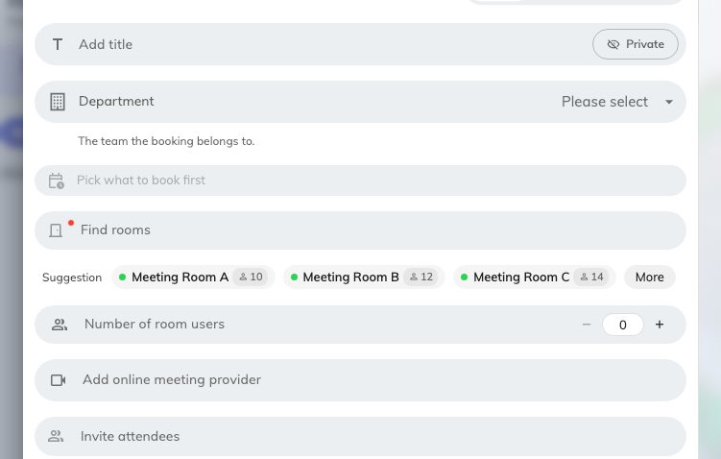
Before a room is picked: the questions come from the default display form.
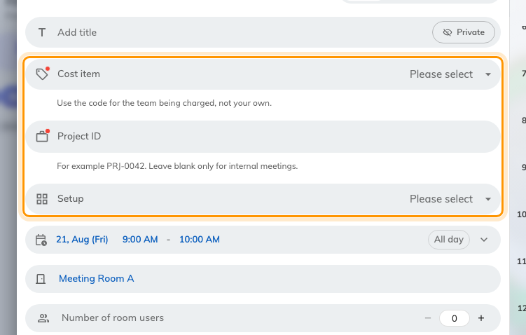
After: the room's own form has taken over, and it asks different questions.

A form is something you compose
Start from the built-in fields, switch off the ones your organisation never
asks, drag the rest into the order you want, rename the ones whose wording does
not fit, and add fields of your own.
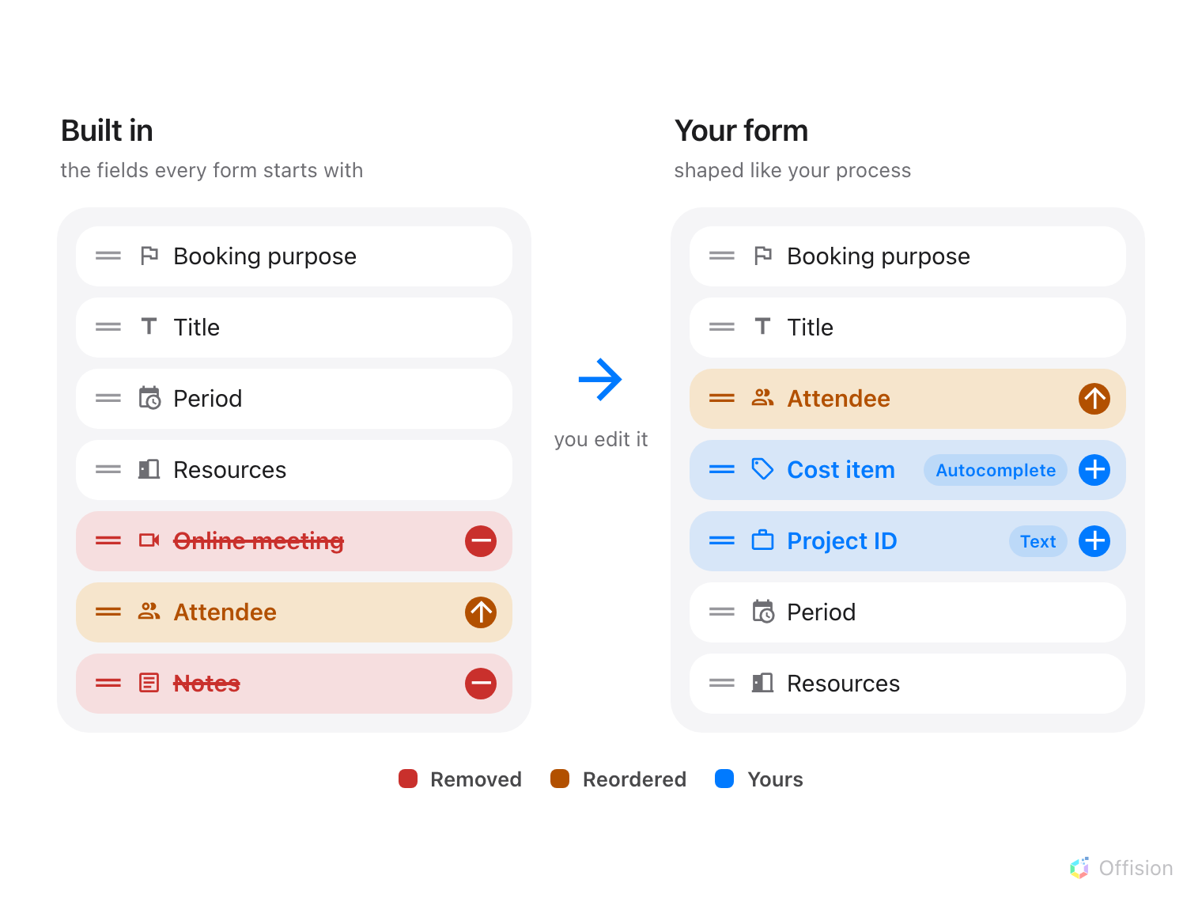
Drop the fields you do not ask for, move the ones that matter to the top, and add your own.
A form is then assigned to resources, and a site can have as many forms as it
has kinds of space — one for chargeable meeting rooms, one for hot desks, one for
everything else. Every field on each of them is documented in the
form fields reference.
Where in Offision: admin app → booking/booking-form (Booking form)

Three routes, tried in order
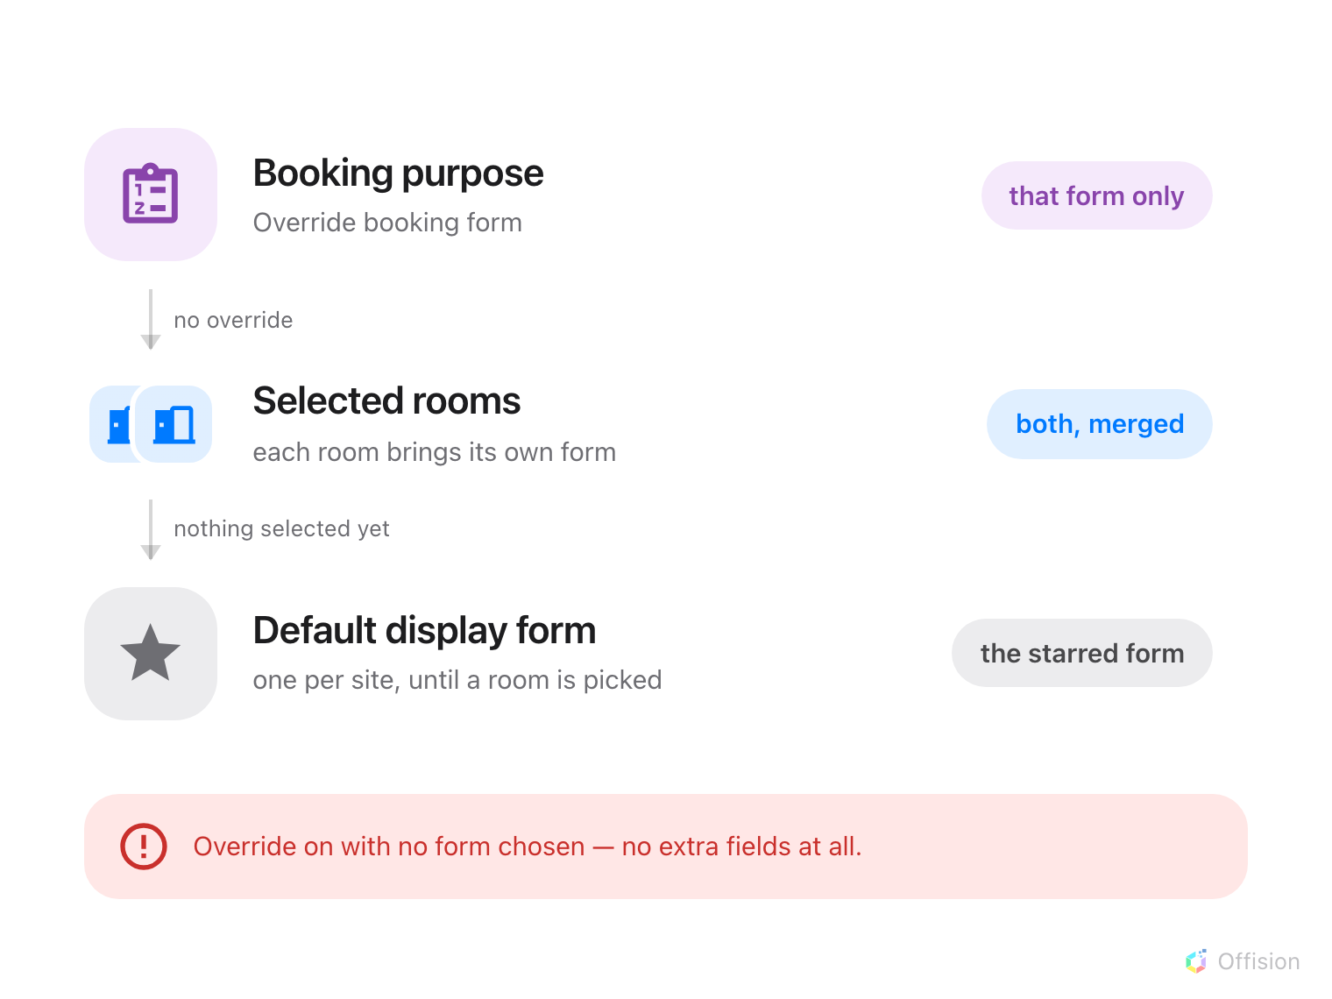
A booking purpose override wins outright; otherwise the selected resources decide; otherwise the default display form.
A booking purpose carrying Override booking form wins outright. That form
replaces everything else, and it is set on the purpose rather than on the form.
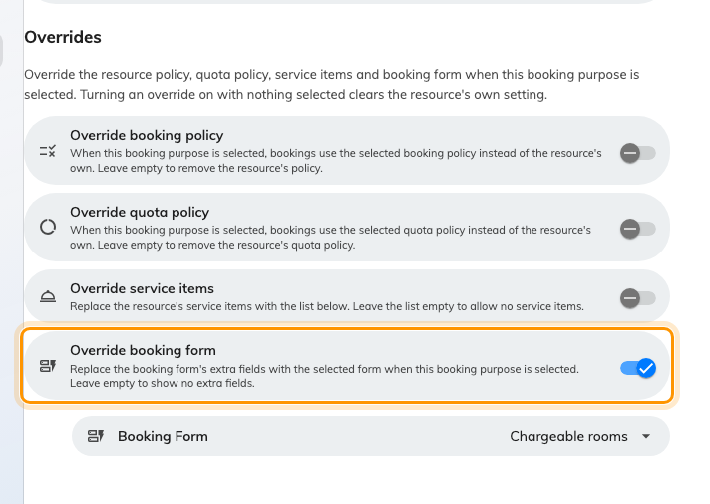
A booking purpose, with Override booking form turned on.
Note:
Turn the override on and choose no form, and the booking gets no fields of your
own at all. The resources' forms do not step back in, and neither does the
default display form.
Otherwise the selected resources decide. Selecting several merges their forms
rather than picking the strictest, so a booking spanning a room and a parking
space asks everything either of them asks, each question once.
Otherwise the default display form. At most one form per site can hold it,
and it is what somebody sees before they have picked anything. That is the
switch behind the two screenshots at the top of this page — and the reason an
answer already typed in can vanish.
Where in Offision: admin app → booking/booking-purpose (Booking purpose setting)

What this does not control
- Who may book at all. Team spaces and resource policies decide that — see
the booking rules reference. Nothing
here changes who can reach a resource.
- Whether approval is needed. That is the resource policy, not the form.
- Whether the Host field appears. Also the resource policy: the form only
carries that field's name.
- What a panel or signage shows as the booking's title. A field can be
promoted into the panel title, but that is set on the player configuration.
- How the form looks. Which fields it has is decided here; how much of a
room's own description prints beside them is a separate setting per form — see
Show a room's description on the booking form.
- Visitor forms. Visiting has its own form builder on its own screen, and the
two never share fields or data sets.

