What Offision emails when someone books
One booking sends two different messages to two different sets of people, and the calendar invitation that rides with them is usually not a file you can click — which is why it gets reported missing when it is not.
2026-08-25 · https://offision.com/help/en/booking/what-offision-emails-when-someone-books/
One booking sends two different messages. The person who booked gets a
confirmation; everybody they invited gets an invitation. They are not the same
mail, they do not say the same thing, and only one of them is addressed to
somebody who already knows about the meeting.
Mail | Goes to | Sent when
Booking created | the organiser | they book
Booking confirmed | the organiser | they book, where the resource needs approving — this one instead of Booking created
Meeting invitation | each attendee | they are invited
Booking edited | the organiser | anything about the booking changes
Meeting updated | each attendee | the booking changes under them
Booking deleted | the organiser | the booking is cancelled
Meeting cancelled | each attendee | the booking is cancelled, or they are dropped from it

Editing sorts the attendees rather than mailing them all the same thing: somebody
added to an existing booking gets Meeting invitation, not Meeting updated,
and somebody removed gets Meeting cancelled.

The invitation is usually not a file
This is the part that generates reports, so it is worth being exact about. The
calendar invitation always travels with these messages. Whether it arrives as
something you can see depends on how your Offision sends mail, which is set on
Email settings:
- Sending through your own SMTP server, the invitation is built into the
message itself. Outlook and most mail apps read it and show the meeting with
Accept and Decline — there is no attachment row, and nothing to click.
- Sending through the Offision address, or through a Microsoft 365 or Exchange
connection, it arrives as a file named offision.ics alongside the message.
Both deliver the same meeting. A booking mail with no attachment on it is almost
never a mail with no invitation in it — it is the first case, working normally.
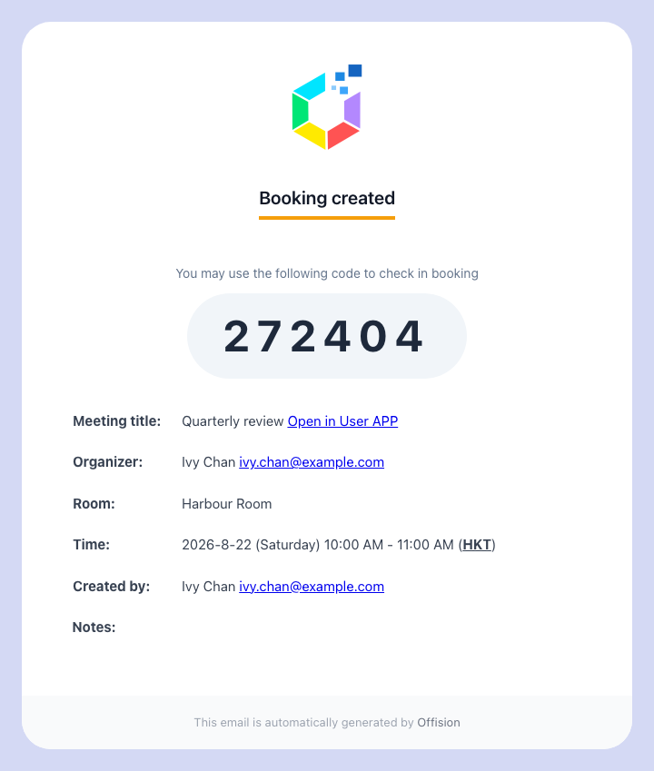
The organiser's confirmation. The invitation travels with it, visible as a file or not depending on the sender.

Rooms always carry it. Desks and equipment are asked
A room booking always carries the invitation. A desk, a piece of equipment or a
parking space carries it only where its booking policy says so — the switch is
Attach .ics data in email when booking Desk or Equipment, and it is on unless
somebody turned it off. A resource with no policy attached at all behaves as
though it were on.
It exists because a month of desk bookings arriving as calendar entries buries
everything else in somebody's week, and because a desk has no attendees to inform.

One resource can silence the whole booking
Disable booking email notifications is read across every resource in the
booking, not just the one you were thinking of. Book a room and a projector
together, and if the projector's policy has this on, the organiser and every
attendee get nothing at all — no confirmation, no invitation, no cancellation.
The room's own policy does not overrule it.
That is the first thing to check when mail stops for some bookings and not
others. Choose which booking emails go out
is where the switch lives.

Getting the invitation again
Nobody has to keep the mail. Open the booking in the app, choose the ⋯ menu
on it and pick Download ICS: the invitation comes down as a file to open into
whichever calendar you use. Booking managers have the same item on the
management calendar.
Accepting the invitation does not book anything:
The invitation is a copy of a booking that already exists. Accepting it puts the
meeting in a personal calendar; declining it does not release the room, and
deleting it does not cancel anything. The booking is cancelled in Offision or not
at all.

What this does not control
- The wording. Subjects and body text are set once for the whole site — see
Change the wording of an Offision email.
- Who it comes from. The sender address, and therefore the attachment
behaviour above, is
Send email from your own address.
- Reminders. The mail that arrives before a booking starts, or when it is
about to be released, is a separate set of switches on the booking settings
page, not on any policy.
- The forecast digest. A scheduled summary for managers is its own
subscription — see Email your managers a forecast of upcoming bookings.
- An integrated room's own invitation. Where a booking is made through
Microsoft 365 or Google, that calendar sends its own invitation on its own
terms; the mail above is in addition to it, not instead of it.

