What a booking's status means
Twelve statuses: seven on the line a booking walks and five it can end at instead, the colour each one is drawn in, the three stops that are skipped unless the room asks for them, and the three that are the same slate.
2026-08-18 · https://offision.com/help/en/booking/what-a-booking-status-means/
A booking's status says where it has got to between being asked for and being
over. It is the word on the chip in every calendar and list, and it is what the
Booking status filter narrows by.
Nobody sets it. Offision works it out from the booking's own facts — whether the
room has answered, whether the room needs approving, whether the check-in window
has opened, whether anybody arrived — and works it out again each time one of
those changes. There is no control that makes a booking say something else, and
checking in can take a moment to show for the same reason.
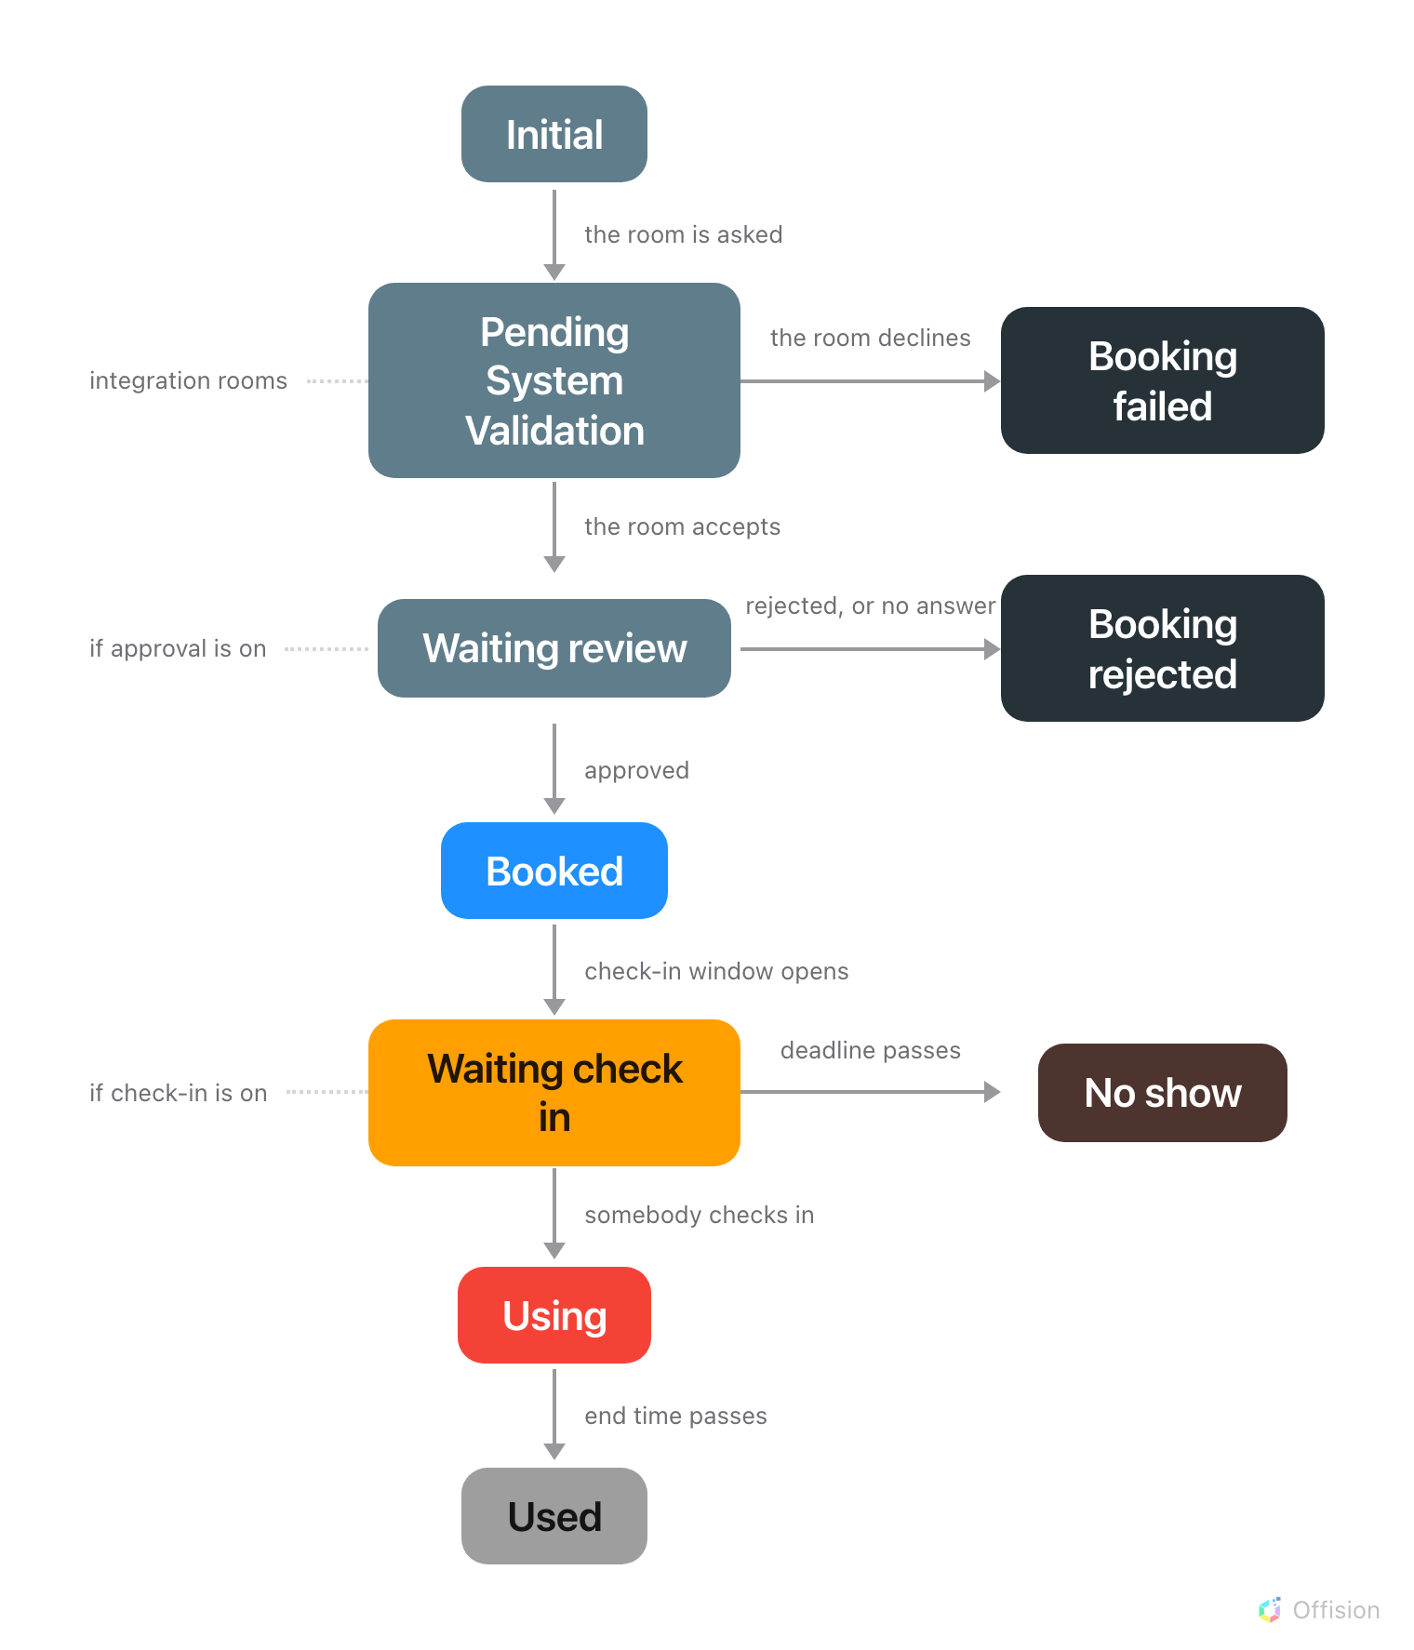
A booking walks one line to the bottom. The dotted tags down the left say which stops are skipped unless the room asks for them; only a refusal — or nobody arriving — leaves the line to the right.

The seven on the line
Three of these are skipped unless the room asks for them. The Appears
column is what decides whether a booking ever shows that word at all.
The chip says | Colour | Appears | What it means
Initial | slate | always | Saved, and no room has answered yet
Pending System Validation | slate | integration rooms | A room has been asked, and has not answered yet
Waiting review | slate | if approval is on | Sent to an approver, and not decided yet
Booked | blue | always | Confirmed. Nothing to do until it starts
Waiting check in | amber | if check-in is on | It has started, and nobody has checked in
Using | red | always | Somebody checked in — or the room never asked
Used | grey | always | The end time passed. The ordinary end of a booking

The employee app draws one of them differently: what the admin console calls
Using, the app's own calendar and its status filter call In use. Same
status, same red.
Three of the seven are skipped, and none of them is skipped by the person
booking:
- Pending System Validation appears only on a room whose calendar lives
somewhere else — one synced from Microsoft 365 or Google Workspace. A room
Offision owns outright has nothing to wait for.
- Waiting review appears only where the resource policy asks for approval.
Without it, a booking goes from Initial straight to Booked — see
Require approval before a room is booked.
- Waiting check in appears only where the resource policy requires
check-in. Without it, a booking turns Using at its start time and can
never be a No show — see
How check-in and no-show work.
A booking on an ordinary room with neither setting on therefore only ever shows
four words: Initial, Booked, Using, Used.
A booking can also go backwards. On a room that needs approving, editing a
confirmed booking can send it back to Waiting review — see
Edit a booking.

The five it can end at instead
The chip says | Colour | What happened
No show | brown | The check-in deadline passed unattended, and the room went back
Booking rejected | near-black | An approver said no
Timeout | near-black | Nobody answered the request in time
Booking failed | near-black | The room's own calendar refused it
External calendar rejected | near-black | The room's calendar refused it, and Offision found out late

No show is the only one of the five that is not a refusal — the booking was
fine, nobody came. The other four all mean somebody or something said no, which
is why they are drawn the same near-black.

Waiting for the room to answer
Initial and Pending System Validation are the gap between pressing save
and the room answering. On an ordinary room the gap is too short to see; on an
integration room it is the whole point of the two words.
- Initial — the booking is saved and no room has answered yet.
- Pending System Validation — a room has been asked and has not replied.
A room synced from Microsoft 365 or Google Workspace answers over that
connection, and until it does, the booking is not confirmed. Nothing is wrong
for the first few seconds, and nothing you can press makes it go faster. Both
are ordinary statuses in every other way: the booking can still be edited or
cancelled while it sits there.
A booking that has sat in either for longer than a few minutes is a sync
problem, not a booking problem. Offision retries them on its own, and a room
that answers no ends at Booking failed rather than staying put — so a
booking still showing one of these the next day is worth raising with whoever
looks after the calendar connection.
You cannot filter for these two:
The Booking status filter has no entry for Initial or Pending System
Validation — they stay visible whichever statuses you pick, so a booking
waiting on a room never disappears from a filtered calendar.

Three of them are the same slate
Initial, Pending System Validation and Waiting review are drawn in
exactly the same colour, and Used and the four near-black refusals are
neutrals too. At a glance down a month, most of the statuses are grey-ish and
three of them are identical. The word is what separates them, not the colour — so filter
rather than scan when you are looking for requests still waiting.
The two that want attention are the ones with colour in them: amber is a room
being held for somebody who has not turned up, blue is a booking nothing needs
doing about. Using is red because the room is occupied, not because anything
has gone wrong.
Blue and grey mean the opposite on a panel:
On a booking, blue means confirmed and grey means finished. On the panel by the
door, blue means the room is free and grey means it cannot be booked at all.
The two are separate colour systems — see
What the panel's colours mean.

What a status does not tell you
- Whether anybody is in the room. Using means a booking is running and
somebody checked in, which is not the same as somebody being there.
- Whether it was cancelled. There is no cancelled status. A cancelled
booking is removed, so it leaves the calendar rather than turning grey — and
it is never counted as a no-show. See
Cancel a booking and
What counts as a no-show.
- Who attended. Attendance is recorded per person, separately, and only on
bookings that ask for it. A booking can be Used with nobody marked present.
- What the room is doing. A room out of service, closed for the day, or
turning around between meetings has no booking status at all — that is the
room's state, and only a panel shows it.

