Two bookings overlap on the same room
The management calendar shows two blocks on one room at the same time, or somebody says their room was taken. Offision refuses a real overlap at every door, so this is one of six things that look like one — a pending request that never held the slot, a combined-room mirror block, a warning-only closure, a no-show that freed the room, or preparation time.
2026-08-26 · https://offision.com/help/en/booking/two-bookings-overlap-on-the-same-room/
Is the second block a booking at all?:
Click it. A booking opens its details, with an organizer and a status. A grey
hatched block labelled Split or Combined, a band across the whole day,
or a thin block hanging off the front of a meeting is not a second booking — it
is a mirror of one, a closure, or preparation time, and solutions 3, 4 and 6
are where to look.
Every way a booking is made — the app, a panel, the management calendar, a
spreadsheet, a calendar invitation — runs the same check, and a booking that
overlaps a standing one is refused with This time slot conflicts with another
booking. So two blocks on one room are never two confirmed bookings fighting
for it. They are one of the six things below, in the order they come up.
Where in Offision: admin app → booking/calendar (Management calendar)
Solution 1 — Both bookings are waiting for approval, and the policy does not hold the slot (most common)
A booking policy offers two approval settings that read almost the same.
Require booking approval puts a request in the queue and leaves the slot
open — any number of people can ask for the same hour, and the calendar draws
every request. Require booking approval (Time slot will be hold before
approve) holds the slot from the first request; its status shows as Waiting
review (Reserved) and a second request is refused.
Under the first setting, two pending requests on one slot are working as
designed. The approver sees it: the approval dialog has a Conflict bookings
section — Select which bookings to reject or keep as pending — listing the
other requests for the same time. Approve one, and the others must be rejected;
approving a second one fails with This time slot conflicts with another
booking.
If the queue is confusing people, switch the policy to the holding variant, and
the second requester is told at once instead of days later. See
Require approval before a room is booked.
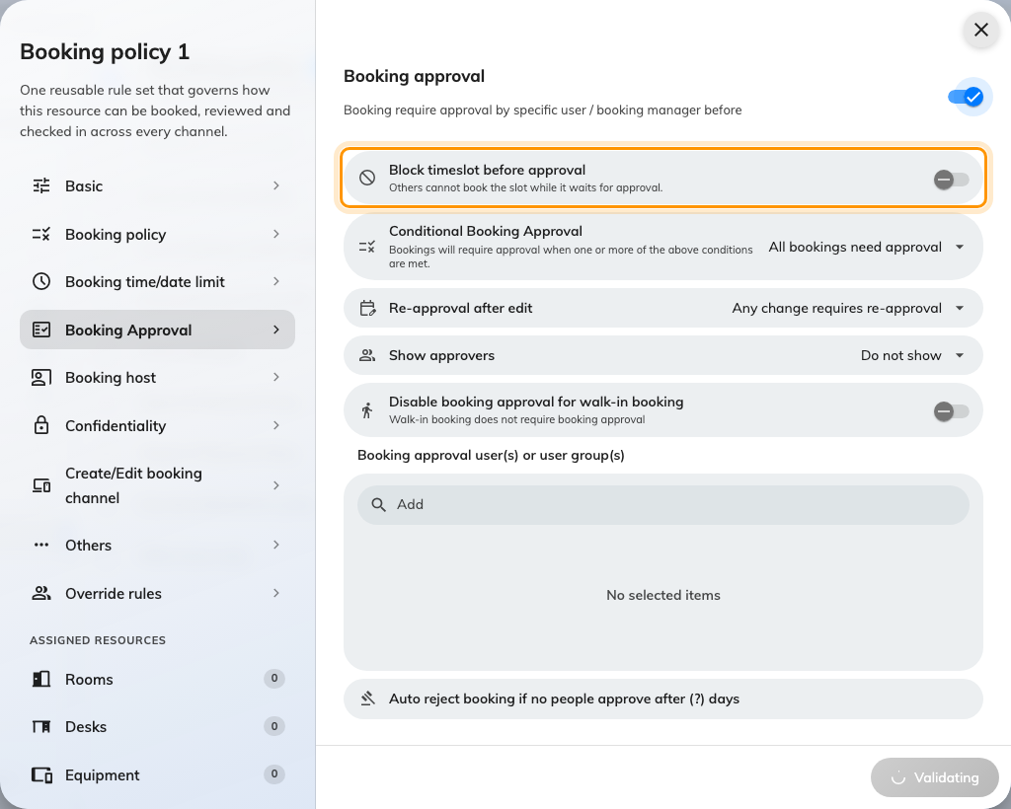
The policy's Approval page: the holding variant is the switch under Require booking approval.
Solution 2 — The calendar draws more than the booking check counts (common)
The management calendar shows every booking that is still alive, including
requests waiting for approval and meetings already over. The overlap check only
counts bookings that hold the room — confirmed, in use, waiting for check-in, or
waiting for approval under the holding policy. A pending request under the
plain approval policy is drawn but does not block, so it can sit on top of a
confirmed booking without either being wrong.
Read the status of each block before treating the pair as a fault. One of them
pending means solution 1; the resolution is the same.
Solution 3 — One of them is a combined room's mirror block (common)
Booking a combine room takes each of its parts, and booking a part takes the
combine room. The calendar shows the other side as a grey, diagonally hatched
block: Combined on a part's column when the whole room is booked, Split
on the combine room's column when a part is. Those are the same booking seen
from the other column, not a second one.
A real overlap between a part and the whole is refused like any other. See
Combine two rooms into one bookable room.
Solution 4 — An out of service period is overlapping bookings (common)
A closure is not a booking and never cancels one. Two versions of this:
- Block booking during this period was left off — a warning-only
period. The booking form warns and lets the booking through, so the
calendar shows a faint band with bookings on top of it. That is what the
switch means.
- The period was added after the bookings existed. Adding a closure emails
the organizers, where the policy says so, and does nothing else — the
bookings stay until somebody moves or cancels them.
Either way, nothing is double-booked; the room is closed and somebody has a
booking inside the closure. Take a room out of service
covers both switches.
Solution 5 — A no-show or an early check-out freed the room, and a screen has not caught up (less common)
When a booking is released for no-show, or the organizer checks out early, its
end is cut to that moment and the rest of the slot becomes bookable at once.
Somebody books it, and the room now genuinely has two bookings back to back —
the truncated one and the new one.
A panel, an Outlook calendar or a browser tab that has not refreshed still
shows the original block at full length, and that is the classic "someone took
my room while I was in it" report. Open the first booking: its end time is the
release moment, not the time it was booked for. See
How check-in and no-show work.
Solution 6 — The second block is service preparation time (rare)
A service item with a preparation time — catering laid out before the meeting,
a room reset after it — is drawn on the calendar as its own block beside the
meeting it belongs to. It is checked separately, and a booking that runs into
it is refused with Preparation time conflict with other booking rather than
the message above. Different words, different cause: adjust the preparation
time on the service item, or move the meeting.

What never causes it
- A spreadsheet import never books over an existing booking. Rows that
conflict are left behind by Skip conflicts & book and handed back in a
failed-rows sheet with the reason — the import did not "make a mess", it
skipped.
- The Microsoft 365 or Google sync matches an invitation to the booking it
already made and updates it; it does not create a twin. An invitation that
conflicts is declined by the room mailbox, with the conflicts listed in the
reply.
- Dragging a booking on the management calendar has no override — it runs
the same check, and refuses.
Before you open a ticket:
Collect the status of both blocks as the calendar shows them, the
booking policy's approval setting for the room, whether either block is
hatched or labelled Split or Combined, and — for the first booking — its
end time as it is now against the time it was booked for. Those four
separate every cause above.

