Trace what happened to a booking
Every create, edit, check-in and cancellation a booking has ever had, on one screen. Ask the caller for the booking reference, paste it in, read the trail, and download it as a spreadsheet. About five minutes.
2026-08-18 · https://offision.com/help/en/booking/trace-what-happened-to-a-booking/
Somebody's meeting moved and nobody admits to moving it. The booking log is
where that gets settled: every create, edit, check-in, extension and
cancellation a booking has ever had, each one stamped with who did it and which
part of Offision they did it from.
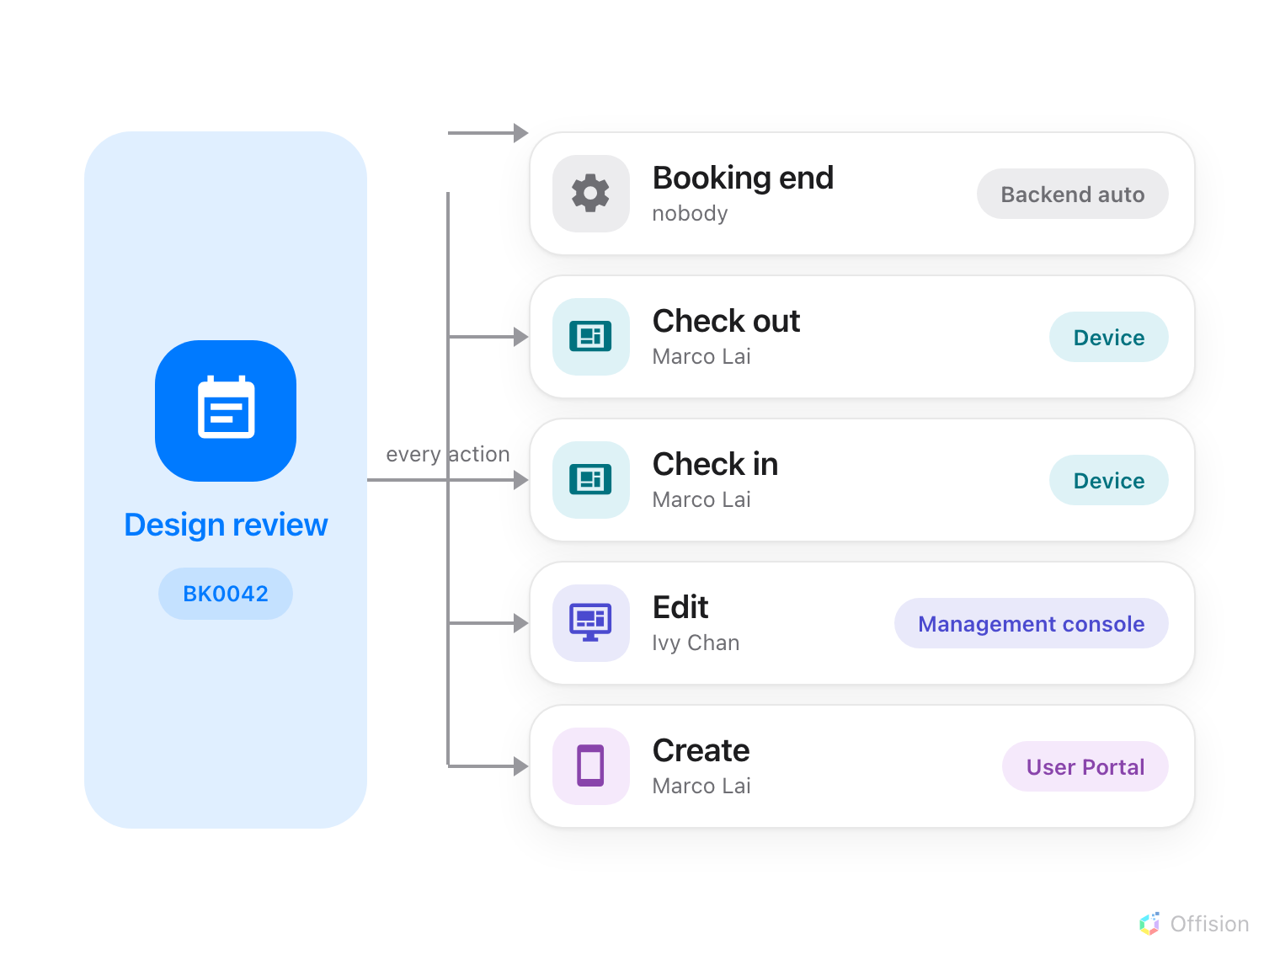
One booking reference gathers every action, wherever it came from — a person in the app, an administrator in the console, a room panel, or Offision itself.
Before you start:
You need Booking manager read permission.

1. Open the booking log
In the Booking module the log sits in the list down the left — but it is not
one of the pinned entries, so choose Show more before Booking log
appears.
Where in Offision: admin app → booking/log (Booking log)
It opens on the whole estate, newest action first, with no date filter applied.
That first view is everything Offision has ever recorded about every booking, so
it is not somewhere to browse — it is somewhere to look one thing up.
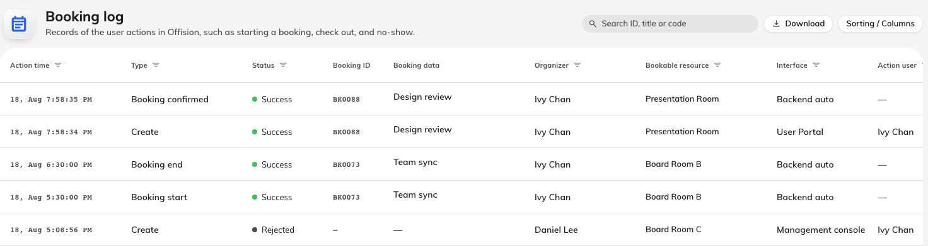
The log at rest: one row per thing that happened, newest at the top.

2. Ask for the booking reference
Every booking carries a reference: BK followed by its number, padded to four
digits — BK0042. It is fixed for the life of the booking, and past 9999 it
simply runs longer. Nothing ever renumbers.
The reference matters because the person who booked can see it too. It is a
row near the bottom of their booking's details in the Offision app, under
Booking ID. So the first question to ask a caller is not "which meeting?" —
it is "what does the booking ID say?". That one string replaces a conversation
about which Tuesday and which big room, and it is the only handle that still
works after the booking has been deleted.
It is the organiser's copy that carries it. Open a colleague's booking and
the app shows a short card with the room and the organiser and no reference, so
ask the person who made the booking, not whoever forwarded you the invitation.
A repeating booking has one reference for the series:
Every occurrence of a repeating booking shows the series' reference, not one
of its own. So BK0042 from a caller means the whole series, and searching it
returns the series and its individual dates as separate choices — pick whichever
one the question is about.

3. Find the booking
The search box at the top right is labelled Search ID, title or code, which
undersells it. Three different things go in, and it works out which you meant:
What you type | What it finds
BK0042, bk 42 or just 42 | The booking with that reference
42 | Also a booking whose check-in PIN is 42
Anything else | Bookings whose title contains it

Type at least two characters and the matches appear beneath. A repeating booking
is listed as the series, with its individual dates indented under it. Choose one
and it becomes a chip in the search box: the table below is now that booking's
trail and nothing else. Clear the chip to go back to the estate.
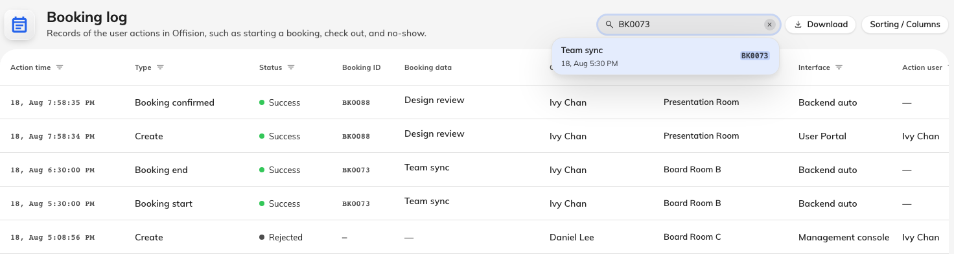
Pasting in a reference. The matching booking appears — choose it to scope the log to it.
Two things save typing:
- Clicking any reference in the table scopes the log to that booking, so you
can follow a row you noticed into its full history without going back to the
search box.
- A deleted booking still has a trail. Search its reference and it appears
marked Booking no longer exists; choose it anyway and the log shows
everything up to and including the deletion. This is usually the booking being
asked about.

4. Read the trail
One row is one thing that happened. Rows are newest first, always — no column
sorts, and that is deliberate for a log. Narrowing is done with the filters, and
every column header carries its own: a date range on Action time,
tick-lists on Type, Status and Interface, and people, resource and
device pickers on the rest.
Four columns carry most answers:
- Action time, to the second — enough to put two near-simultaneous changes in
order.
- Type — what was done. Create, Edit, Delete, Check in,
Check out, Extend, Approved / Rejected.
- Status — how it ended. Success carries a green dot and Error a red
one; Rejected and Running carry a neutral one. Rejected is the case
worth reading: somebody tried and a rule said no. Which rule is in
Description.
- Interface — where the action came from, and the column that usually settles
the argument.
Interface | The action came from
Management console | An administrator, in the admin console
User Portal | The person themselves, in the Offision app
Device | A room panel
Visitor APP | A visitor, on their own device
Outside Access | Somebody with no Offision account
External calendar | A Microsoft 365 or Google Workspace sync
Third party API | Another system, through the external API
Workflow | An automation you built
Backend auto | Offision itself

Backend auto is the one to know. A booking nobody touched still grows rows —
Booking start, Booking end, Mark as no show, Rejected by system,
Synchronize from external calendar. This is why a trail is nearly always
longer than anyone's memory of the booking, and why "I never touched it" and a
five-row history can both be true.
Selecting a row opens the same fields as a panel on the right, which is quicker
than widening columns when you only care about one row.
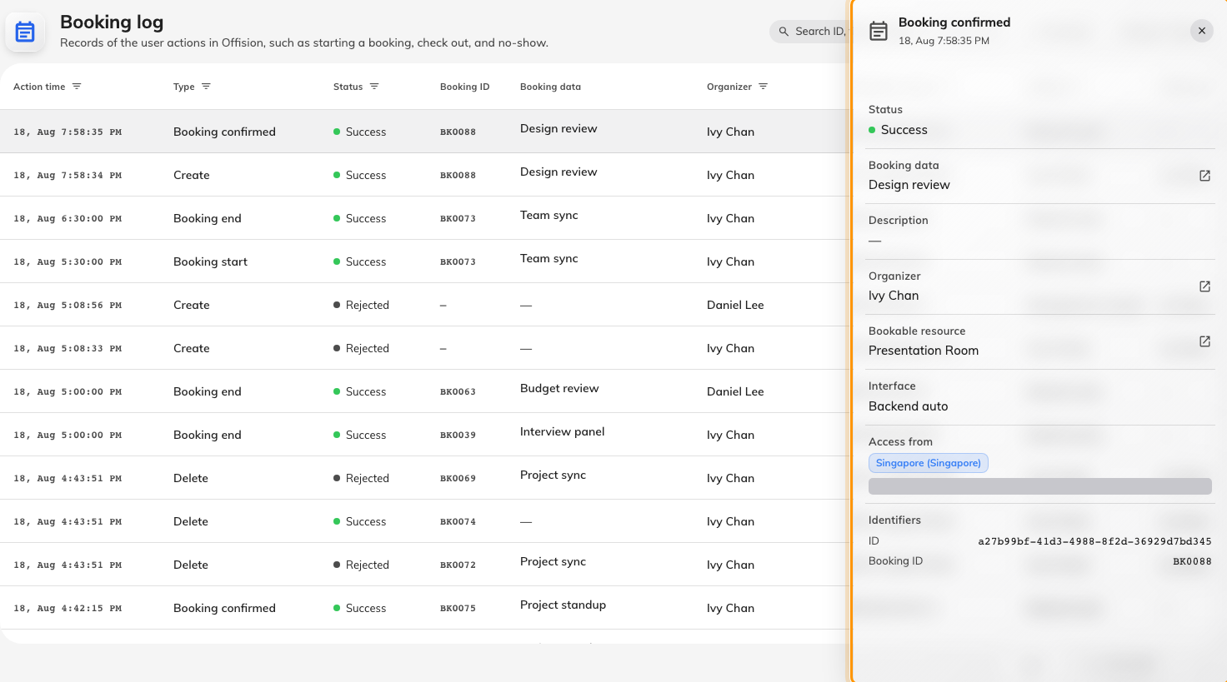
One row, read as a panel.

5. Show the columns an investigation needs
Six columns are hidden until you ask for them, under the Sorting / Columns
pill. Two of them are the ones you actually came for.
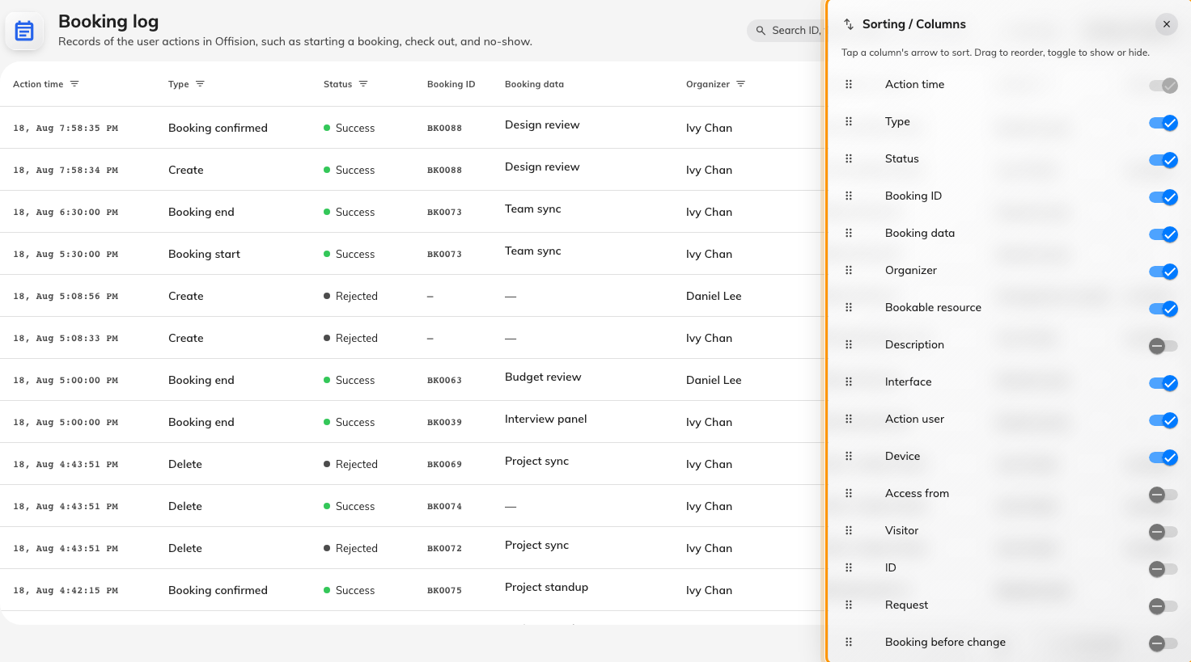
The columns chooser. Drag to reorder, tick to show.
Column | What it adds
Booking before change | The booking as it stood before this row changed it — the only way to see what an edit actually edited
Access from | The city, country and IP address the action came from
Description | The full sentence, and the rule that refused a rejected row
Visitor | Who the visitor was, when a visitor did it
Request, ID | The raw instruction and the row's own id — what support will ask for

Ticks and drag order are remembered against your account, so the layout follows
you to another machine.

6. Download it
Download opens a period picker — This week, Last month, Last 30
days and so on, or a custom range on the two-month calendar. Its confirm
button also reads Download. The file covers the dates you pick plus whatever
filters are still set, including a booking chip, so scoping to one reference
first gives you that booking's history and nothing else.
To send just a few rows instead, select them and use Download in the bar
that floats up from the bottom.
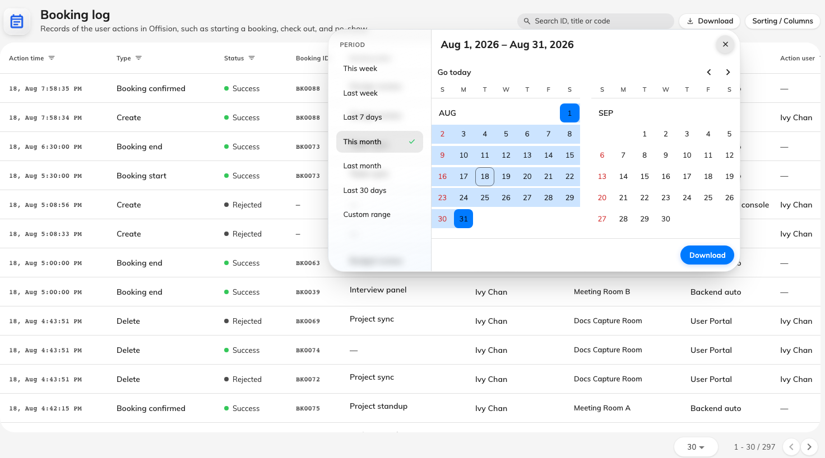
Choosing the period to download.
The spreadsheet has every column, in your order:
Hiding a column does not keep it out of the file — all sixteen are always
written. What the columns chooser decides is the order they appear in, so
drag the ones you want to read first to the top of the list before downloading.
Column headings come out in your language; Type, Status and
Interface come out as Offision's internal names, so Check in reads
CheckIn and Management console reads AdminConsole.

7. Check you have the right booking
Open the file and confirm two things. The Booking ID column should read the
same reference the caller gave you, on every row. And the oldest row — the last
one — should be a Create. If it is not, the period you chose starts after the
booking was made: clear the date range and download it again.

What the booking log does not show
- Sign-ins, passwords and user administration. Those are audit trails, kept
in system settings, not here.
- What happened to a room. The log records what happened to bookings — a
room taken out of service is not a row in it.
- Why an approval went the way it did. The decision appears as
Approved / Rejected; the approver's comment lives with the approval.
- Anything you can change. The log is read-only, and nothing in it can be
undone from this screen.

