Take a room out of service
Close a room or a desk for a fixed period — for maintenance, a repair or a private event. The period either refuses overlapping bookings outright or lets them through with a warning, and the people who already booked can be emailed about it.
2026-08-18 · https://offision.com/help/en/booking/take-a-room-out-of-service/
A room being decorated, a desk whose monitor has gone back to the supplier, a
lab handed over to a contractor for a fortnight — all the same thing to Offision:
an out of service period on the resource, with a start, an end, and a note
explaining why.
The part worth reading before you set one is that a period does not have to stop
anybody. One switch decides whether an overlapping booking is refused or merely
flagged, and the two behave very differently for the person trying to book.
Before you start:
You need booking management access, and the room or desk must already exist —
see Add a room.

1. Open the calendar and click the room's name
Where in Offision: admin app → booking/calendar (Management calendar)
Click the resource's name — the column header in the daily schedule, the row
label in the weekly and monthly ones. Not the column, the name. A card opens with
that resource's details, and its last section is Out of service period.
The button on that section says Add when the resource has none, and
Manage when it has. Either opens the same place. The section also lists the
next three periods, with a Now badge on one that is running.
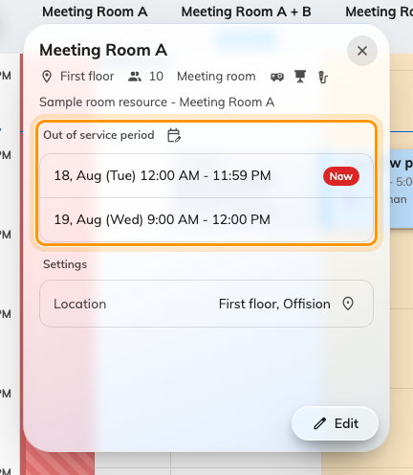
Clicking a resource's name opens its card, with Out of service period at the bottom.
Note:
The same page is reachable without the calendar: open the resource from
Rooms or Hot desks, click Edit, and pick Out of service period
from the pages down the left. Selecting a single row in the resource list also
puts an Out of service button in the header.

2. Set the period
The resource's editor opens on its Out of service period page: existing
periods on the left, the editor sliding in from the right.
Period takes a start and an end, and it may cross days — a closure from
Friday evening to Monday morning is one period, not three. All day turns the
two times into whole days.
Remarks is the line the person who runs into the closure will read, in the
booking form and on the room panel, so write it for them: Air conditioning
replacement, use Meeting Room B. Internal Remarks never leaves this screen —
it is for whoever picks the job up after you.
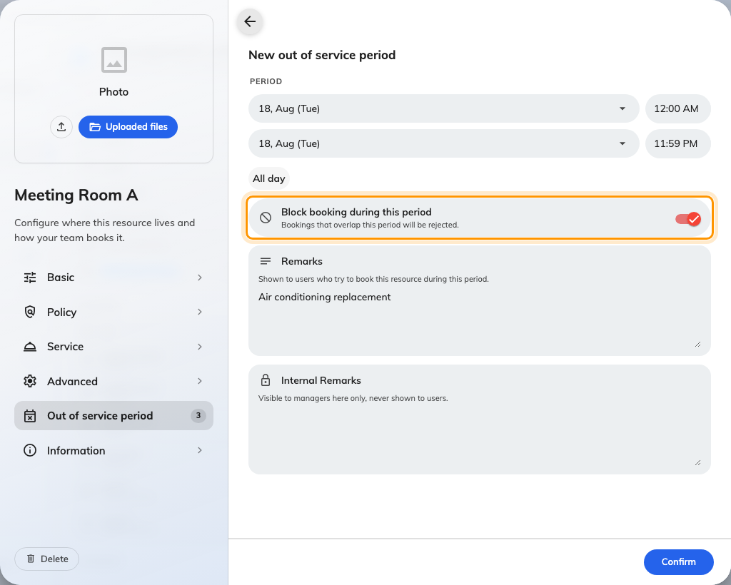
The editor, with Block booking during this period left on.

3. Decide whether it blocks bookings
Block booking during this period is on by default. It is the only choice on
this page that changes what other people can do.
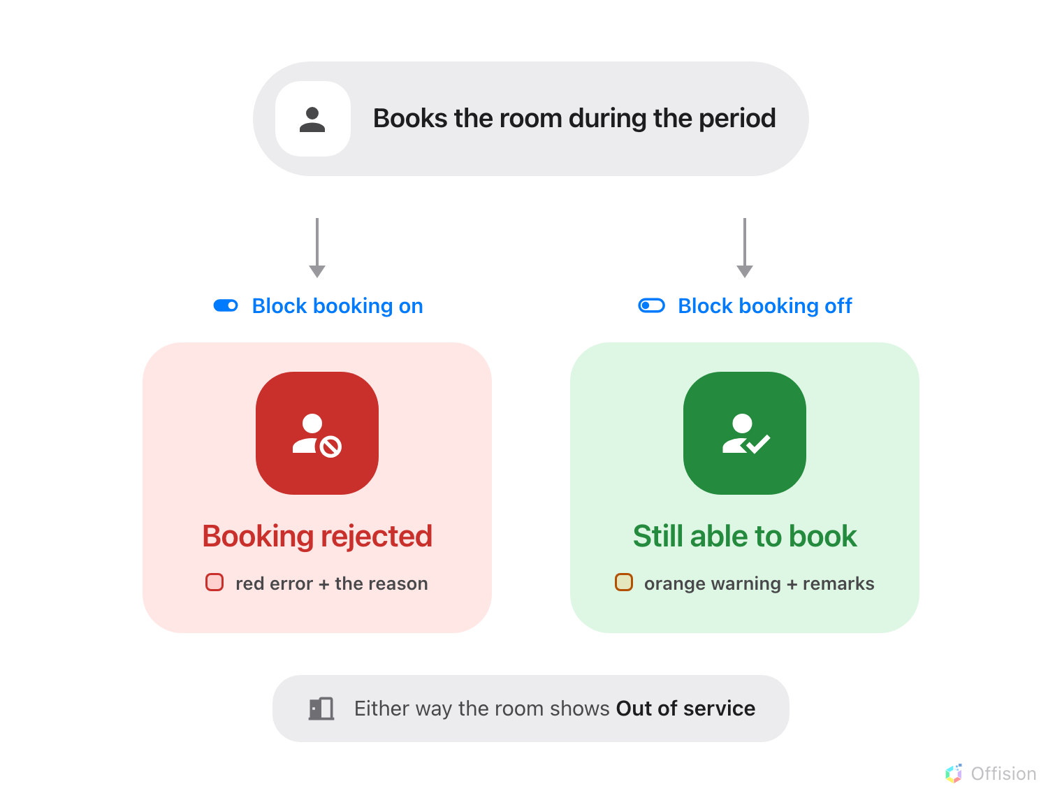
The switch decides one thing: whether the booking is rejected, or goes through anyway.

Which one to pick
 | Pick it when | For example
On — blocks booking | The room genuinely cannot be used, and a booking made anyway would be a wasted journey | The air conditioning is being replaced · the floor is up · the room is a building site · a client has the room for the day
Off — warning only | The room is still usable, or the closure might not happen at all | The projector is broken but the table is fine · a contractor is booked and may finish early · a decorator has one wall and the room seats twelve

The rule of thumb: if somebody who ignored the notice could still hold their
meeting, choose warning only. Blocking a room that is merely inconvenient
sends people hunting for another one they did not need.
On — Bookings that overlap this period will be rejected. Nobody can create
or move a booking onto the resource across those hours, from any surface.
Recurring bookings are checked occurrence by occurrence, so one bad week stops
that week and leaves the rest.
Off — Booking is still allowed but the organizer is notified that the
resource is out of service. The booking goes through, but not silently, and the
organizer is emailed once it is made. What people see below has each surface.
That notice is the entire difference between a warning-only period and no period
at all. It is what tells somebody the projector is missing before they walk in
expecting one — so the Remarks you wrote in step 2 matter more here than on a
blocking period, where nobody gets as far as reading them.
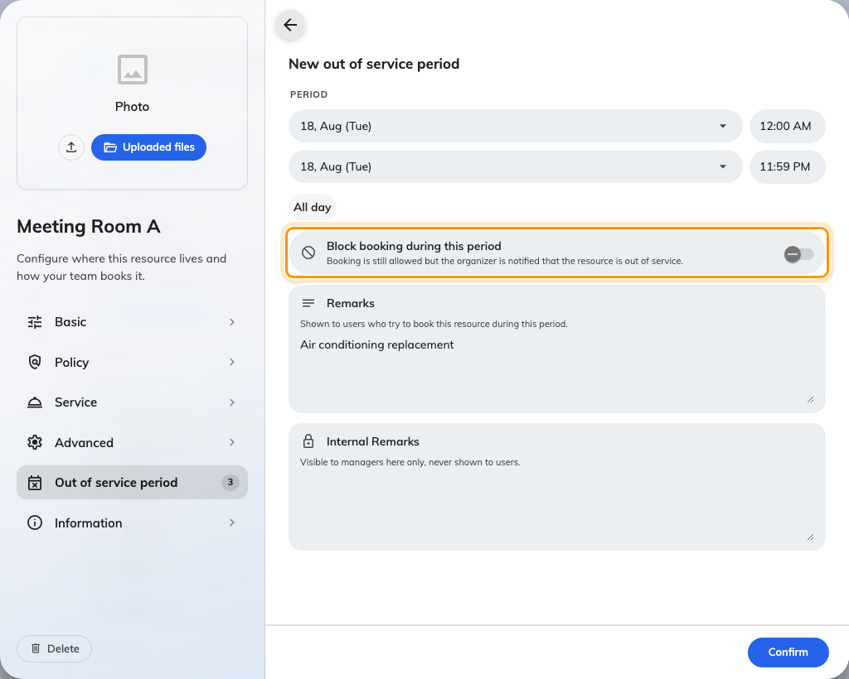
The same switch off: the sentence under it changes, and so does what happens to the booking.

4. Confirm, then save the resource
Confirm returns you to the list, where the new period joins Currently out
of service, Upcoming or Past, tagged Blocks booking or Warning
only, with a countdown to whichever end of it is next.
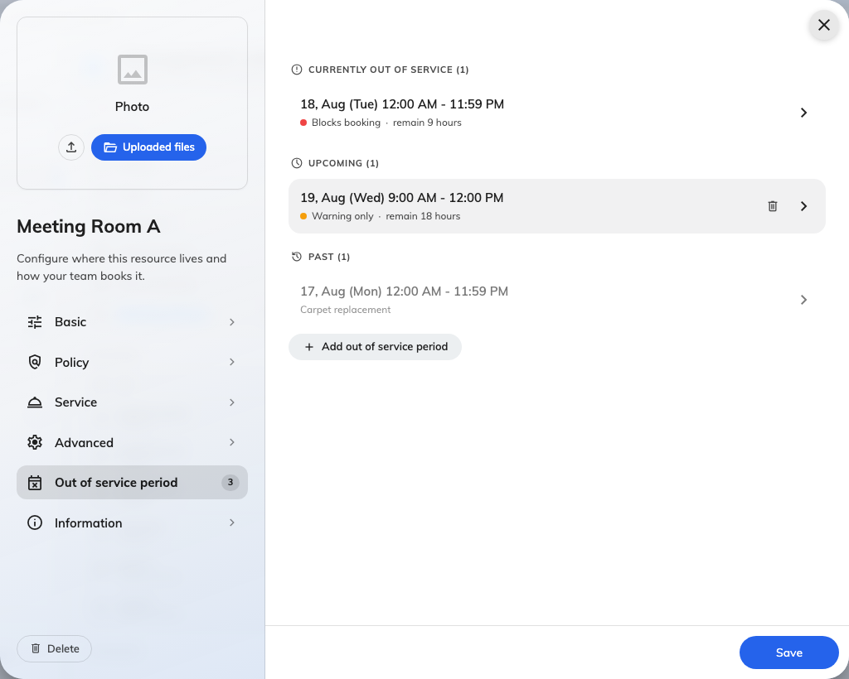
The list: grouped by when, tagged by what the period does.
Note:
Confirm does not save anything. Adds, edits and deletions on this page are held
until you Save the resource itself — closing the editor first throws them
away.
Back on the calendar, a blocking period is a solid hatched band you can click to
edit; a warning-only one is a faint band behind the day, with bookings still
drawn on top of it.
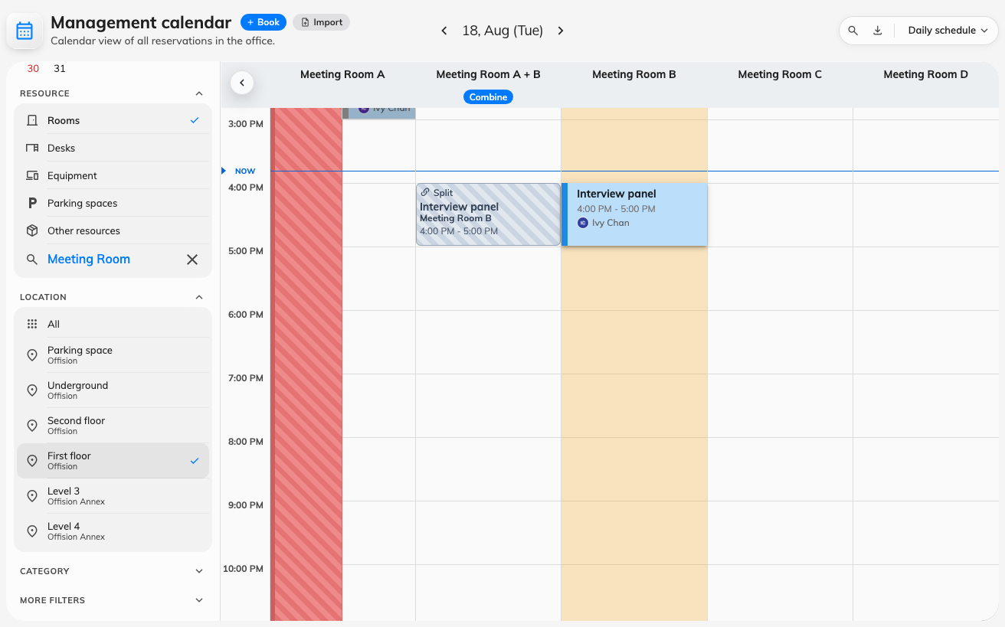
Both kinds on one grid: the blocking band is drawn over the day, the warning-only one behind it.

5. Choose whether the affected bookings are emailed
Closing a room does not cancel the bookings already in it. What Offision can do
is tell the people who made them, and that is a booking rule, not a property
of the period — so it is set once for a group of resources rather than every
time you close one.
Where in Offision: admin app → booking/advance-policy (Booking policy)
Open the policy that applies to the resource, go to its Others page, and find
Out of service notification. Three switches, and only the first is on out of
the box:
- Notify when an out-of-service period is created
- Notify when an out-of-service period is updated — covers the bookings in
the old window as well as the new one
- Notify when an out-of-service period is deleted
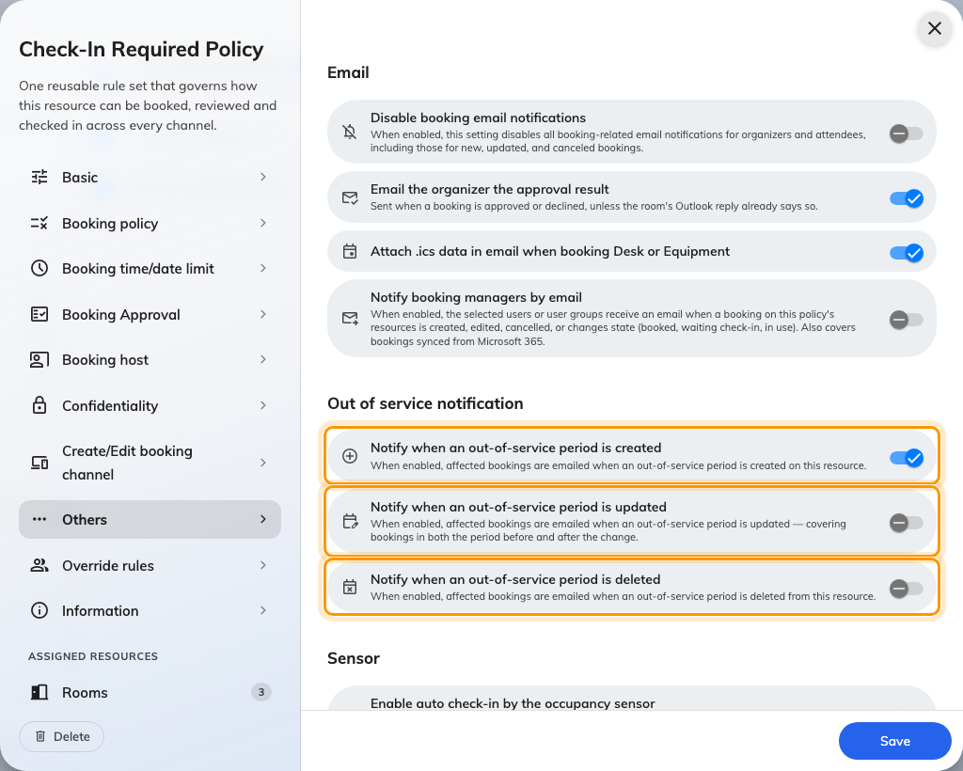
Out of service notification, on the policy's Others page. Only the first switch is on by default.
Leave the other two off unless closures on these resources genuinely move. A
maintenance window pushed back twice sends three emails to the same people,
which is how a useful notice becomes something nobody reads.
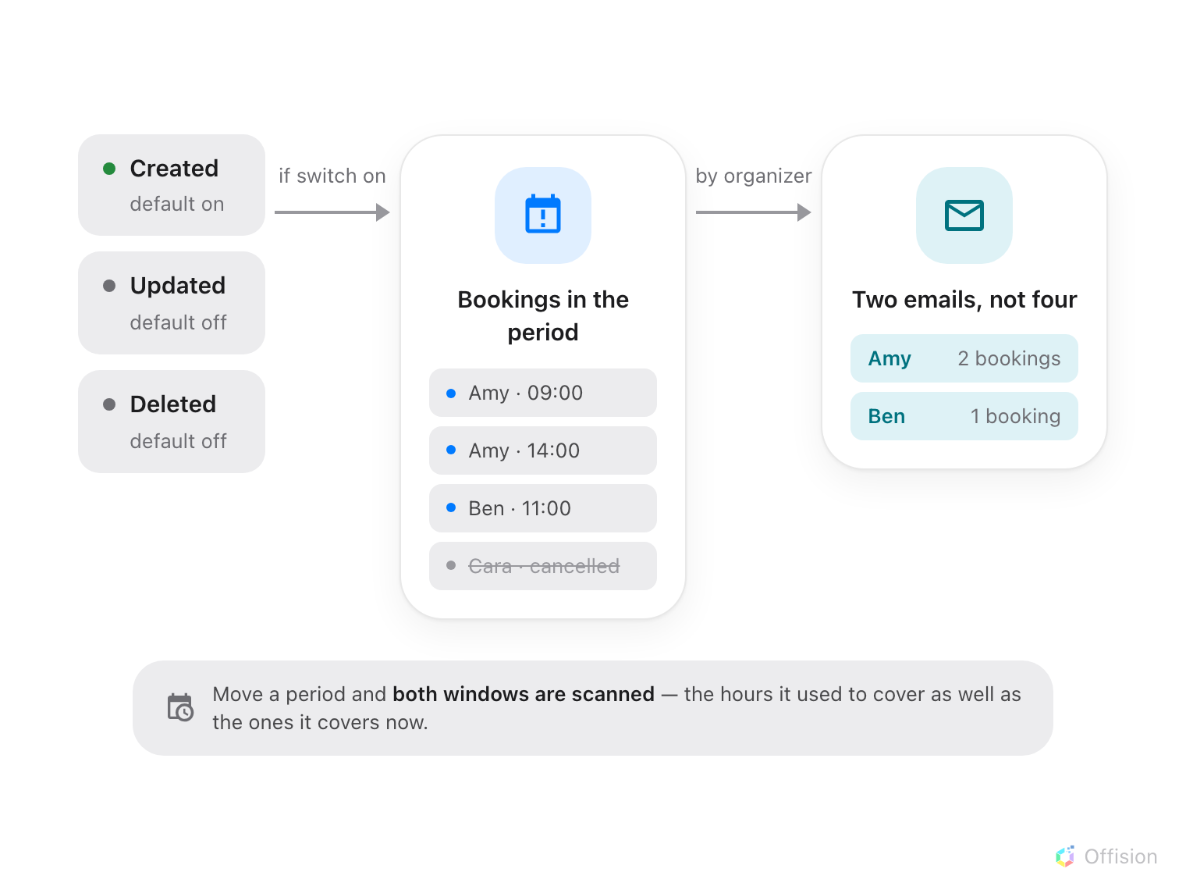
One email per organizer, listing only their own bookings — and only the ones still standing.
The mail is titled Out of service notification and names the resource, the
period, your Remarks, and each of that person's affected bookings as a link.
Only the organizer is written to, not the attendees, and only for bookings that
are still standing — anything already cancelled, rejected or marked a no-show is
left out.

6. Check it worked
Open the room in the Offision app and try to book it across the period. A
blocking one refuses you; a warning-only one lets you through after a warning.
That single test covers the period, its mode and the remarks in one go.

What people see
Where | Blocking | Warning only
Management calendar, Resource calendar | Hatched band over the day, labelled Blocks booking | Faint band behind the day, no label, bookings drawn on top
Booking form | "@name is out of service at @period" — the booking is refused | "@name is out of service during the selected time but can still be booked", then your remarks
Panel and lobby board | Out of service, with the period and remarks | Out of service — the panel does not tell the two apart
Room list in the app | Red Out of service badge | Red Out of service badge

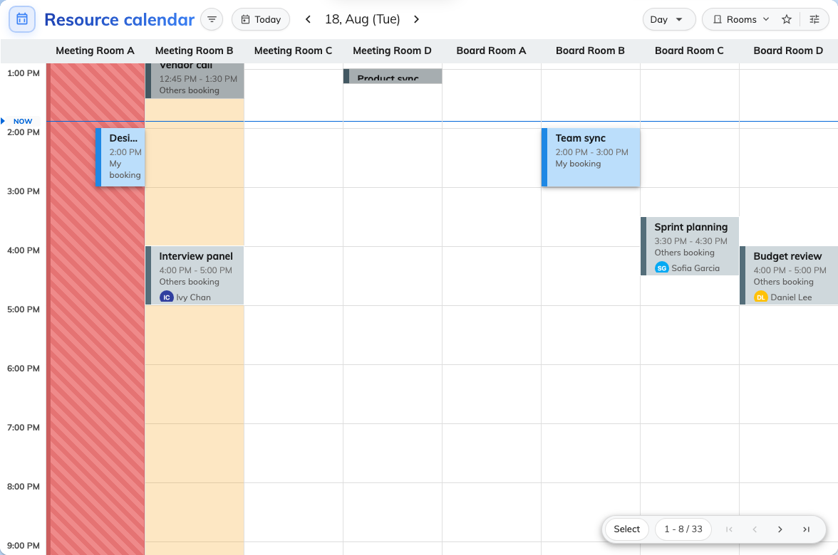
The same two rooms on a colleague's Resource calendar.
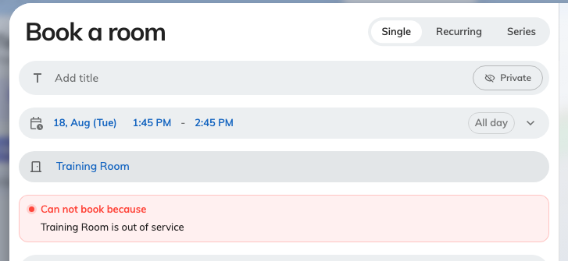
A blocking period, in the booking form: the room is refused.
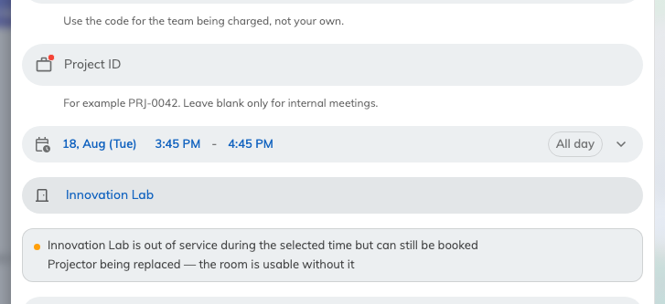
A warning-only period: the same room, the same hours, and the booking still goes through.

What this does not control
Warning only is not "half available". Everything that reports a resource's
availability — the badge in the room list, where the room sorts in the picker,
the free-room counts on a lobby board, the panel outside the door — treats any
overlapping period the same way and says Out of service. Only the calendars,
the booking form and the quick-book flows read the switch. So a warning-only
period is best understood as the room looks closed, and booking it anyway is
allowed — not as a quieter closure.
A period does not repeat. There is no recurrence: a room closed every Friday
afternoon needs a period for each Friday.
Existing bookings stay. Setting a blocking period does not cancel what is
already in the room; it only stops new ones. Moving them is a separate job — see
Move a booking on the management calendar.
This is not how you retire a resource. A room leaving the estate for good is
switched off in the resource's own booking settings, not given a period stretching
into next year — see Add a room.
The email switches are shared. They live on the booking rules, so they apply
to every resource that rule covers, and if a resource resolves to more than one
rule, a single one with the switch on is enough to send the mail — see
Booking rules reference.

