Stop one person keeping the same resource
A desk, a meeting room, a parking bay — one person books it and nobody else gets near it. One booking rule caps how much of a single resource a person may take, a second stops the standing weekly claim, and two more are there when those are not enough, plus the one thing Offision cannot do.
2026-09-14 · https://offision.com/help/en/booking/stop-one-person-keeping-the-same-resource/
One person is at the same desk every morning. Or holds the project room all
week, or the good parking bay, or the camera kit nobody else can get near.
Nothing is broken: a shared resource is bookable by anyone, so whoever books
first and books often keeps it. Two rules on the booking policy change that, and
both live on the policy the resources point at rather than on a person or a
resource — which is why the same pair works for desks, rooms, equipment and
parking alike.
Before you start:
The resources exist and point at a booking policy. Everything here applies to
every resource on that policy, so put the contested ones on a policy of their
own rather than on the policy everything else uses.

1. Cap how much of one resource a person may take
Where in Offision: admin app → booking/advance-policy (Booking policy)
Select the policy those resources use, choose Edit, and open Booking
time/date limit — the third page in the editor. Turn on Limit each
person's time on one resource, then set the period below it.
This is the rule people look for and rarely find, because of what it counts.
It counts per person, per resource, per period: within each period, one
person may hold at most eight hours on any single resource. Set the period to
one week and the same person gets one working day a week on desk 14, and one on
the project room — and still has the rest of the week free on everything else.
Two things to know before you save. The eight hours is not editable — you choose
the period, not the allowance. And on any period longer than a day you also set a
Reference date, which is the date the first period counts from; the limit
resets when the next one begins.

2. Stop the standing weekly claim
A cap on hours does nothing about a repeating series, which claims its slot once
and holds it indefinitely — the standing Tuesday meeting that owns the boardroom,
or the desk booked every weekday until further notice.
On Booking policy, the second page, turn off Allow users to create
recurrence booking.
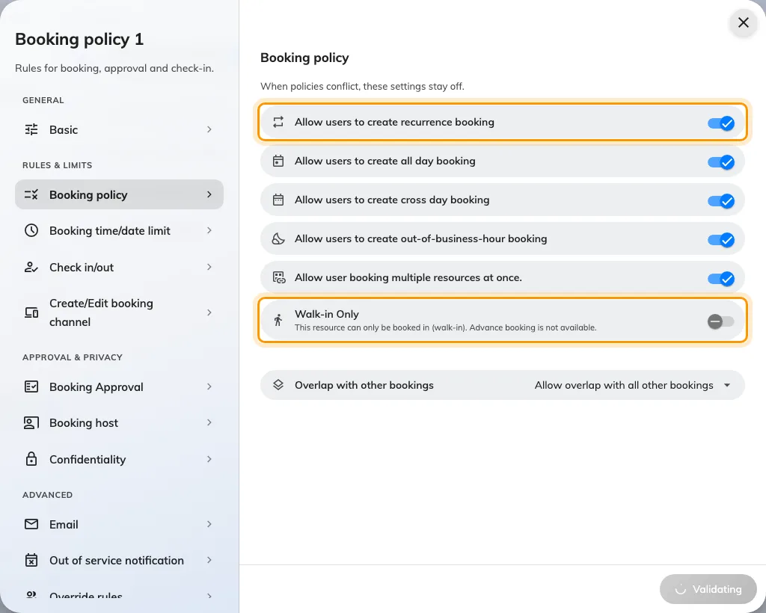
Allow users to create recurrence booking, and below it Walk-in Only — the two switches on this page that decide whether a resource can be claimed in advance at all.
People who had a series keep it; the switch only stops new ones. Turning it off
costs least on desks and equipment, where a booking is a day rather than a
standing commitment; on meeting rooms it is a real trade, so weigh it against
the no-show rule that cancels an abandoned series.
Allow or block all-day, recurring and cross-day bookings
covers what else that switch changes.

3. When those two are not enough
- Shorten the booking window. On Booking time/date limit, turn on
Limit the booking date range and set To to two or three days. Nobody
can lock in next month, and Release time decides the hour each new day
opens — move it off midnight so the whole floor competes at the same moment.
See Limit how far ahead people can book.
- Walk-in Only. On Booking policy. The resource disappears from the
booking form entirely and can only be claimed on the spot, which ends advance booking
and therefore camping. It is the right answer for touchdown desks and phone
booths, and too blunt for anything people plan their week around.
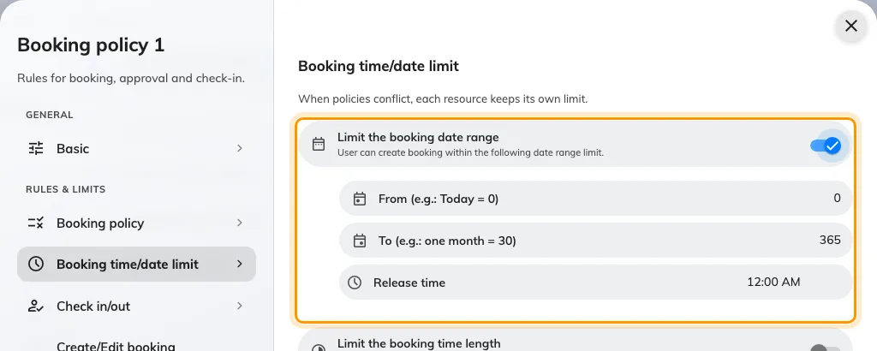
Limit the booking date range, with From, To and Release time. A short window turns a contested resource into a daily scramble rather than a standing claim.
Tighten one group, not everyone:
To apply any of this to the few people it is aimed at, leave the policy as it is
and add the rule for that group on the policy's Override rules page — the
same mechanism used to let managers book further
ahead.

4. Reclaim what is held but never used
Some of what looks like camping is a booking made out of habit and never used.
Turn on Require check-in on the Basic page and give it an All-day
booking check-in time, and a resource nobody claims by that hour goes back in
the pool as a no-show. Set the rules a hot-desk floor
needs walks that pair.
One trap if you run occupancy sensors: Ignore occupancy sensor auto check-out
for all-day bookings. is on by default, and an all-day booking is exactly what
a camper makes. Sensor-driven release will not touch those until you turn it off.

What this cannot do
There is no setting that caps consecutive days. Nothing in Offision says "not
this one again tomorrow", and nothing names a person and a resource together. The
rule in step 1 is the closest thing, and it works in hours per period rather than
in days in a row.
Quota is volume, not identity. A budget caps how much somebody books across
all the resources sharing it, not how often they return to one — useful alongside
these rules, not instead of them. See How booking quota works.
If they genuinely need it, give it to them. A Fixed Desk or Fixed
Room is assigned to one person permanently, which takes it out of the shared
pool honestly instead of leaving everyone else to discover it is taken every
morning. See Add a desk.

Check it worked
Sign in as an ordinary user and book the same resource twice inside one period.
The second booking should be refused by name, and the first should still be
there. If both save, the resource is on a different policy than the one you
edited — check which policy it carries.

