Show a room's description on the booking form
A room's own description can be printed under the resource picker as a quiet line or as a caution — set separately for the user app's form and the console's.
2026-09-01 · https://offision.com/help/en/booking/show-a-rooms-description-on-the-booking-form/
A room carries a Description — the projector needs the front HDMI cable,
ask facilities before moving the tables. It is written once on the resource,
and this decides whether the person booking that room ever reads it.
Before you start:
The rooms you want it for need a description written on them. A resource without
one contributes nothing, so the block never appears on a form where nothing has
anything to say.

1. Open User booking form
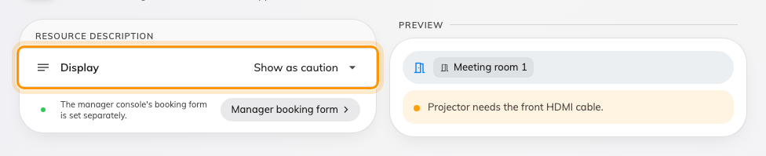
Display set to Show as caution, and the notice it draws on the form beside it.
Where in Offision: admin app → ui-customization/user-booking-form (User booking form)
It sits under UI customization, beside the other pages that decide how
Offision looks. More detail setting in booking form, in the header, is the
way over to which fields the form has — a different page and a different
question.

2. Choose how much attention it gets
Under Resource description, the Display row is one of three:
Value | What somebody booking sees
Hidden | Nothing under the resource. The description stays on the room, read by administrators only
Show description | Quiet line under the selection, once a room is chosen
Show as caution | Highlighted notice under the selection — the same words on an amber panel, with a dot beside them

Show as caution is informational and nothing more: it never blocks Save
and it never stops the booking. Use it for the thing people get wrong — the cable,
the door code, the room that has to be left as it was found — and leave everything
else on Show description, or the notice stops being read.
Pick several rooms at once and each contributes its own line, named, so nobody
has to guess which caution belongs to which room.

3. Do the same for the console's form
The two forms are set separately, and the page says so: The manager console's
booking form is set separately. The pill beside that line goes straight to
Manager booking form, on Management calendar, which carries the same three
values for the form an administrator books on.
Setting one and not the other is a reasonable choice — a caution written for
staff booking their own meeting is not always the one an administrator needs —
but it is a choice, not a default.
Where in Offision: admin app → ui-customization/management-calendar (Management calendar)

4. Check it worked
Book the room you wrote the description on, in the app. The line should appear
under the resource once the room is selected, and disappear when you swap to a
room that has no description.

