See which rooms are worth the space
Resource usage analytics colours a floor plan by how hard each room and desk is worked, then ranks the estate, the people and the hours. What its usage rate is a fraction of, why the colours move, and which cards ignore the floor you picked.
2026-08-30 · https://offision.com/help/en/booking/see-which-rooms-are-worth-the-space/
Resource usage analytics is the page to open when the question is about the
estate rather than about a person: which floor is full, which room nobody books,
whether the answer to "we need more meeting rooms" is another room or a different
hour.
Find it under Booking › Analytics › Resource usage analytics.
Where in Offision: admin app → booking/usage-map (Resource usage analytics)
Before you start:
The floor you want to look at has a floor plan drawn, with its rooms and desks
placed on it. Without one there is nothing to colour.

1. Choose what "used" means
Two controls sit above everything else, and they change every number on the page.
Business hours and 24 × 7 are the two ways to divide. In 24 × 7 a
room's usage rate is its booked minutes over every minute of the period — nights
and weekends included, so nothing ever looks busy. In Business hours it is
the booked minutes that fall inside that resource's own business hours, over the
business-hour minutes it had available. That second one is the number to quote,
and the one to compare rooms with.
Note:
A resource with no business hour of its own falls back to the system's standard
hours, so a room nobody has configured is still measured against a working day
rather than against the clock.
The choice is remembered in your browser and shared with the other rate
reports, so switching here switches them too.
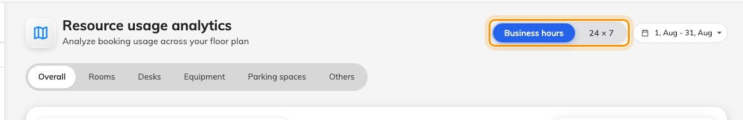
The two divisors, the period, and the resource types underneath.
Then set the period, and pick a resource type — Overall, Rooms,
Desks, Equipment, Parking spaces or Others. Compare like with
like: rooms and desks are used in completely different shapes, and Overall
averages the difference away.

2. Read the floor plan
Pick a floor, and the plan colours itself. Data beside it decides what the
colour measures — Count, Total hours, Total minutes or
Percentage — and the legend at the bottom left spells out the band each
colour stands for, in that unit.
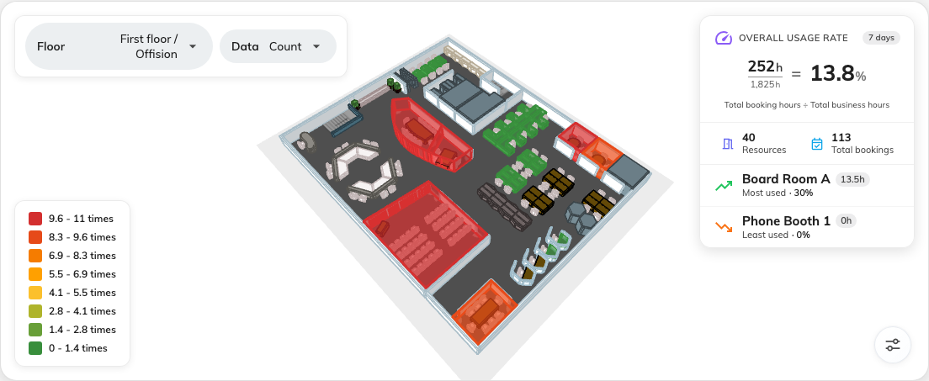
Green through red, the legend that defines the bands, and the summary panel.
The scale is relative, not absolute. The eight bands are rebuilt from the
highest value currently on screen, so a red room means the busiest thing in this
view — never busy enough. Change the floor, the period, the unit or the
resource type and the same room can change colour without a single booking
changing. Read the legend before you read the colours, every time.
Click a coloured room or desk to open the resource itself.
The panel in the corner prints its own arithmetic: Overall usage rate is
total booking hours ÷ total business hours, for the resources on this floor.
Underneath it, Resources counts what is on the floor and Total bookings
counts what was booked.
Note:
Most used and Least used are chosen by the number of bookings, while
the figure printed beside the name is hours. A room taken twenty times for half
an hour beats one taken twice for a day, so the two can disagree — and on a floor
of phone booths they usually do.

3. Read the cards underneath
Four of them, and the first thing to know is what they are not:
Note:
The floor picker only scopes the map. Everything below it is the whole
estate, narrowed by the period and the resource type alone. So a ranking that
lists rooms you cannot see on the plan is not a fault.
Card | What it shows | Export
Usage trend | Bookings as bars against hours as a line, bucketed Daily, Weekly or Monthly | No
Resource ranking | The top ten resources with their bookings, hours and usage rate, ordered by bookings | Yes — the whole ranking, not just the ten on screen
Top users | Who booked the most, ten at a time, with Show more | Yes
Top user groups | The same by group, so a department reads as one line | Yes
Peak hours | A heatmap of day against hour, following the Data unit and the rate mode above | No

Resource ranking and the two Top cards each carry a column chooser, so you
can put the columns your own reporting needs into the export. Top users can
add user attributes to that list; the others offer a fixed set.
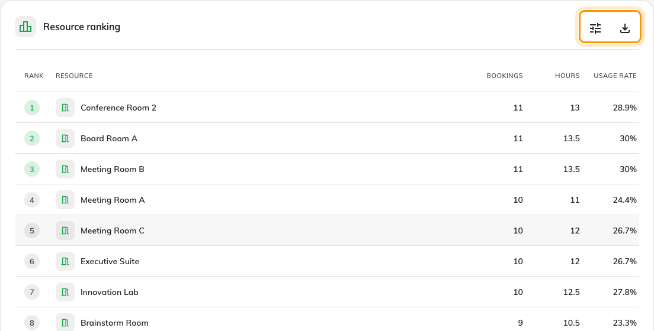
The ranking, with its column chooser and Export.
Peak hours is the card that answers "do we need another room". A wall of dark
between ten and noon and nothing after three is not a shortage of rooms — it is a
shortage of rooms at eleven. Click any cell to see the bookings in that hour.
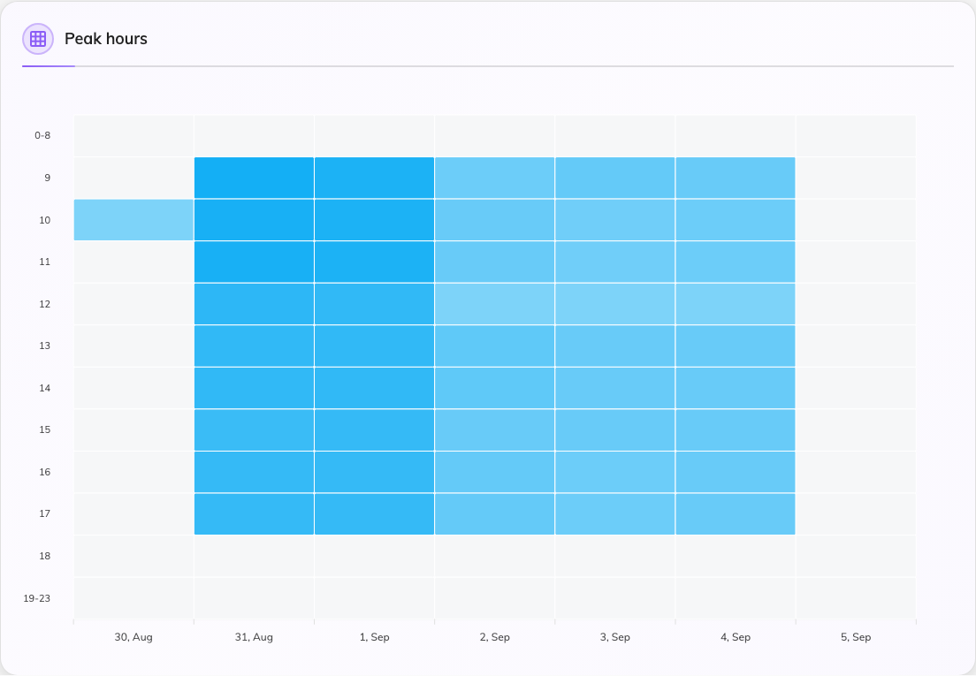
Each column is a day, each row an hour.

4. Check it worked
Set the period to a week you know well, switch to Business hours, and look at
a room you know is busy. If it comes back pale, the room's business hours are
probably wider than the hours anybody actually books it for — which is a real
finding, not a broken report.

What this does not tell you
- Whether anybody was in the room. Every number here is booked time. A
room booked all week and entered by nobody looks identical to one in constant
use — that is what check-in and
no-show reporting are for, and what occupancy
sensors measure. Where a room counts people, the measured figures are in
Check whether the room was actually full.
- How busy a room is in absolute terms. The colours rank what is on screen
against itself. The percentage in the legend and in the summary panel is the
absolute figure.
- Who used it, crossed with anything else. One dimension at a time is all
this page offers. For department against resource type, or a cost code against
the month, build it in
the usage report.

