See how much your rooms are used
The user resource usage report crosses any two dimensions — who booked against what they booked, month by month. How to build the grid by dragging, what the hours actually count, and why the download is wider than the screen.
2026-08-30 · https://offision.com/help/en/booking/see-how-much-your-rooms-are-used/
User resource usage answers one shape of question: who used what, and for how
long. It is a grid you build yourself — put anything down the side, anything
across the top, and read hours and bookings where they cross.
Find it under Booking › Analytics › User resource usage.
Where in Offision: admin app → booking/user-resource-usage-report (User resource usage)
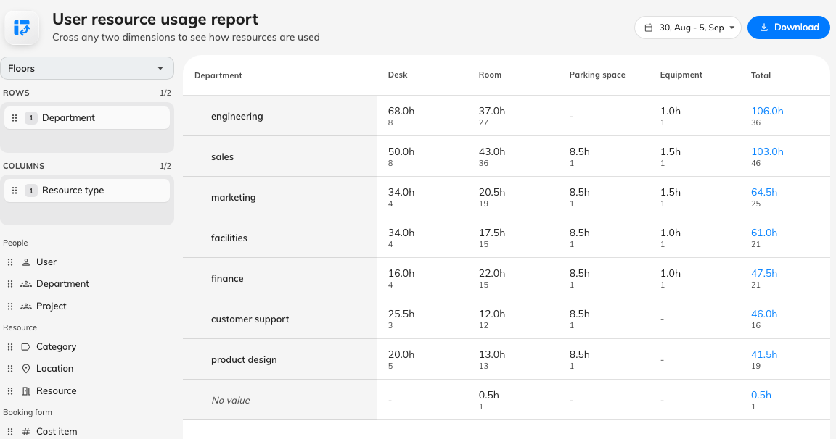
Departments down the side, resource types across the top.

What the numbers mean
Read this before quoting a figure to anybody, because the definition is narrower
than "how busy the room was":
Usage is the booked length of each resource booking — start to end as
scheduled — credited to whoever organised it. Checking in does not change the
figure, and neither does leaving early or never turning up at all.
Which means:
- Bookings that were cancelled, rejected or marked as a no-show are not
counted. A booking that becomes a no-show has its usage removed, so the same
room can show fewer hours this week than it did last week.
- A booking waiting for approval only counts where the approval holds the
time. Where approval does not block the slot, it counts once approved.
- A booking of two rooms counts as two, and a weekly repeat counts once per
occurrence, because a row is one resource on one occurrence.
- Hours are credited to the organizer, not shared among attendees.
- A booking that straddles the start or end of the period is counted whole.
Nothing is clipped to the period, and nothing is clipped to business hours.
This is a booking report, not an occupancy report. For whether anybody was
actually in the room, that is the sensors' story rather than this one.

Build the grid
There is no Apply button and no wizard. Drag a field into Rows or
Columns and the grid redraws.
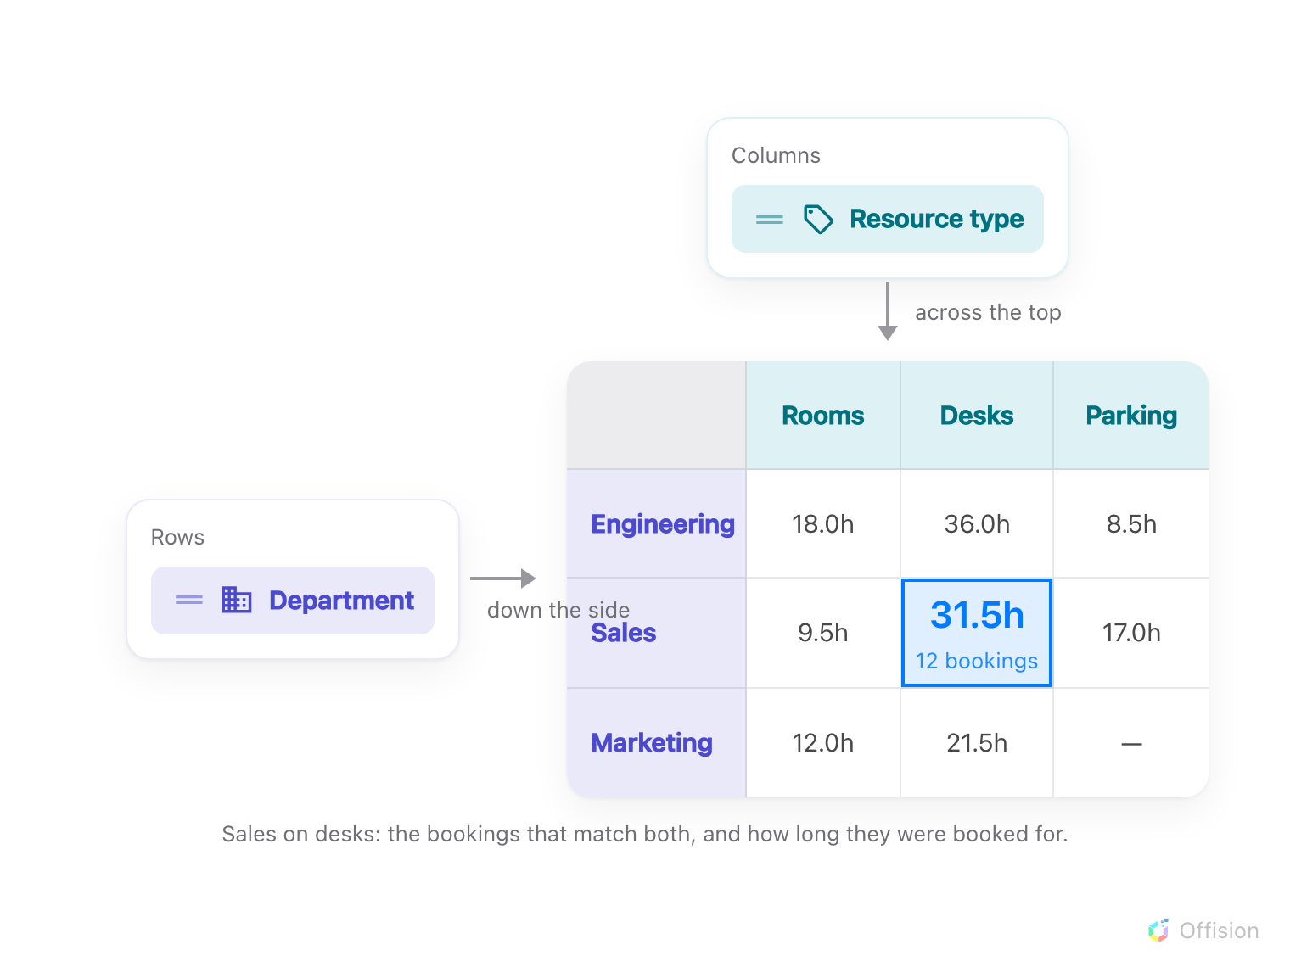
The field on Rows and the field on Columns decide what every cell counts: the bookings and hours that match both.
The fields come in four groups:
Group | Fields
People | User (the organizer), Department, User group, and one entry per user-group category you have defined
Resource | Resource type, Category, Location, Resource
Booking form | One entry per booking-form field that can be pivoted on
Time | Week, Month

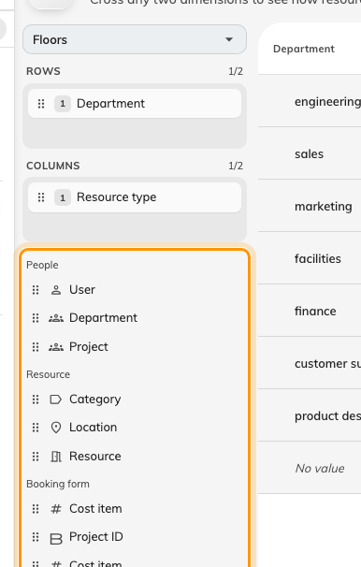
Everything not already on an axis, grouped. Department has left the list — it is on Rows.
It opens on User down the side and Resource type across the top.
A field appears here under the name you gave it, which is how the same word can
appear twice: the Department on a person's record and a user-group category
you happened to call Department are different fields, and they group differently.
Three rules are worth knowing, because the screen enforces them silently:
- Two levels per axis, no more. Drop a third field on a full tray and it
springs back — the tray does not resize and nothing is said. The counter beside
the label reads 2/2 when it is full.
- A field can only be on one axis. Placing it removes it from the list.
- An axis is never empty. The last field on an axis cannot be removed.
Note:
Location is the building, not the floor. There is no floor dimension —
floors are a filter, in the rail, rather than something to pivot on.
Note:
A booking counts in every group its owner is in. This holds for User group
and for the user-group category fields alike: someone in both Finance and Ops has
each of their bookings counted under both, because leaving them out of one would
understate that group's usage. The totals are therefore larger than the number of
bookings actually made, and the report says so in a line under the table whenever
one of these fields is on an axis.
User group lists every group you have, whatever category it sits in —
including the groups that belong to no category, which the per-category fields
cannot reach.
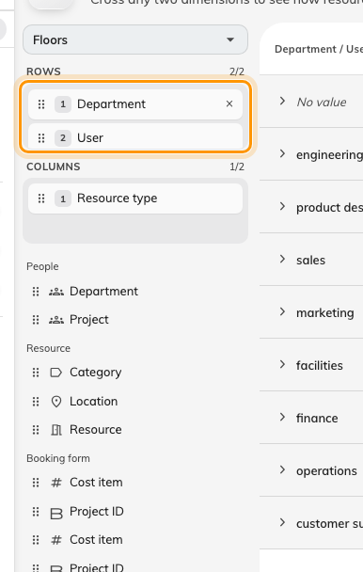
Two levels on Rows: departments, and the people inside each one.

Reading a large report
The grid shows at most 50 rows by 50 columns at a time. When there is more:
- A strip below the grid reads Rows 1–50 of 12,431 and Columns 1–50 of
312, each with arrows. Columns are ordered biggest first, so the second page
never reshuffles the first.
- Expanding a row that has many children adds a Show 50 more line beneath it,
with a count of how many of them are loaded.
- Changing either page collapses whatever you had expanded, because those cells
belonged to the previous window.
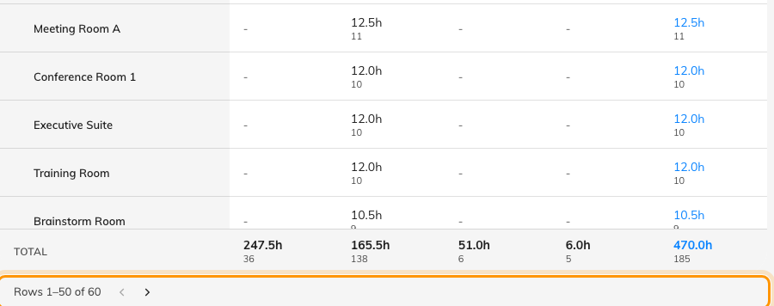
Resource down the side, and the strip that pages through it.
The totals stay true while the grid is partial. A row's Total is that
row's total across every column, not just the visible ones, and the footer
totals are whole-axis figures. So a page of the grid never adds up to its own
total, and that is correct.

Open a cell
Click any cell — or a row's Total — to see the bookings behind it, grouped by
day, with tiles for the period, the number of bookings, the total hours and, when
there are any, no-shows. Export in that dialog writes what the dialog is
showing to a spreadsheet.
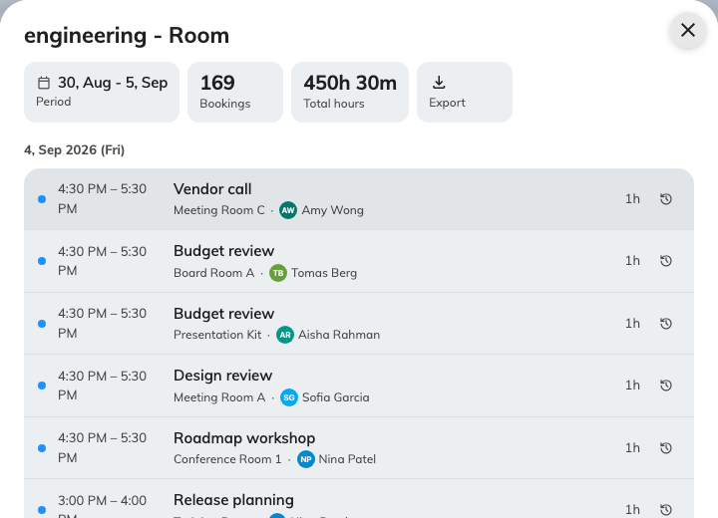
The bookings behind one cell, day by day.
Note:
The dialog is scoped by who and when, not by the column you clicked. On a
cell where Alice crosses Desk, it lists all of Alice's bookings in the
period, not only her desk bookings — the title names the cell, but the list is
wider. Read the cell's own figure for the number.
Because no-shows are excluded from usage but still appear in the list, the
dialog's booking count can be higher than the cell's.

Download
Download produces a spreadsheet with two sheets: Pivot, laid out like the
screen, and Raw data, one flat row per combination — the shape to feed into
Excel's own PivotTable.
The file is much wider and deeper than the screen: it walks the axes past the
50×50 window. It is not unlimited, though — it stops at 200 keys on each
axis, with no marker in the file to say so. On a report bigger than that,
narrow the period or the floor filter rather than trusting the file to be
complete.

Limits
- A period longer than a year is refused. The picker simply will not let you
apply it — Apply greys out beyond 366 days. If it is ever refused after the
fact the page says "Period is over 1 year. Shorten it or add a floor filter."
- A very large report is refused too, with "Report too large. Narrow the
period or filters."
- A new booking takes a few minutes to appear. The figures are cached for
about three minutes.

What this does not control
- Quota. How much somebody is allowed to book is a different screen —
Quota usage history.
- Whether anyone turned up. Usage is booked time; attendance is check-in and
no-show reporting.
- Occupancy. Sensor-measured occupancy is not what this counts.

