Booking rules reference
How resource policy, quota and team space combine to decide whether a booking is allowed, and every field on the resource policy and team space screens.
2026-09-04 · https://offision.com/help/en/booking/resource-policy-reference/
Three separate things decide whether a booking is allowed, and they are
configured on three different screens:
- A resource policy is a reusable rule set — the booking window, durations,
check-in, approval, which channels may book. Attach it to a class of space,
not to one room.
- A quota gives a booking a price and a person a balance. Quota has settings
of its own and a section of the manual to
match.
- A team space decides who may book the resources at all.
This article covers the resource policy and the team space in full, and starts
with how all three interact — that is the part that surprises people.

How the rules combine
There is no order of precedence. When a booking is saved, every rule is checked
in one pass and every failure comes back together, so a booking that is both
outside the window and short of quota reports both problems at once.
What is worth holding in your head is that the three rules answer three
different questions:
- Can this person see the resource at all? — team space. This is applied
when the resource list is built, not only when the booking is saved. Someone
with no access does not get a greyed-out room; the room is not in their list.
- Is the booking shaped legally? — resource policy. Window, duration,
all-day, recurring, cross-day, business hours, walk-in, channel.
- Can they afford it? — quota.
What the person sees | Which rule did it
The room is missing from search and from the resource list | Team space — they are blocked, or Other users is on its default
The room is listed, the schedule is readable, Book is a disabled lock | Team space — they are a readonly member
"You're not allowed to book this resource" | Team space, at save time
"You don't have enough quota to book this resource" | Quota
"This date is outside the allowed booking period" | Resource policy — booking date range or release schedule
"The booking duration exceeds the allowed limit" | Resource policy — booking time length
"This time is outside business hours" | Business hours on the resource, allowed by the policy

Four behaviours that catch people out:
- Team space is judged against the organizer, not against whoever is
clicking. A booking manager creating a booking for someone outside the team
is refused, even though the manager can see the room.
- Quota is charged when the booking is saved, not when it is approved.
Rejecting a request does not give the quota back — only cancelling does, and
only where the resource refunds at
all.
- A booking purpose can switch the rules off. A purpose option may override
the resource policy and the quota policy, and an override left empty means
no policy and no quota rather than falling back to the resource's own.
- A booking purpose can never override a team space. It is the one rule
nothing else unlocks.
There is no role that bypasses all of this. A booking manager gets whatever
Override rules the policy grants them; approval relaxes most of the policy
but leaves team space and business hours in force; quota has no exemption for
anyone.

Resource policy
Where in Offision: admin app → booking/advance-policy (Booking policy)
A policy opens as a rail of pages down the left — Basic, Booking policy,
Booking time/date limit, Booking Approval, Booking host,
Confidentiality, Create/Edit booking channel, Others and Override
rules — followed by one page per resource type for the resources it covers.
The sections below follow that order.
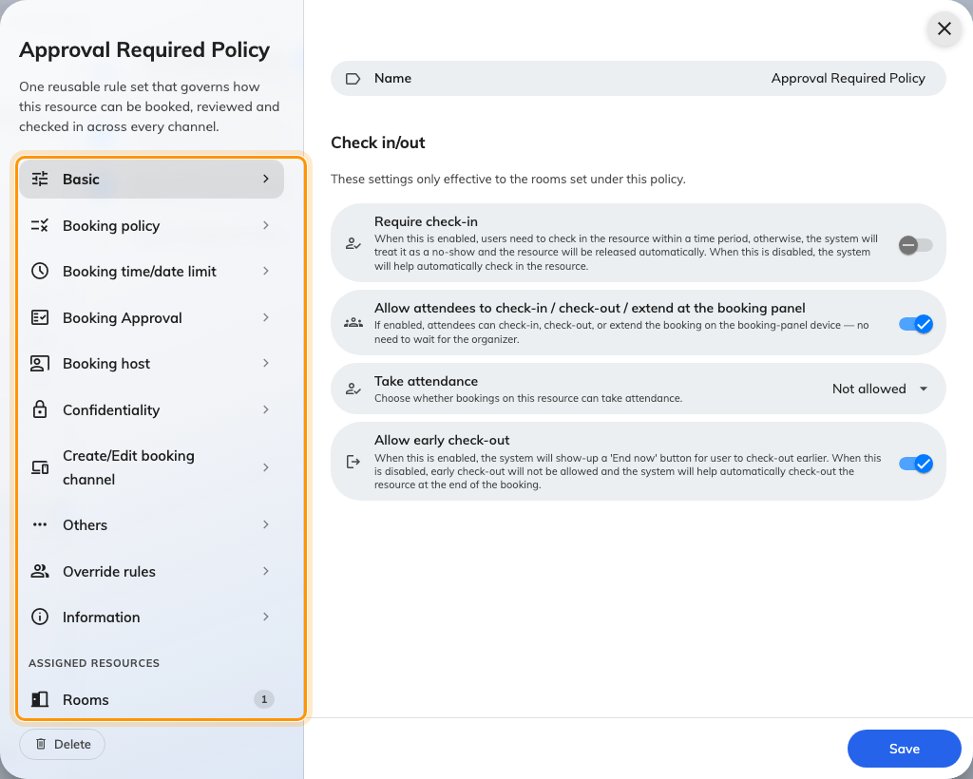
The policy editor. Every setting below sits on one of these pages.
A resource has one policy:
Settings on a policy apply only to the resources placed under it. Where a
booking spans resources on different policies, the permissive toggles on
Booking policy default to off for that booking.

Basic
Most of this page is check-in. For how the pieces fit together — what the window
actually is, and what happens when it closes — see
How check-in and no-show work.
Setting | What it does | When to change it
Require check-in | Without a check-in the booking counts as a no-show and the resource is released. Off, the system checks in for the user | Turn on for rooms in demand. Leave off where nobody competes for space
Can check-in before (in mins) | How early someone may check in | Widen where people arrive well before their slot
Can check-in after (in mins) | How long after the start time check-in is still accepted, before the no-show release | Shorter frees rooms faster, but strands anyone delayed on the way
Show check-in button in User Portal | Puts a check-in button in the app, so people can check in without touching the panel | Turn off if you need check-in to prove somebody was physically there — remote check-in makes no-show analytics unreliable
Allow attendees to check-out / extend in User Portal & check-in via QR | Extends those app actions from the organizer to the attendees | Turn on where the organizer often sends someone else
All-day booking check-in time | A fixed clock deadline for all-day bookings, instead of a window measured from the start | Set it for desks and all-day rooms, where a midnight start makes the normal window meaningless
GPS check-in | Opens a page with Require GPS check-in and an Allowed distance, so app check-in only works near the building | Turn on where remote check-in is being used to hold a room from home
Cancel recurring booking after consecutive no-shows | Cancels the remaining occurrences of a series once it has been abandoned. The organizer is warned one no-show before | Turn on for standing weekly meetings that outlive the reason for them
Consecutive no-shows before cancelling | How many in a row it takes | Two is aggressive on a fortnightly series, forgiving on a daily one
Allow attendees to check-in / check-out / extend at the booking panel | Same as above, at the door panel | Turn off where only the organizer should end a meeting
Take attendance | Whether bookings on these resources record who attended: Not allowed, Optional, or Always required | Set Always required where headcount is reported on
Allow early check-out | Shows an End now button so a room is freed when the meeting ends early | Leave on unless you need the full slot held
Allow cancel while waiting check-in | Whether the organizer may still cancel once the check-in window has opened. Off, the booking is committed from that moment and a missed one is recorded as a no-show | Turn off on rooms in demand, where a late cancellation frees a room nobody can use in time and hides the no-show
Allow cancel while in use | Whether a booking that has already been checked into may be cancelled. Off, it can only be ended early or left to check out on its own | Turn on where people genuinely walk away from a meeting they started; leave off where a checked-in booking should stay on the record

The Allowed distance is measured from the building's own location, which is
set on the building rather than here — resources whose building has no location
cannot be checked into at all once GPS check-in is required. See
Checking in by QR code, and proving you are there.

Booking policy
What may be booked at all.
Setting | What it does | When to change it
Allow recurring booking | Lets people create a repeating series | Turn off on scarce rooms, where one series can claim a slot indefinitely
Allow all day booking | Lets a booking take the whole day in one go | Turn off on meeting rooms; leave on for desks
Allow cross day booking | Lets one booking run past midnight | Turn on for overnight equipment, off for rooms
Allow non-business hour booking | Lets people book outside the resource's business hours | Turn off where out-of-hours use needs building access nobody has
Allow booking multiple resources | Lets one booking hold several resources at once — a room plus its equipment | Turn off where each resource must be booked deliberately
Allow extend booking | Lets people extend from the panel when nothing follows | Turn off where the next booking must start on time
Walk-in Only | The resource can only be claimed on the spot; advance booking disappears | Use for touchdown desks and phone booths
Overlap with other bookings | Whether a person may hold two bookings at the same time: Allow overlap with all other bookings, Not allow overlap with bookings that involve resources using this booking policy, or Not allow overlap with all other bookings | Tighten it where people hold a backup room "just in case"

Booking time/date limit
See Limit how far ahead people can book
for the task itself.
Setting | What it does | When to change it
Limit the booking date range | Turns on the rolling window below | Turn on to stop the calendar being claimed months out
From (e.g.: Today = 0) | The earliest bookable day, in days from today. 0 is today | Raise where rooms need preparing between meetings
To (e.g.: one month = 30) | The furthest bookable day, in days from today. Two months is 60; the field accepts up to 1095 | Shorten on contested rooms. Off, the system falls back to 365 days
Release time | The hour at which each newly reachable day opens | Move off midnight on rooms people compete for
Limit the booking time length | Turns on the minimum and maximum below | Turn on for scarce rooms
Minimum booking time in minute(s) | The shortest single booking allowed | Raise to stop the calendar filling with five-minute holds
Maximum booking time in minute(s) | The longest single booking allowed | Lower on scarce rooms to stop all-day holds
Limit the booking time length for walk-in booking | The same pair of limits, applied only to bookings made on the spot | Set shorter than the main limit — a walk-in should not take the room all afternoon
Limit user can edit or delete booking before it start | Freezes a booking once the start time is close | Turn on where a room is prepared per booking
Limit the maximum booking time per booking | A budget of minutes per person per period — day, week, two weeks or month — with a reference date the period counts from | Use where a few people would otherwise book the room every afternoon
Allow booking before a specific date | A fixed calendar cut-off rather than a rolling one | Use for a date that does not move, like a fiscal year end
Allow booking after a specific date | The same, from the other side | Use to keep a space closed until it opens
Booking time sector restriction | Holds a whole period closed until an announced release moment. Each time sector names a booking period and the date and time it opens; the list can be uploaded and downloaded | Use where a term or quarter should open at one moment for everyone

Booking Approval
The whole page is behind the Booking approval master toggle. See
Require approval before a room is booked.
Setting | What it does | When to change it
Booking approval | Requests wait for a decision instead of confirming | Turn on for rooms somebody owns
Block timeslot before approval | Holds the slot while the request is pending, so nobody else takes it | Turn on where a rejected request would otherwise lose the slot to a race
Room replies in Outlook while waiting | Outlook and Google rooms only. Whether the holding acceptance that blocks the slot also mails the organiser. Off, the room holds the slot silently and replies once approved | Turn off if a pending request appearing as confirmed in Outlook causes confusion — see How a booking on a synced room is validated
Conditional Booking Approval | Switches from "every booking" to "only bookings matching the conditions below" | Use to approve the expensive cases and let routine bookings through
Re-approval after edit | Whether an approved booking goes back into the queue when it is edited: Any change requires re-approval, Only time or resource changes require re-approval, or Edits never require re-approval | Loosen to time or resource where organizers keep editing the subject line
Show approvers | Whether the person booking is told who will decide: Do not show, Show approvers, or Show approvers and managers | Show them where people would otherwise chase the wrong person
Disable booking approval for walk-in booking | Lets somebody standing at the door claim the room without waiting | Turn on wherever a panel is the main way in
Booking approval user(s) or user group(s) | Who may decide. The first decision wins — there is no chain | Name a group rather than a person, so leave does not stall the queue
Auto reject booking if no people approve after (?) days | Clears requests nobody answered | Set it below the booking window, or requests expire after the date they were for

The conditions available under Conditional Booking Approval:
Condition | Sends the booking for approval when
Minimum booking duration | It runs longer than the duration you set
All-Day Booking | It reserves the resource for the whole day
Recurring Booking | It repeats on multiple dates
Cross-Day Booking | It spans two or more days
Outside Business Hours | Any part of it falls outside business hours
Multiple Bookings by the Same User | That person exceeds a number of bookings in one day
Too many upcoming bookings by the same user | They already hold that many upcoming confirmed bookings
Room Capacity Utilization | Attendees are fewer than a percentage of the room's capacity
Booking with Service Requests | It asks for additional services

Booking host
Setting | What it does | When to change it
Allow invite a host | Master switch for the host field. Off, the field is hidden and the rest of this page does not apply | Turn on where somebody other than the organizer runs the meeting
Allow multiple hosts | Lets a booking name more than one host | Turn on for panels and interviews
Host field | Optional, or Required — a host must be chosen before the booking saves. Across several rooms the strictest answer wins, and it is only enforced where the field is usable at all: never when the host field is hidden, and never against somebody who may not assign a host | Rooms whose bookings are charged or staffed to a named person
Default host to organizer | Pre-fills the host with the booking's organizer, and keeps it in step while the organizer or delegate changes — until somebody edits the host row themselves | Off where the host is usually somebody other than the person booking
Who can assign a host | All users, or only the users and groups you name | Restrict where hosting carries a cost, so not everyone can volunteer somebody
Host assigner user(s) or user group(s) | The list used when the answer is Specify users | —
Who can be a host | All users, or only the users and groups you name | Restrict to the people actually trained to host in that space
Eligible host user(s) or user group(s) | The list used when the answer is Specify users | —

Default host to organizer is on for every policy that existed before 4.5.12.
The pre-fill used to be unconditional, so an upgraded policy keeps behaving
exactly as it did — the setting only matters once somebody turns it off.

Confidentiality
Setting | What it does | When to change it
Hidden booking information | Hides booking detail from people not involved, in the app, on panels and on signage | Turn on for executive and HR rooms
Information Confidentiality Level | Hide all booking detail — others see only that the resource is occupied. Hidden booking detail, except organizer name — others also see who has it | Keep the organizer visible where people need to ask for the room back
Terms and Conditions | Requires the text below to be accepted before a booking is created | Use where a space carries house rules or a safety briefing
Require scrolling to the end | The accept button stays inactive until the text has been read to the bottom | Leave on where acceptance has to mean something

Create/Edit booking channel
Setting | What it does | When to change it
Allow booking manager book for user | Lets a manager create and edit these bookings from the admin console | Turn off for spaces that must be self-service only
Allow booking from User Portal | Lets people book from the app — browser, phone, Teams and Outlook, and a sticker scan, all one channel | Turn off for a room that is only ever claimed at the door, knowing the sticker stops booking too
Allow booking from booking panel and signage | Lets people book at the panel outside the room. Shown where panel hardware is enabled | Turn off where every booking has to be planned
Skip user verification in booking panel | Books from the panel without asking who is booking. Appears only while the row above it is on | Turn on for open areas where a sign-in step just makes people give up

Off is not one behaviour. Switching off the admin console or the User Portal
removes the resource from that surface's list — it is absent, not greyed out.
Switching off the panel leaves it on the panel's screen and refuses when somebody
tries to take it.
The three arrangements people usually want out of these rows — bookable only from
the app, only by scanning the sticker, or not from the portal at all — are walked
through in
Choose where a resource can be booked from.

Others
The occupancy-sensor rows below are a matched-looking pair that does not behave
symmetrically.
Setting | What it does | When to change it
Disable booking email notifications | Stops all booking email to organizers and attendees — new, changed and cancelled | Turn on for desks and equipment, where the mail is noise
Attach .ics data in email when booking Desk or Equipment | Puts a calendar invitation in those emails | Turn off if desk bookings are cluttering people's calendars
Notify booking managers by email | Emails the people below when a booking on these resources is created, edited, cancelled, or changes state. Also covers bookings synced from Microsoft 365 | Turn on for spaces somebody has to prepare
Booking manager user(s) or user group(s) | Who gets that mail | —
Notify when an out-of-service period is created / updated / deleted | Emails the affected bookings when the resource is taken out of service | Leave creation on; the other two are for spaces whose closures move
Enable auto check-in by the occupancy sensor | Checks the booking in once the sensor has seen someone for long enough | Turn on where people never touch the panel
Continuous presence duration (in minutes) | How long presence must last before it counts | Raise where people walk through the room
Exclude out of business hour auto check-in | Stops sensor check-in outside business hours | Turn on where cleaners trip the sensor at night
Enable auto checkout by the occupancy sensor | Releases the room once the sensor has seen nobody for long enough | Turn on to reclaim rooms people walk out of
Continuous no presence duration (in minutes) | How long the room must stay empty first | Too short and a coffee break ends the meeting
Ignore occupancy sensor auto check-out for all-day bookings | Stops a full-day booking being released overnight before anyone arrives | Leave on wherever all-day bookings are used
Exclude out of business hour auto check-out | Stops sensor checkout outside business hours | Pair with the check-in equivalent
Enable auto extend by the occupancy sensor | Extends a booking that is about to end while the room is still occupied. It keeps extending, bounded by the next booking, business hours and the maximum duration | Turn on where meetings routinely overrun and the next slot is usually free
Trigger when ending within (in minutes) | How close to the end the check happens | —
Extend by (in minutes) | How much time each extension adds | Small increments, so an empty room is given back quickly
User Portal check-in IP restriction | Only accepts check-in from the addresses you list | Use to force check-in onto the office network

Override rules
A policy can carry exceptions for named users or user groups. Each rule picks an
Override condition — Organizer, which applies when those people create
or edit their own bookings, or Booking manager, which applies when they work
through the admin console — and then reopens a subset of the settings above: the
date range and release schedule, durations, check-in, edit and delete limits,
the all-day, recurring, cross-day and out-of-hours toggles, overlap behaviour,
the approval requirement and the sensor automation.
Rules are ordered, and the first matching rule wins. Use overrides where one
team genuinely needs a longer horizon than everyone else — not as the normal way
to configure people, since an override is invisible from the resource itself.
See Let managers book further ahead than
everyone else for the walkthrough.

Booking quota
Quota is configured on four tabs of its own and is documented separately — start
at how booking quota works, or go
straight to the settings
reference.
Where in Offision: admin app → booking/quota-policy (Quota settings)

Team space
Where in Offision: admin app → booking/user-restriction (Team spaces)
A team space is a set of resources plus the people allowed to use them. See
Give a department its own rooms for the
walkthrough.

Resources
One rail page per resource type, each with a count of what the team space
covers. A resource belongs to one team space at a time — picking a room here
takes it from whichever team space had it before. A room shared between two
departments needs one team space listing both groups, not two team spaces.
A resource on no team space stays bookable by everyone.

Members & access
Setting | What it does | When to change it
Team members | Users and groups that can see and book these resources | Add the department's user group, not a list of names
Readonly members | Can see the resources and their schedules, but cannot book | Use for everyone who has to plan around the space without claiming it
Block | No access at all. Block wins over everything, including Team members | Use to carve one exception out of a large group, never as the general tool
Other users | What everyone not named above gets: Default (no access to the resources), Readonly, or Full access | Default is stricter than most people expect — the resource vanishes for them. Readonly is usually the kinder answer

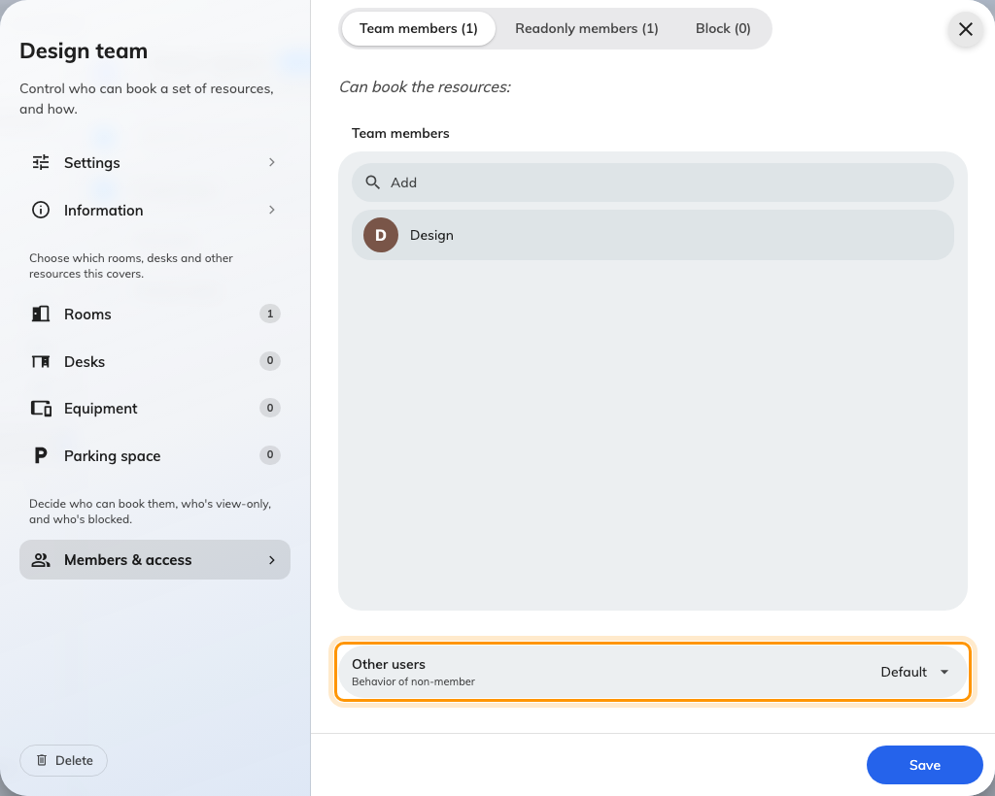
Other users: what people outside the team get.
Those four are read in order — Block, then Team members, then Readonly
members, then Other users — and the first match wins. Someone who is both
a team member and blocked is blocked.

What these do not control
- Business hours belong to the resource. A policy can allow or forbid
booking outside them; it does not define them. Setting the pair up is its own
article: Limit booking times to business hours.
- Booking purposes, and the overrides that let a purpose replace the policy
or the quota, are configured under Booking purpose.
- The booking form — extra fields, custom labels — is its own screen, as is
the auto-complete configuration.
- Service items and catering attached to a booking follow their own rules;
the only trace of them here is the approval condition for bookings that
request services.
- Calendar sync with Microsoft 365 or Google is set up under integrations.
The only sync-related setting on these screens is whether the room replies in
Outlook while approval is pending — see How a booking on a synced room is
validated.
- What a resource is — its name, capacity, building, amenities and which
policy, quota policy and team space it belongs to — is set on the resource.

