Rename, edit or delete a room
Change a room after it exists — its name, capacity, photo, category or floor — and know what each change ripples to. Then the three ways to stop a room being booked without deleting it, what deleting actually does to its bookings, and how to get a deleted room back from the recycle bin.
2026-08-26 · https://offision.com/help/en/booking/rename-edit-or-delete-a-room/
A room rarely stays as it was created. It gets a proper name, loses two chairs,
moves a floor, and one day is knocked through into the room next door. Every
one of those is a change to the same record, and most of them are safe — the
one that is not safe is Delete, and it is less final than it looks.
Before you start:
You need booking management access, and the room must already exist — see
Add a room. Everything here applies equally to a desk, a
piece of equipment, a parking space or an other resource; only the list you
start from changes.

1. Open the room and rename it
Where in Offision: admin app → booking/room (Standard Rooms)
Click the room's row. A detail panel opens on the right, with Edit,
Copy and Change across its top and Delete at its foot. Click
Edit: the editor opens on its Basic page, and Name is the first
field — one value per enabled language, with a language switcher beside it.
Change it and Save.
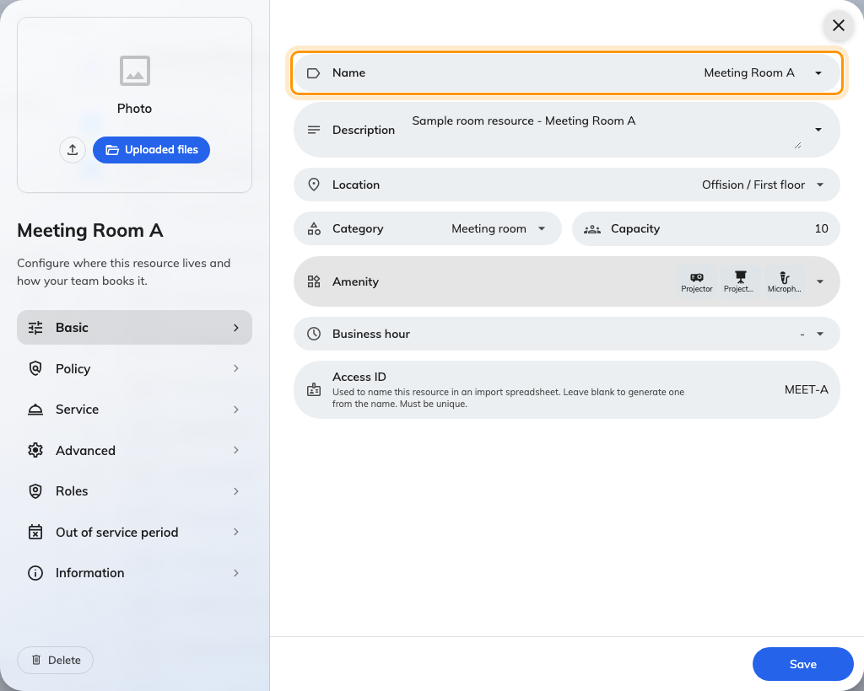
Basic, with Name — one value per enabled language.
What a rename reaches, and what it does not:
- Panels, boards and calendars pick the new name up within a second or two.
Nothing has to be restarted.
- Existing bookings are untouched. A booking points at the room, not at its
name, so every past and future booking simply shows the new one. Emails and
calendar invitations already sent keep the old text.
- A room synced from Microsoft 365 or Google Workspace keeps the name you give
it here. The nightly sync brings in new rooms and removes vanished ones; it
does not write the mailbox's name back over yours. The reverse is also true —
renaming the mailbox in Exchange changes nothing in Offision.
- A spreadsheet import does overwrite the name. The row is matched by its
ID column, so re-importing an old sheet puts old names back.
Nothing stops two rooms sharing a name. If the list has two Boardroom rows,
that is two rooms, not a display fault.

2. Change the capacity, photo or category
All three are on the same editor. Capacity is on Basic, below
Location — a whole number, required for a room. It is what "seats 8"
searches match and what warns a booker who has invited more people than fit,
so lowering it can make the room drop out of searches that used to find it.
Category is on Basic too, and its options are the room categories
only — the list is filtered by resource type. Photo is not on a page: it
sits in the left rail above the page list, and accepts an image in 4:3.
Save once. One save covers every page of the editor.
Copy:
Copy, beside Edit, opens the add form filled in from this room, with
Copy appended to every language of the name. The floor comes with it; the
point on the floor plan does not, so place the copy before you save it. It is
the quickest way to make a second room with the same policy, hours and
amenities.

3. Move it to another floor
Two places do it, and both write the same thing. In the detail panel, the
Location row opens the building and floor picker directly. In the editor,
Location on Basic does the same and also lets you click the room's area
or a point on the new floor plan.
Changing the floor clears the room's point on the old floor plan. Pick its
place on the new plan in the same edit, or the room has a floor and no spot on
the map. Nothing else moves: the room's panel stays bound to it, its bookings
stay where they are, and its policy is unchanged.
What does unbind a panel is Change → Change type. Turning a room into a
desk, a piece of equipment or an other resource releases every panel and
e-paper tag bound to it, and clears its category, because categories belong to
a type. It is refused while the room is part of a combine room — Cannot change
since it is linked with a combined resource.

4. Stop bookings without deleting
Three switches take a room out of circulation and leave everything else in
place. Reach for one of these before Delete.
To | Use | Where
Keep the room but let nobody book it, indefinitely | Booking settings off | Editor → Policy. The rest of the page, and all of Service, is replaced by This resource will not be available for booking
Close it for a fixed period, with or without blocking | Out of service period | Editor → Out of service period — see Take a room out of service
Keep it bookable in Offision only, with the room mailbox no longer feeding it | Stop connection with external calendar | Detail panel → the calendar row's menu (synced rooms only). Confirms with Bookings will no longer synchronize from the external calendar

Booking settings is also the first thing to check when a room has stopped
appearing in the user app. On a list with several rooms selected, the same
switch is Enable for booking on the batch toolbar.

5. Delete it
Delete is at the foot of the detail panel, on the batch toolbar when several
rows are selected, and in the editor's left rail. Each asks Are you sure you
want to delete this item? and lists what is about to go; Delete confirms.
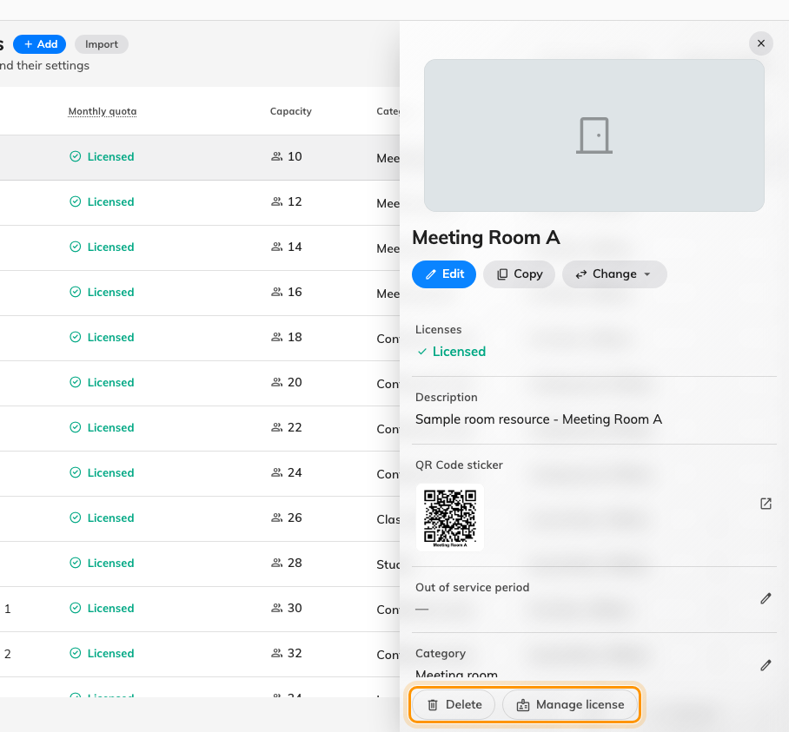
Delete is at the foot of the detail panel.
What happens:
- Bookings are not cancelled and nobody is emailed. The room's past and
future bookings are kept exactly as they are — but the room itself no longer
appears in the resource lists or on the management calendar, so those
bookings are not visible anywhere until the room is restored. Cancel or move
the future ones first if the room is genuinely gone.
- Its point on the floor plan is cleared, and its licence goes back to the
spare pool.
- A synced room's calendar connection is stopped.
It can be undone. The list header has a Recycle bin pill, with a count.
Open it and the header reads Deleted items — Restore items to bring them
back to the active list. Each row is read-only and shows Delete by and the
deletion date; Restore puts it back, confirming with Confirm to restore
following item(s)?. A restored room reclaims its licence, and its bookings are
visible again as if nothing had happened.
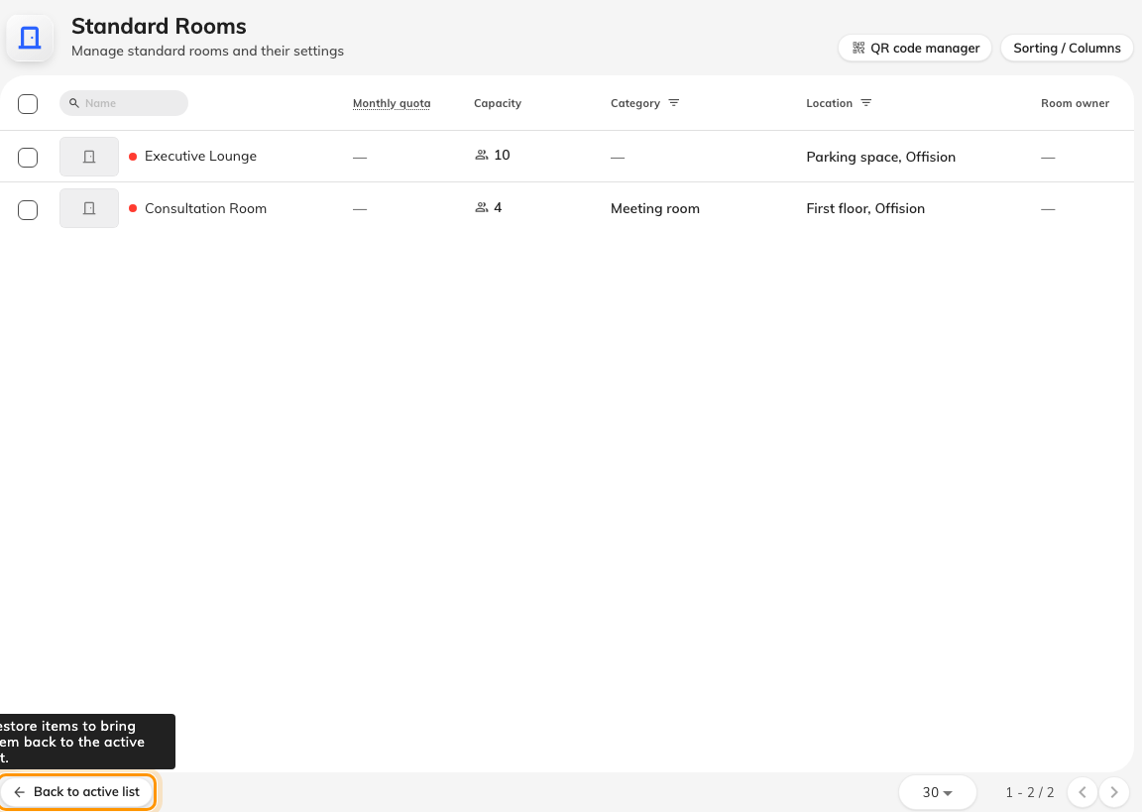
The Recycle bin toggle on the list footer, and the deleted items it opens.
Thirty days, and synced rooms:
The recycle bin empties itself: anything deleted more than 30 days ago is
purged for good in the nightly clean-up. And a room synced from Microsoft 365 or
Google Workspace does not stay deleted — the next nightly sync does not see the
deleted row, so it creates the room again as a new resource with none of
its old settings or bookings. To get rid of a synced room, remove the mailbox
on the provider's side; the sync then deletes it here.

6. Check it worked
For a rename or a move, open the room in the user app: the new name and floor
are what a colleague searches by, and the admin list would show them either
way. For anything meant to stop bookings, try to book the room from the user
app — the admin console shows every room whatever its state, so it is the wrong
place to check. A deleted room should be missing from the app and present under
Recycle bin.

