Offer suggested booking times
Suggested times fill the booking form's period field with the blocks a normal day is divided into, without ever forcing them — Custom time is always there. Set one grid for the whole company, and give a room its own only where it differs.
2026-08-27 · https://offision.com/help/en/booking/offer-the-same-suggested-times-everywhere/
Suggested time slots are the blocks the booking form offers as hints — nine to
ten, ten to eleven — so most people book by tapping one instead of setting two
times by hand.
They are only ever hints. Whatever is on offer, Custom time sits under the
list and hands the ordinary date and time pickers back, so nobody is ever stuck
with the blocks somebody else chose. That is the whole difference from
fixed time slots, where the list is
the only thing there is.
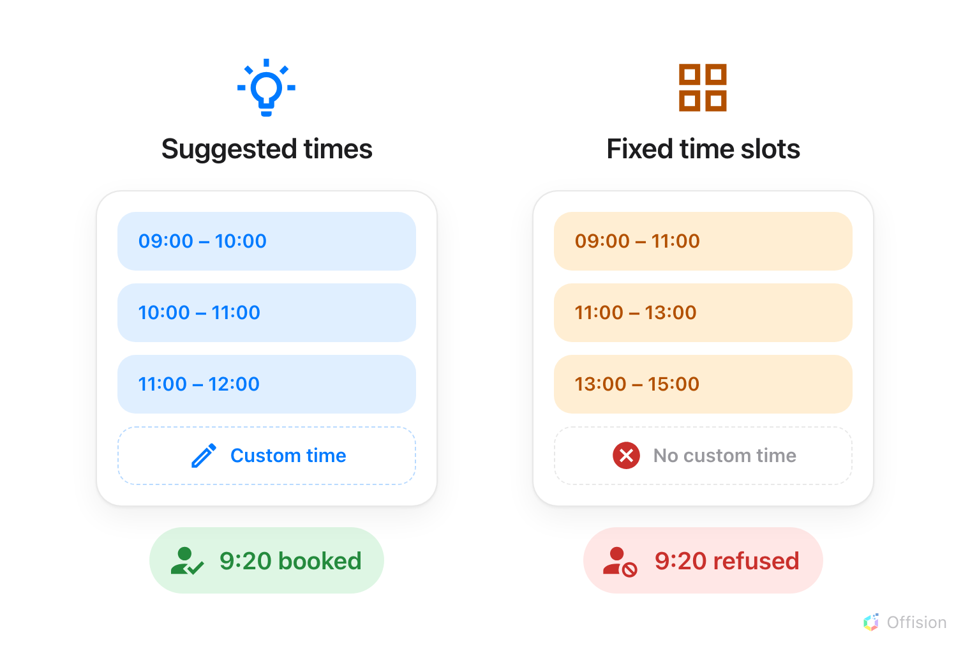
Both offer a list. Only one leaves a way off it.

1. Set one grid for the whole company
Start here. A company-wide grid is the one most estates need, and it is the only
one that reaches the booking form before a room has been picked at all — the
form asks for the period above the room, so until this existed the first field
anybody touched had nothing to suggest.
Where in Offision: admin app → booking/email-reminder (Email reminder settings)
Go to Booking › Setting / Email reminder. Suggested time slots is the
third group on the page, under the reminder settings. Switch on Show suggested
times — "Rooms without their own use these."
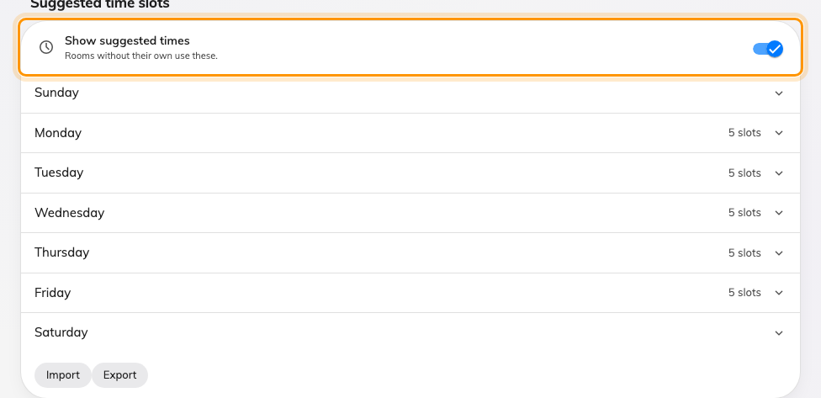
The Suggested time slots group, with the company-wide grid switched on.
The seven weekdays appear beneath it. Open one and add the blocks a normal day
is divided into; the count beside each weekday says how many it holds without
opening it. Import and Export at the foot of the group carry the whole
week as a spreadsheet, in the same format the per-schedule editor uses — so a
grid built in one place can be moved to the other rather than typed twice.
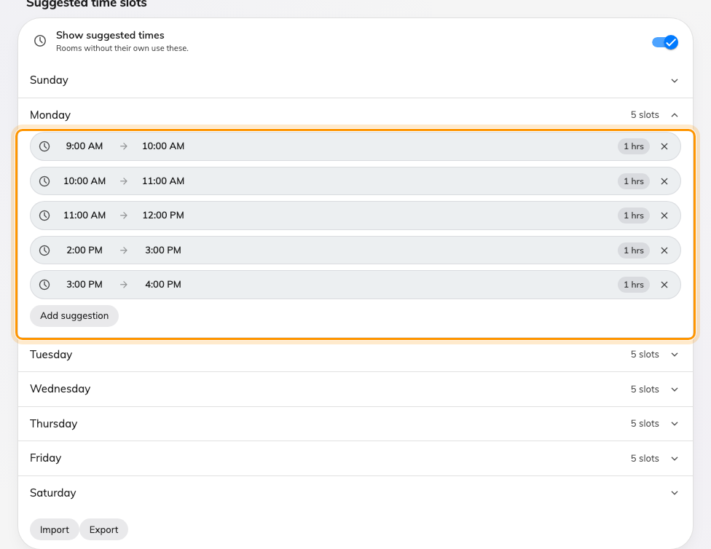
A weekday opened, with its blocks and Add suggestion.

2. Give a room its own, where it differs
Only if one has to. A room that should offer the same blocks as everywhere else
needs nothing here — it inherits.
Where a room genuinely differs — a studio booked in half hours, a hall booked in
mornings and afternoons — the list goes on the Booking hours schedule that
room carries, and it overrides the company grid for every room on that schedule.
Where in Offision: admin app → booking/business-hour (Booking hours)
Select the schedule and choose Edit, then its Suggested time slots page —
the third in the rail, with the total on a badge beside it. Each weekday says how
many blocks it holds, and a day the schedule closes is marked.
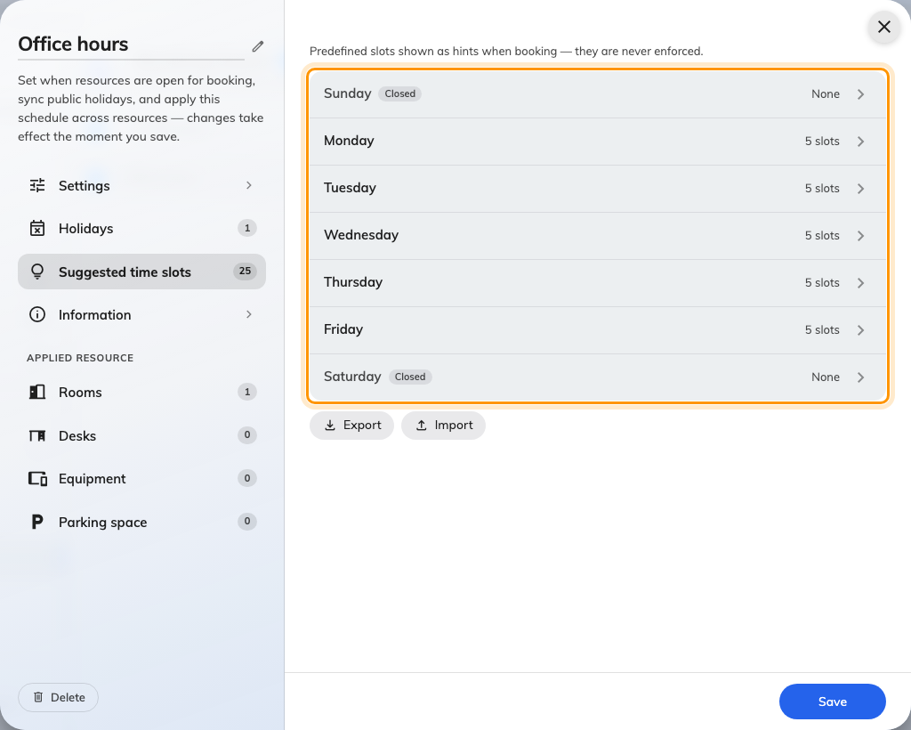
A schedule's own suggested times, one row per weekday.
Open a weekday for its own page of blocks, with the same row editor and the same
Add suggestion button.
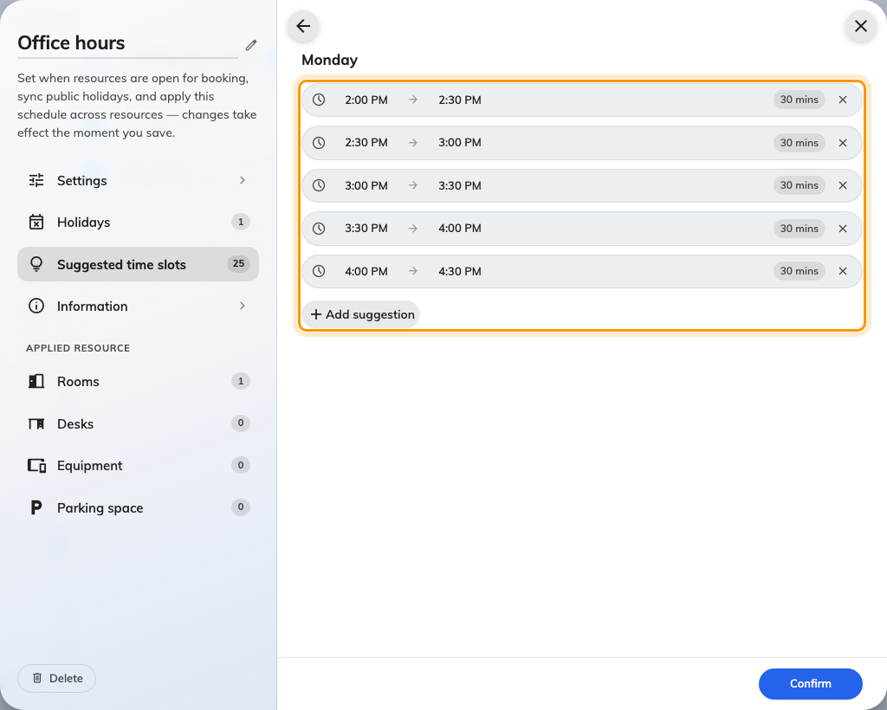
One weekday's blocks on a schedule — half hours, where the company grid runs in whole ones.
Setting up a schedule and attaching rooms to it is covered in
Business hours.

3. Which list a booker actually gets
The situation | What the booking form suggests
No room picked yet | The company-wide grid
The room has its own suggested times | The room's own list — it overrides
The room has none | The company-wide grid, inherited
The room is on fixed time slots | Its enforced grid — not a suggestion

The important row is the third. A room with no list of its own no longer offers
nothing: it falls back. So the suggestions never vanish when somebody picks a
room, they only narrow — which is the behaviour people can actually predict.
A room that should genuinely offer nothing is set that way by restricting it to
fixed time slots, not by leaving its suggestions empty.

4. Suggested, or fixed?
If | Use
People usually book the same blocks, but somebody occasionally needs twenty minutes or a long afternoon | Suggested times — the blocks are offered, Custom time is still there
The grid exists because something downstream depends on it — a cleaning round between slots, a shuttle, a class timetable | Fixed time slots — nothing else can be booked

You cannot have both:
While a schedule restricts booking start times, its Suggested time slots page
says so and accepts nothing: "Suggested time slots are unavailable while booking
timeslots are restricted." Suggestions the schedule already held are
discarded on the next save, so turning the restriction off again leaves an
empty list rather than the old one. The company-wide grid does not reach a
restricted room either.

5. What people see when booking
A fresh + Add booking opens on the list, with the next block already
selected. Nobody chose the period it seeded — the next hour, usually — so it is
moved onto the nearest block ahead of it rather than left between two.
A period somebody did choose is never moved. Drag the calendar, or open an
existing booking, and the form starts on Custom time: the ordinary date and
time pickers, with the list still beside them. Suggested times, at the foot
of the timeline, goes back to the blocks.
Open the form after the day's last block has passed and it moves to the next day
that still has one, rather than offering a column of elapsed times. The date
field says so.
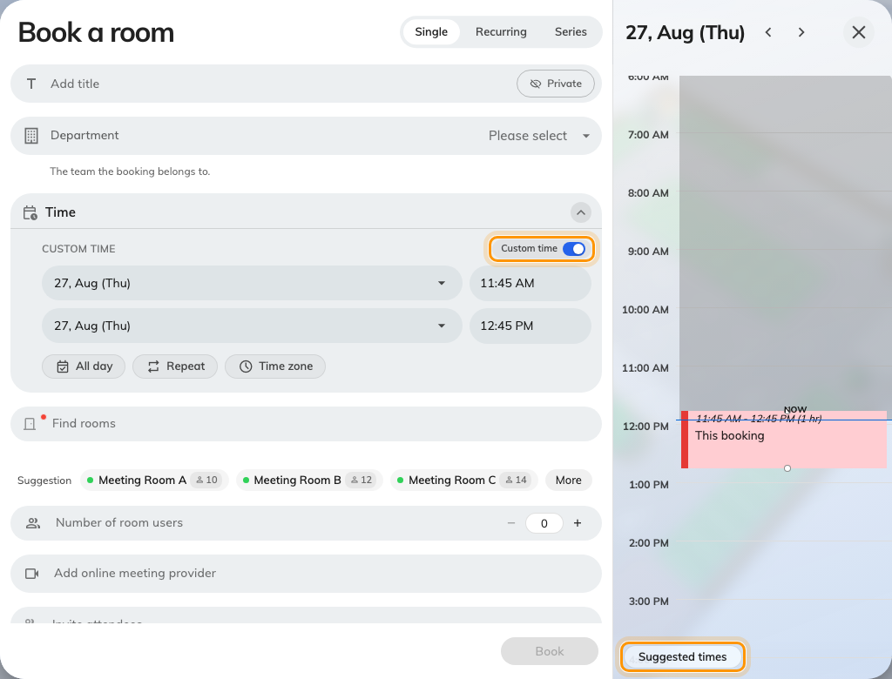
Custom time, and the two controls that move between it and the blocks.
Pick a room and the list narrows to that room's, or stays on the company blocks
where the room has none of its own. Tapping one sets the period; Custom time
under the list is still there.
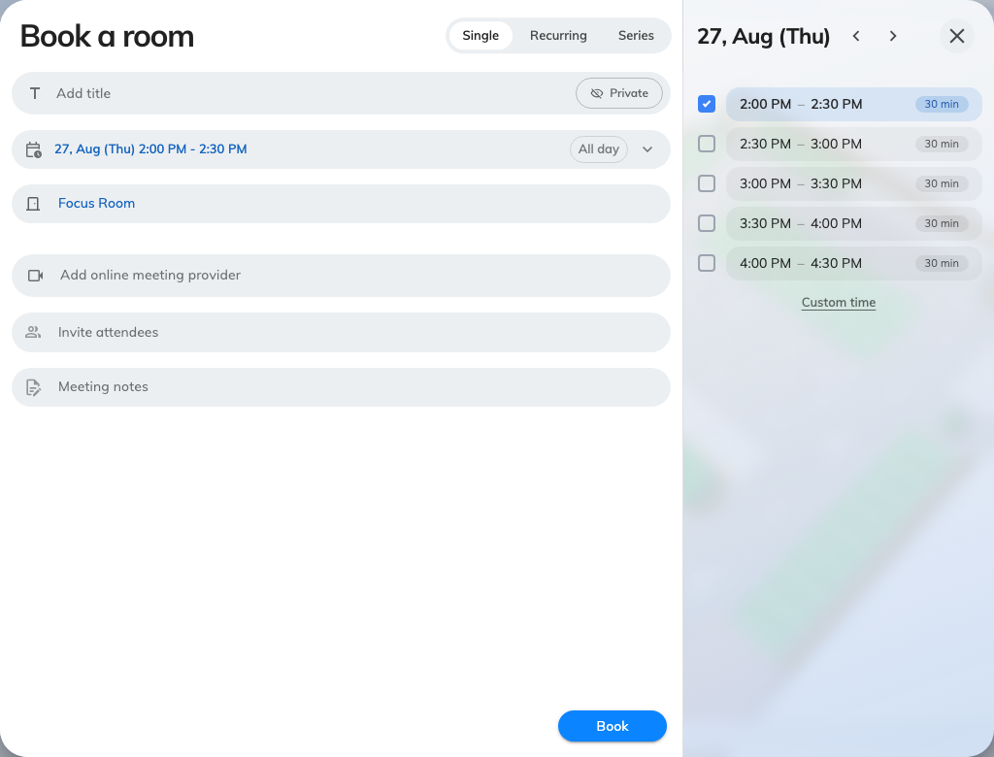
A room with its own half-hour list, replacing the company grid.
The Resource calendar in the user app paints the same blocks behind the day
as faint bands, so a room's suggested rhythm is visible without opening a form.
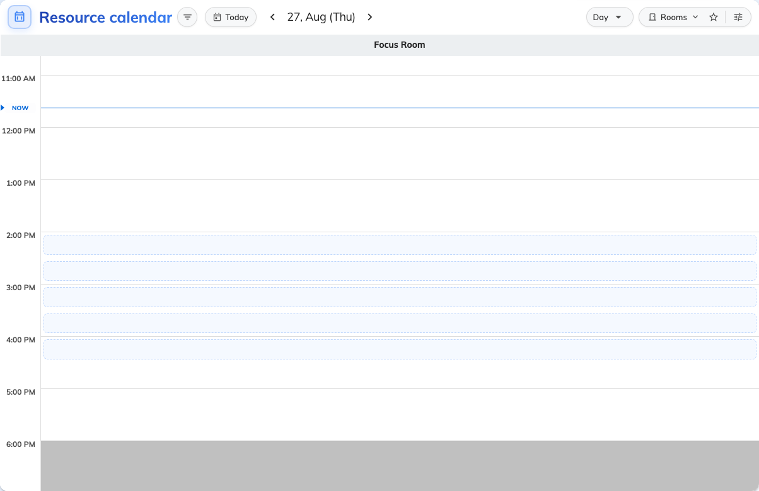
Suggestion bands behind the day on the Resource calendar.

6. Daylight saving
The company-wide blocks are stored as times of day and resolved against the
building's time zone each day, so a nine o'clock block stays at nine o'clock
across a daylight saving change rather than drifting by an hour.
A schedule's own suggestions do not work that way: a Booking hours schedule
freezes its offset when it is saved. If you have ever seen a schedule slip by an
hour in spring, that is the reason — and it is one more argument for keeping the
company-wide grid as the default and the per-room list as the exception.

7. Check it worked
Open the booking form and choose nothing at all. The blocks you entered should
already be on screen with one selected — that is the case that had nothing to
offer before, and it should not need a room, or a tap on Suggested times, to
appear.
Then pick a room with no suggestions of its own and confirm the same blocks are
still there, and a room that has its own and confirm the list changes to that
room's. Finally switch Custom time on and confirm the ordinary pickers come
back.

What this does not control
- Whether the times are enforced. These are hints, always. To make the
offered times the only bookable ones, use
fixed time slots.
- When a room is open. Suggestions are not cut to a room's business hours
or its holidays — a block outside them is still offered, and the booking is
then refused when it is saved. Keep the grid inside the hours the estate
actually opens. See Business hours.
- All-day bookings. Switch All day on and the suggestions step aside; an
all-day booking sets its own times.
- Room panels and lobby boards. Suggestions are offered in the app and the
web booking form. A panel by the door offers its usual durations.

