Move a booking on the management calendar
The one screen in Booking that shows the estate rather than configures it. Every room's day side by side, and a booking manager can drag anyone's booking to a different time or a different room — through a confirmation and the booking form, not straight into the database.
2026-08-18 · https://offision.com/help/en/booking/move-a-booking-on-the-management-calendar/
The management calendar is where a booking manager watches the estate instead of
configuring it: every resource's day on one grid, everybody's bookings on it, and
the ability to move any of them by dragging.
That last part is what separates this screen from the calendar your colleagues
use. In the app, people can only move their own bookings. Here, a manager can
move anyone's — which is how a room gets freed for the visitor who arrived early,
without asking the person who booked it to do it themselves.
Before you start:
You need read access to booking management. Without it, the page is not in the
menu.

1. Open the calendar
Where in Offision: admin app → booking/calendar (Management calendar)
The grid arrives showing today. The toolbar across the top adds new records —
Booking and Service — and exports what is on screen; the filters narrow
it by Location, Resource, category and More filters.
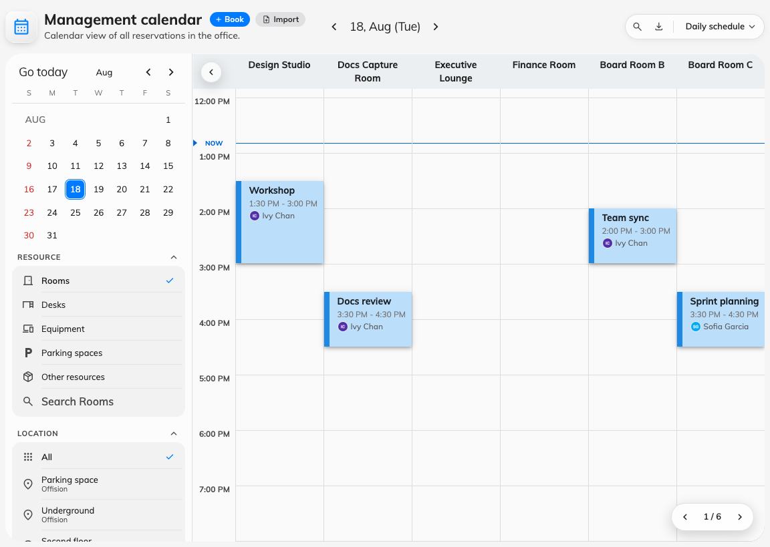
The management calendar on Daily schedule: a column per resource, everybody's bookings on it.
The view menu offers Daily schedule, Weekly schedule, Monthly
schedule and List, plus Show full day and Show weekend to widen
what the grid covers. Dragging works in the schedule views; the list is for
reading, not for moving.
How many resource columns fit on a page, how much of the day is visible, and
what each block prints are all set separately — see Density and
privacy and Colour-code the calendar by
booking purpose.

2. Find the booking and drag it
Drop it higher or lower to change the time, onto another resource's column to
change the resource, or drag its edge to change how long it runs. In the weekly
and monthly schedules the axes swap — resources become rows — but the gesture is
the same.
You are not limited to bookings you made — the only test here is the booking's
own state. A booking that has finished, been rejected or timed out will not lift;
one that is merely somebody else's will.
Everything on the grid that is not a booking is refused before the drag even
registers: business holidays,
out-of-service periods, service appointments and
public events all snap straight back.

3. Confirm, then finish in the booking form
Dropping the booking asks you to confirm, and then — unlike the app, which can
save a simple move outright — opens the full booking form with the new time
and resource already filled in. Save it there.
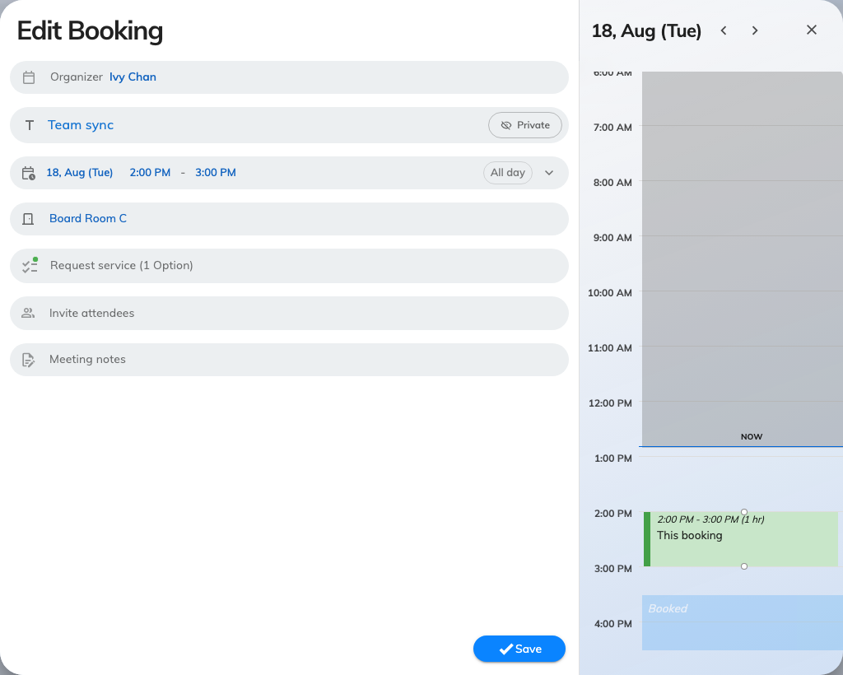
After confirming the drag: the booking form, with the new room and time already in it.
The route through the form is deliberate: moving somebody else's meeting often
means changing something else too — the room's services, the approval it now
needs, the attendees who have to be told. The form is where those are.
Note:
The block you dragged snaps back to its old position a few seconds later, then
the grid refreshes with the real answer from the server. That flicker is not a
failure — read the refreshed grid, not the snap-back.

4. Check it worked
Look at the booking in its new position on the refreshed grid. If the resource
requires approval, the move re-submits the booking and it will be waiting for a
reviewer — see
Approve or reject a booking request.

When a booking will not move
What happens | Why
The block will not lift | The booking is in a state that can no longer be edited — finished, rejected, cancelled or timed out
Not allow end before now | The new end time is in the past
It snaps back immediately, with no dialog | You dragged a holiday, an out-of-service period, a service appointment or a public event. None of them are bookings
You are asked about the series first | It repeats. Answer for this booking, this and after, or the whole series — each opens the form scoped accordingly
The form refuses to save | Clashes, quotas and booking rules are enforced on save, not on the drop. The drag never checked them

What this does not control
The management calendar moves bookings; it does not decide who could have made
them. Which resources a person may book, how far ahead, and whether a booking
needs approval all live with the resource and its rules — see
Booking rules reference.
It is also not the screen your colleagues use. Employees get their own calendar
in the Offision app, where they compare rooms and move their own bookings —
Compare room schedules and move a booking.

