Limit booking times to business hours
Bookings only stay inside opening hours when two settings are set together — a Booking hours schedule on the room, and a policy that forbids out-of-hours booking. Either half alone does nothing.
2026-08-25 · https://offision.com/help/en/booking/limit-booking-to-business-hours/
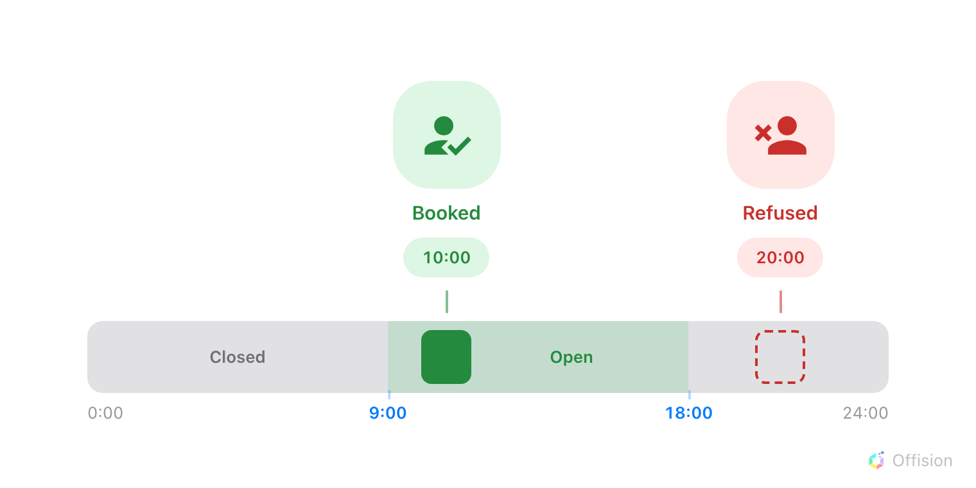
A booking has to land inside the room's open hours — outside them it is refused before it is ever created.
Before you start:
The rooms must already exist and be assigned to a booking policy.

1. Create the schedule
A schedule holds the opening hours for a set of resources: which days are open,
the open time ranges on each day, the time zone they are counted in, and the
holidays on which the whole day closes.
Where in Offision: admin app → booking/business-hour (Booking hours)
Choose Add, name the schedule, and set its Time zone — the hours you
draw are read in that zone, not in each user's. Then drag on the
Week timetable to draw an open period on each working day; click a drawn
period to fine-tune its start and end.
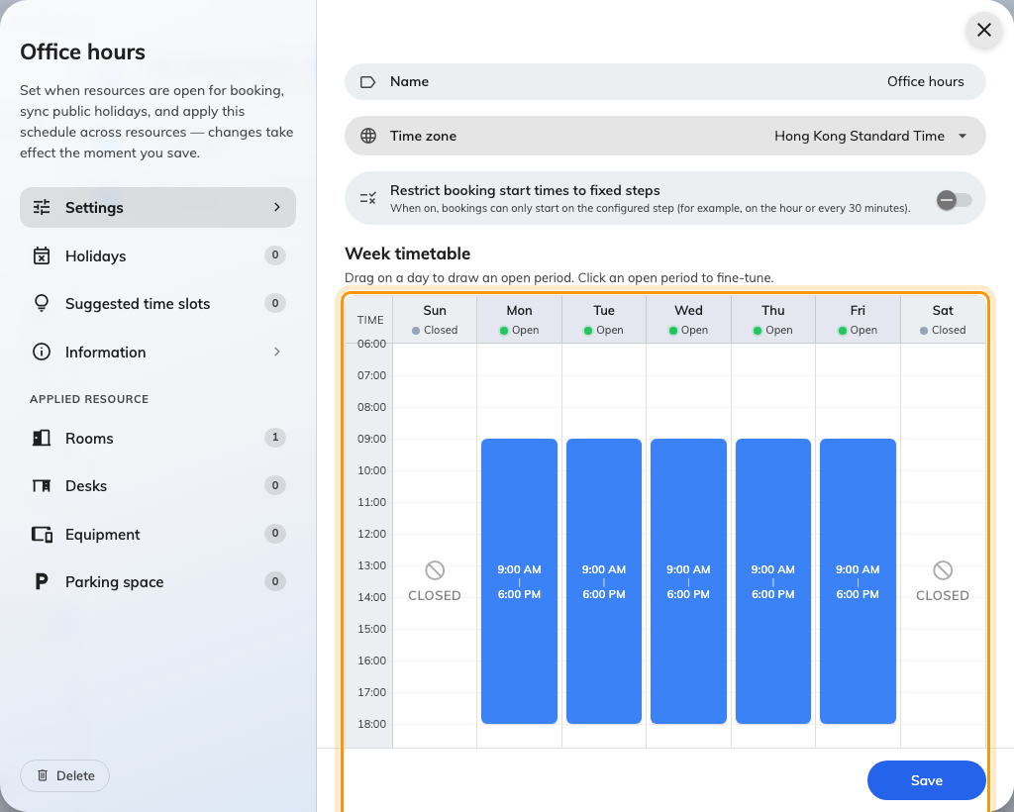
A schedule open in the editor, with the week timetable drawn Monday to Friday.
The Holidays page of the same editor closes whole days, whatever the week
timetable says for them. You can add dates by hand, import an .ics file, or
auto-sync a country's public calendar so next year's holidays arrive on their
own — see closing the office on public holidays.

2. Apply it to the rooms
A schedule does nothing until resources carry it. In the same editor, the pages
under Applied resource list your rooms, desks and equipment — tick the ones
this schedule should govern.
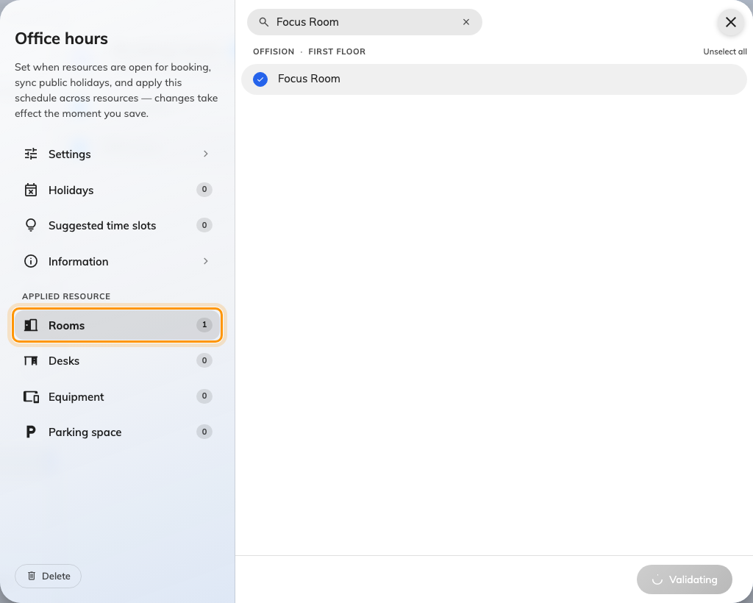
The Applied resource pages, where the schedule is attached to rooms.
The same link can be made from the other end: each room's own form has a
Business hour field. Both write the same setting, so use whichever end you
are already on — but check it, because a room with no schedule is untouched
by everything below.
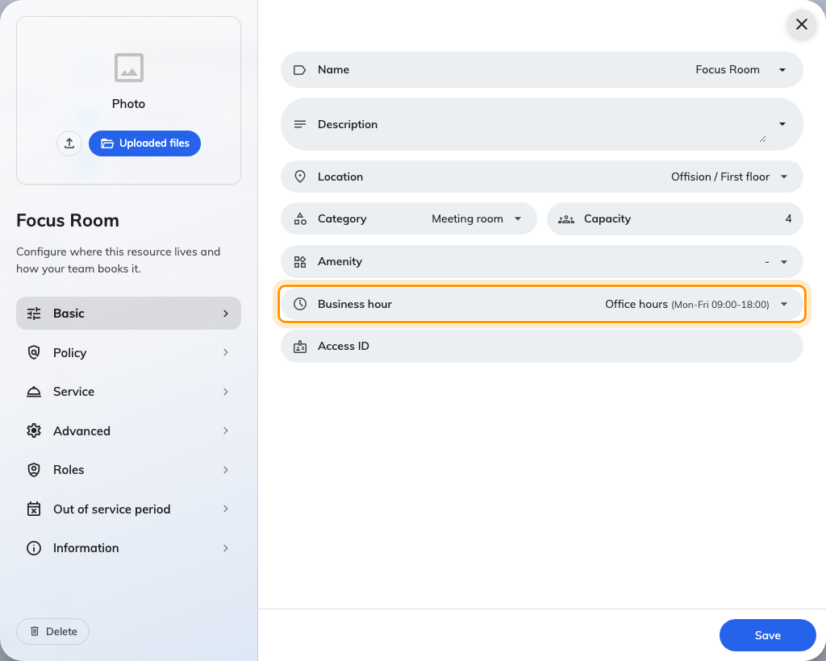
The room's own form, with the Business hour field carrying the schedule.

3. Forbid out-of-hours booking on the policy
The schedule alone only describes the opening hours; the booking policy is what
makes them binding.
Where in Offision: admin app → booking/advance-policy (Booking policy)
Select the policy those rooms use and choose Edit in the panel on the
right. In the editor's page list choose Booking policy — the second one —
and turn off Allow users to create out-of-business-hour booking.
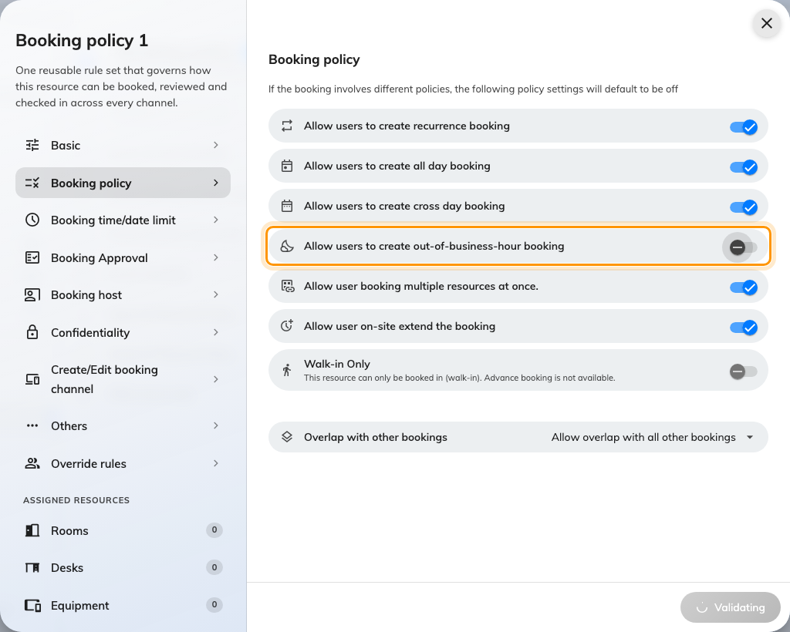
The Booking policy page, with out-of-hours booking turned off.
The two settings only work together:
A room is restricted only when it carries both the schedule and a policy
with this switch off. A schedule with the switch still on is decoration — the
closed hours show on the calendar but nothing stops a booking in them. The
switch with no schedule checks against nothing, and the room stays bookable
around the clock. Neither half warns you that the other is missing.
Two details worth knowing before you rely on it:
- A booking must fit inside one open period. Where a day is drawn as two
ranges — say 9:00–12:00 and 13:00–17:00 — a 9:00–17:00 booking is refused,
because it crosses the closed hour between them.
- A booking that holds several resources must fit the hours of every one of
them. And where one group of people should be exempt — security, facilities —
the policy's Override rules page can switch this back on just for them.

4. What people see when booking
Once both halves are in place, a booking placed outside the hours does not
save. The form refuses with the room's name and its open hours — the same
refusal for a closed evening, a weekend or a holiday:
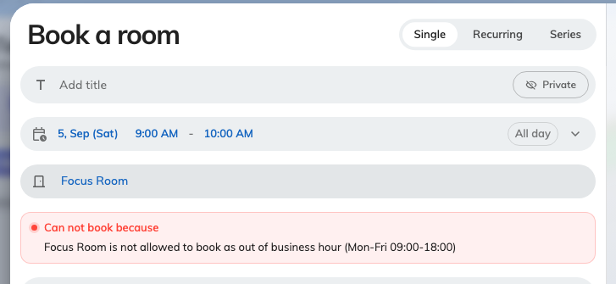
A booking placed outside the room's hours, with Book unavailable.
Suggested times do not play along, and it is worth knowing: the blocks
offered when booking are not cut to the room's open hours or its holidays, so
a block sitting on a closed evening is still proposed and the booking is then
refused on save. Keep a suggestion grid inside the hours the room actually
opens. Suggestions stay suggestions either way — to make the offered times the
only times, see Fixed time slots.
A schedule is no longer the only place suggestions can come from. Where a room
has none of its own it falls back to a company-wide grid, which is also what the
booking form offers before any room has been picked — see
Suggested times. Setting them
here still wins for the rooms on this schedule.

5. What the room panel shows
Outside its hours the panel by the door goes grey and reads
Out of business hour, with the room's weekly Open time underneath — and
on a holiday, the holiday's name. The booking and walk-in buttons are gone
while it shows.
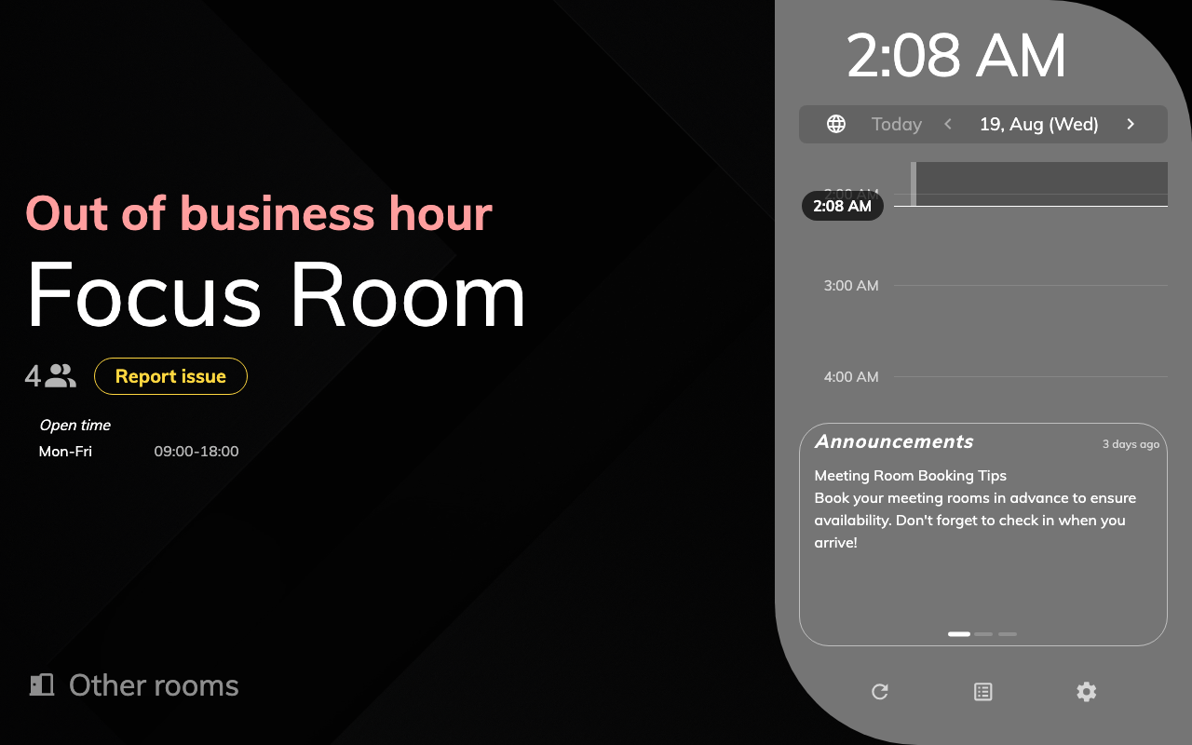
The panel outside business hours: no booking buttons, and the open hours on display.
The panel flips at the exact minute the schedule opens or closes. Inside the
open hours it behaves as usual, with one difference: booking from the panel
can only run up to closing time, so the offered durations shrink as the end of
the day approaches.

6. Check it worked
Sign in as an ordinary user and try to book the room outside its hours — a
weekend day, or eight in the evening. The form should refuse with the message
above. If the booking goes through instead, one half of the pair is missing —
the room is not on the schedule, or its policy still allows out-of-hours
booking.

