Let outside attendees check in with a booking pin
The one code you can hand to somebody with no account — six digits, different for every booking, and already in every mail Offision sends. Turning it on, where the code reaches, and what the panel does with it. About ten minutes.
2026-08-19 · https://offision.com/help/en/booking/let-outside-attendees-check-in-with-a-booking-pin/
Before you start:
The room must already exist, be attached to a policy, and have a panel outside
the door. If you are starting from nothing, set up a room
first.
Every other way of checking in at the panel identifies a person — a QR code, a
staff card, a passcode, a face — and each of them needs an account behind it, and
usually a phone or a piece of hardware in front of it.
The booking pin needs none of that. It identifies the booking: six digits
minted when the booking is made, different for every booking, and pushed out on
their own to the organiser's mail, to each attendee's invitation, and onto the
booking itself in the app. There is nothing to install, nothing to enrol and
nothing for you to distribute — by the time a client asks how they get in, they
have already been sent the answer.
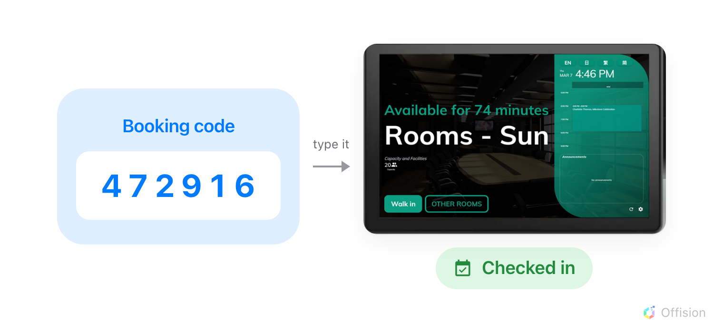
Type the six digits on the panel and that booking is checked in. The code identifies the booking, not the person, which is why the person needs no account.

1. Turn on Booking pin as a check-in method
The check-in methods are set once for the whole organisation, on User identify
settings. Turn on Booking pin.
Where in Offision: admin app → device/check-in-method (Check-in method)
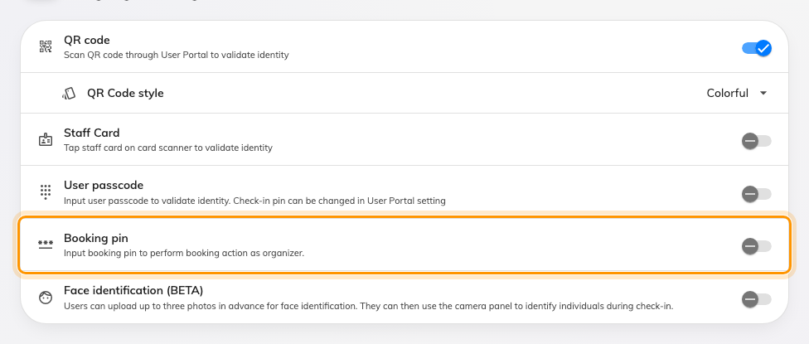
Booking pin, alongside the methods that need an account.
Leave at least one other method on. A booking pin only exists once a booking
does, so it is never offered to someone walking up to a free room — turn
everything else off and walk-in booking stops working, which is what the warning
at the top of the page is about.

2. Choose how long the code is
Booking PIN length sets the number of digits, from 3 to 8. Six is the
default and a good answer: it is what the panel's number pad expects and what
the email prints.
Shorten it only for a panel people will use in a hurry, and only if you are
comfortable that a shorter code is an easier code to guess.
Where in Offision: admin app → booking/email-reminder (Email reminder settings)
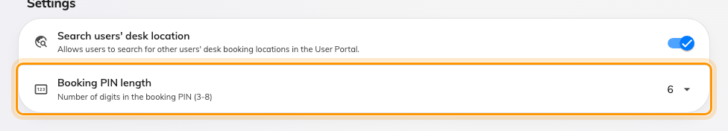
Booking PIN length, on the Settings card of the email reminder page.
The length applies to codes minted from now on. Bookings already made keep the
codes they were given.

3. Let attendees use the code
This is the step that decides whether an attendee ever sees a pin, and it is easy to
miss because it lives somewhere else entirely — on the policy the room uses,
not on the check-in settings you just changed.
Open the policy, and on its first page, under Check in/out, check that
Allow attendees to check-in / check-out / extend at the booking panel is on.
It is on by default — but a policy someone has already tightened is exactly the
kind that will have it off.
Where in Offision: admin app → booking/advance-policy (Booking policy)
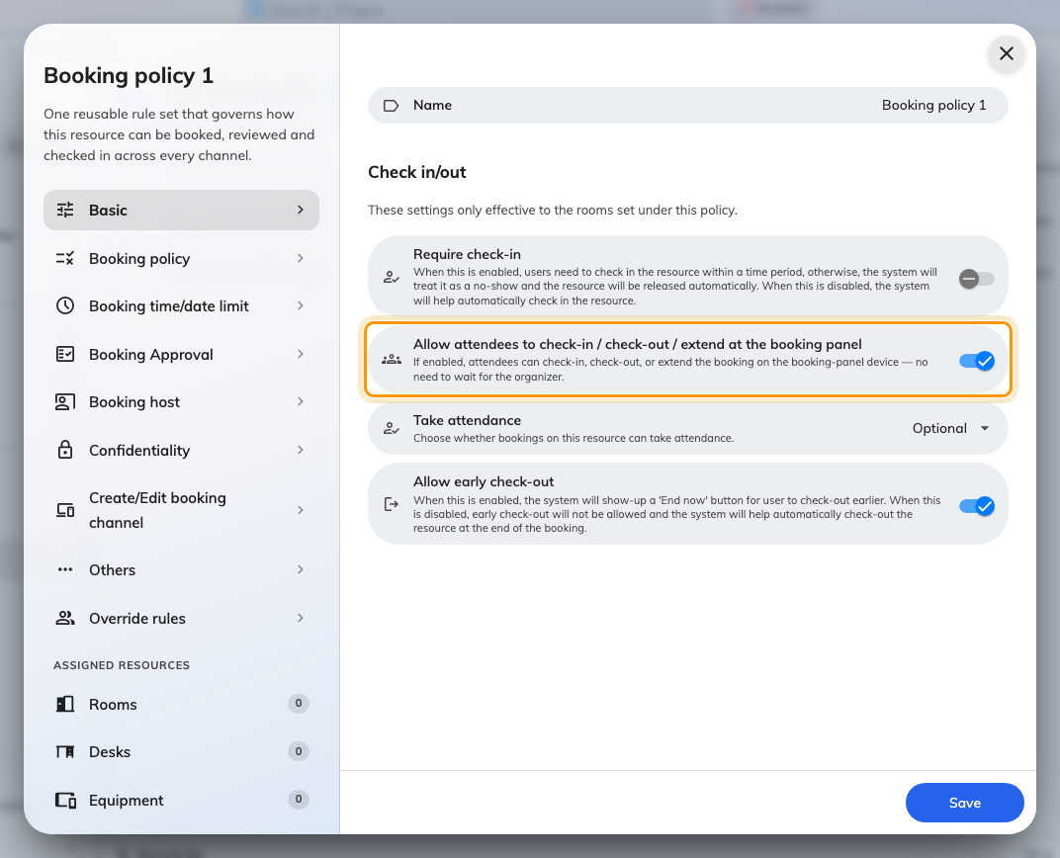
Off, only the organiser is sent the code. On, every attendee is.
With it off, the pin goes to the organiser alone and the attendee's invitation
arrives without a code — the room is not broken, the attendee simply has nothing
to type. With it on, everyone invited gets it.
While you are on the policy, check that booking email notifications are not
disabled on it. If they are, no invitation is sent at all and there is no code to
find.

4. Invite them by email
Add the person to the booking the ordinary way, by typing their address into the
attendee field and choosing Invite by email. They are recorded as an
Outsider — an attendee with no account, and none is created.
Someone signing in at reception is a different thing:
This gets someone into a room. If they also need signing in at the front desk,
a badge, and a record of when they arrived, they are a visitor rather than an
attendee — see Set up a visiting purpose,
which is what decides the details they are asked for.

5. Where the code shows up
You do not have to send it anywhere. Once step 1 is on, every booking mail
carries the code, printed large under the line "You may use the following code
to check in booking":
Mail | Goes to | Sent when
Booking created | the organiser | they book
Booking edited | the organiser | anything about the booking changes
Meeting invitation | each attendee | they are invited
Meeting update | each attendee | the booking changes under them

The organiser's copy always carries it. The attendees' copies carry it only where
step 3 is on — and where the policy disables booking email notifications, none of
the four is sent at all.
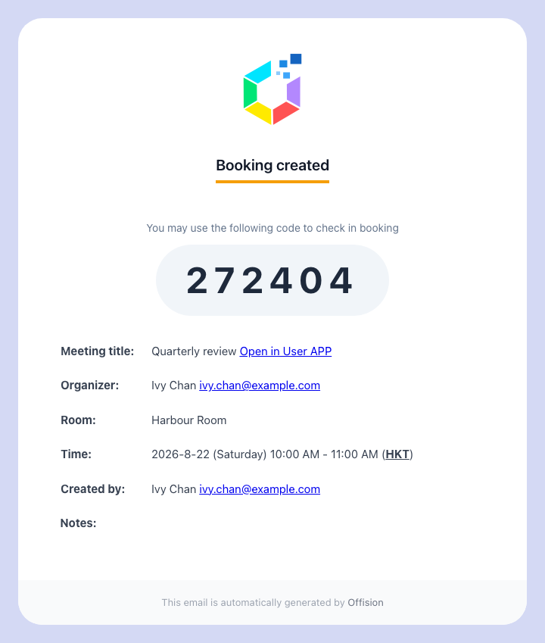
The organiser's own confirmation, with the code in the body.
The attendee's invitation carries the same digits, plus the calendar invite as
an attached file, so the meeting drops into whichever calendar they use and they
can accept or decline from there. Rooms always attach it; desks and equipment
attach it only when the policy says to.
Where the booking still needs approving, the code is shown with "Active after
approval." — it exists, but it will not work at the panel yet.
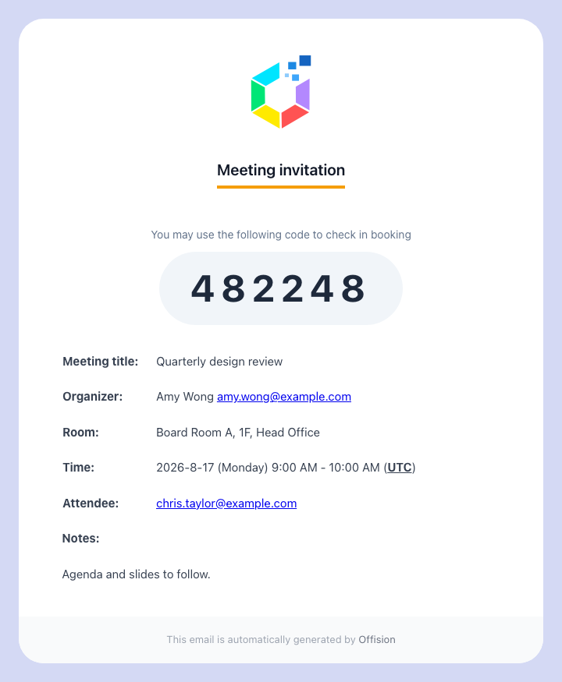
The invitation: the code in the body, the calendar file attached.
The code is also on the booking itself, in the app — a Booking code row on
the booking's own card, which is the fastest place for an organiser to read it off
when somebody rings and asks. The same rule decides who sees it: the organiser
always, an attendee only where step 3 is on. Find and share your booking
code is the page to send
people.
It is not in the calendar file:
The attached .ics carries the meeting, not the code — so an attendee who accepts
the invitation and then deletes the message has kept the meeting and thrown away
the code. That is most of the "they never got a pin" reports. Tell them to keep
the mail, or be ready to read the code back to them.
One exception: for a booking made from Outlook or Google, the room's
acceptance carries the code in its reply, where Outlook shows it under its own
"Accepted" heading.

6. Checking in at the panel
At the door, the attendee taps Check in. Where more than one method is enabled
the panel asks first — Choose authentication method — and the booking pin is
the teal tile. Checking in at the booking panel
covers the rest of what that screen offers, and why a button can go missing from it.
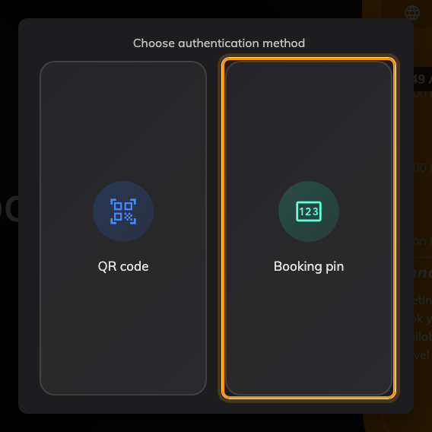
The booking pin sits beside the methods that need an account.
Then the number pad, with a reminder of where to find the code.
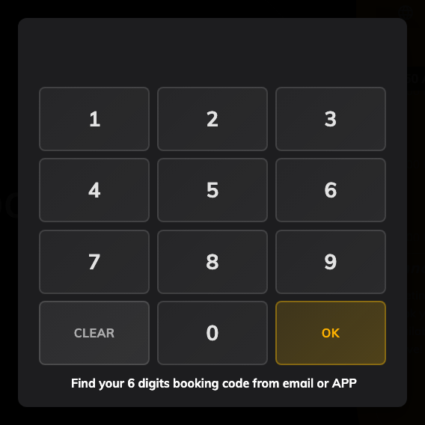
The number pad, with the expected digit count in the footer.
Four things worth knowing before someone asks:
- The same code also checks out and extends, not just checks in. An attendee who
needs another twenty minutes can take them at the panel.
- The check-in is recorded against the organiser. The pin identifies the
booking, and the booking's organiser is who the panel credits — so the
attendance record will not name the attendee who actually stood there.
- A wrong code is not locked out. There is no attempt counter and no cooldown;
a rejected code simply clears the pad.
- A repeating booking has one code for the whole series, not one per
occurrence. Convenient for a weekly meeting with the same outside attendees; worth
knowing before you give the code to somebody who should only be in the building
once.

7. Check it worked
Book the room, add an address you can read as an attendee, and open the mail.
The code should be in the body and the calendar file attached. Type the code at
the panel and the booking should check in.
If the mail arrived with no code in it, the cause is almost always step 3 — the
toggle is off, or the room is on a different policy from the one you edited.
Same code, two names:
The admin console and the panel call it the booking pin. The user app and the
lobby board call it the booking code. There is only one number.
It never expires:
The code is minted once and kept. Editing the booking, moving it, or sending it
back for approval all leave it alone — so a code given out weeks ago still works,
right up until the booking itself is over or cancelled.
It cannot be changed on one device:
Unlike the other check-in methods, the booking pin is set for the whole
organisation and cannot be overridden on an individual panel. A room that should
not accept it needs a different approach — restrict who can book it instead, as
in Give a department its own rooms.

