Let managers book further ahead than everyone else
Keep the booking window short for everyone, then give one user group — the management team — a longer horizon with an override rule on the same policy. About five minutes.
2026-09-02 · https://offision.com/help/en/booking/let-managers-book-further-ahead/
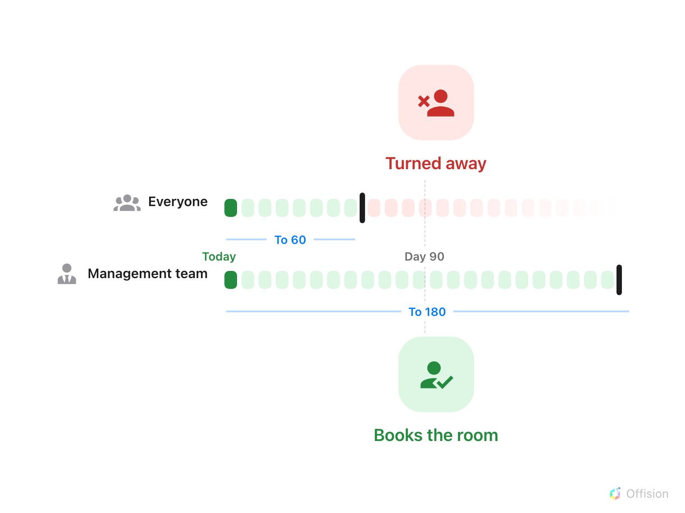
The policy's window still applies to everyone — except the group named in the override rule, which carries a window of its own.
Before you start:
The rooms' policy should already carry a booking window — set one up with
Booking window first.

1. Put the managers in a user group
An override rule targets users or user groups. Use a group — people are promoted
and leave, and a group means the rule never has to be edited for that. Offision
ships a Department category of groups, so a suitable one may already exist;
see Create a user group if not. This
article uses a group called Management team.
Where in Offision: admin app → directory/user-group (User groups)

2. Open the policy those rooms use
The rule lives on the booking policy, beside the window it overrides — not on
the room, and not on the group. Select the policy, then choose Edit in the
panel that opens on the right.
Where in Offision: admin app → booking/advance-policy (Booking policy)

3. Add an override rule for that group
In the editor's page list choose Override rules — near the bottom, with a
badge counting the rules the policy already has. Choose Add Override Rule
and fill in the three parts every rule has:
- Name — name it after the group: Management team. The list you come back
to shows only these names, so a rule named after its group reads as policy.
- Override condition — Organizer applies when these people create or
edit their own bookings, which is the case here. Booking manager instead
applies when they work through the admin console on anyone's booking.
- User(s) / user group(s) — pick the Management team group.
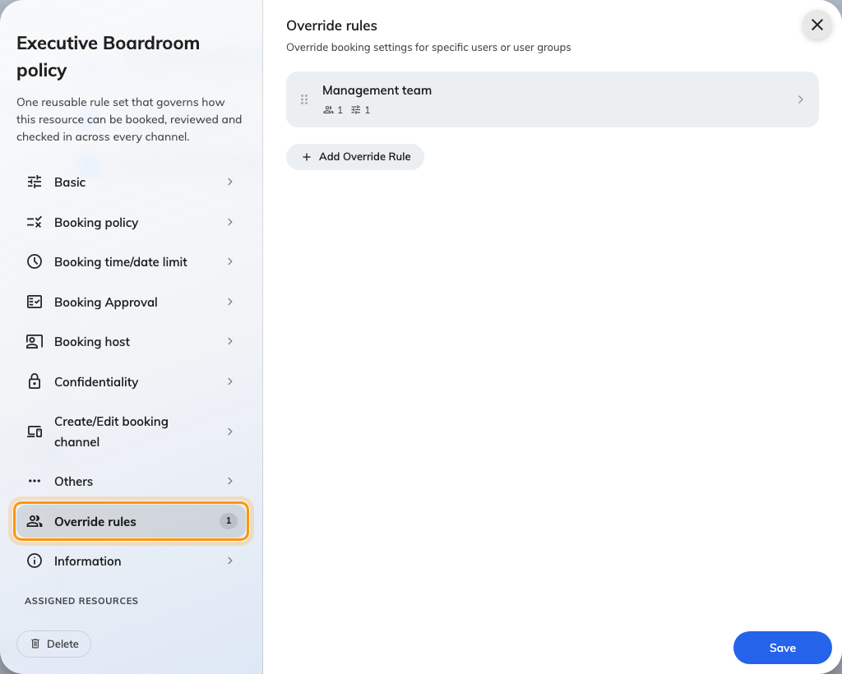
Override rules, in the policy editor's page list.
A person is matched by at most one rule per policy: the first matching rule from
the top wins. If you add a second rule later — say a wider one for directors —
drag the more specific rule above the more general one.
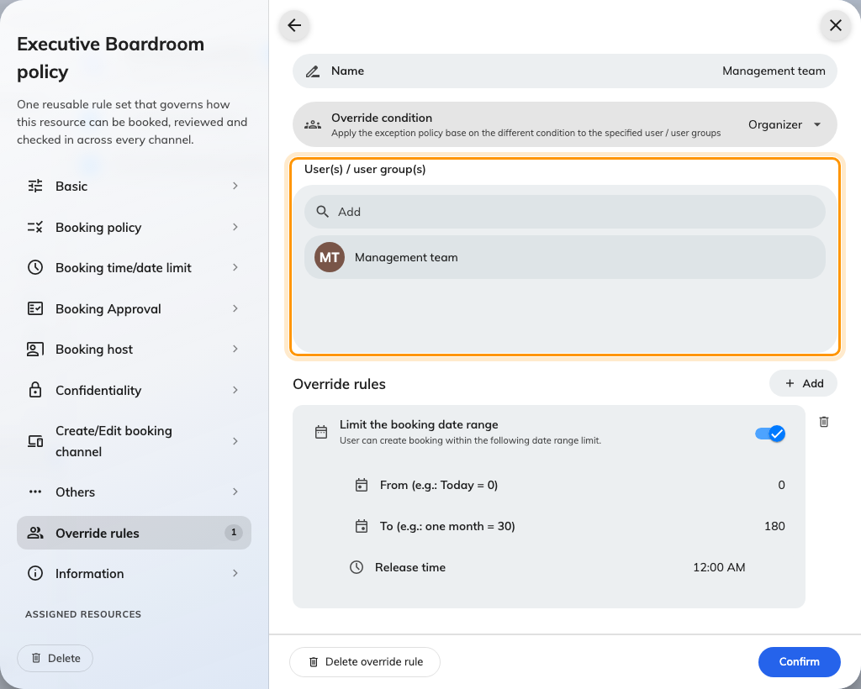
One rule: a name, the condition, and the group it applies to.

4. Give the rule its own date range
Under Override rules inside the rule, choose Add and pick Limit the
booking date range. The same control as the policy's own page appears —
From (e.g.: Today = 0), To (e.g.: one month = 30) and Release time —
but what you set here applies only to the people in this rule. With the policy
at To 60, give the management team To 180: six months of horizon against
everyone else's two.
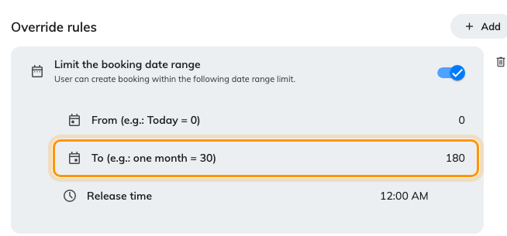
The rule's own window: To 180 for the management team.
Two details are easy to misread:
- Only the settings added to the rule change. Everything not listed in the
rule follows the policy unchanged — a rule with just the date range in it
alters nothing else about how these people book.
- Adding the row with the toggle off removes the window entirely for these
people, rather than leaving the policy's. A ceiling still applies — the
system-wide maximum of 365 days — but nothing shorter.
Save the policy when you are done.

5. Check it worked
Sign in to the user app as someone who is not in the group and try one of the
rooms about three months out — the date is refused, or simply unavailable in the
picker. Then try the same room and date as a member of the Management team
group: the form accepts it without complaint.
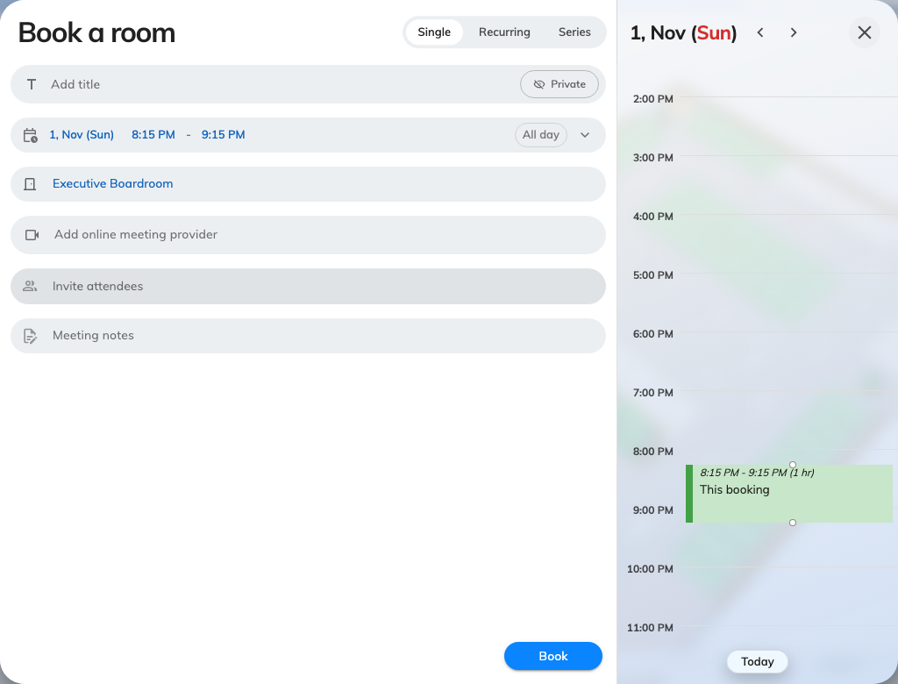
The same date that everyone else is refused, accepted for a manager.
If the manager is refused too, they are not in the group, or the rule's date
range row was never added — a rule with no settings in it overrides nothing.
A longer window, not their own rooms:
An override rule changes how far ahead these people can book rooms everyone
shares. To reserve a set of rooms for the group outright, use a team space
instead — see Give a department its own rooms.

