Import bookings from a spreadsheet
Bulk-create bookings from an Excel file on the management calendar: download the tenant's own template, fill one row per booking, fix what the preview flags, then book everything at once — and re-import whatever was skipped.
2026-09-04 · https://offision.com/help/en/booking/import-bookings-from-a-spreadsheet/
One row per booking, one file for the lot: the management calendar's Import
takes an Excel sheet and turns it into real bookings, with every rule — clashes,
quotas, booking windows — still enforced. It is the fastest way to load a term's
recurring meetings, and the way to bring your booking history's future half with
you when moving in from another system.
Before you start:
You need write access to booking management, with editing enabled on the
management calendar. Rooms are named in the sheet by their Access ID or
room email — so the rooms must exist first.

1. Open the calendar and press Import
Import sits beside Book at the top of the management calendar.
Where in Offision: admin app → booking/calendar (Management calendar)
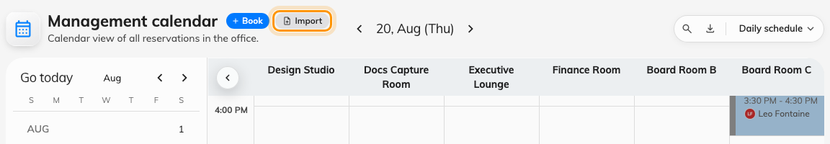
Import, next to Book on the management calendar.
The dialog that opens has pages down the left: Import, Import IDs, and —
when your tenant uses booking purposes — Purpose IDs.
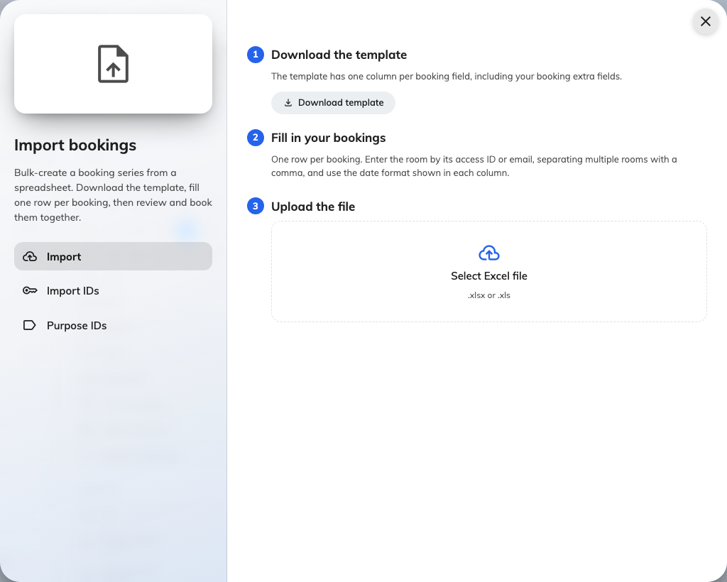
The Import page: download the template, fill it in, upload it back.

2. Check every room has an import ID
The sheet names a room by its Access ID or its email address — never by its
display name. The Import IDs page lists every bookable room with both, each
with a copy button, and Download takes the whole table as its own Excel file
to keep beside the template while you fill it in.
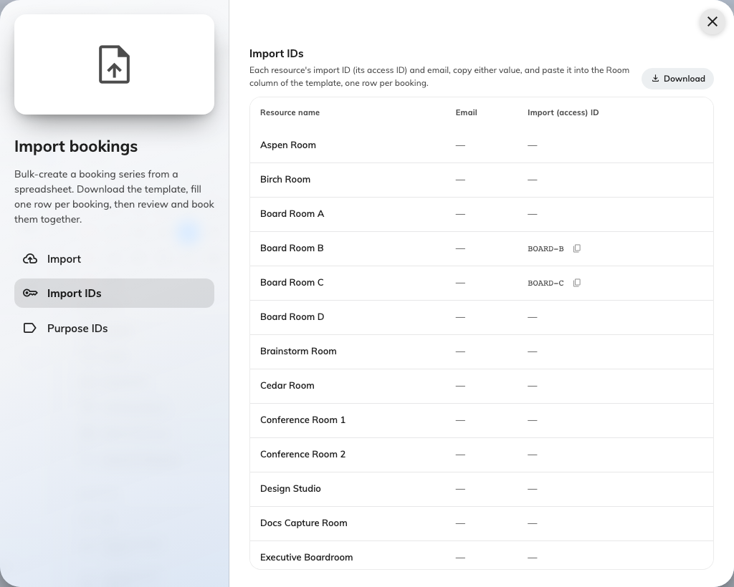
Import IDs: every room's access ID and email, ready to copy.
A room with no Access ID and no email cannot be named in the sheet. Point at
its row and a pencil appears — it opens the resource form so you can give it
one without leaving the dialog; the field is Access ID, on the resource's
basic page.
If your tenant asks for a booking purpose, the Purpose IDs page does the
same job for purposes. A purpose's Import ID is set on the purpose itself;
the row's pencil opens it too.
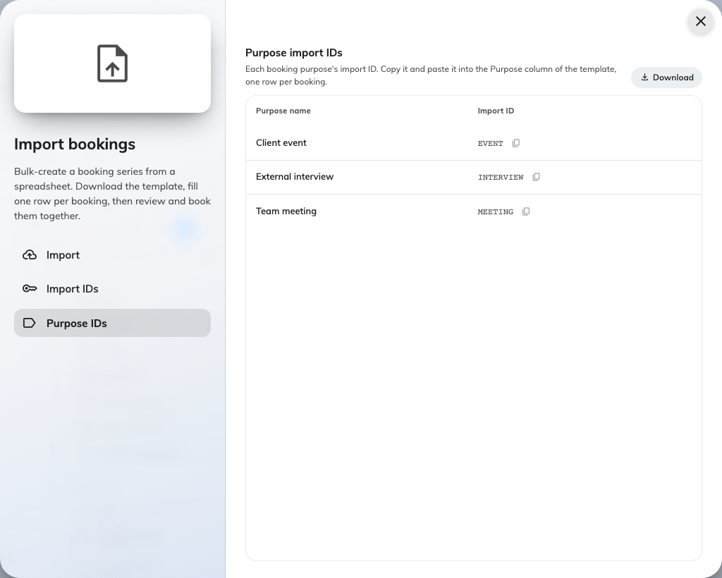
Purpose IDs: the code the Purpose column expects.

3. Download the template
Download template builds the file from your own tenant — your purposes, your
booking form's extra fields — so the columns below are the general shape, not
necessarily your exact sheet. It arrives with one sample row showing the
expected formats.
Column | What goes in it
Purpose import ID | Only present when your tenant has booking purposes. The purpose's import ID, from the Purpose IDs page. Leads the sheet
Subject | The booking's title
Start / End | YYYY-MM-DD HH:mm
Room import ID | The room's Access ID or email. Several rooms on one booking: separate them with commas
Attendees | Email addresses, comma-separated
Organizer | A user's email address. The booking is made in their name, under their permissions
Number of room users | A number, for rooms that count occupancy
Meeting notes | The booking's notes — the same field the booking form shows, under the same name (if your form calls it Remarks, so does the column). Each line becomes a paragraph; leave it blank for none
Series ID | Optional. Rows sharing a Series ID become one booking series; blank rows stay standalone
One column per extra field | The header carries the format it wants — YYYY-MM-DD, HH:mm, yes/no, 123, or the option names

Extra fields that take a file or formatted text cannot ride in a spreadsheet
and are simply not in the template — set those on the booking afterwards if you
need them.

4. Fill in your bookings
One row per booking. Three habits keep a big sheet importable:
- Do not reorder or delete columns. The file is read by position — which is
also why a sheet built from a template downloaded before 4.5.14 no longer
lines up: Meeting notes now sits after Number of room users, so
Series ID and the extra fields moved one across. Download the template
again rather than editing an old sheet.
- Blank rows are skipped, and every message you see later names the row by its
real Excel row number — so leaving gaps is safe, shuffling is not.
- Give repeating meetings one Series ID each (Q3-PLAN, STANDUP), so they
arrive grouped as a series instead of as loose bookings.

5. Upload it and fix what it flags
Drop the file on Select Excel file (.xlsx or .xls). The dialog reads it
and answers with one line — ready and need attention counts — and then
lists only the rows with a problem, each showing just the field that failed:
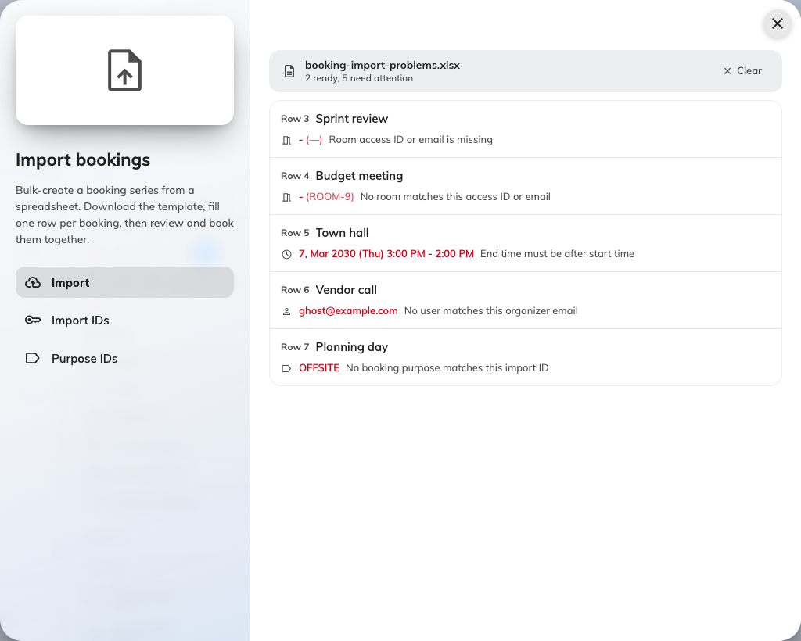
Only the problem rows are listed, each with the one field that failed.
What it says | What it means
Room access ID or email is missing | The Room column is empty on that row
No room matches this access ID or email | At least one of the row's room keys is not on the Import IDs page
Start or end time is missing or invalid | A time cell is empty or not YYYY-MM-DD HH:mm
End time must be after start time | The two cells are swapped, or equal
No user matches this organizer email | The Organizer address does not belong to a user who can book
No booking purpose matches this import ID | The Purpose cell does not match anything on the Purpose IDs page
Duplicate of an earlier row (same room and time) | Two rows would create the same booking; only the first is kept

Fix the sheet in Excel and upload it again — Clear discards the current
file. A sheet with nothing to flag does not pause here at all: the moment every
row is clean, the dialog moves straight on.

6. Review and book
The clean rows land in the booking form's series overview — grouped by Series
ID, each row checked against the server for the things a spreadsheet cannot
know: clashes with existing bookings, quotas, booking windows and the rest of
the booking rules. A row that fails any of them
shows as a conflict; the overview names the person it clashes with when that is
the reason, but it does not say which rule refused the others — open the row
if you need to know.
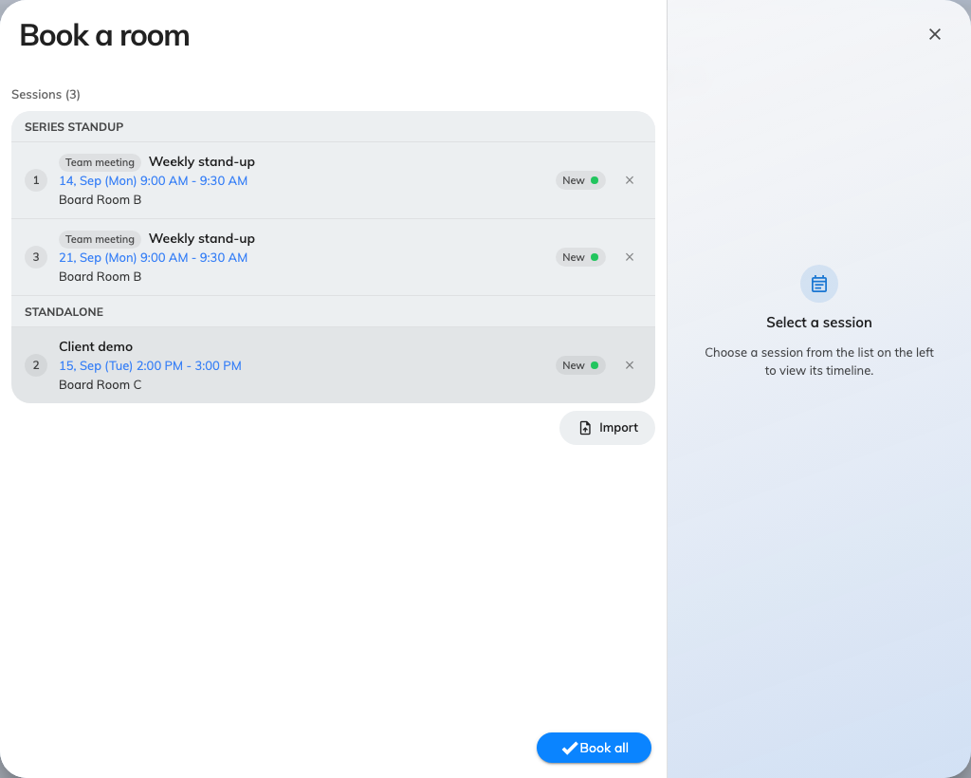
The imported rows, grouped by series and checked against the estate.
Two ways to finish:
- Book all — books everything, and stops if anything cannot be booked.
- Skip conflicts & book — books what it can and sets the rest aside.

7. Collect the leftovers
After Skip conflicts & book, the Bookings created dialog counts what was
Booked and what was Bypassed, with the reason on each skipped row — and
its own instruction: Fix the skipped rows and import them again.
Download takes the skipped rows as a spreadsheet in exactly the template's
columns, plus one trailing Import result column carrying the reason. Fix
the cells, and the same file goes straight back into step 5 — the result column
is ignored on the way in. Export all takes every row, marked Success or not,
as the import's record.
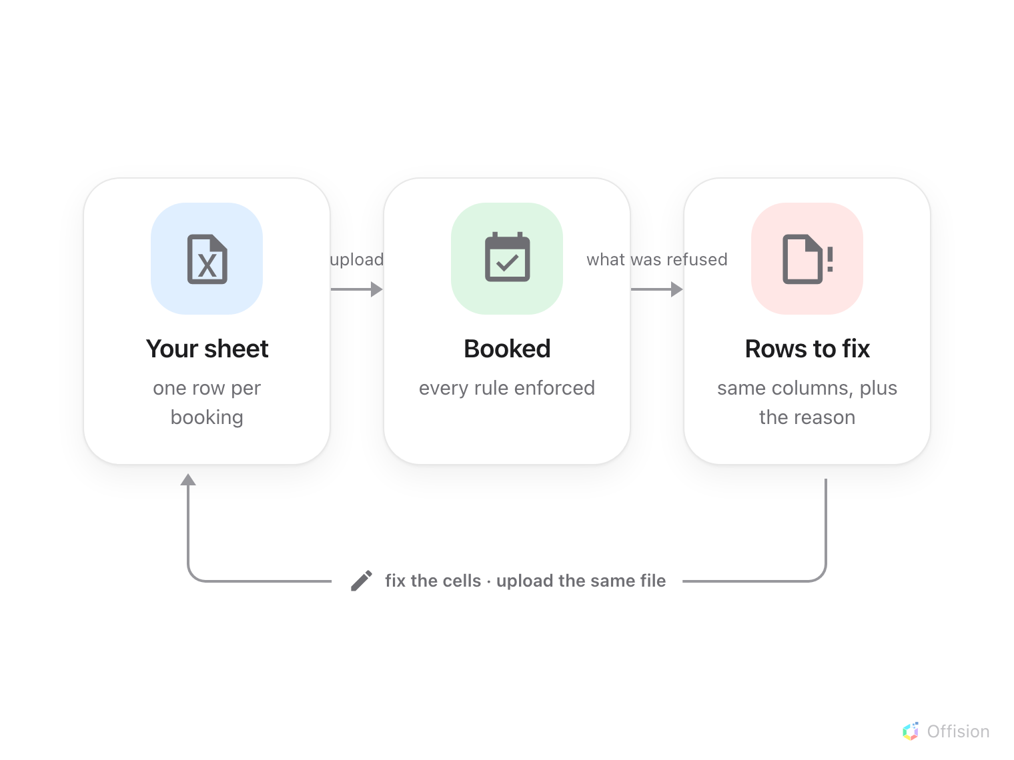
Whatever cannot be booked comes back as a spreadsheet in the same columns, so fixing and re-importing is the same file going round again.

8. Check it worked
The new bookings are on the calendar behind the dialog — filter to one of the
imported rooms and look at the week you loaded. A booking made for a room that
requires approval arrives as a request, not a confirmed booking — see
Approve or reject a booking request.

What this does not cover
- The export button is a report, not a round-trip. The download icon on the
same toolbar produces the booking report — check-ins, durations, attendee
counts — whose columns do not match the import template. To reproduce
bookings elsewhere, keep the sheets you imported.
- Employees have their own version. In the Offision app, the booking form's
Multiple page carries an Import for a personal series — same template,
minus the Organizer column, because the booker is always the organizer.
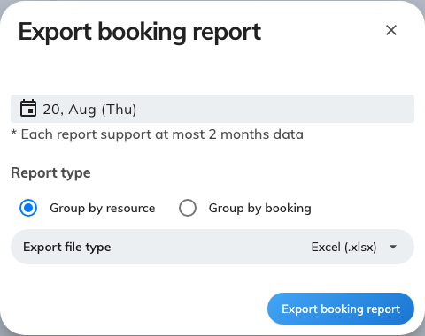
Export booking report: a report of what happened, not an importable file.

