How check-in and no-show work
Check-in is what turns a booking into a used room. Without it the room is given back — and the timer that decides when is not called what you would expect.
2026-08-16 · https://offision.com/help/en/booking/how-check-in-and-no-show-work/
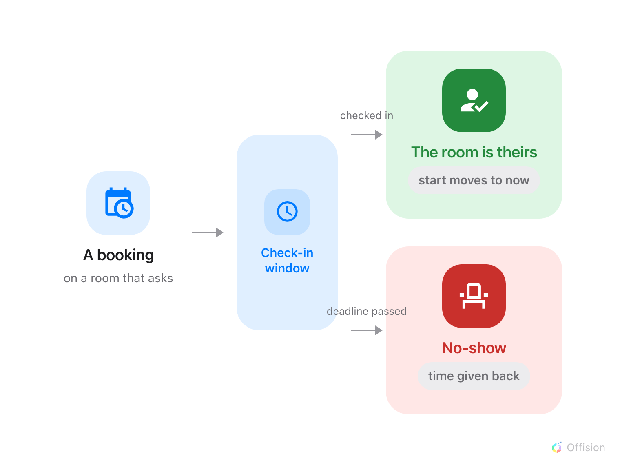
Every booking leaves by one of two doors: somebody checks in and the room is theirs, or nobody does and the room goes back.
Check-in is the step that turns a booking into a room somebody is actually using.
Where a resource requires it, a booking that nobody checks into is recorded as a
no-show and the room is given back.

The timer is not called what you expect
There is no setting named "auto-release". The deadline is a field called Can
check-in after (in mins), in the Check in/out group of the resource's policy.
It is written as a permission — how late somebody may still check in — and it is the
same number that decides when the room is taken away.
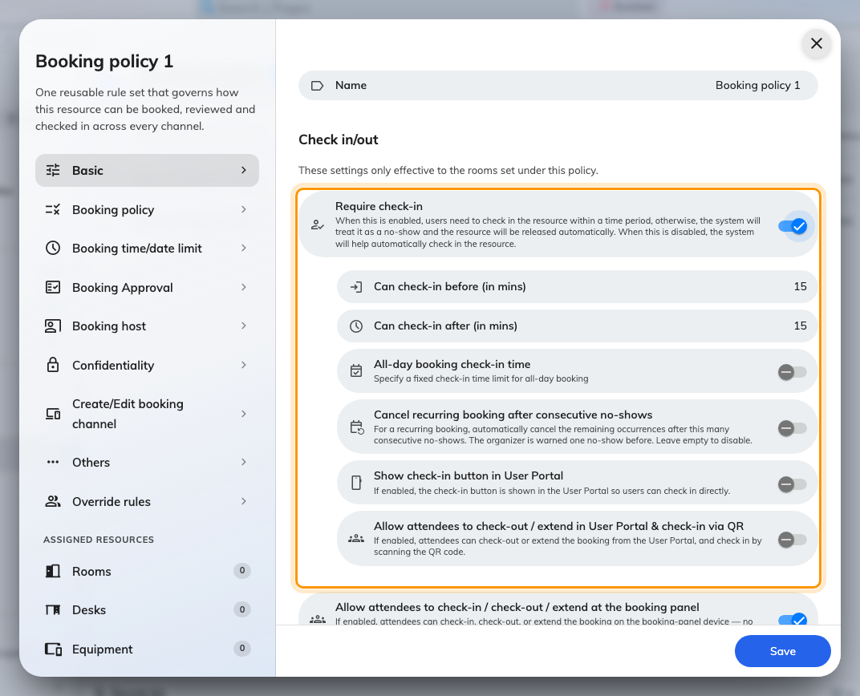
Require check-in, and the two numbers that open and close the window.
Nothing happens at all unless Require check-in is on. With it off, the system
checks the booking in on the organiser's behalf and the room is held for the full
booked period — which is why an unattended booking on a relaxed policy looks like a
fault and is not one.

The window, and where it closes early
Both numbers are measured from the booking's start time — one backwards, one
forwards.
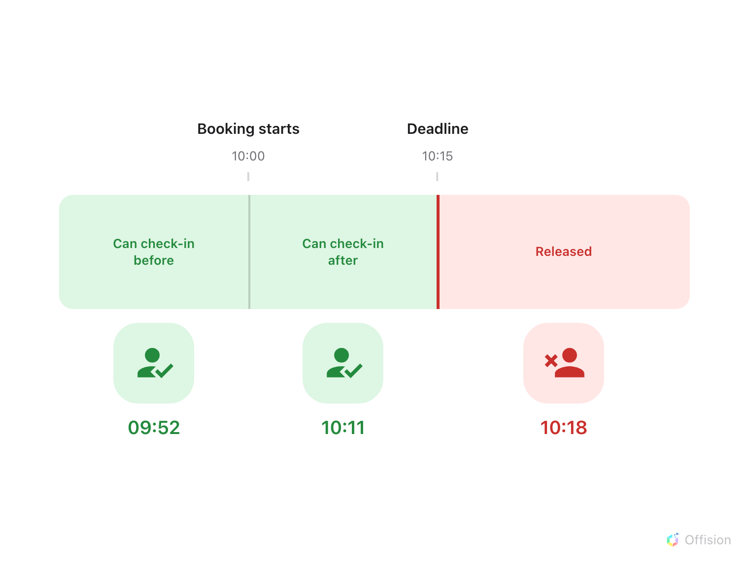
Both ends are counted from the booking's start, and the room is released the moment the right-hand end is reached.
Three things close it earlier than the arithmetic suggests:
- The booking's own end time wins. A 10-minute booking on a policy with a
15-minute grace has a 10-minute window, not 25.
- All-day bookings ignore the window entirely when All-day booking check-in
time is set, and use that clock time as the deadline instead. A midnight start
makes a window measured in minutes meaningless.
- A booking on several resources takes the strictest policy. The smallest before
and after values across every resource in the booking are the ones that apply.

Releasing is a real release
A no-show is not only a label. The resource's reserved period is shortened to the
moment of release, so the rest of the slot is genuinely free and shows as free
everywhere. On a room synced from Microsoft 365 or Google, the shortened period is
pushed back to that calendar too.
Checking in rewrites the booking the same way, in the other direction: check-in
moves the start to now, and checking out moves the end to now. The record ends up
describing what happened rather than what was booked, which is what makes the usage
figures worth reading.
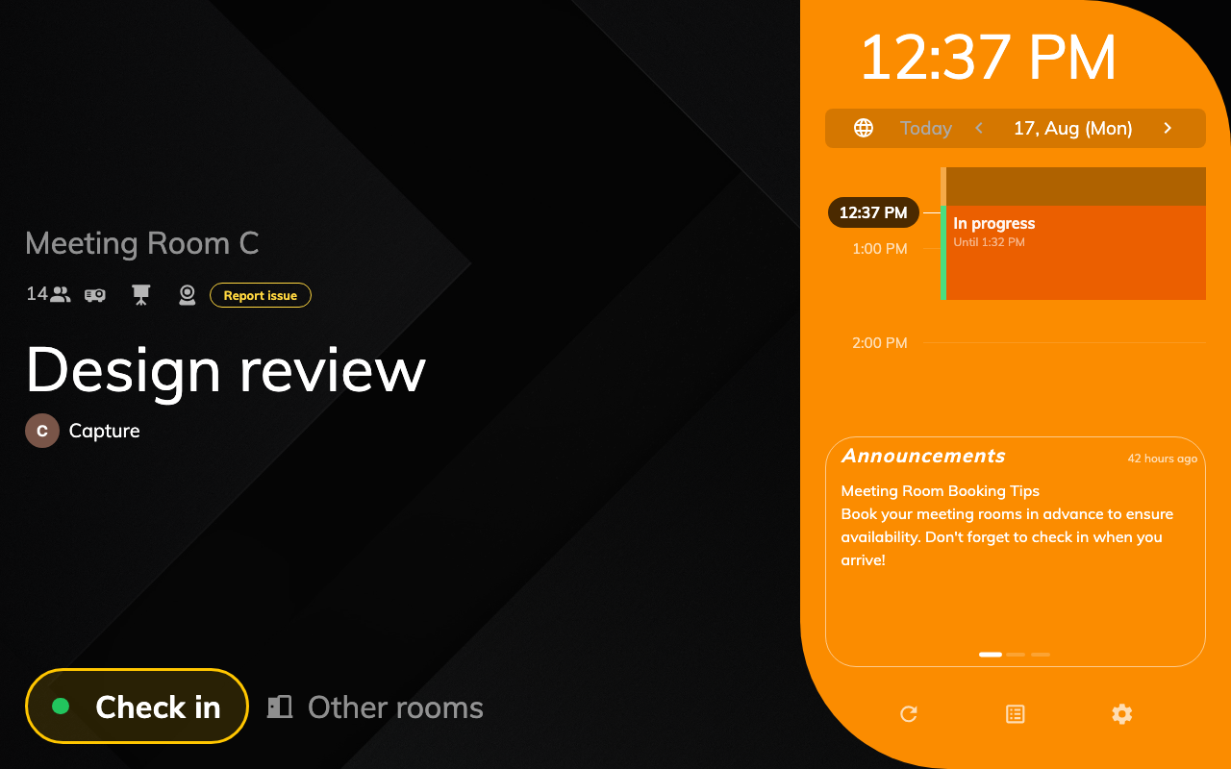
The panel while a booking is waiting: the check-in button, and the only countdown the product shows.

Nobody has to be watching
The system writes to the organiser at both ends of the window — a Waiting for
check-in reminder when the resource becomes available to check into, and a
No-show email reminder when it is released — with matching notifications in the
app. Both can be switched off for the whole organisation.
Where in Offision: admin app → booking/email-reminder (Email reminder settings)
That matters when you are deciding how tight to make a window. A ten-minute grace
that nobody is warned about feels arbitrary; the same ten minutes with a reminder at
the start of it is a fair warning.
Release happens within the minute, not on the second:
Bookings are re-checked once a minute, so a room comes back very shortly after its
deadline rather than exactly on it. A panel that still shows the old booking for a
few seconds is not stuck.

Two more behaviours worth knowing
- Walk-in bookings never require check-in. Somebody standing at the panel
claiming a free room has already proved they are there.
- A repeating series can cancel itself. Where Cancel recurring booking after
consecutive no-shows is on, a series that is abandoned often enough has its
remaining occurrences cancelled, and the organiser is warned one no-show before it
happens.

What it does not control
- Quota is not refunded by a no-show. The booking is released, the charge is
not. Only cancelling returns quota, and only inside the refund deadline — see
Booking rules reference.
- The booking release schedule is a different feature. It decides when a future
period opens for booking. It has nothing to do with releasing an unattended room,
despite the name.
- Early check-out and extend are their own policy settings, and neither is
affected by the check-in window.
- Who may press the button is decided per method — at the panel, in the app, by a
sensor. Each has its own article.

Where check-in can happen
- At the booking panel — the only method that
proves somebody was at the door.
- By QR code, and GPS — scanning a code, and
proving you are near the building.
- What counts as a no-show — once it has happened,
what the reports say about it.

