Give a department a shared booking budget
A user group quota policy gives a whole team one pool to book from, with a cap so one person cannot drain it — and it is not the same as putting that group on a user quota policy.
2026-08-25 · https://offision.com/help/en/booking/give-a-department-a-shared-booking-budget/
A department that keeps taking the good rooms is the usual reason to reach for
quota. A user group quota policy gives the whole team one budget to share,
so the department is limited as a department rather than person by person.
Before:
You need a user group for the department, a quota unit, and a resource quota
policy that charges in that unit and is attached to the rooms. If none of that
exists yet, start from how booking quota works.

One shared pool, not one budget each
The difference between the two user tabs is the whole point of this page, and
nothing on screen says it:
- Put a group on a User Quota Policy and every member gets their own
balance. Ten people on 50 each is 500 spent by whoever turns up.
- Put the same group on a User Group Quota Policy and they get one
balance between them. Ten people on 500 shared is 500 total, and the first
person to book has all of it.
The second is what a department budget means. It also brings a problem the first
one does not have, which is step 4.
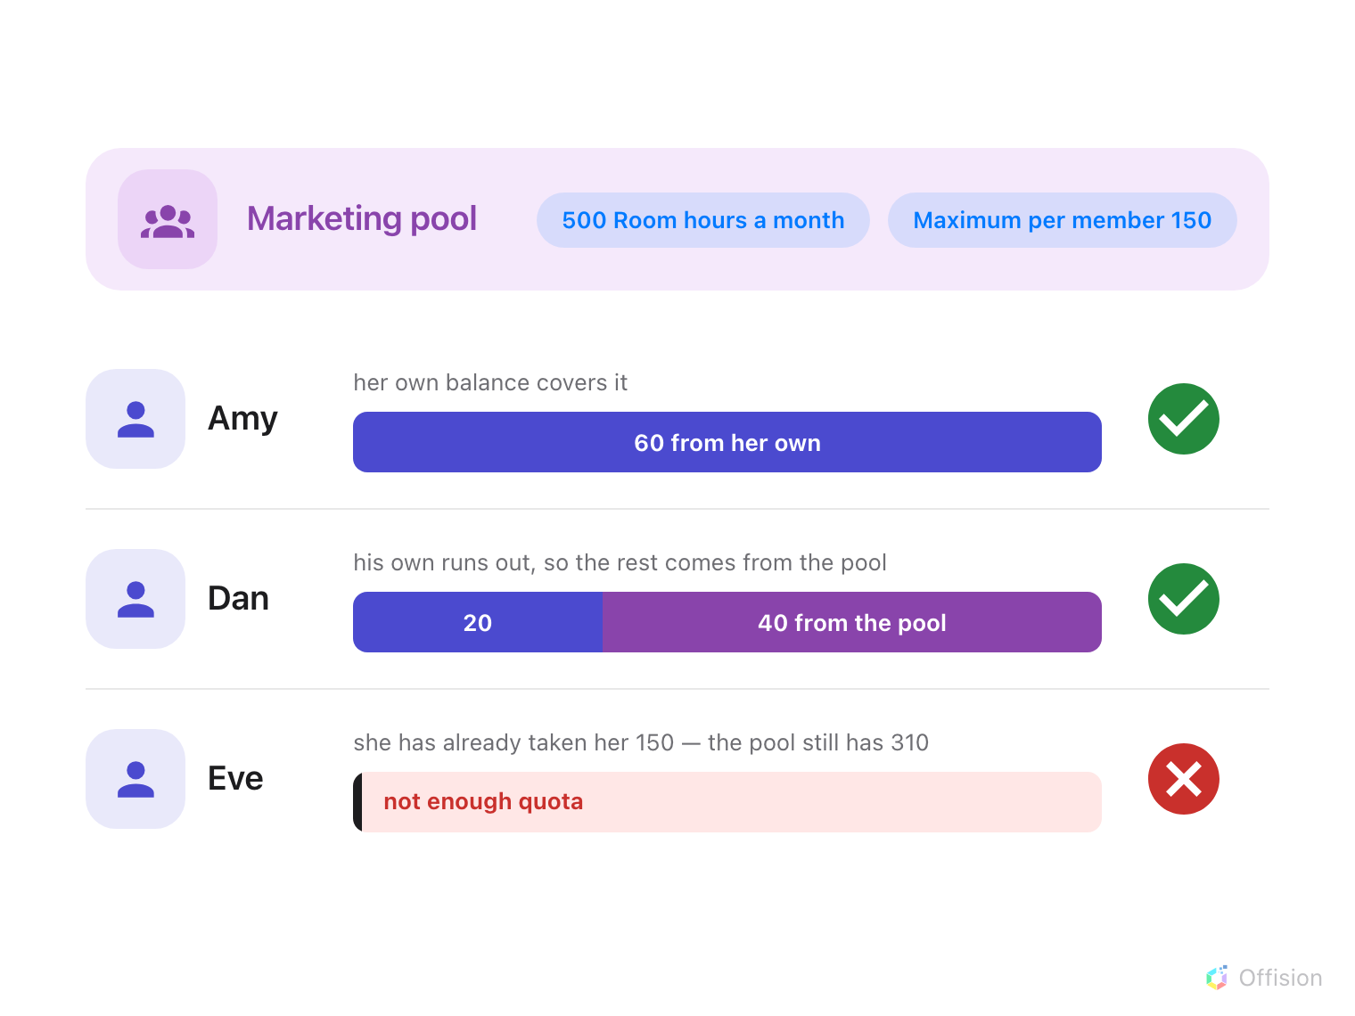
A booking drains the person's own balance first and only then the department pool — and a member who has taken their per-member maximum is short of quota even while the pool still has plenty.

1. Open Quota settings
In Booking, open Settings. Quota settings is under Booking rules
— if it is not in the sidebar, choose Show more first, because it is not one
of the pages pinned by default.
Where in Offision: admin app → booking/quota-policy (Quota settings)

2. Add a user group quota policy
Go to the User Group Quota Policy tab, the third one, and choose Add.
Name it after the department, then pick the Quota unit it grants.
Note:
Choose the unit carefully. Quota unit can only be set while the policy is
being created — it is not editable afterwards, so changing it later means
deleting the policy and starting again.

3. Decide what the department gets, and how often
Choose Grant a set amount and put the department's budget in Distribute
amount — this is what the whole group gets for one period, not what each
member gets.
Then set Quota period. A department budget is usually Monthly. For
Weekly, Biweekly, Quarterly and Yearly the form also asks for a
Start counting date — every period is measured from it, and the form previews
the next few so you can check them. Align that to your term or your financial
year rather than to the day you happen to be creating the policy. Nothing carries
over — an unspent period is gone.
Unlimited quota is the other option, and it is not pointless here: combined
with step 4 it gives a department no total ceiling but a firm per-person one.

4. Stop one person taking it all
Switch on Limit per member and set Maximum per member.
Without it, one person booking a fortnight of workshops in January leaves the
department with nothing until February. Turn it on the moment a pool has more
than a handful of people in it, and set it above a fair share — the cap is
there to catch hoarding, not to ration normal use.
A member who reaches their cap is simply short of quota. Everybody else can still
draw on what is left.
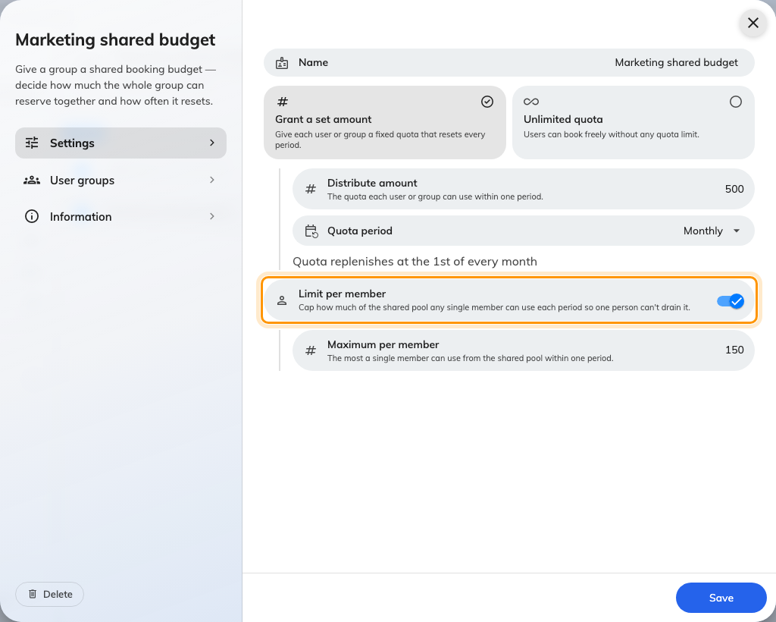
The shared amount, the period it resets on, and the cap on any one member.

5. Name the groups that share it
On the User groups page, add the department's group. More than one
group here share a single pool between all of them — which is how two teams that
work together get a joint budget rather than two.
Save.

6. Check it worked
Ask somebody in the department to open a booking on one of the charged rooms.
The booking form shows Charge, the amount, and what they have left; if the
pool is exhausted or they have hit their own cap it turns red and says Not
enough quota, and the booking will not save.
Then open Quota usage history and confirm the charge was recorded against the
group policy rather than against the person.
Where in Offision: admin app → booking/quota-history (Quota usage history)
Note:
A person's own balance is always spent first. If somebody in the department also
holds a personal quota policy, the pool is only touched once their own balance is
empty — so a department pool that never seems to go down usually means everybody
in it has personal quota as well.
Note:
Monthly does not reset on the 1st. The form says it replenishes then, but the
cycle is anchored to the date stored when the policy was created — which, on this
screen, is the Monday of the week you created it. So a monthly budget usually
resets on that day of the month instead. Check Quota usage history after the
first cycle if the exact day matters.

