Find a single room's busiest hours
Booking analytics is the one usage page whose filter narrows every chart on it, so the Daily heatmap can show one room's hours instead of the whole estate's. How to filter down to a single room, what the heatmap's rows and columns are, and why no page anywhere breaks usage down by day of the week.
2026-09-13 · https://offision.com/help/en/booking/find-a-rooms-busiest-hours/
Booking analytics is the usage page to open when the question is about one
meeting room rather than about the estate: which hours this room fills, and which
hours nobody wants it.
Find it under Booking › Booking analytics.
Where in Offision: admin app → booking/analytics (Booking analytics)
Note:
Two answers up front, because people ask for them together. By hour, yes —
the Daily heatmap's rows are hours of the day, and the filter above it can
narrow the whole page to a single room. By day of the week, no — the heatmap's
columns are calendar dates, and nothing in Offision totals usage by weekday.

1. Narrow it to the room you mean
The filter strip along the top is the part that makes this page different from
Resource usage analytics, where the
floor picker scopes only the map and every card beneath it stays estate-wide.
Here the filter scopes everything — each of the seven views redraws for
whatever set of resources the filter leaves standing.
It filters on Type, Location, Category, Capacity, Amenity,
Booking service, and a free-text Search. For one room, type its name into
Search. The count under Number of resources on the left tells you what
you actually caught — if it reads more than 1, the name matched more than one
room.
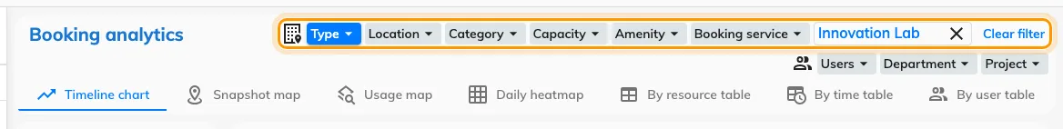
The filter narrows all seven views underneath it, not just one.
Set the period on the left as well. It cannot be pushed past today.

2. Open the Daily heatmap
The tabs across the header are the seven views of the same filtered data:
View | What it shows
Timeline chart | Usage over the period, bucketed by hour up to month
Snapshot map | The floor plan as it stood at one chosen moment
Usage map | The floor plan coloured by usage over the period
Daily heatmap | Hours of the day against the dates in the period
By resource table | One row per resource
By time table | One row per time bucket
By user table | One row per person

Daily heatmap is the one that answers the question. Pick it.

3. Read it
Each row is an hour of the day; each column is one date in the period. Data
above the grid decides what the shading measures — Count, Total hours,
Total minutes or Percentage. Click any cell to list the bookings that
made it.
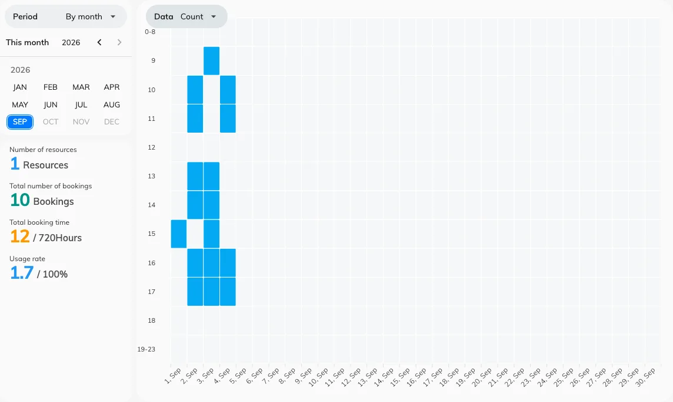
One room, hours down the side and dates across the top.
With the filter down to one room, the shape the dark cells make is that room's
answer to "when is it actually wanted". A band that repeats at the same hour day
after day is the case for a second room at that hour, rather than simply for a
second room.

4. Check it worked
Put a room you know well into Search, set the period to a few days you
remember, and read the heatmap against the bookings you can recall. Then clear
the filter: the same grid should darken everywhere, because it is now every
resource in the estate at once. If it does not change, the filter never applied.

What this does not tell you
- Anything by day of the week. There is no weekday axis, no weekday total,
and the date columns do not print a weekday name — so "are Tuesdays busier
than Fridays" has to be counted off the dates by eye, over a period you choose
to make that readable. No page in Offision aggregates it for you.
- A business-hours percentage. Percentage here is measured against every
minute of the period, around the clock. The business-hours divisor — booked
hours over the hours a resource was actually open — is on
Resource usage analytics, and what
goes into it is in
What a room's usage rate counts. The two
pages will disagree about the same room, and that is why.
- Whether anybody turned up. Every figure here is booked time. A room held
all week and entered by nobody reads as busy — see
what counts as a no-show.
- Two dimensions at once. For department against resource type, or a cost
code against the month, build it in
the usage report.

