Find a booking on the management calendar
The calendar shows one period at a time, so a booking you cannot date is hard to reach. Search it by subject, by who booked it, by room, or by the booking reference off somebody's email — then narrow the results and export them.
2026-09-15 · https://offision.com/help/en/booking/find-a-booking-on-the-management-calendar/
The management calendar draws one period at a time. That is the right shape for
"what is happening on Tuesday" and the wrong one for "where is the booking
somebody is emailing me about" — you would have to know the date before you
could look. Search answers the second question.
Before you start:
Read access to booking management. Search reads the same bookings the grid
does, so it shows you nothing the calendar would not.

1. Type in the search pill
It sits at the top right of the calendar header. On a phone it is a magnifier
that opens across the row when tapped.
Where in Offision: admin app → booking/calendar (Management calendar)
Typing opens a palette of live suggestions under three headings:
- Booking — matching bookings themselves. Each row carries the day, the
matched text with the hit picked out, the booking reference, a status dot, the
time, the resource and the organizer. Choosing one opens it.
- Organizer — the people whose bookings matched. Choosing one adds them as
a filter rather than opening anything.
- Resource — the same, for rooms and desks.
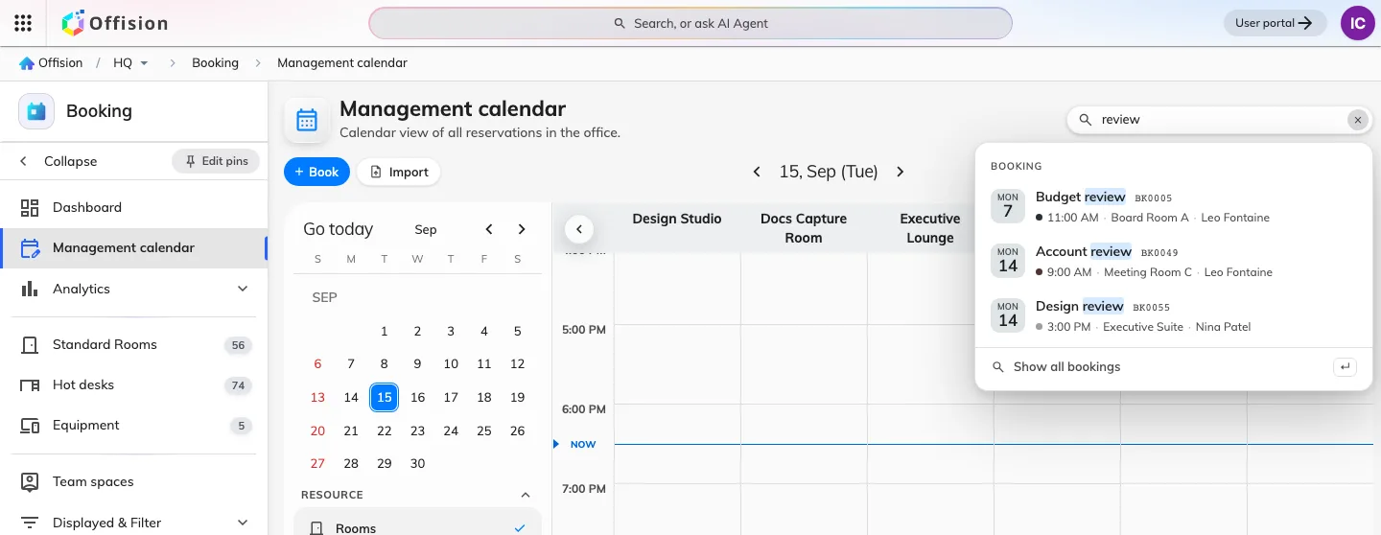
Suggestions as you type, under the heading they matched — here bookings, with the matched word picked out and the booking reference beside it.
The keyword reaches the booking's subject, its organizer and the resource it is
on, so a room name and a person's name are both fair game.

2. Or paste the booking reference
Every booking has one — BK0042, shown on the booking itself and the thing
the booking log is searched by, so it is what a colleague quotes when they ring
up about a meeting. Typed on its own it goes straight to that booking, and it is
forgiving about how it arrives: BK0042, bk42, #42 and 42 are all read as
the same reference.
A reference belongs to the whole series, so quoting one finds every date of a
repeating booking, not just the first.
Put anything else in the box beside it — BK0042 review — and it stops being a
reference and goes back to being ordinary words.

3. Show all the matches
Press Enter, or choose Show all bookings at the foot of the palette. The
grid gives way to a list of every match, with a row of filter chips and a count
above it.
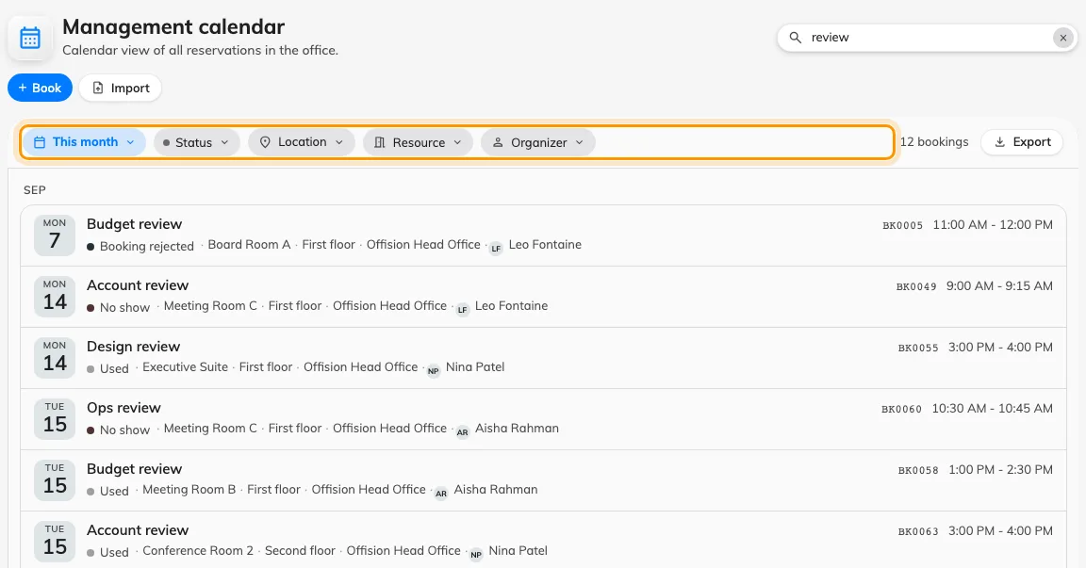
Results replace the grid: the chips narrow them, the count says how many there are.
While results are showing, the date navigator, the resource columns and their
paginator are all out of the way — none of them describes what you are looking
at any more.

4. Narrow it with the chips
Chip | Narrows to
The period | Today, This week, This month, Next 30 days, or Custom for two dates of your own. It opens on This month
Status | One or more booking states — see What a booking status means
Location | Buildings, and the floors inside them
Resource | Named rooms and desks
Organizer | The person who made the booking

A chip you have set carries what it is set to, and clears from its own menu.

5. Take the results away, or put the grid back
Export beside the count turns exactly these results into a spreadsheet —
see Export the bookings you are looking at.
Clearing the box returns the calendar to the day it was on.

The search is in the address bar
Every chip and the keyword itself live in the page's own address, so a search
survives a reload, a back button and being pasted to a colleague — who sees the
same list, filtered by their own permissions.

What this does not cover
- Bookings you could not otherwise see. Search is subject to the same
permissions as the calendar.
- Visits. Visitor invitations have a search of their own on the visiting
calendar — see Find a visit on the visiting calendar.
- Moving anything. Results are a list, not a grid; dragging a booking to
another room is still done on the calendar itself — see
Move a booking on the management calendar.

